Project Gutenberg's Moody’s Anecdotes And Illustrations, by Dwight L. Moody

This eBook is for the use of anyone anywhere at no cost and with
almost no restrictions whatsoever. You may copy it, give it away or
re-use it under the terms of the Project Gutenberg License included
with this eBook or online at www.gutenberg.org

Title: Moody’s Anecdotes And Illustrations
Related in his Revival Work by the Great Evangilist

Author: Dwight L. Moody

Release Date: November 16, 2006 [EBook #19830]

Language: English

Character set encoding: ASCII

*** START OF THIS PROJECT GUTENBERG EBOOK MOODY’S ANECDOTES AND ILLUSTRATIONS ***

Produced by Don Kostuch

[Transcriber's Notes]

Text has been move to avoid breaking sentences across page boundaries.

Here are the definitions of some unfamiliar (to me) terms.

antediluvian
Person who lived before the Biblical Flood. Very old or old-fashioned.

cavil
Raise irritating and trivial objections; find fault unnecessarily.

conies
Rabbits.

Chromo (chromolithograph)
Colored print.

livery (clothing)
Distinctive uniform.

tares
Weedy plants of the genus Vicia, especially the common vetch. Several weedy plants that grow in grain fields.
MOODY'S

ANECDOTES AND ILLUSTRATIONS.

RELATED IN HIS REVIVAL WORK
BY THE GREAT EVANGELIST
DWIGHT L. MOODY.

FULLY ILLUSTRATED FROM GUSTAVE DORE

REVISED EDITION.
EDITED BY
REV. J. B. McClure.

CHICAGO:
Rhodes & McClure Publishing Co.
1899

Entered according to act of Congress, in the year 1896 by the
Rhodes & McClure Publishing Company,
in the Office of the Librarian of Congress, Washington, D. C.
All Rights Reserved.
PREFACE.

The breathless interest given to Mr. Moody's anecdotes while being related by him before his immense audiences, and their wonderful power upon the human heart, suggested to the compiler this volume, and led him to believe and trust that, properly classified and arranged in book form, they would still carry to the general reader a measure of their original potency for good. The best anecdotes have been selected and carefully compiled under appropriate headings, alphabetically arranged, making the many stories easily available for the private reader and public teacher. Mr. Moody's idiom has been strictly preserved. He tells the story. "Gold" will be found scattered through the volume, which includes Mr. Moody's terse declarations of many precious and timely truths.
The compiler acknowledges the benefit received from the extended reports of the Tabernacle meetings given in the Daily press of Chicago, also the Hippodrome services reported in the New York papers, and the volume of Addresses revised by Mr. Moody. With the earnest prayer that God's blessing may accompany the reading of these stories that have blessed so many thousands as they fell from the lips of the great Evangelist, this volume is dedicated to the public by the compiler,
J. B. McClure
Chicago, Ill.
REVISED EDITION.

We retain in this, all that was in former editions and give forty pages additional of new anecdotes, properly classified, taken from the revival work in Boston and elsewhere. We also give engravings of Messrs. Moody, Sankey, Whittle, and the late lamented P. P. Bliss, the four evangelists who have so long and industriously labored together, and whose names conjoined, are household words throughout the land. The hearty reception already given by the public to this book justifies these improvements, which are gladly made, and which lead the compiler to hope that in this form the volume may prove yet more interesting and effective for good.
The engraving of Mr. Moody is from a copyrighted photograph by Gentile, used by permission. That of Mr. Whittle is by the same artist.
J. B. Mc.

REVISED EDITION 1896

This edition includes additional anecdotes and many handsome and appropriate illustrations.
Over one million copies of this book have been sold since the first issue. No single volume in the history of literature on the American continent has met with such a sale, and probably the only approximate comparison in the world is that of "Pilgrim's Progress."
Both of these volumes, it should be noted, derive their merited power and success from the vital truths of the Holy Scriptures which they so aptly illustrate. May Heaven's blessing follow.
J. B. McClure
Chicago, Ill.
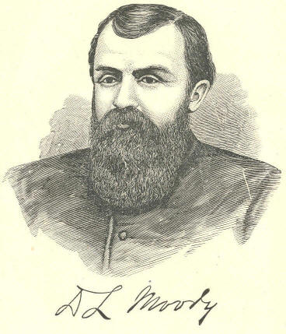
D. L. Moody
DWIGHT L. MOODY.

Self-made, and conscious of the absolute truthfulness of every Bible declaration, Dwight Lyman Moody is today, perhaps, the most independent and powerful of living evangelists. Man, rather than books, and God, rather than man, have been his study, and made his life intensely individual, and one which has constantly increased in good works. In his thirty-five years labor for Christ, from his mission class of fourteen scholars in a Chicago saloon, down to the ten thousand listening souls in the Halls of Europe and Tabernacles of America, he has been the same faithful, persevering, original, and pungent D. L. Moody, with an unshaken faith in God, and a burning desire for the conversion of souls. At home Mr. Moody is cheerful and happy; in the social circle he is genial and companionable; in the pulpit he is Truth on fire. His native town is Northfield, Mass., where he was born February 5th, 1837. He is therefore now, (1896), fifty-nine years old.
IRA D. SANKEY.

Ira David Sankey, known throughout the world as the companion of Mr. Moody, was born in Edenburg, Pa., August 28, 1840. His musical talents were early developed. Political glee clubs at first monopolized his genius, but after his conversion in 1857, the Sunday School and Church opened wider fields, in which he has since labored with increasing usefulness. In June, 1870, at a Christian Convention in Indianapolis, after a morning service, where Mr. Sankey led the singing, he met, for the first time, Mr. Moody. "Where do you live! Are you married? What business are you in?" at once inquired the Evangelist; "I want you." "What for?" "To help me in my work in Chicago." "I cannot leave my business," replied the now astonished singer. "You must," said Moody. "I have been looking for you for the last eight years." And thus was Mr. Sankey "called" to be the companion and helper of the great Evangelist. They have been laboring together, for about a score of years.
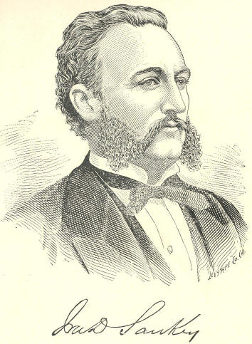
IRA D. SANKEY
D. W. WHITTLE.

For many years D. W. Whittle has been engaged in evangelistic work, giving it all his time, talents and energy. His first effort in connection with Mr. Bliss, who afterwards became his companion in the cause, was made over twenty years ago in a small town near Chicago. It was on this occasion that he told the story, "Hold the Fort," which the "Singing Evangelist" has rendered immortal. He is in the prime of life, and earnestly devoted to the Master's cause. His discourses are concise and clear, abounding with Scripture quotations, and, like those of Mr. Moody, interspersed with pointed anecdotes and illustrations. His preaching has been signally blessed wherever he has been called to labor.
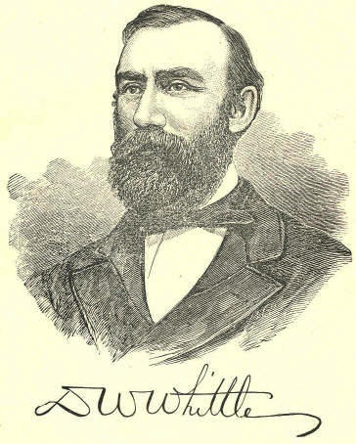
D. W. WHITTLE
P. P. BLISS

Philip Paul Bliss, the "Sweet Singer," was born in Clearfield County, Pa., in 1837. It was not until after he had reached the period of manhood that he "felt the stirrings of his musical gift." And then, under the inspiration of his wife, he entered upon the study of musical science, and laid the basis of his immortal "hymns," now sung around the world. In 1864 he removed to Chicago, where his musical talent and Christian character soon placed him in charge of the choir and Sunday School of the First Congregational Church, and where he made the acquaintance of D. W. Whittle, with whom, for the last five years of his life he labored in the great Gospel work. Deep spirituality and persuasiveness pervade all of Mr. Bliss' musical compositions. It is doubtful if the world ever heard sweeter hymns. Had he lived longer we should have heard more, but God, who raised him up for the work, called him:
For those who sleep,
And those who weep,
Above the portals narrow
The mansions rise
Beyond the skies--
We're going home to-morrow.

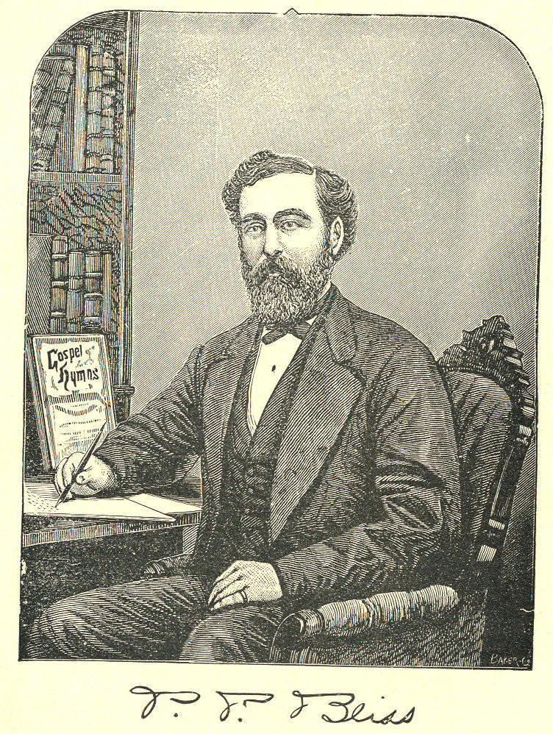
P. P. BLISS
CONTENTS.

A PAGE.
A Blind Man Preaches to 3,000,000 People 41
A Boy's Mistake--A Sad Reconciliation 52
A Business Man Confessing Christ 86
A Child at Its Mother's Grave 27
A Child Looking for its Lost Mother 63
A Child's Prayer Answered 169
A Child Visits Abraham Lincoln and Saves
the Life of a Condemned Soldier 11
A Commercial Traveler 71
A Day of Decision 99
A Defaulter's Confession 159
A Distiller Interrogates Moody 140
A Dream 77
A Dying Infidel's Confession 135
A Father's Love for his Boy 66
A Father's Love Trampled under Foot 155
A Father's Mistake 52
Affection 5
Affliction 11
A Good Excuse 108
A Heavy Draw on Alexander the Great 125
A Little Boy Converts his Mother 50
A Little Boy's Experience 48
A Little Child Converts an Infidel 56
All Right or All Wrong 44
A London Doctor Saved after Fifty Years of Prayer 176
A Long Ladder Tumbles to the Ground 125
Always Happy 164
A Man Drinks up a Farm 44
A Man who Would not Speak to his Wife 73
A Mother Dies that her Boy May Live 43
A Mother's Mistake 39
An Emperor Sets Forty Million Slaves Free 146
Angry at First--Saved at Last 177
An Infidel who would not Talk Infidelity before his Daughter 135
An Irishman Leaps into the Life-boat 96
A Remarkable Case 141
A Rich Father Visits his Dying Prodigal
Son in a Garret and Forgives him 116
Arthur P. Oxley! Your Mother Wishes to See You 162
A Rumseller's Son Blows his Brains Out 139
A Sad and Singular Story 130
Assurance 20
A Story Moody Never Will Forget 82
A Voice from the Tomb 166
A Wife's Faith 112
A Zealous Young Lady 83

B

Believe 26
Bible Study 34
Black-Balled by Man--Saved by Christ 168
Blind 39
Broken Hearts 12
By the Wayside 173

C

Calling the Roll of Heaven 132
Cast Out but Rescued 138
Child Stories 47
Christian Work 75
Christian Zeal 80
Christ Saves 64
Condemned to be Shot 147
Confessing Christ 85
Conversion 91

D

Decision 98
Deliverance 101
"Deluged With Blood" 32
Dr. Arnott's Dog "Rover" 124

E
"Emma. This is Papa's Friend" 59
Engaging Rooms Ahead 105
Excused at Last 109
Excuses 105

F

Faith 111
Faith More Powerful than Gunpowder 114
"Father, Father, Come This Way" 16
Five Million Dollars 20
Forgiveness 115
Forty-one Little Sermons 79
Four-score and Five 84
"Free" 93

G

George H. Stewart Visits a Doomed Criminal 101
Get the Key to Job 31
Gold 18
Gold 25
Gold 29
Gold 33
Gold 38
Gold 42
Gold 46
Gold 73
Gold 75
Gold 90
Gold 97
Gold 100
Gold 104
Gold 110
Gold 114
Gold 122
Gold 126
Gold 132
Gold 137
CONTENTS. 3

PAGE.
Gold 143
Gold 150
Gold 165
Gold 170
Gold 181
Governor Pollock and the Condemned Criminal 72
Grace 123

H

Heaven 127
"He Will Not Rest" 22
"Hold the Fort, for I am Coming" 182
How a Citizen Became a Soldier 94
How a Little Study Upset the Plans of a few Prominent Infidels 137
How a Young Irishman Opened Moody's Eyes 7
How Christ Expounded It 31
"How Funny You Talk" 30
How Moody's Faith Saved an Infidel 111
How Moody's Mother Forgave her Prodigal Son 115
How Moody Treated the Committees 84
How Moody was Blessed--Mark your Bible 34
How Moody was Encouraged 75
How Three Sunday-School Children Met their Fate 154

I

I Am not All Right 105
I Am not One of the Elect 107
I Am Trusting Jesus--A Young Lady's Trust. 186
I Can't Feel 106
"I Don't Know" 23
"If I Knew" 23
I Have Intellectual Difficulties 105
"I Know" 24
Infidel Books 136
Infidelity 133
Intemperance 138
It's Better Higher Up 132
"It Will Kill Her" 15

J

Jesus "Wants them All to Come" 55
Johnny, Cling Close to the Rock 152
Jumping into Father's Arms 153

L

Lady Ann Erkskine and Rowland Hill 68
"Let the Lower Lights be Burning" 183
Liberty 144
Liberty Now and Forever 144
Little Folks 151
Little Jimmy 60
Little Moody 47
Love 50
Love, not the Rattan, Conquers Little Moody 5
Love's Triumph in John Wannamaker's Sunday-School 9

M
Madness and Death 17?
Money Blind 42
Moody and his Little Willie 54
Moody and the Dying Soldier 26
Moody and the Infidel 32
Moody and the Judge 119
Moody Asks a Few Questions 142
Moody a Young Convert 95
Moody in a Billiard Hall--A Remarkable Story 118
Moody in a California Sunday-School 127
Moody in Prison 64
Moody on Duty--How he Loves his Mother 146
Moody Puts a Man in his Prophets Room 99
Moody Visits Prang's Chromo Establishment 35
Moody with Gen. Grant's Army In Richmond 147
Moody's Declaration 24
Moody's First Impulse in Converting Souls 91
Moody's First Sermon on Grace 121
Moody's Little Emma 60
Moody's Mistake 98
Mothers Are Looking down from Heaven 128
"More to Follow" 184
Mr. Morehouse's Illustration 113
Mrs. Moody Teaching her Child 187

N

Napoleon and the Conscript 148
Napoleon and the Private 20
Never to see its Mother 55
Note What Jesus Says 37

O

Obedience 153
O, Edward 141
Old Sambo and his Massa 144
One Book at a Time 36
One Word 37
Out of Libby Prison 145

P

Parental 155
Peter's Confession 88
Praise 164
Prayer 166
Prayer Answered 166
Pull for the Shore 40
"Pull for the Shore, Sailor" 185

R

Rational Belief 29
Reaping 171
Reaping the Whirlwind 174
Removing the Difficulties 177
Reuben Johnson Pardoned 121

S

Sad Ending of a Life that Might Have Been Otherwise 171
Sad Lack of Zeal 83
Safe In the Ark 97
4 CONTENTS.
PAGE
Sambo and the Infidel Judge 134
Satan's Match 80
Saved 176
"Saved" 178
Saved and Saving 81
Snapping the Chains 148
Song Stories 182
Sowing the Tares 173
Spurgeon and the Little Orphan 63
Spurgeon's Parable 103
Stubborn Little Sammy 61
Sudden Conversion (See Conversion) 91

T
Taking the Prince at his Word 112
Ten Years in a Sick Bed--yet Praising God 165
Terribly in Earnest 178
That is the Price of my Soul 155
"That is Your Fault" 14
The Arrows of Conviction 93
The Artist and the Beggar 70
The Bible 30
The Blind Beggar 88
The Blood 43
The Cross and Crown 192
The Cruel Mother--Hypothetical 162
The Czar and the Soldier 69
The Demoniac 102
The Drunken Father and his Praying Child 142
The Dying Boy 129
The Dying Child 57
The Eleventh Commandment 131
The Faithful Aged Woman 76
The Faithful London Lady 161
The Faithful Missionary 78
The Family that Hooted at Moody 88
The Fettered Bird Freed 45
The Finest Looking Little Boy Mr. Moody Ever Saw 58
The Horse that was Established 151
The "I am's," "I will's," Etc. 38
The Invitation 109
The King's Pardon 149
The Little Child and the Big Book 151
The Little Tow-headed Norwegian 87
The Loving Father 163
The Missing Stone 83
The Moody and Sankey Humbug 179
The Most Hopeless Man in New York now a Sunday-school
Superintendent 140
The Orphan's Prayer 170
The Place of Safety 18
The Praying Cripple 169
The Praying Mother 167
The Prodigal Son 191
The Repentent Father 158
The Reporter's Story 179
The Rich Man Poor 128
The Scotch "Draw the Bible" on False Doctrine 31
The Scotch Lassie 101
The Scotch Lassie and Dr. Chalmers 152
The Sinner's Prayer Heard 168
The Skeptical Lady 18?
The Sleep of Death 158
The Stolen Boy--A Mother's Love 157
The Two Fathers 156
The Way of the Transgressor is Hard 139
The Young Convert 89
The Young French Nobleman and the Doctor 133
Those Hypocrites 106
"Three Cheers" 164
True Love 6
Trust 186
Two Young Men 87

V

Very Hard, yet Very Easy 92
Very Orthodox 23

W
"We Will Never Surrender" 76
What a Woman Did 85
What Moody saw in a Chamber of Horror 174
Wisdom 189
Word Pictures 191
Why Did he not Take his Wife along? 108
"Won by a Smile" 47

Y

"You Know me, Moody" 28
Young Moody, Penniless in Boston,
is Warned by his Sister to "Beware of Pick-pockets" 124
D. L. MOODY'S
Anecdotes and Illustrations.

AFFECTION

Love, not the Rattan, Conquers Little Moody.

I remember when a boy, I used to go to a certain school in New England, where we had a quick-tempered master, who always kept a rattan. It was, "If you don't do this, and don't do that, I'll punish you." I remember many a time of this rattan being laid upon my back. I think I can almost feel it now. He used to rule that school by the law. But after a while there was somebody who began to get up a movement in favor of controlling the school by love. A great many said you can never do that with those unruly boys, but after some talk it was at last decided to try it. I remember how we thought of the good time we would have that winter when the rattan would be out of the school. We thought we would then have all the fun we wanted. I remember who the teacher was--it was a lady--and she opened the school with prayer. We hadn't seen it done before and we were impressed, especially when she prayed that she might have grace and strength to rule the school with love. Well, the school went on for several weeks and we saw no rattan, but at last the rules were broken, and I think I was the first boy to break them. She told me to wait till after school and then she would see me. I thought the rattan was coming out sure, and stretched myself up in warlike attitude. After school, however, I didn't see the rattan, but she sat down by me and told me how she loved me, and how she had prayed to be able to rule that school by love, and concluded by saying, "I want to ask you one favor--that is; if you love me, try and be a good boy;" and I never gave her trouble again. She just put me under grace. And that is what the Lord does. God is love, and He wants us all to love Him.
6 MOODY'S ANECDOTES Affection.

True Love.

One day when I was in Brooklyn, I saw a young man going along the street without any arms. A friend who was with me, pointed him out, and told me his story. When the war broke out he felt it to be his duty to enlist and go to the front. He was engaged to be married, and while in the army letters passed frequently between him and his intended wife. After the battle of the Wilderness the young lady looked anxiously for the accustomed letter. For a little while no letter was received. At last one came in a strange hand. She opened it with trembling fingers, and read these words: "We have fought a terrible battle. I have been wounded so awfully that I shall never be able to support you. A friend writes this for me. I love you more tenderly than ever, but I release you from your promise. I will not ask you to join your life with the maimed life of mine:" That letter was never answered. The next train that left, the young lady was on it. She went to the hospital. She found out the number of his cot, and she went down the aisle, between the long rows of the wounded men. At last she saw the number, and, hurrying to his side, she threw her arms around his neck and said: "I'll not desert you. I'll take care of you." He did not resist her love. They were married, and there is no happier couple than this one. We are dependent on one another. Christ says, "I'll take care of you. I'll take you to this bosom of mine." That young man could have spurned her love; he could, but he didn't. Surely you can be saved if you will accept the Saviour's love. If God loves us, my friends, He loves us unto the end. "For God so loved the world, that He gave His only begotten Son, that whosoever believeth in Him should not perish, but have everlasting life."
Affection. AND ILLUSTRATIONS. 7

How a Young Irishman Opened Moody's Eyes.

I want to tell you how I got my eyes open to the truth that God loves the sinner. When I went over to Europe I was preaching in Dublin, when a young fellow came up to the platform and said to me that he wanted to come to America and preach. He had a boyish appearance; did not seem to be over seventeen years old. I measured him all over, and he repeated his request, and asked me when I was going back. I told him I didn't know; probably I should not have told him if I had known. I thought he was too young and inexperienced to be able to preach. In course of time I sailed for America, and hadn't been here long before I got a letter from him, dated New York, saying that he had arrived there. I wrote him a note and thought I would hear no more about him, but soon I got another letter from him, saying that he was coming soon to Chicago, and would like to preach. I sent him another letter, telling him if he came to call upon me, and closed with a few common-place remarks. I thought that would settle him, and I would hear no more from him. But in a very few days after he made his appearance. I didn't know what to do with him. I was just going off to Iowa, and I went to a friend and said: "I have got a young Irishman--I thought he was an Irishman, because I met him in Ireland--and he wants to preach. Let him preach at the meetings--try him, and if he fails, I will take him off your hands when I come home." When I got home--I remember it was on Saturday morning--I said to my wife: "Did that young man preach at the meetings?" "Yes." "How did they like him?" "They liked him very much," she replied: "He preaches a little different from you; he preaches that God loves sinners." I had been preaching that God hated sinners; that he had been standing behind the sinners with a double-bladed sword, ready to cut the heads of the sinners off. So I concluded if he preached different from me, I would not like him. My prejudice was up. Well, I went down to the meeting that night, and saw them coming in with their Bibles with them. I thought it was curious. It was something strange to see the people coming in with Bibles, and listen to the flutter of the leaves.
8 MOODY'S ANECDOTES Affection

The young man gave out his text, saying: "Let us turn to the third chapter of John, and sixteenth verse: 'For God so loved the world that He gave His only begotten Son that whosoever believeth in Him should not perish, but have everlasting life.' " He didn't divide up the text at all. He, went from Genesis to Revelation, giving proof that God loved the sinner, and before he got through two or three of my sermons were spoiled. I have never preached them since.
The following day--Sunday--there was an immense crowd flocking into the hall, and he said, "Let us turn to the third chapter of John, sixteenth verse: 'For God so loved the world that He gave His only begotten Son, that whosoever believeth in Him shall not perish, but have everlasting life;' " and he preached the fourth sermon from this verse. He just seemed to take the whole text and throw it at them, to prove that God loved the sinner, and that for six thousand years he had been trying to convince the world of this. I thought I had never heard a better sermon in my life. It seemed to be new revelation to all. Ah, I notice there are some of you here who remember those times; remember those nights. I got a new idea of the blessed Bible. On Monday night I went down and the young man said, "Turn to the third chapter of John, sixteenth verse;" and he seemed to preach better than ever. Proof after proof was quoted from Scripture to show how God loved us. I thought sure he had exhausted that text, but on Tuesday he took his Bible in his hand and said: "Turn to the third chapter of John, sixteenth verse,' " and he preached the sixth sermon from that verse. He just seemed to climb over his subject, while he proved that there was nothing on earth like the love of Christ, and he said "If I can only convince men of His love, if I can but bring them to believe this text; the whole world will be saved." On Thursday he selected the same text, John iii., 16, and at the conclusion of the sermon he said: "I have been trying to tell you for seven nights now, how Christ loves you, but I cannot do it. If I could borrow Jacob's ladder and climb up to heaven, and could see Gabriel there and ask him to tell me how much God loves me, he would only say, "God so loved the world that He gave His only begotten Son, that whosoever believeth in Him should not perish; but have everlasting life." How a man can go out of this tabernacle after hearing this text, saying, "God does not love me," is a mystery to me.
Affection. AND ILLUSTRATIONS. 9

Love's Triumph in John Wannamaker's Sunday School.

Mr. John Wannamaker, superintendent of probably one of the largest Sunday schools in the world, had a theory that he would never put a boy out of his school for bad conduct. He argued if a boy misbehaved himself, it was through bad training at home, and that if he put him out of the school no one would take care of him. Well, this theory was put to the test one day. A teacher came to him and said, "I've got a boy in my class that must be taken out; he breaks the rules continually, he swears and uses obscene language, and I cannot do anything with him." Mr. Wannamaker did not care about putting the boy out, so he sent the teacher back to his class. But he came again and said that unless the boy was taken from his class, he must leave it. Well, he left, and a second teacher was appointed. The second teacher came with the same story, and met with the same reply from Mr. Wannamaker. And he resigned. A third teacher was appointed, and he came with the same story as the others. Mr. Wannamaker then thought he would be compelled to turn the boy out at last. One day a few teachers were standing about, and Mr. Wannamaker said: "I will bring this boy up and read his name out in the school, and publicly excommunicate him." Well, a young lady came up and said to him: "I am not doing what I might for Christ, let me have the boy; I will try and save him." But Mr. Wannamaker said: "If these young men cannot do it, you will not." But she begged to have him, and Mr. Wannamaker consented.
She was a wealthy young lady, surrounded with all the luxuries of life. The boy went to her class, and for several Sundays he behaved himself and broke no rule. But one Sunday he broke one; and, in reply to something she said, spit in her face.
10 MOODY'S ANECDOTES Affection.

She took out her pocket-handkerchief and wiped her face, but she said nothing. Well, she thought upon a plan, and she said to him; "John,"--we will call him John,--"John, come home with me." "No," says he, "I won't; I won't be seen on the streets with you." She was fearful of losing him altogether if he went out of the school that day, and she said to him, "Will you let me walk home with you?" "No; I won't," said he, "I won't be seen on the street with you." Then she thought upon another plan. She thought on the "Old Curiosity Shop," and she said, "I won't be at home tomorrow or Tuesday, but if you will come round to the front door on Wednesday morning there will be a little bundle for you." "I don't want it; you may keep your own bundle." She went home, but made the bundle up. She thought that curiosity might make him come.
Wednesday morning arrived and he had got over his mad fit, and thought he would just like to see what was in that bundle. The little fellow knocked at the door, which was opened, and he told his story. She said: "Yes; here is the bundle." The boy opened it and found a vest and a coat and other clothing, and a little note written by the young lady, which read something like this:
"DEAR JOHNNIE:--Ever since you have been in my class I have prayed for you every morning and evening, that you might be a good boy and I want you to stop in my class. Do not leave me."
The next morning, before she was up, the servant came to her and said there was a little boy below who wished to see her. She dressed hastily, and went downstairs, and found Johnnie on the sofa weeping. She put her arms around his neck, and he said to her, "My dear teacher, I have not had any peace since I got this note from you. I want you to forgive me." "Won't you let me pray for you to come to Jesus?" replied the teacher. And she went down on her knees and prayed. And now Mr. Wananamaker says that boy is the best boy in his Sunday-school. And so it was love that broke that boy's heart.

AND ILLUSTRATIONS. 11

AFFLICTION.

A Child Visits Abraham Lincoln, and Saves the Life of a Condemned Soldier.

During the war I remember a young man, not twenty, who was court-martialed down in the front and sentenced to be shot; The story was this: The young fellow had enlisted. He was not obliged to, but he went off with another young man. They were what we would, call "chums." One night this companion was ordered out on picket duty, and he asked the young man to go for him. The next night he was ordered out himself; and having been awake two nights, and not being used to it, fell asleep at his post, and for the offense he was tried and sentenced to death. It was right after the order issued by the President that no interference would be allowed in cases of this kind. This sort of thing had become too frequent, and it must be stopped. When the news reached the father and mother in Vermont it nearly broke their hearts. The thought that their son should be shot was too great for them. They had no hope that he would be saved by anything they could do. But they had a little daughter who had read the life of Abraham Lincoln, and knew how he had loved his own children, and she said: "If Abraham Lincoln knew how my father and mother loved my brother he wouldn't let mm he shot." That little girl thought this matter over and made up her mind to see the President. She went to the White House, and the sentinel, when he saw her imploring looks, passed her in, and when she came to the door and told the private secretary that she wanted to see the President, he could not refuse her.
12 MOODY'S ANECDOTES Affliction.

She came into the chamber and found Abraham Lincoln surrounded by his generals and counselors, and when he saw the little country girl he asked her what she wanted. The little maid told her plain, simple story--how her brother, whom her father and mother loved very dearly, had been sentenced to be shot; how they were mourning for him, and if he was to die in that way it would break their hearts. The President's heart was touched with compassion, and he immediately sent a dispatch canceling the sentence and giving the boy a parole so that he could come home and see that father and mother. I just tell you this to show you how Abraham Lincoln's heart was moved by compassion for the sorrow of that father and mother, and if he showed so much do you think the Son of God will not have compassion upon you, sinner, if you only take that crushed, bruised heart to him?

Broken Hearts.

There is no class of people exempt from broken hearts. The rich and the poor suffer alike. There was a time when I used to visit the poor that I thought all the broken hearts were to be found among them, but within the last few years I have found there are as many broken hearts among the learned as the unlearned, the cultured as the uncultured, the rich as the poor. If you could but go up one of our avenues and down another and reach the hearts of the people; and get them to tell their whole story, you would be astonished at the wonderful history of every family. I remember a few years ago I had been out of the city for some weeks. When I returned I started out to make some calls. The first place I went to I found a mother; her eyes were red with weeping. I tried to find out what was troubling her, and she reluctantly opened her heart and told me all. She said: "Last night my only boy came home about midnight, drunk. I didn't know that he was addicted to drunkenness, but this morning I found out that he had been drinking for weeks, and," she continued, "I would rather have seen him laid in the grave than have have had him brought home in the condition I saw him in last night."
Affliction. AND ILLUSTRATIONS. 13

I tried to comfort her as best I could when she told me her sad story. When I went away from that house I didn't want to go into any other house where there was family trouble. The very next house I went to, however, where some of the children who attended my Sunday school resided, I found that death had been there and laid his hand on one of them. The mother spoke to me of her afflictions, and brought to me the playthings and the little shoes of the child, and the tears trickled down that mother's cheeks as she related to me her sorrow. I got out as soon as possible, and hoped I would see no more family trouble that day.
The next visit I made was to a home where I found a wife with a bitter story. Her husband had been neglecting her for a long time; "and now," she said, "he has left me, and I don't know where he has gone. Winter is coming on, and I don't know what is going to become of my family." I tried to comfort her, and prayed with her, and endeavored to get her to lay all her sorrows on Christ. The next home I entered I found a woman crushed and broken-hearted. She told me her boy had forsaken her, and she had no idea where he had gone. That afternoon I made five calls, and in every home I found a broken heart. Everyone had a sad tale to tell, and if you visited every house in Chicago you would find the truth in the saying that "there is a skeleton in every house." I suppose while I am talking you are thinking of the great sorrow in your own bosom. I do not know anything about you, but if I were to come around to everyone of you, and you were to tell me the truth I would hear a tale of sorrow. The very last man I spoke to last night was a young mercantile man who told me his load of sorrow had been so great that many times during the last few weeks he had gone down to the lake and had been tempted to plunge in and end his existence. His burden seemed too much for him. Think of the broken hearts in Chicago tonight! They could be numbered by hundreds--yea, thousands. All over this city are broken hearts.
If all the sorrow represented in this great city were written in a book, this building couldn't hold that book, and you couldn't read it in a long lifetime. This earth is not a stranger to tears, neither is the present the only time when they could be found in abundance. From Adam's days to ours tears have been shed, and a wail has been going up to heaven from the broken-hearted. And I say it again, it is a mystery to me how all those broken hearts can keep away from Him who has come to heal them.

14 MOODY'S ANECDOTES Affliction.

"That is Your Fault."

I remember a mother coming to me and saying, "It is easy enough for you to speak in that way; if you had the burden that I've got, you couldn't cast it on the Lord." "Why, is your burden so great that Christ can't carry it?" I asked. "No; it isn't too great for Him to carry; but I can't put it on Him." "That is your fault," I replied; and I find a great many people with burdens who, rather than just come to Him with them, strap them tighter on their backs and go away struggling under their load. I asked her the nature of her trouble, and she told me. "I have an only boy who is a wanderer on the face of the earth. I don't know where he is. If I only knew where he was I would go around the world to find him. You don't know how I love that boy. This sorrow is killing me." "Why can't you take him to Christ? You can reach Him at the throne, even though he be at the uttermost part of the world. Go tell God all about your trouble, and he will take away his sin, and not only that, but if you never see him on earth, God can give you faith that you will see your boy in heaven." And then I told her of a mother who lived down in the southern part of Indiana. Some years ago her boy came up to this city. He was a moralist. My friends, a man has to have more than morality to lean upon in this great city. He hadn't been here long before he was led astray. A neighbor happened to come up here and found him one night in the streets drunk.
When that neighbor went home, at first he thought he wouldn't say anything about it to the boy's father, but afterward he thought it was his duty to tell him. So in a crowd in the street of their little town he just took the father aside, and told him what he had seen in Chicago. It was a terrible blow. When the children had been put to bed that night he said to his wife, "Wife, I have bad news. I have heard from Chicago today."
Afflictions. AND ILLUSTRATIONS. 15

The mother dropped her work in an instant and said: "Tell me what it is." "Well, our son has been seen on the streets of Chicago, drunk." Neither of them slept that night, but they took their burden to Christ, and about daylight the mother said: "I don't know how, I don't know when or where, but God has given me faith to believe that our son will be saved and will never come to a drunkard's grave."
One week after, that boy left Chicago. He couldn't tell why--an unseen power seemed to lead him to his mother's home, and the first thing he said on coming over the threshold was, "Mother, I have come home to ask you to pray for me;" and soon after he came back to Chicago a bright and shining light. If you have a burden like this, fathers, mothers, bring it to Him and cast it on Him, and He, the Great Physician, will heal your broken hearts.

"It will Kill Her."

I was thinking to-day of the difference between those who knew Christ when trouble comes upon them and those who knew Him not. I know several members of families who are just stumbling into their graves over trouble. I know two widows in Chicago who are weeping and mourning over the death of their husbands, and their grief is just taking them to their graves. Instead of bringing their burdens to Christ, they mourn day and night, and the result will be that in a few weeks or years at most their sorrow will take them to their graves when they ought to take it all to the Great Physician.
Three years ago a father took his wife and family on board that ill-fated French steamer. They were going to Europe, and when out on the ocean another vessel ran into her and she went down. That mother when I was preaching in Chicago used to bring her two children to the meetings every night. It was one of the most beautiful sights I ever looked on, to see how those little children used to sit and listen, and to see the tears trickling down their cheeks when the Saviour was preached. It seemed as if nobody else in that meeting drank in the truth as eagerly as those little ones.
16 MOODY'S ANECDOTES Affliction.

One-night when an invitation had been extended to all to go into the inquiry room, one of these little children said: "Mamma, why can't I go in too?" The mother allowed them to come into the room, and some friend spoke to them, and to all appearances they seemed to understand the plan of salvation as well as their elders. When that memorable night came that mother went down and came up without her two children. Upon reading the news I said: "It will kill her," and I quitted my post in Edinburgh--the only time I left my post on the other side--and went down to Liverpool to try and comfort her. But when I got there I found that the Son of God had been there before me, and instead of me comforting her, she comforted me. She told me she could not think of those children as being in the sea; it seemed as if Christ had permitted her to take those children on that vessel only that they might be wafted to Him, and had saved her life only that she might come back and work a little longer for Him. When she got up the other day at a mothers' meeting in Farwell Hall, and told her story, I thought I would tell the mothers of it the first chance I got.
So if any of you have had some great affliction, if any of you have lost a loving father, mother, brother, husband, or wife, come to Christ, because God has sent Him to heal the broken-hearted.

"Father, Father, Come This Way."

I remember a number of years ago I went out of Chicago to try to preach. I went down to a little town where was being held a Sunday-school convention. I was a perfect stranger in the place, and when I arrived a man stepped up to me and asked me if my name was Moody. I told him it was, and he invited me to his house. When I got there he said he had to go to the convention, and asked me to excuse his wife, as she, not having a servant, had to attend to her household duties. He put me into the parlor, and told me to amuse myself as best I could till he came back. I sat there, but the room was dark and I could not read, and I got tired.
Affliction. AND ILLUSTRATIONS. 17

So I thought I would try and get the children and play with them. I listened for some sound of childhood in the house, but could not hear a single evidence of the presence of little ones. When my friend came back I said: "Haven't you any children?" "Yes," he replied, "'I have one, but she's in Heaven, and I am glad she is there, Moody." "Are you glad that your child's dead?" I inquired.
He went on to tell me how he had worshiped that child; how his whole life had been bound up in her to the neglect of his Saviour. One day he had come home and found her dying. Upon her death he accused God of being unjust. He saw some of his neighbors with their children around them. Why hadn't He taken some of them away? He was rebellious. After he came home from her funeral he said: "All at once I thought I heard, her little voice calling me, but the truth came to my heart that she was gone. Then I thought I heard her feet upon the stairs; but I knew she was lying in the grave. The thought of her loss almost made me mad. I threw myself on my bed and wept bitterly. I fell asleep, and while I slept I had a dream, but it almost seemed to me like a vision.
"I thought I was going over a barren field, and I came to a river so dark and chill-looking that, I was going to turn away, when all at once I saw on the opposite bank the most beautiful sight I ever looked at. I thought death and sorrow could never enter into that lovely region. Then I began to see beings all so happy looking, and among them I saw my little child. She waved her little angel hand to me and cried, 'Father, Father, come this way.' I thought, her voice sounded much sweeter than it did on earth. In my dream I thought I went to the water and tried to cross it, but found it deep and the current so rapid that I thought if I entered it would carry me away from her forever. I tried to find a boatman to take me over, but couldn't, and I walked up and down the river trying to find a crossing, and still she cried: 'Come this way.' All at once I heard a voice come rolling down, 'I am the way, the truth, and the life; no man cometh unto the Father but by Me.' The voice awoke me from my sleep,' and I knew it was my Saviour calling me, and pointing the way for me to reach my darling child.
"I am now superintendent of a Sunday-school; I have made many converts; my wife has been converted, and we will, through Jesus as the way, see one day our child."
18 MOODY'S ANECDOTES Affliction

The Place of Safety.

My friends, there is one spot on earth where the fear or Death, of Sin, and of Judgment, need never trouble us, the only safe spot on earth where the sinner can stand--Calvary. Out in our western country, in the autumn, when men go hunting, and there has not been rain for many months, sometimes the prairie grass catches fire. Sometimes, when the wind is strong, the flames maybe seen rolling along, twenty feet high, destroying man and beast in their onward rush. When the frontiersmen see what is coming, what do they do to escape? They know they cannot run as fast as that fire can run. Not the fleetest horse can escape it. They just take a match and light the grass around them. The flames sweep onwards; they take their stand in the burnt district and are safe. They hear the flames roar as they come along; they see death bearing down upon them with resistless fury, but they do not fear. They do not even tremble as the ocean of flame surges around them, for over the place where they stand the fire has already past and there is no danger. There is nothing for fire to burn. And there is one spot all earth that God has swept over. Eighteen hundred years ago the storm burst on Calvary; the Son of God took it into his own bosom, and now, if we take our stand by the Cross, we are safe for time and eternity.

GOLD.

--Christ never preached any funeral sermons.
--His is a loving, tender hand, full of sympathy and compassion.
--Take your stand on the Rock of Ages. Let death, let the judgment come: the victory is Christ's and yours through Him.
Afflictions. AND ILLUSTRATIONS. 19

--The only man who ever suffered before Christ was that servant who had his ear cut off. But most likely in a moment afterward he had it on, and very likely it was a better ear than ever, because whatever the Lord does He does it well No man ever lost his life with Him.
--A great many people wonder why it was that Christ did not come at once to Martha and Mary, whom He loved, whenever He heard of their affliction. It was to try them, and it is the same with His dealings toward us. If He seems not to come to us in our afflictions, it is only to test us.
--When the Spirit came to Moses, the plagues came upon Egypt, and he had power to destroy men's lives; when the Spirit came upon Elijah, fire came down from heaven; when the Spirit came upon Gideon, no man could stand before him; and when it came upon Joshua, he moved around the city of Jericho and the whole city fell into his, hands; but when the Spirit came upon the Son of Man, He gave His life; He healed the broken-hearted.
--No matter how low down you are; no matter what your disposition has been; you may be low in your thoughts, words, and actions; you may be selfish; your heart may be overflowing with corruption and wickedness; yet Jesus will have compassion upon you. He will speak comforting words to you; not treat you coldly or spurn you, as perhaps those of earth would, but will speak tender words, and words of love and affection and kindness. Just come at once. He is a faithful friend--a friend that sticketh closer than a brother.
20 MOODY'S ANECDOTES

ASSURANCE.

Napoleon and the Private.

It is said of Napoleon that while he was reviewing his army one day, his horse became frightened at something, and the Emperor lost his rein, and the horse went away at full speed, and the Emperor's life was in danger. He could not get hold of the rein, and a private in the ranks saw it, and sprang out of the ranks towards the horse, and was successful in getting hold of the horse's head at the peril of his own life. The Emperor was very much pleased. Touching his hat, he said to him, "I make you Captain of my Guard." The soldier didn't take his gun, and walk up there. He threw it away, stepped out of the ranks of the soldiers, and went up to where the body-guard stood. The captain of the body-guard ordered him back into the ranks, but he said "No! I won't go!" "Why not?" "Because I am Captain of the Guard." "You Captain of the Guard?" "Yes;" replied the soldier. "Who said it?" and the man, pointing to the Emperor; said, "He said it." That was enough. Nothing more could be said. He took the Emperor at his word. My friends, if God says anything, let us take Him at His word. "He that believeth on the Lord Jesus Christ shall not perish, but have everlasting life." Don't you believe it? Don't you believe you have got everlasting life? It can be the privilege of every child of God to believe and then know that you have got it.

"Five Million Dollars."

One thing I know--I cannot speak for others, but can speak for myself; I cannot read other minds and other hearts; I cannot read the Bible and lay hold for others; but I can read for myself, and take God at his word.
Assurance. AND ILLUSTRATIONS. 21

The great trouble is that people take everything in general, and do not take it to themselves. Suppose a man should say to me, "Moody, there was a man in Europe who died last week, and left five million dollars to a certain individual." "Well," I say, "I don't doubt that; it's rather a common thing to happen," and I don't think anything more about it. But suppose he says, "But he left the money to you." Then I pay attention; I say, "To me?" "Yes, he left it to you." I become suddenly interested. I want to know all about it. So we are apt to think Christ died for sinners; He died for everybody, and for nobody in particular. But when the truth comes to me that eternal life is mine, and all the glories of Heaven are mine, I begin to be interested. I say, "Where is the chapter and verse where it says I can be saved?" If I put myself among sinners, I take the place of the sinner, then it is that salvation is mine and I am sure of it for time and eternity.

Engaging Rooms Ahead.

Mr. Sankey and myself--going about and preaching the gospel, is nothing new. You will find them away back eighteen hundred years ago, going off two by two, like Brothers Bliss and Whittle, and Brothers Needham and Stebbins, to different towns and villages. They had gone out, and there had been great revivals in all the cities, towns, and villages they had entered. Everywhere they had met with the greatest success. Even the very devils were subject to them. Disease had fled before them. When they met a lame man they said to him, "You don't want to be lame any longer," and he walked. When they met a blind man they but told him to open his eyes, and behold, he could see. And they came to Christ and rejoiced over their great success, and He just said to them, "I will give you something to rejoice over. Rejoice that your names are written in heaven."
Now there are a great many people who do not believe in such an assurance as this, "Rejoice, because your names are written in heaven." How are you going to rejoice if your names are not written there?
22 MOODY'S ANECDOTES Assurance.

While speaking about this some time ago, a man told me we were preaching a very ridiculous doctrine when we preached this doctrine of assurance. I ask you in all candor what are you going to do with this assurance if we don't preach it? It is stated that our names are written there; blotted out of the Book of Death and transferred to the Book of Life.
I remember while in Europe I was traveling with a friend--she is in this hall to-night. On one occasion we were journeying from London to Liverpool, and the question was put as to where we would stop. We said we would go to the "Northwestern," at Lime street, as that was the Hotel where Americans generally stopped at. When we got there the house was full and they could not let us in. Every room was engaged. But this friend said, "I am going to stay here. I engaged a room ahead. I sent a telegram on." My friends, that is just what the Christians are doing--sending their names in ahead. They are sending a message up saying: "Lord Jesus, I want one of those mansions You are preparing; I want to be there." That's what they are doing.
Every man and woman who wants one, if you have not already got one, had better make up your mind. Send your names up now. I would rather a thousand times have my name written in the Lamb's Book than have all the wealth of the world rolling at my feet.

"He Will Not Rest."

Suppose a man is going to Cincinnati, and he gets on the cars, but he feels uneasy lest, the train will take him to St. Louis instead of his destination. He will not rest till he knows he is on the right road, and the idea that we are on the road to eternity as fast as time can take us, and do not know our destination, is contrary to Scripture. If we want peace we must know it, and we can know it; it is the Word of God. Look What Peter says: "We know we have an incorruptible dwelling." Then in Paul's epistle to the Colossians, i., 12, "Giving thanks unto the Father which hath made us meet"--hath made us, not going to--"to be partakers of the inheritance of the saints in light. Who hath delivered us"--not going to deliver us, but He hath delivered us: this is an assurance--"from the power of darkness, and hath translated us into the kingdom of His dear Son."
Assurance. AND ILLUSTRATIONS. 23

"Very Orthodox."

A person came to me some time ago and said: "Mr. Moody, I wish you would give me a book that preaches assurance, and that tells the children of God it is their privilege to know they are accepted." I said, "Here is a book; it is very orthodox. It was written by John, the most intimate friend of Jesus while He was on earth. The man who laid his head upon His bosom." Turn to John and see what he says in the 5th chapter, "For in them ye think ye have eternal life."

"I Don't Know."

There is no doubt about assurance in the Word of God. A person said to me some time ago: "I think it is great presumption for a person to say she is saved." I asked her if she was saved. "I belong to a church," she sobbed. "But are you saved?" "I believe it would be presumption in me to say that I was saved." "Well I think it is a greater presumption for anyone to say: 'I don't know if I believe in the Lord Jesus Christ because it is written, He that believeth on me hath everlasting life.' " It is clearly stated that we have assurance.

"If I Knew."

Many think that assurance is not to be had while traveling through this world--they must wait till they get before the terrible judgment seat to know whether they are accepted or not. And I find some ministers preach this precious doctrine from their pulpits. I heard of a minister who, while on his way to the burial of a man, began to talk upon the subject of assurance. "Why," said he, "if I knew for a certainty that I was saved the carriage couldn't hold me. I would have to jump out with joy." A man should be convinced that he has the gospel, before he preaches it to anyone else. Why, a man need not try to pull a man out of the river if he is in it himself. A man need not try to lift a man out of a pit if he is there too. No man can preach salvation till he knows he is saved.
24 MOODY'S ANECDOTES Assurance.

"I Know!"

The man of God who has fixed his feet on the rock of salvation can say with certainty, "I know." If you have not got assurance and want it, just believe God's Word. If you go down South and ask those three million colored people how they think they are free, they won't talk about their feelings; they just believe that Abraham Lincoln made them free. They believe the proclamation, and so we must believe the proclamation God has made in the Bible. "One thing thou teachest," that is salvation.

Moody's Declaration.

A great many people say, "Mr. Moody, I would like to know whether I am a Christian or not. I would like to know if I am saved." The longer I live the more I am convinced that it is one of the greatest privileges of a child of God to know--to be able to say, "I am saved." The idea of walking through life without knowing this until we get to the great white throne is exploded. If the Bible don't teach assurance it don't teach justification by faith; if it don't teach assurance it don't teach redemption. The doctrine of assurance is as clear as any doctrine in the Bible.
How many people in the Tabernacle when I ask them if they are Christians, say, "Well, I hope so,"--in a sort of a hesitating way. Another class say, "I am trying to be." This is a queer kind of testimony, my friends. I notice no man is willing to go into the inquiry room till he has got a step beyond that. That class of Christians don't amount to much. The real Christian puts it, "I believe; I believe that my Redeemer liveth; I believe that if this building of flesh were destroyed, I have a building not made with hands, eternal in the heavens." No hoping and trusting with them. It is, "I know." Hope is assured to the Christian. It is a sure hope; it isn't a doubting hope. Suppose a man asked me if my name was Moody, and I said, "Well, I hope so," wouldn't it sound rather strange? "I hope it is;" or, "I'm trying to be Moody." Now, if a man asks you if you are a Christian, you ought to be able to give a reason.
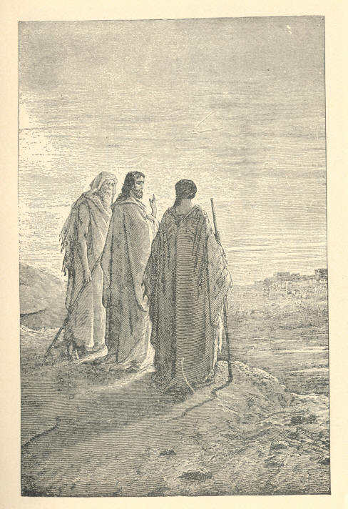
The Journey To Emmaus. Luke xxiv, 13-32.
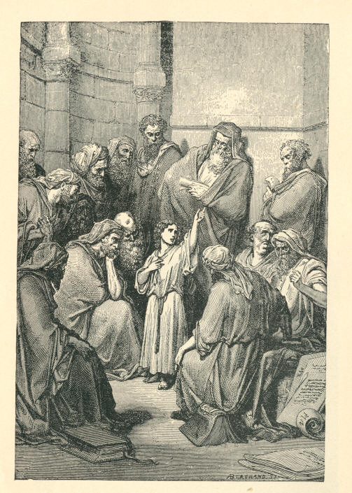
Jesus Questioning The Doctors. Luke ii, 41-51
Assurance. AND ILLUSTRATIONS. 25

GOLD.

-- There cannot be any peace where there is uncertainty.
-- There is no knowledge like that of a man who knows he is saved, who can look up and see his "title clear to mansions in the skies."
-- I believe hundreds of Christian people are being deceived by Satan, now on this point, that they have not got the assurance of salvation just because they are not willing to take God at His word.
-- "But," a man said to me, "no one has come back, and we don't know what is in the future. It is all dark, and how can we be sure?" Thank God! Christ came down from heaven, and I would rather have Him coming as he does right from the bosom of the Father, than anyone else. We can rely on what Christ says, and He says, "He that believeth on Me shall not perish, but have everlasting life." Not that we are going to have it when we die, but right here to-day.
-- Now, I find a great many people who want some evidence that they have accepted the Son of God. My friends, if you want any evidence, take God's word for it. You can't find better evidence than that. You know that when the Angel Gabriel came down and told Zachariah he should have a son he wanted a further token than the angel's word. He asked Gabriel for it and he answered, "I am Gabriel, who stands in the presence of the Lord." He had never been doubted, and he thundered out this to Zachariah. But he wanted a further token, and Gabriel said, "You shall have a token: you shall be dumb till your son shall be given you."
26 MOODY'S ANECDOTES

BELIEVE.

Moody and the Dying Soldier.

After the battle of Pittsburgh Landing and Murfreesboro' I was in a hospital at Murfreesboro'. And one night after midnight, I was woke up and told that there was a man in one of the wards who wanted to see me. I went to him and he called me "chaplain!"--I wasn't a chaplain--and he said he wanted me to help him die. And I said, "I'd take you right up in my arms and carry you into the kingdom of God if I could; but, I can't do it; I can't help you to die." And he said, "Who can?" I said: "The Lord Jesus Christ can--He came for that purpose." He shook his head and said, "He can't save me; I have sinned all my life." And I said, "But He came to save sinners." I thought of his mother in the North, and I knew that she was anxious that he should die right, and I thought I'd stay with him. I prayed two or three times, and repeated all the promises I could, and I knew that in a few hours he would be gone. I said I wanted to read him a conversation that Christ had with a man who was anxious about his soul. I turned to the third chapter of John. His eyes were riveted on me, and when I came to the 14th and 15th verses, he caught up the words, "As Moses lifted up the serpent in the wilderness, even so must the Son of Man be lifted up; that whosoever believeth on Him should not perish, but have eternal life." He stopped me and said, "Is that there?" I said "Yes," and he asked me to read it again, and I did so. He leaned his elbows on the cot and clasped his hands together and said, "That's good; won't you read it again."
I read it the third time, and then went on with the rest of the chapter. When I finished, his eyes were closed, his hands were folded, and there was a smile on his face. Oh! how it was lit up!
Believe. AND ILLUSTRATIONS. 27

What a change had come over it! I saw hits lips quivering, and I leaned over him and heard, in a faint whisper; "As Moses lifted up the serpent in the wilderness, so must the Son of Man be lifted up, that whosoever believeth on Him should not perish, but have eternal life." He opened his eyes and said, "That's enough; don't read any more." He lingered a few hours and then pillowed his head on those two verses, and then went up in one of Christ's chariots and took his seat in the Kingdom of God.
You may spurn God's remedy and perish; but I tell you God don't want you to perish. He says, "As I live I have no pleasure in the death of the wicked." "Turn ye, turn ye, for why will ye die?"

A Child at its Mother's Grave.

I remember seeing a story some time ago in print. It has been in the papers, but it will not hurt us to hear it again. A family in a Southern city were stricken down with yellow fever. It was raging there, and there were very stringent sanitary rules. The moment anybody died, a cart went around and took the coffin away. The father was taken sick and died and was buried, and the mother was at last stricken down. The neighbors were afraid of the plague, and none dared go into the house. The mother had a little son and was anxious about her boy, and afraid he would be neglected when she was called away, so she called the little fellow to her bedside, and said, "My boy, I am going to leave you, but Jesus will come to you when I am gone." The mother died, the cart came along and she was laid in the grave. The neighbors would have liked to take the boy, but were afraid of the pestilence. He wandered about and finally started up to the place where they had laid his mother and sat down on the grave, and wept himself to sleep. Next morning he awoke and realized his position--alone and hungry. A stranger came along and seeing the little fellow sitting on the ground, asked him what he was waiting for. The boy remembered what his mother had told him, and answered, "I am waiting for Jesus," and told him the whole story. The man's heart was touched, tears trickled down his cheeks and he said, "Jesus has sent me," to which the boy replied, "You have been a good while coming, sir." He was provided for. So it is with us. To wait for results, we must have courage and patience and God will help us.
28 MOODY'S ANECDOTES Believe.

"You Know Me, Moody."

Well, let me illustrate it then, and perhaps you will be able to understand it. Suppose I am dying with consumption; which I inherited from my father or mother. I did not get it by any fault of my own, by any neglect of my health; I inherited it, let us suppose. Well, I go to my physician, and to the best physicians, and they all give me up. They say I am incurable; I must die; I have not thirty days to live. Well, a friend happens to come along and looks at me and says: "Moody, you have got the consumption." "I know it very well; I don't want any one to tell me that." "But," he says, "There is a remedy--a remedy, I tell you. Let me have your attention. I want to call your attention to it. I tell you there is a remedy." "But sir, I don't believe it. I have tried the leading physicians in this country and in Europe, and they tell me there is no hope." "But you know me, Moody; you have known me for years." "Yes, sir." "Do you think, then, I would tell you a falsehood?" "No." "Well, ten years ago I was far gone. I was given up by the physicians to die, but I took this medicine and it cured me, I am perfectly well--look at me;" I say that it is a very strange case. "Yes, it may be strange, but it is a fact. That medicine cured me; take this medicine and it will cure you. Although it has cost me a great deal, it shall not cost you anything. Although the salvation of Jesus Christ is as free as the air, it cost God the richest jewel of heaven. He had to give his only Son; give all He had; He had only one Son, and He gave Him. Do not make light of it, then, I beg of you." "Well" I say, "I would like to believe you, but this is contrary to my reason." Hearing this, my friend goes away and brings another friend to me and he testifies to the same thing. He again goes away when I do not yet believe, and brings in another, and another; and another, and they all testify to the same thing.
Believe. AND ILLUSTRATIONS. 29

They say they were as bad as myself; and they took the same medicine that has been offered to me, and it cured them. He then hands me the medicine. I dash it to the ground; I do not believe in its saving power: I die. The reason is, then, that I spurned the remedy.
So it will not be because Adam fell, but that you spurn the remedy offered to you to save you. You will have darkness rather than light. How, then, shall ye escape if ye neglect so great salvation? There is no hope for you if you neglect the remedy.

Rational Belief.

Once there were a couple of men arranging a balloon ascension. They thought they had two ropes fastened to the car, but one of them only was fastened, and they unfastened that one rope, and the balloon started to go up. One of the men seized hold of the car, and the other seized hold of the rope. Up went the balloon, and the man who seized hold of the car went up with it, and was lost. The man who laid hold of the rope was just as sincere as the man who laid hold of the car. There was just as much reason to say that the man who laid hold of that would be saved because he was sincere as the man who believed in a lie because he is sincere in his belief. I like a man to be able to give a reason for the faith that is in him. Once I asked a man what he believed, and he said he believed what his church believed. I asked him what his church believed, and he said he supposed his church believed what he did; and that was all I could get out of him. And so men believe what other people believe and what their church believes, without really knowing what their church and other people do believe.

GOLD.

-- God is truth.
-- What grounds have we for not believing God?
30 MOODY'S ANECDOTES

THE BIBLE.

"How Funny You Talk."

No book in the world has been so misjudged as the Bible. Men judge it without reading it. Or perhaps they read a bit here and a bit there, and then close it saying, "It is so dark and mysterious!" You take a book, now-a-days, and read it. Some one asks you what you think about it. "Well," you say, "I have only read it through once, not very carefully, and I should not like to give an opinion." Yet people take up God's book, read a few pages, and condemn the whole of it. Of all the skeptics and infidels I have ever met speaking against the Bible, I have never met one who read it through. There may be such men, but I have never met them. It is simply an excuse. There is no man living who will stand up before God and say that kept him out of the kingdom. It is the devil's work trying to make us believe it is not true, and that it is dark and mysterious. The only way to overcome the great enemy of souls is by the written Word of God. He knows that, and so tries to make men disbelieve it. As soon as a man is a true believer in the Word of God, he is a conqueror over Satan. Young man! the Bible is true. What have these infidels to give you in its place? What has made England but the open Bible? Every nation that exalteth the Word of God is exalted, and every nation that casteth it down is cast down. Oh, let us cling close to the Bible. Of course, we shall not understand it all at once. But men are not to condemn it on that account. Suppose I should send my little boy, five years old, to school tomorrow morning, and when he came home in the afternoon, say to him, "Willie, can you read? can you write? can you spell? Do you understand all about Algebra, Geometry; Hebrew, Latin, and Greek?" "Why, papa," the little fellow would say, "hew funny you talk. I have been all day trying to learn the A B C!"
The Bible. AND ILLUSTRATIONS. 31

Well; suppose I should reply, "If you have not finished your education, you need not go any more." What would you say? Why, you would say, I had gone mad. There would he just as much reason in that, as in the way that people talk about the Bible. My friends, the men who have studied the Bible for fifty years--the wise men and the scholars, the great theologians--have never got down to the depths of it yet. There are truths there that the Church of God has been searching out for the last eighteen hundred years, but no man has fathomed the depths of that ever-living stream.

"How Christ Expounded It."

You will find Christ, after He had risen, again speaking about the Old Testament prophets: "And beginning at Moses, and all the prophets, he expounded unto them in all the Scripture the things concerning Himself." Concerning Himself. Don't that settle the question? I tell you I am convinced in my mind that the Old Testament is as true as the New. "And He began at Moses and all the prophets." Mark that, "all the prophets." Then in the forty-fourth verse: "And He said unto them, these are the words which I spake unto you, while I was yet with you, that all things must be fulfilled which were written in the law of Moses and in the prophets and in the psalms concerning Me. Then opened He their understanding that they might understand the Scripture."

The Scotch "Draw the Bible" on False Doctrine.

There is no place I have ever been in where people so thoroughly understand their Bibles as in Scotland. Why, little boys could quote Scripture and take me up on a text. They have the whole nation just educated, as it were, with the Word of God. Infidelity cannot come there. A man got up in Glasgow, at a corner, and began to preach universal salvation. "Oh, sir," said an old woman, "that will never save the like of me." She had heard enough preaching to know that it would never save her. If a man comes among them with any false doctrine, these Scotchmen instantly draw their Bibles on him. I had to keep my eyes open and be careful what I said there. They knew their Bibles a good deal better than I did. And so if the preachers could get the people to read the Word of God more carefully, and note what they heard, there would not be so much infidelity among us.
32 MOODY'S ANECDOTES The Bible.

Moody and the Infidel.

An infidel had come the other day, to one of our meetings, and when I talked with him, he replied that he didn't believe one-twelfth part of the Bible, but I kept on quoting Scripture, feeling that if the man didn't believe, God could do what He chose with His word, and make it quick and powerful, and sharper than a two-edged sword. The man kept saying that he did not believe what the Bible said, and I kept on quoting passage after passage of Scripture, and the man, who, two hours before, had entered the hall an infidel, went out of it a converted man, and a short time after his conversion he left the City for Boston, a Christian, to join his family in Europe. Before this gentleman went away, I asked him if he believed the Bible, and his reply was: "From back to back, every word of it."

"Deluged with Blood."

A good many years ago there was a convention held in France, and those who held it wanted to get the country to deny a God, to burn the Bible, wanted to say that men passed away like a dog and a dumb animal. What was the result! Not long since, that country was filled with blood. Did you ever think what would take place if we could vote the Bible and the ministers of the gospel and God out from among the people? My friends, the country would be deluged with blood. Your life and mine would not be safe in this City to-night. We could not walk through these streets with safety. We don't know how much we owe God and the influence of His gospel among even ungodly men.
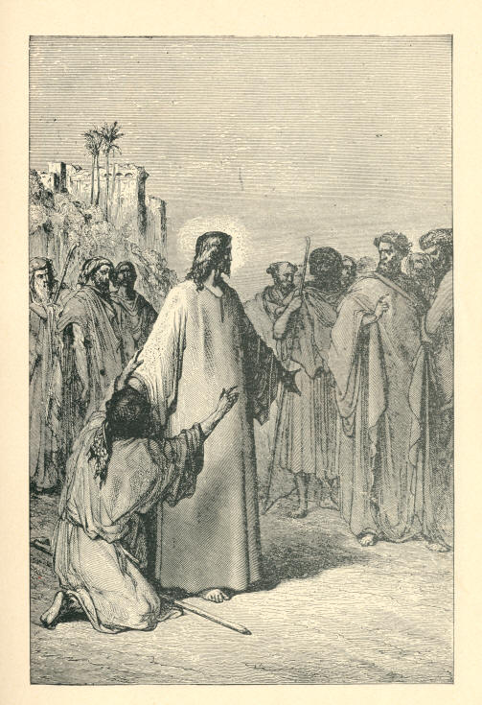
The Dumb Man Possessed. Matthew, ix, 32.
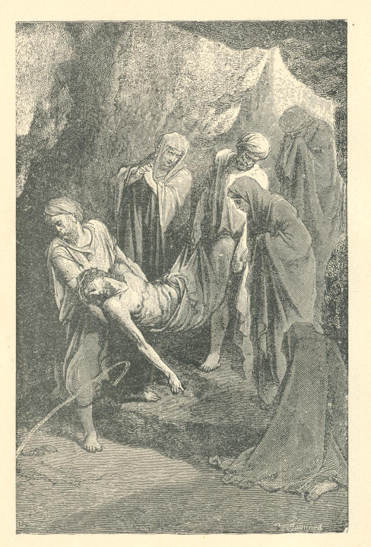
The Burial Of Jesus. John, xix, 38-42.
The Bible. AND ILLUSTRATIONS 33

GOLD.

-- There are over two hundred passages in the Old Testament which prophesied about Christ, and every one of them has come true.
-- God didn't give the world two different Bibles; they are one, and must be believed from back to back, from Genesis to Revelations, or not at all.
-- I haven't found the first man who ever read the Bible from back to back carefully who remained an infidel. My friends, the Bible of our mothers and fathers is true.
-- The Word of God may be darkened to the natural man, but the way of Salvation is written so plain, that the little child six years old can understand it if she will.
-- Set more and more store by the Bible. Then troubles in your Christian life will pass away like a morning cloud. You will feed and live on the Word of God, and it will become the joy of your soul.
-- There are dark and mysterious things in the Bible now, but when you begin to trust Christ your eyes will be opened and the Bible will be a new book to you. It will become the Book of books to you.
-- I notice if a man goes to cut up the Bible and comes to you with one truth and says, "I don't believe this, and I don't believe that,"--I notice when he begins to doubt portions of the Word Of God he soon doubts it all.
-- If you will show me a Bible Christian living on the Word of God, I will show you a joyful man. He is mounting up all the time. He has got new truths that lift him up over every obstacle, and he mounts over difficulties higher and higher, like a man I once heard of who had a bag of gas fastened on either side, and if he just touched the ground with his foot, over a wall or a hedge he would go; and so these truths make us so light that we bound over every obstacle.

3
34 MOODY'S ANECDOTES

BIBLE STUDY.

How Moody was Blessed--"Mark Your Bible."

I want to tell you how I was blessed a few years ago, upon hearing a discourse upon the thirtieth chapter of Proverbs. The speaker said the children of God were like four things. The first thing was: "The ants are a people not strong," and he went on to compare the children of God to ants. He said the people of God were like, ants. They pay no attention to the things of the present, but go on steadily preparing for the future. The next thing he compared them to was the conies. "The conies are but a feeble folk." It is a very weak little thing. "Well," said I, "I wouldn't like to be as a coney." But he went on to say that it built upon a rock. The children of God were very weak, but they laid their foundation upon a rock. "Well," said I, "I will be like a coney and build my hopes upon a rock." Like the Irishman who said he trembled himself, but the rock upon which his house was built never did. The next thing the speaker compared them to was a locust. I didn't think much of locusts; and I thought I wouldn't care about being like one. But he went on to read, "They have no king, yet they go forth all of them by bands." There were the Congregationalist, the Presbyterian, the Methodist bands going forth without a king, but by and by our King will come back again, and these bands will fly to Him. "Well, I will be like a locust; my King is away," I thought. The next comparison was a spider. I didn't like this at all, but he said if we went into a gilded palace filled with luxury, we might see a spider holding on to something, oblivious to all the luxury below. It was laying hold of the things above. "Well," said I, "I would like to be a spider." I heard this a good many years ago, and I just put the speaker's name to it, and it makes a sermon. But take your Bibles and mark them. Don't think of wearing them out. It is a rare thing to find a man wearing his Bible out now-a-days--and Bibles are cheap, too. You are living in a land where they are plenty. Study them and mark them, and don't be afraid of wearing them.
Bible Study. AND ILLUSTRATIONS. 35

Moody Visits Prang's Chromo Establishment.

When I went to Boston, I went into Mr. Prang's chromo establishment. I wanted to know how the work was done. He took me to a stone several feet square, where he took the first impression, but when he took the paper off the stone I could see no sign of a man's face there. "Wait a little," he said. He took me to another stone, but when the paper was lifted I couldn't see any impression yet. He took me up, up to eight, nine, ten stones, and then I could see just the faintest outlines of a man's face. He went on till he got up to about the twentieth stone, and I could see the impression of a face, but he said it was not very correct yet. Well, he went on till he got up, I think, to the twenty-eighth stone, and a perfect face appeared, and it looked as if all it had to do was to speak and it would be human. If you read a chapter of the Bible and don't see anything in it, read it a second time, and if you cannot see anything in it read it a third time. Dig deep. Read it again and again, and even if you have to read it twenty-eight times do so, and you will see the Man Christ Jesus, for He is in every page of the Word.

Get the Key to Job.

An Englishman asked me some time ago, "Do you know much about Job?" "Well, I know a little," I replied. "If you've got the key of Job, you've got the key to the whole Bible." "What?" I replied, "I thought it was a poetical book." "Well," said he, "I will just divide Job into seven heads. The first is the perfect man--untried; and that is Adam and Eve before they fell. The second head is tried by adversity--Adam after the fall. The third is the wisdom of the world--the three friends who came to try to help Job out of his difficulties.
36 MOODY'S ANECDOTES Bible Study.

They had no power to help him at all." He could stand his scolding wife, but he could not stand them. The fourth head takes the form of the Mediator, and in the fifth head God speaks at last. He heard him before by the ear, but he hears Him now by the soul, and he fell down flat upon his face. A good many men in Chicago are like Job. They think they are mighty good men, but the moment they hear the voice of God they know they are sinners, they are in the dust. There isn't much talk about their goodness then. Here he was with his face down. Job learned his lesson. That was the sixth head, and in these heads were the burdens of Adam's sin. The seventh head was when God showed him His face. Well, I learned the key to the Bible. I cannot tell how this helped me. I told it to another man, and he asked me if I ever thought how he got his property back and his sheep back. He gave Job double what he had and gave him ten children besides, so that he should have ten in heaven besides his ten on earth.

One Book at a time.

I have found it a good plan to take up one book at a time. It is a good deal better to study one book at a time than to run through the Bible. If we study one book and get its key, it will, perhaps, open up others. Take up the book of Genesis, and you will find eight beginnings; or, in other words, you pick up the key of several books. The gospel was written that man might believe on Jesus Christ, and every chapter speaks of Him. Now, take the book of Genesis; it says it is the book of beginnings. That is the key; then the book of Exodus--it is the book of redemption; that is the key word of the whole. Take up the book of Leviticus, and we find that it is the book of sacrifices. And so on through all the different books; you will find each one with a key. Another thing: We must study it unbiased. A great many people believe certain things. They believe in certain creeds and doctrines, and they run through the book to get Scripture in accordance with them. If a man is a Calvinistic man he wants to find something in accordance with his doctrine. But if we go to seek truth the Spirit of God will come. Don't seek it in the blue light of Presbyterianism, in the red light of Methodism; or in the light of Episcopalianism, but study it in the light of Calvary.
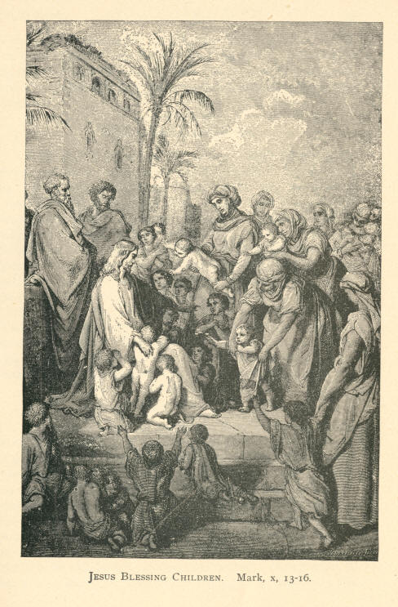
Jesus Blessing Children. Mark, x, 13-16
Bible Study. AND ILLUSTRATIONS. 37

Note what Jesus Says.

Some people say to me, "Moody, you don't believe in the flood. All the scientific men tell us it is absurd." Let them tell us. Jesus tells us of it, and I would rather take the word of Jesus than that of any other one. I haven't got much respect for those men who dig down for stones with shovels, in order to take away the word of God. Men don't believe in the story of Sodom and Gomorrah, but we have it sealed in the New Testament. "As, it was in the days of Sodom and Gomorrah." They don't believe in Lot's wife, but He says, "Remember Lot's wife." So there is not a thing that men to-day cavil at but the Son of God indorses. They don't believe, in the swallowing of Jonah. They say it is impossible that a whale could swallow Jonah--its throat is too small. They forget that the whale was prepared for Jonah; as the colored woman said, "Why, God could prepare a man to swallow a whale, let alone a whale to swallow a man."

One Word.

I remember I took up the word "love," and turned to the Scriptures and studied it, and got so that I felt I loved everybody, I got full of it. When I went on the street, I felt as if I loved everybody I saw. It ran out of my fingers. Suppose you take up the subject of love and study it up. You will get so full of it that all you have got to do is to open your lips and a flood of the love of God flows upon the meeting. If you go into a court you will find a lawyer pleading a case. He gets everything bearing upon one point, heaped up so as to carry his argument with all the force he can, in order to convince the jury. Now it seems to me a man should do the same in talking to an audience; just think that he has a jury before him, and he wants to convict a sinner. If it is love, get all you can upon the subject and talk love, love.
38 MOODY'S ANECDOTES Bible Study.

The "I Ams," "I Wills," Etc.

A favorite way to study the Bible with me, is first to take up one expression, and run through the different places where they are found. Take the "I ams" of John; "I am the bread of life;" "I am the water of life;" "I am the way, the truth, and the life;" "I am the resurrection;" "I am all, and in all." God gives to His children a blank; and on it they can write whatever they most want and He will fill the bill. And then the promises. A Scotchman found out thirty one thousand distinct promises in the Word of God. There is not a despondent soul but God has a promise just to suit him.

GOLD.

-- The best truths are got by digging deep for them.
-- When we know our Bible, then it is that God can use us.
-- When we find a man meditating on the words of God, my friends, that man is full of boldness and is successful.
-- When a man is filled with the Word of God you cannot keep him still. If man has got the Word, he must speak or die.
-- Let us have one day exclusively to study and read the Word of God. If we can't take time during the week, we will have Sunday uninterrupted.
-- Now, as old Dr. Bonner, of Glasgow, said, "The Lord didn't tell Joshua how to use the sword, but He told him how he should meditate on the Lord day and night, and then he would have good success."
-- One thing I have noticed in studying the Word of God, and that is, when a man is filled with the Spirit he deals largely with the Word of God, whereas the man who is filled with his own ideas refers rarely to the Word of God. He gets along without it, and you seldom see it mentioned in his discourses.

AND ILLUSTRATIONS. 39

BLIND.

A Mother's Mistake.

While I was attending a meeting in a certain city sometime ago a lady came to me and said: "I want you to go home with me; I have something to say to you." When we reached her home, there were some friends there; After they had retired, she put her arms on the table, and tears began to come into her eyes, but with an effort she repressed her emotion. After a struggle she went on to say that she was going to tell me something which she had never told any other living person. I should not tell it now; but she has gone to another world. She said she had a son in Chicago, and she was very anxious about him. When he was young he got interested in religion at the rooms of the young Men's Christian Association. He used to go out in the street and circulate tracts. He was her only son, and she was very ambitious that he should make a name in the world, and wanted him to get into the very highest circles. Oh, what a mistake people make about these highest circles. Society is false; it is a sham. She was deceived like a good many more votaries of fashion and hunters after wealth at the present time. She thought it was beneath her son to go down and associate with those young men who hadn't much money. She tried to get him away from them, but they had more influence than she had, and, finally, to break his whole association, she packed him off to a boarding-school. He went soon to Yale College, and she supposed he got into one of those miserable secret societies there that have ruined so many young men; and the next thing she heard was that the boy had gone astray.
She began to write letters urging him to come into the Kingdom of God, but she heard that he tore the letters up without reading them.
40 MOODY'S ANECDOTES Blind.

She went to him to try and regain whatever influence she possessed over him, but her efforts were useless, and she came home with a broken heart. He left New Haven, and for two years they heard nothing of him. At last they heard he was in Chicago, and his father found him and gave him $30,000 to start in business. They thought it would change him, but it didn't. They asked me when I went back to Chicago to try and use my influence with him. I got a friend to invite him to his house one night, where I intended to meet him, but he heard I was to be there, and did not come near, like a good many other young men, who seem to be afraid of me. I tried many times to reach him, but could not. While I was traveling one day on the New Haven Railroad, I bought a New York paper, and in it I saw a dispatch saying he had been drowned in Lake Michigan. His father came on to find his body, and, after considerable searching, they discovered it. All his clothes and his body were covered with sand. The body was taken home to that broken-hearted mother. She said "If I thought he was in heaven I would have peace." Her disobedience of God's law came back upon her.
So, my friends, if you have a boy impressed with the gospel, help him to come to Christ. Bring him in the arms of your faith, and He will unite you closer to him.

"Pull for the Shore."

Look at that man in a boat on Niagara River. He is only about a mile from the rapids. A man on the bank shouts to him, "Young man, young man, the rapids are not far away; you'd better pull for the shore." "You attend to your own business; I will take care of myself," he replies. Like a great many people here, and ministers, too, they don't want any evangelist here--don't want any help, however great the danger ahead. On he goes; sitting coolly in his boat. Now he has got a little nearer, and a man from the bank of the river sees his danger, and shouts: "Stranger, you'd better pull for the shore; if you go further, you'll be lost. You can be saved now if you pull in." "Mind your business, and you'll have enough to do; I'll take care of myself."
Blind. AND ILLUSTRATIONS. 41

Like a good many men, they are asleep to the danger that's hanging over them while they are in the current. And I say, drinking young man, don't you think you are standing still. You are in the current, and if you don't pull for a rock of safety you will go over the precipice. On he goes. I can see him in the boat laughing at the danger. A man on the bank is looking at him, and he lifts up his voice and cries, "Stranger, stranger, pull for the shore; if you don't you'll lose your life;" and the young man laughs at him--mocks him. That is the way with hundreds in Chicago. If you go to them and point out their danger, they will jest and joke at you. By and by he says: "I think I hear the rapids--yes, I hear them roar;" and he seizes his oars and pulls with all his strength, but the current is too great, and nearer and nearer he is drawn on to that abyss, until he gives one unearthly scream, and over he goes. Ah, my friends, this is the case with hundreds in this city. They are in the current of riches of pleasure, of drink, that will take them to the whirlpool.

A Blind Man Preaches to 3,000,000 People.

I was at a meeting in London, when I was there, and I heard a man speaking with wonderful power and earnestness. "Who is that man?" I asked, my curiosity being excited. "Why, that is Dr. ----. He is blind." I felt some interest in this man and at the close of the meeting, I sought an interview, and he told me that he had been stricken blind when very young. His mother took him to a doctor, and asked him about his sight. "You must give up all hope," the doctor said. "Your boy is blind, and will be forever." "What, do you think my boy will never see?" asked his mother. "Never again." The mother took her boy to her bosom and cried, "Oh, my boy, ''Who will take care of you when I am gone? Who will look to you?"--forgetting the faithfulness of that God she had taught him to love. He became a servant of the Lord and was permitted to print the Bible in twelve different languages, printed in the raised letters, so that all the blind people could read the Scriptures themselves. He had a congregation, my friends, of three millions of people, and I think that blind man was one of the happiest beings in all London. He was naturally blind, but he had eyes to his soul, and could see a bright eternity in the future. He had built his foundation upon the living God. We pity those who have not their natural sight; but how you should pity yourself if you are spiritually blind.
42 MOODY'S ANECDOTES Blind.

Money Blind.

I heard of a man who had accumulated great wealth, and death came upon him suddenly, and he realized, as the saying is, that "there was no bank in the shroud," that he couldn't take anything away with him; we may have all the money on earth, but we must leave it behind us. He called a lawyer in and commenced to will away his property before he went away. His little girl couldn't understand exactly where he was going, and she said: "Father, have you got a home in that land you are going to?" The arrow went down to his soul. "Got a home there?" The rich man had hurled away God and neglected to secure a home there for the sake of his money, and he found it was now too late. He was money mad, he was money blind.

GOLD.

-- Now I am no prophet, nor the son of a prophet, but one thing I can predict; that every one of our new converts that goes to studying his Bible, and loves this book above every other book, is sure to hold out. The world will have no charm for him; he will get the world under his feet, because in this book he will find something better than the world can give him.
--What can botanists tell you of the lily of the valley? You must study this book for that. What can geologists tell you of the Rock of Ages, or mere astronomers about the Bright Morning Star? In those pages we find all knowledge unto salvation; here we read of the ruin of man by nature, redemption by the blood, and regeneration by the Holy Ghost. These three things run all through and through them.

AND ILLUSTRATIONS 43

THE BLOOD.

A Mother Dies that her Boy may Live.

When the California gold fever broke out, a man went there, leaving his wife in New England with his boy. As soon as he got on and was successful he was to send for them. It was a long time before he succeeded, but at last he got money enough to send for them. The wife's heart leaped for joy. She took her boy to New York, got on board a Pacific steamer, and sailed away to San Francisco. They had not been long at sea before the cry of "Fire! fire!" rang through the ship, and rapidly it gained on them. There was a powder magazine on board, and the captain knew the moment the fire reached the powder, every man, woman, and child must perish. They got out the life-boats, but they were too small! In a minute they were overcrowded. The last one was just pushing away, when the mother pled with them to take her and her boy. "No," they said, "we have got as many as we can hold." She entreated them so earnestly, that at last they said they would take one more. Do you think she leaped into that boat and left her boy to die? No! She seized her boy, gave him one last hug, kissed him, and dropped him over into the boat. "My boy," she said, "if you live to see your father, tell him that I died in your place." That is a faint type of what Christ has done for us. He laid down his life for us. He died that we might live. Now will you not love Him? What would you say of that young man if he should speak contemptuously of such a mother! She went down to a watery grave to save her son. Well, shall we speak contemptuously of such a Saviour? May God make us loyal to Christ! My friends, you will need Him one day. You will need Him when you come to cross the swellings of Jordan. You will need Him when you stand at the bar of God. May God forbid that when death draws nigh it should find you making light of the precious blood of Christ!
44 MOODY'S ANECDOTES The Blood.

A Man Drinks up a Farm.

A few years ago, I was going away to preach one Sunday morning, when a young man drove up in front of us. He had an aged woman with him. "Who is that young man?" I asked. "Do you see that beautiful meadow?" said my friend, "and that land there with the house upon it?" "Yes" "His father drank that all up," said he. Then he went on to tell me all about him. His father was a great drunkard, squandered his property, died, and left his wife in the poor-house. "And that young man," he said, "is one of the finest young men I ever knew. He has toiled hard and earned money, and bought back the land; he has taken his mother out of the poor-house, and now he is taking her to church." I thought, that is an illustration for me. The first Adam in Eden sold us for naught, but the Messiah, the second Adam, came and bought us back again. The first Adam brought us to the poor-house, as it were; the second Adam makes us kings and priests unto God. That is redemption. We get in Christ all that Adam lost, and more. Men look on the blood of Christ with scorn and contempt, but the time is coming when the blood of Christ will be worth more than all the kingdoms of the world.

All Right or all Wrong.

I remember when in the old country a young man came to me--a minister--and said he wanted to talk with me. He said to me: "Mr. Moody, you are either all right and I am all wrong, or else I am right, and you are all wrong." "Well, sir," said I, "You have the advantage of me. You have heard me preach, and you know what doctrines I hold, whereas I have not heard you, and don't know what you preach." "Well," said he, "the difference between your preaching and mine is that you make out that salvation is got by Christ's death, and I make out that it is attained by His life." "Now, what do you do with the passages bearing upon the death?" and I quoted the passages, "Without the shedding of blood there is no remission," and "He Himself bore our own sins by His own body on the tree," and asked him what he did with them, for instance.
The Blood. AND ILLUSTRATIONS. 45

"Never preach them at all." I quoted a number of passages more, and he gave me the same answer. "Well, what do you preach?" I finally asked. "Moral essays," he replied. Said I, "Did you ever know anybody to be saved by that kind of thing, did you ever convert anybody by them?" "I never aimed at that kind of conversion; I meant to get men to heaven by culture--by refinement." "Well," said I, "If I didn't preach those texts, and only preached culture, the whole thing would be a sham." "And it is a sham to me," was his reply. I tell you the moment a man breaks away from this doctrine of blood, religion becomes a sham, because the whole teaching of this book is of one story, and this is, that Christ came into the world and died for our sins.

The Fettered Bird Freed.

A friend in Ireland once met a little Irish boy who had caught a sparrow. The poor little bird was trembling in his hand, and seemed very anxious to escape. The gentleman begged the boy to let it go, as the bird could not do him any good; but the boy said he would not; for he had chased it three hours before he could catch it. He tried to reason it out with the boy, but in vain. At last he offered to buy the bird; the boy agreed to the price, and it was paid. Then the gentleman took the poor little thing and held it out on his hand. The boy had been holding it very fast, for the boy was stronger than the bird, just as Satan is stronger than we, and there it sat for a time, scarcely able to realize the fact that it had got liberty; but in a little while it flew away, chirping, as if to say to the gentleman, "Thank you! thank you! you have redeemed me." That is what redemption is--buying back and setting free. So Christ came back to break the fetters of sin, to open the prison doors and set the sinner free. This is the good news, the gospel of Christ--"Ye are not redeemed with corruptible things, as silver and gold, but with the precious blood of Christ."
46 MOODY'S ANECDOTES The Blood.

GOLD.

-- The most solemn truth in the gospel is that the only thing Christ left down here is His blood.
-- A man who covers up the cross, though he may be an intellectual man, and draw large crowds, will have no life there, and his church will be but a gilded sepulcher.
-- There is either of two things we must do. One is to send back the message to heaven that we don't want the blood of Christ to cleanse us of our sin, or else accept it.
-- Into every house where the blood was not sprinkled, the destroying angel came. But wherever the blood was on door-post and lintel, whether they had worked much, or whether they had worked none, God passed them over.
-- A man who has not realized what the blood has done for him has not the token of salvation. It is told of Julian, the apostate, that while he was fighting he received an arrow in his side. He pulled it out, and, taking a handful of blood threw it into the air and cried, "Galilean, Galilean, thou hast conquered."
-- Look at that Roman soldier as he pushed his spear into the very heart of the God-man. What a hellish deed! But what was the next thing that took place? Blood covered the spear! Oh! thank God, the blood covers sin. There was the blood covering that spear--the very point of it. The very crowning act of sin brought out the crowning act of love; the crowning act of wickedness was the crowning act of grace.
-- It Is said that old Dr. Alexander, of Princeton College, when a young student used to start out to preach, always gave them a piece of advice. The old man would stand with his gray locks and his venerable face and say: "Young man, make much of the blood in your ministry." Now, I have traveled considerable during the past few years, and never met a minister who made much of the blood and much of the atonement but God had blessed his ministry, and souls were born into the light by it.
AND ILLUSTRATIONS. 47

CHILD STORIES.

"Little Moody."

I remember when I was a boy I went several miles from home with an older brother. That seemed to me the longest visit of my life. It seemed that I was then further away from home than I had ever been before, or have ever been since. While we were walking down the street we saw an old man coming toward us, and my brother said, "There is a man that will give you a cent. He gives every new boy that comes into this town a cent." That was my first visit to the town, and when the old man got opposite to us he looked around, and my brother not wishing me to lose the cent, and to remind the old man that I had not received it, told him that I was a new boy in the town. The old man, taking off my hat, placed his trembling hand on my head, and told me I had a Father in heaven. It was a kind, simple act, but I feel the pressure of the old man's hand upon my head to-day. You don't know how much you may do by just speaking kindly.

"Won by a Smile."

In London, in 1872, one Sunday morning a minister said to me, "I want you to notice that family there in one of the front seats, and when we go home I want to tell you their story." When we got home I asked him for the story, and he said, "All that family were won by a smile." "Why," said I, "how's that?" "Well," said he, "as I was walking down a street one day I saw a child at a window; it smiled, and I smiled, and we bowed. So it was the second time; I bowed, she bowed. It was not long before there was another child, and I had got in a habit of looking and bowing, and pretty soon the group grew, and at last, as I went by, a lady was with them.
48 MOODY'S ANECDOTES Child Stories.

I didn't know what to do. I didn't want to bow to her, but I knew the children expected it, and so I bowed to them all. And the mother saw I was a minister, because I carried a Bible every Sunday morning. So the children followed me the next Sunday and found I was a minister. And they thought I was the greatest preacher, and their parents must hear me. A minister who is kind to a child and gives him a pat on the head, why the children will think he is the greatest preacher in the world. Kindness goes a great way. And to make a long story short, the father and mother and five children were converted, and they are going to join our church next Sunday."
Won to Christ by a smile! We must get the wrinkles out of our brows, and we must have smiling faces.

A Little Boy's Experience.

One day as a young lady was walking up the street, she saw a little boy running out of a shoemaker's shop, and behind him was the old shoemaker chasing him with a wooden last in his hand. He had not run far until the last was thrown at him, and he was struck in the back. The boy stopped and began to cry. The Spirit of the Lord touched that young lady's heart, and she went to where he was. She stepped up to him, and asked him if he was hurt. He told her it was none of her business. She went to work then to win that boy's confidence. She asked him if he went to school. He said, "No." "Well, why don't you go to school?" "Don't want to." She asked him if he would not like to go to Sunday school. "If you will come," she said, "I will tell you beautiful stories and read nice books." She coaxed and pleaded with him, and at last said that if he would consent to go, she would meet him on the corner of a street which they should agree upon. He at last consented, and the next Sunday, true to his promise, he waited for her at the place designated. She took him by the hand and led him into the Sabbath-school "Can you give me a place to teach this little boy?" she asked of the superintendent.
Child Stories AND ILLUSTRATIONS. 49

He looked at the boy, but they didn't have any such looking little ones in the school. A place was found, however, and she sat down in the corner and tried to win that soul for Christ. Many would look upon that with contempt, but she had got something to do for the Master. The little boy had never heard anybody sing so sweetly before. When he went home he was asked where he had been. "Been among the angels," he told his mother. He said he had been to the Protestant Sabbath-school, but his father and mother told him he must not go there any more or he would get a flogging. The next Sunday he went, and when he came home he got the promised flogging. He went the second time and got a flogging, and also a third time with the same result. At last he said to his father, "I wish you would flog me before I go, and then I won't have to think of it when I am there." The father said, "If you go to that Sabbath-school again I will kill you." It was the father's custom to send his son out on the street to sell articles to the passers-by, and he told the boy that he might have the profits of what he sold on Saturday. The little fellow hastened to the young lady's house and said to her, "Father said that he would give me every Saturday to myself, and if you will just teach me, then I will come to your house every Saturday afternoon." I wonder how many young ladies there are that would give up their Saturday afternoons just to lead one boy into the kingdom of God. Every Saturday afternoon that little boy was there at her house, and she tried to tell him the way to Christ. She labored with him, and at last the light of God's spirit broke upon his heart.
One day while he was selling his wares at the railroad station, a train of cars approached unnoticed and passed over both his legs. A physician was summoned, and the first thing after he arrived, the little sufferer looked up into his face and said, "Doctor, will I live to get home?" "No," said the doctor, "you are dying." "Will you tell my mother and father that I died a Christian?" They bore home the boy's corpse and with it the last message that he died a Christian.
50 MOOD Y'S ANECDOTES Child Stories.

Oh, what a noble work was that young lady's in saving that little wanderer! How precious the remembrance to her! When she goes to heaven she will not be a stranger there. He will take her by the hand and lead her to the throne of Christ. She did the work cheerfully. Oh, may God teach us what our work is that we may do it for His glory.

Love.

In our city a few years ago there was a little boy who went to one of the mission Sunday-schools. His father moved to another part of the city about five miles away, and every Sunday that boy came past thirty or forty Sunday-schools to the one he attended. And one Sunday a lady who was out collecting scholars for a Sunday-school met him and asked why he went so far, past so many schools. "There are plenty of others," said she, "just as good." He said, "They may be as good but they are not so good for me." "Why not?" she asked "Because they love a fellow over there," he answered. Ah! love won him. "Because they love a fellow over there!" How easy it is to reach people through love! Sunday-school teachers should win the affections of their scholars if they wish to lead them to Christ.

A Little Boy Converts his Mother.

I remember when on the North Side I tried to reach a family time and again and failed. One night in the meeting, I noticed one of the little boys of that family. He hadn't come for any good, however; he was sticking pins in the backs of the other boys. I thought if I could get hold of him it would do good. I used always to go to the door and shake hands with the boys, and when I got to the door and saw this little boy coming out, I shook hands with him, and patted him on the head, and said I was glad to see him, and hoped he would come again. He hung his head and went away. The next night, however, he came back, and he behaved better than he did the previous night. He came two or three times after, and then asked us to pray for him that he might become a Christian.

Child Stories. AND ILLUSTRATIONS. 51

That was a happy night for me. He became a Christian and a good one. One night I saw him weeping. I wondered if his old temper had got hold or him again, and when he got up I wondered what he was going to say. "I wish you would pray for my mother," he said. When the meeting was over I went to him and asked, "Have you ever spoken to your mother or tried to pray with her?" "Well, you know, Mr. Moody," he replied, "I never had an opportunity; she don't believe, and won't hear me." "Now," I said, "I want you to talk to your mother to-night." For years I had been trying to reach her and couldn't do it.
So I urged him to talk to her that night, and I said "I will pray for you both." When he got to the sitting-room he found some people there, and he sat waiting for an opportunity, when his mother said it was time for him to go to bed. He went to the door undecided. He took a step, stopped, and turned around, and hesitated for a minute, then ran to his mother and threw his arms around her neck, and buried his face in her bosom. "What is the matter?" she asked--she thought he was sick. Between his sobs he told his mother how for five weeks he had wanted to be a Christian; how he had stopped swearing; how he was trying to be obedient to her, and how happy he would be if she would be a Christian, and then went off to bed. She sat for a few minutes, but couldn't stand it, and went up to his room. When she got to the door she heard him weeping and praying, "Oh, God, convert my dear mother." She came down again, but couldn't sleep that night. Next day she told the boy to go and ask Mr. Moody to come over and see her. He called at my place of business--I was in business then--and I went over as quick as I could. I found her sitting in a rocking chair weeping. "Mr. Moody," she said, "I want to become a Christian." "What has brought that change over you. I thought you didn't believe in it?" Then she told me how her boy had come to her, and how she hadn't slept any all night, and how her sin rose up before her like a dark mountain. The next Sunday that boy came and led that mother into the Sabbath-school, and she became a Christian worker.
Oh, little children, if you find Christ tell it to your fathers and mothers. Throw your arms around their necks and lead them to Jesus.
52 MOODY'S ANECDOTES Child Stories.

A Father's Mistake.

There is a little story that has gone the round of the American press that made a great impression upon me as a father. A father took his little child out into the field one Sabbath, and, it being a hot day, he lay down under a beautiful shady tree. The little child ran about gathering wild flowers and little blades of grass, and coming to its father and saying, "Pretty! pretty!" At last the father fell asleep, and while he was sleeping the little child wandered away. When he awoke, his first thought was, "Where is my child?" He looked all around, but he could not see him. He shouted at the top of his voice, but all he heard was the echo of his own voice. Running to a little hill, he looked around and shouted again. No response! Then going to a precipice at some distance, he looked down, and there, upon the rocks and briars, he saw the mangled form of his loved child. He rushed to the spot, took up the lifeless corpse, and hugged it to his bosom, and accused himself of being the murderer of his child. While he was sleeping his child had wandered over the precipice. I thought as I heard that, what a picture of the church of God!
How many fathers and mothers, how many Christian men, are sleeping now while their children wander over the terrible precipice right into the bottomless pit. Father, where is your boy to-night?

A Boy's Mistake--A Sad Reconciliation.

There was an Englishman who had an only son; and only sons are often petted, and humored, and ruined. This boy became very headstrong, and very often he and his father had trouble. One day they had a quarrel and the father was very angry, and so was the son; and the father said he wished the boy would leave home and never come back.
Child Stories. AND ILLUSTRATIONS. 53

The boy said he would go, and would not come into his father's house again till he sent for him. The father said he would never send for him. Well, away went the boy. But when a father gives up a boy, a mother does not. You mothers will understand that, but the fathers may not. You know there is no love on earth so strong as a mother's love. A great many things may separate a man and his wife; a great many things may separate a father from his son; but there is nothing in the wide world that can ever separate a true mother from her child. To be sure, there are some mothers that have drank so much liquor that they have drunk up all their affection. But I am talking about a true mother; and she would never cast off her boy.
Well, the mother began to write and plead with the boy to write to his father first, and he would forgive him; but the boy said, "I will never go home till father asks me." Then she pled with the father, but the father said, "No, I will never ask him." At last the mother came down to her sick-bed, broken-hearted, and when she was given up by the physicians to die, the husband, anxious to gratify her last wish, wanted to know if there was nothing he could do for her before she died. The mother gave him a look; he well knew what it meant. Then she said, "Yes, there is one thing you can do. You can send for my boy. That is the only wish on earth you can gratify. If you do not pity him and love him when I am dead and gone, who will?" "Well," said the father, "I will send word to him that you want to see him." "No," she says, "you know he will not come for me. If ever I see him you must send for him."
At last the father went to his office and wrote a dispatch in his own name, asking the boy to come home. As soon as he got the invitation from his father he started off to see his dying mother. "When he opened the door to go in he found his mother dying, and his father by the bedside. The father heard the door open, and saw the boy, but instead of going to meet him, he went to another part of the room, and refused to speak to him. His mother seized his hand--how she had longed to press it!
54 MOODY'S ANECDOTES Child Stories.

She kissed him, and then said, "Now, my son, just speak to your father. You speak first, and it will all be over." But the boy said, "No, mother, I will not speak to him until he speaks to me." She took her husband's hand in one hand and the boy's in the other, and spent her dying moments in trying to bring about a reconciliation. Then just as she was expiring--she could not speak--so she put the hand of the wayward boy into the hand of the father, and passed away! The boy looked at the mother, and the father at the wife, and at last the father's heart broke, and he opened his arms, and took that boy to his bosom, and by that body they were reconciled. Sinner, that is only a faint type, a poor illustration, because God is not angry with you.
I bring you to-night to the dead body of Christ. I ask you to look at the wounds in his hands and feet, and the wound in his side. And I ask you, "Will you not be reconciled?"

Moody and his Little Willie.
I said to my little family, one morning, a few weeks before the Chicago fire, "I am coming home this afternoon to give you a ride." My little boy clapped his hands. "Oh, papa, will you take me to see the bears in Lincoln Park?" "Yes." You know boys are very fond of seeing bears. I had not been gone long when my little boy said, "Mamma, I wish you would get me ready." "Oh," she said, "it will be a long time before papa comes." "But I want to get ready, mamma." At last he was ready to have the ride, face washed, and clothes all nice and clean. "Now, you must take good care and not get yourself dirty again," said mamma. Oh, of course he was going to take care; he wasn't going to get dirty. So off he ran to watch for me. However, it was a long time yet until the afternoon, and after a little he began to play. When I got home, I found him outside, with his face all covered with dirt. "I can't take you to the Park that way, Willie." "Why, papa? you said you would take me." "Ah, but I can't; you're all over mud. I couldn't be seen with such a dirty little boy." "Why, I'se clean, papa; mamma washed me." "Well, you've got dirty since." But he began to cry, and I could not convince him that he was dirty.
Child Stories. AND ILLUSTRATIONS. 55

"I'se clean; mamma washed me!" he cried. Do you think I argued with him? No. I just took him up in my arms, and carried him into the house, and showed him his face in the looking-glass. He had not a word to say. He could not take my word for it; but one look at the glass was enough; he saw it for himself. He didn't say he wasn't dirty after that!
Now the looking-glass showed him that his face was dirty--but I did not take the looking-glass to wash it; of course not. Yet that is just what thousands of people do. The law is the looking-glass to see ourselves in, to show us how vile and worthless we are in the sight of God; but they take the law and try to wash themselves with it.

Jesus "Wants them All to Come."

I heard of a Sunday-school concert at which a little child of eight was going to recite. Her mother had taught her, and when the night came the little thing was trembling so she could scarcely speak. She commenced, "Jesus said," and completely broke down. Again she tried it: "Jesus said suffer," but she stopped once more. A third attempt was made by her, "Suffer little children--and don't anybody stop them, for He wants them all to come," and that is the truth. There is not a child who has a parent in the Tabernacle but He wants, and if you but bring them in the arms of your faith and ask the Son of God to bless them and train them in the knowledge of God, and teach them as you walk your way, as you lie down at night, as you rise up in the morning, they will be blessed.

Never to See its Mother.

I was in an infirmary not long since, and a mother brought a little child in. She said, "Doctor, my little child's eyes have not been opened for several days, and I would just like you to do something for them." The doctor got some ointment and put it first on one and then on the other, and just pulled them open.
56 MOODY'S ANECDOTES Child Stories.

"Your child is blind," said the doctor; "perfectly blind; it will never see again." At first the mother couldn't take it in, but after a little she cast an appealing look upon that physician, and in a voice full of emotion, said, "Doctor, you don't mean to say that my child will never see again?" "Yes," replied the doctor, "your child has lost its sight, and will never see again." And that mother just gave a scream, and drew that child to her bosom. "O my darling child," sobbed the woman, "are you never to see the mother that gave you birth? never to see the world again?" I could not keep back the tears when I saw the terrible agony of that woman when she realized the misfortune that had come upon her child. That was a terrible calamity, to grope in total darkness through this world; never to look upon the bright sky, the green fields; never to see the faces of loved ones; but what was it in comparison to the loss of a soul? I would rather have my eyes plucked out of my head and go down to my grave in total blindness than lose my soul.

A Little Child Converts an Infidel.

I remember hearing of a Sabbath-school teacher who had led every one of her children to Christ. She was a faithful teacher. Then she tried to get her children to go out and bring other children into the school. One day one of them came and said she had been trying to get the children of a family to come to the school, but the father was an infidel, and he wouldn't allow it. "What is an infidel?" asked the child. She had never heard of an infidel before. The teacher went on to tell her what an infidel man was, and she was perfectly shocked. A few mornings after the girl happened to be going past the post-office on her way to school, and she saw the infidel father coming out. She went up to him and said, "Why don't you love Jesus?" If it had been a man who had said that to him probably he would have knocked him down. He looked at her and walked on. A second time she put the question, "Why don't you love Jesus?" He put out his hand to put her gently away from him, when, on looking down, he saw her tears.
Child Stories. AND ILLUSTRATIONS. 57

"Please, sir, tell me why you don't love Jesus?" He pushed her aside and away he went. When he got to his office he couldn't get this question out of his mind. All the letters seemed to read, "Why don't you love Jesus?" All men in his place of business seemed to say, "Why don't you love Jesus?" When he tried to write his pen seemed to shape the words, "Why don't you love Jesus?" He couldn't rest, and on the street he went to mingle with the business men, but he seemed to hear a voice continually asking him, "Why don't you love Jesus?" He thought when night came and he got home with his family, he would forget it; but he couldn't. He complained that he wasn't well, and went to bed. But when he laid his head on the pillow that voice kept whispering, "Why don't you love Jesus?" He couldn't sleep. By and by, about midnight, he got up and said, "I will get a Bible and find where Christ contradicts himself, and then I'll have a reason," and he turned to the book of John. My friends, if you want a reason for not loving Christ, don't turn to John. He knew Him too long. I don't believe a man can read the gospel of John without being turned to Christ. Well, he read through, and found no reason why he shouldn't love Him, but he found many reasons why he should. He read this book, and before morning he was on his knees, and that question put by that little child led to his conversion.

The Dying Child.

A lady had a little child that was dying. She thought it was resting sweetly in the arms of Jesus. She went into the room and the child asked her: "What are those clouds and mountains that I see so dark?" "Why, Eddy," said his mother, "there are no clouds or mountains, you must be mistaken." "Why, yes, I see great mountains and dark clouds, and I want you to take me in your arms and carry me over the mountains." "Ah," said the mother, "you must pray to Jesus, He will carry you safely," and, my friends, the sainted mother, the praying wife, may come to your bedside and wipe the damp sweat from your brow, but they cannot carry you over the Jordan when the hour comes.
58 MOODY'S ANECDOTES Child Stories.

This mother said to her little boy, "I am afraid that it is unbelief that is coming upon you, my child, and you must pray that the Lord will be with you in your dying moments." And the two prayed, but the boy turned to her and said: "Don't you hear the angels, mother, over the mountains, and calling for me, and I cannot go?" "My dear boy, pray to Jesus, and He will come; He only can take you." And the boy closed his eyes and prayed, and when he opened them a heavenly smile overspread his face as he said, "Jesus has come to carry me over the mountains."
Dear sinner, Jesus is ready and willing to carry you over the mountains of sin, and over your mountains of unbelief. Give yourself to Him.

The Finest Looking Little Boy Mr. Moody ever Saw.

A few years ago I was in a town down in our state, the guest of a family that had a little boy about thirteen years, who did not bear the family name, yet was treated like the rest. Every night when he retired, the lady of the home kissed him and treated him in every respect like all the other children. I said to the lady of the house, "I don't understand it." I think he was the finest looking boy I have ever seen. I said to her, "I don't understand it." She says, "I want to tell you about that boy. That boy is the son of a missionary. His father and mother were missionaries in India, but they found they had got to bring their children back to this country to educate them. So they gave up their mission field and came back to educate their children and to find some missionary work to do in this country. But they were not prospered here as they had been in India, and the father said, "I will go back to India;" and the mother said, "If God has called you to go I am sure it will be my duty to go and my privilege to go, and I will go with you." The father said, "you have never been separated from the children, and it will be hard for you to be separated from them; perhaps you had better stay and take care of them."
Child Stories. AND ILLUSTRATIONS. 59

But after prayer they decided to leave their children to be educated, and they left for India. This lady heard of it and sent a letter to the parents, in which she stated if they left one child at her house she would treat it like one of her own children. She said the mother came and spent a few days at her house, and being satisfied that her boy would receive proper care, consented to leave him, and the night before she was to leave him, the missionary said to the Western lady: "I want to leave my boy tomorrow morning without a tear;" said she, "I may never see him again." But she didn't want him to think she was weeping for anything she was doing for the Master. The lady said to herself, "She won't leave that boy without a tear." But the next day when the carriage drove up to the door, the lady went up stairs and she heard the mother in prayer, crying, "Oh God, give me strength for this hour. Help me to go away from my boy without a tear." When she came down there was a smile upon her face. She hugged him and she kissed him, but she smiled as she did it. She gave up all her five or six children without shedding a tear, went back to India and in about a year there came a voice, "Come up hither." Do you think she would be a stranger in the Lord's world? Don't you think she will be known there as a mother that loved her child?

"Emma, this is Papa's Friend."

A gentleman one day came to my office for the purpose of getting me interested in a young man who had just got out of the penitentiary. "He says," said the gentleman, "he don't want to go to the office, but I want your permission to bring him in and introduce him." I said, "Bring him in." The gentleman brought him in and introduced him, and I took him by the hand and told him I was glad to see him. I invited him up to my house, and when I took him into my family I introduced him as a friend. When my little daughter came into the room, I said, "Emma, this is papa's friend." And she went up and kissed him, and the man sobbed aloud. After the child left the room, I said, "What is the matter?" "O sir," he said, "I have not had a kiss for years. The last kiss I had was from my mother, and she was dying. I thought I would never have another one again." His heart was broken.
60 MOODY'S ANECDOTES Child Stories.

Moody's Little Emma.

I remember one time my little girl was teasing her mother to get her a muff, and so one day her mother brought a muff home, and, although it was storming, she very naturally wanted to go out in order to try her new muff. So she tried to get me to go out with her. I went out with her, and I said, "Emma, better let me take your hand." She wanted to keep her hands in her muff, and so she refused to take my hand. Well, by and by she came to an icy place, her little feet slipped, and down she went. When I helped her up she said, "Papa, you may give me your little finger." "No, my daughter, just take my hand." "No, no, papa, give me your little finger." Well, I gave my finger to her, and for a little way she got along nicely, but pretty soon we came to another icy place, and again she fell. This time she hurt herself a little, and she said, "Papa, give me your hand," and I gave her my hand, and closed my fingers about her wrist, and held her up so that she could not fall. Just so God is our keeper. He is wiser than we.

Little Jimmy.

A friend of mine in Chicago took his Sabbath-school out on the cars once. A little boy was allowed to sit on the platform of the car, when by some mischance he fell, and the whole train passed over him. They had to go on a half a mile before they could stop. They went back to him and found that the poor little fellow had been cut and mangled all to pieces. Two of the teachers went back with the remains to Chicago. Then came the terrible task of telling the parents about it. When they got to the house they dared not go in. They were waiting there for five minutes before anyone had the courage to tell the story.
Child Stories. AND ILLUSTRATIONS. 61

But at last they ventured in. They found the family at dinner. The father was called out--they thought they would tell the father first. He came out with the napkin in his hand. My friend said to him: "I have got very bad news to tell you. Your little Jimmy has got run over by the cars." The poor man turned deathly pale and rushed into the room crying out, "Dead, dead." The mother sprang to her feet and came out of the sitting-room where the teachers were. When she heard the sad story she fainted dead away at their feet. "Moody," said my friend, "I wouldn't be the messenger of such tidings again if you would give me the whole of Chicago. I never suffered so much." I have got a son dearer to me than my life, and yet I would rather have a train a mile long run over him than that he should die without God and without hope. What is the loss of a child to the loss of a soul?

Stubborn Little Sammy.

At one time my sister had trouble with her little boy, and the father said, "'Why, Sammy, you must go now and ask your mothers forgiveness." The little fellow said he wouldn't. The father says, "You must. If you don't go and ask your mothers forgiveness I shall have to undress you and put you to bed." He was a bright, nervous little fellow, never still a moment, and the father thought he would have such a dread of being undressed and put to bed. But the little fellow wouldn't, so they undressed him and put him to bed. The father went to his business, and when he came home at noon he said to his wife: "Has Sammy asked your forgiveness?" "No," she said, "he hasn't." So the father went to him and said, "Why, Sammy, why don't you ask your mother's forgiveness?" The little fellow shook his head, "Won't do it." "But, Sammy, you have got to." "Couldn't." The father went down to his office, and stayed all the afternoon, and when he came home he asked his wife, "Has Sammy asked your forgiveness?" "No, I took something up to him and tried to have him eat, but he wouldn't." So the father went up to see him, and said, "Now, Sammy, just ask your mother's forgiveness, and you may be dressed and come down to supper with us."
62 MOODY'S ANECDOTES Child Stories.

"Couldn't do it," The father coaxed, but the little fellow "couldn't do it." That was all they could get out of him. You know very well he could, but he didn't want to. Now, the hardest thing a man has to do is to become a Christian, and it is the easiest. That may seem a contradiction, but it isn't. The hard point is because he don't want to.
The hardest thing for a man to do is to give up his will. That night they retired, and they thought surely early in the morning, he will be ready to ask his mothers forgiveness. The father went to him--that was Friday morning--to see if he was ready to ask his mother's forgiveness, but he "couldn't." The father and mother felt so bad about it they couldn't eat; they thought it was to darken their whole life. Perhaps that boy thought that father and mother didn't love him. Just what many sinners think because God won't let them have their own way. The father went to his business, and when he came home he said to his wife, "Has Sammy asked your forgiveness?" "No." So he went to the little fellow and said, "'Now, Sammy, are you not going to ask your mother's forgiveness?" "Can't," and that was all they could get out of him. The father couldn't eat any dinner; it was like death in the house. It seemed as if the boy was going to conquer his father and mother. Instead of his little will being broken, it looked very much as if he was going to break theirs. Late Friday afternoon, "Mother, mother, forgive," says Sammy--"me." And the little fellow said "me," and he sprang to his feet and said: "I have said it, I have said it. Now dress me, and take me down to see father. He will be so glad to know I have said it." And she took him down, and when the little fellow came in he said, "I've said it, I've said it."
Oh, my friends, it is so easy to say, "I will arise and go to my God." It is the most reasonable thing you can do. Isn't an unreasonable thing to hold out? Come right to God just this very hour. "Believe on the Lord Jesus Christ and thou shalt be saved."
Child Stories. AND ILLUSTRATIONS. 63

Spurgeon and the Little Orphan.

While we were in London, Mr. Spurgeon one day took Mr. Sankey and myself to his orphan asylum, and he was telling about them--that some of them had aunts and some cousins, and that every boy had some friend that took an interest in him, and came to see him and gave him a little pocket money, and one day he said while he stood there, a little boy came up to him and said, "Mr. Spurgeon, let me speak to you," and the boy sat down between Mr. Spurgeon and the elder, who was with the clergyman, and said, "Mr. Spurgeon, suppose your father and mother were dead, and you didn't have any cousins, or aunts, or uncles, or friends to come and give you pocket money, and give you presents, don't you think you would feel bad--because that's me?" Said Mr. Spurgeon, "the minute he asked that, I put my right hand down into my pocket and took out the money." Because that's me! And so with the Gospel; we must say to those who have sinned, the Gospel is offered to them.

A Child Looking for its Lost Mother.

A little child, whose mother was dying, was taken away to live with some friends because it was thought she did not understand what death is. All the while the child wanted to go home and see her mother. At last, when the funeral was over, and she was taken home, she ran all over the house, searching the sitting room, the parlor, the library, and the bedrooms. She went from one end of the house to the other, and when she could not find her mother, she wished to be taken back to where they brought her from. Home had lost its attractions for the child when her mother was not there. My friends, the great attraction in heaven will not be its pearly gates, its golden streets, nor its choir of angels, but it will be Christ. Heaven would be no heaven if Christ were not there. But we know that He is at the right hand of the Father, and these eyes shall gaze on Him by-and-by; and we shall be satisfied when we awake with his likeness.
64 MOODY'S ANECDOTES

CHRIST SAVES.

Moody in Prison.

I have good news to tell you--Christ is come after you. I was at the Fulton-street prayer-meeting, a good many years ago, one Saturday night, and when the meeting was over, a man came to me and said, "I would like to have you go down to the city prison to-morrow, and preach to the prisoners. I said I would be very glad to go. There was no chapel in connection with that prison, and I was to preach to them in their cells. I had to stand at a little iron railing and talk down a great, long narrow passageway, to some three or four hundred of them, I suppose, all out of sight. It was pretty difficult work; I never preached to the bare walls before. When it was over I thought I would like to see to whom I had been preaching, and how they had received the gospel. I went to the first door, where the inmates could have heard me best, and looked in at a little window, and there were some men playing cards. I suppose they had been playing all the while. "How is it with you here?" I said. "Well, stranger, we don't want you to get a bad idea of us. False witnesses swore a lie, and that is how we are here." "Oh," I said, "Christ cannot save anybody here; there is nobody lost." I went to the next cell. "Well, friend, how is it with you?" "Oh," said the prisoner, "the man that did the deed looked very much like me, so they caught me and I am here." He was innocent, too! I passed along to the next cell. "How is it with you?'" "Well, we got into bad company, and the man that did it got clear, and we got taken up, but we never did anything." I went along to the next cell "How is it with you?" "Our trial comes on next week, but they have nothing against us, and we'll get free." I went round to nearly every cell but the answer was always the same--they had never done anything.
Christ Saves. AND ILLUSTRATIONS. 65

Why, I never saw so many innocent men together in my life. There was nobody to blame but the magistrates, according to their way of it. These men were wrapping their filthy rags of self-righteousness about them. And that has been the story for six thousand years. I got discouraged as I went through the prison, on, and on, and on, cell after cell, and every man had an excuse. If he hadn't one, the devil helped him to make one. I had got almost through the prison, when I came to a cell and found a man with his elbows on his knees, and his head in his hands. Two little streams of tears were running down his cheeks; they did not come by drops that time.
"What's the trouble?" I said. He looked up, the picture of remorse and despair. "Oh, my sins are more than I can bear." "Thank God for that," I replied. "What," said he, "you are the man that has been preaching to us, ain't you?" "Yes." "I think you said you were a friend?" "I am." "And yet you are glad that my sins are more than I can bear!" "I will explain," I said "If your sins are more than you can bear, won't you cast them on One who will bear them for you?" "Who's that?" "The Lord Jesus." "He won't bear my sins." "Why not?" "I have sinned against Him all my life." "I don't care if you have; the blood of Jesus Christ, God's Son, cleanses from all sin." Then I told him how Christ had come to seek and save that which was lost; to open the prison doors and set the captives free. It was like a cup of refreshment to find a man who believed he was lost, so I stood there, and held up a crucified Saviour to him. "Christ was delivered for our offenses, died for our sins, rose again for our justification." For a long time the man could not believe that such a miserable wretch could be saved. He went on to enumerate his sins, and I told him that the blood of Christ could cover them all. After I had talked with him I said, "Now let us pray." He got down on his knees inside the cell, and I got down outside, and I said, "You pray." "Why," he said, "it would be blasphemy for me to call on God." "You call on God," I said. He knelt down, and, like the poor publican, he lifted up his voice and said, "God be merciful to me, a vile wretch!"

5
66 MOODY'S ANECDOTES Christ Saves.

I put my hand through the window, and as I shook hands with him a tear fell on my hand that burned down into my soul. It was a tear of repentance. He believed he was lost. Then I tried to get him to believe that Christ had come to save him. I left him still in darkness. "I will be at the hotel," I said, "between nine and ten o'clock, and I will pray for you." Next morning, I felt so much interested, that I thought I must see him before I went back to Chicago. No sooner had my eye lighted on his face, than I saw that remorse and despair had fled away, and his countenance was beaming with celestial light; the tears of joy had come into his eyes, and the tears of despair were gone. The sun of Righteousness had broken out across his path; his soul was leaping within him for joy; he had received Christ as Zaccheus did--joyfully. "Tell me about it," I said. "Well, I do not know what time it was; I think it was about midnight. I had been in distress a long time, when all at once my great burden fell off, and now, I believe I am the happiest man in New York." I think he was the happiest man I saw from the time I left Chicago till I got back again. His face was lighted up with the light that comes from the celestial hills. I bade him good-by, and I expect to meet him in another world.
Can you tell me why the Son of God came down to that prison that night, and, passing cell after cell, went to that one, and set the captive free? It was because the man believed he was lost.

A Father's Love for his Boy.

A number of years ago, before any railway came into Chicago, they used to bring in the grain from the Western prairies in wagons for hundreds of miles, so as to have it shipped off by the lakes. There was a father who had a large farm out there, and who used to preach the gospel as well as to attend to his farm. One day, when church business engaged him, he sent his son to Chicago with grain. He waited and waited for his boy to return, but he did not come home. At last he could wait no longer, so he saddled his horse and rode to the place where his son had sold the grain.
Christ Saves. AND ILLUSTRATIONS. 67

He found that he had been there and got the money for his grain; then he began to fear that his boy had been murdered and robbed. At last, with the aid of a detective, they tracked him to a gambling den, where they found that he had gambled away the whole of his money. In hopes of winning it back again, he then had sold his team, and lost that money too. He had fallen among thieves, and like the man who was going to Jericho, they stripped him, and then they cared no more about him. What could he do? He was ashamed to go home to meet his father, and he fled. The father knew what it all meant. He knew the boy thought he would be very angry with him. He was grieved to think that his boy should have such feelings toward him. That is just exactly like the sinner. He thinks because he has sinned, God will have nothing to do with him. But what did that father do? Did he say, "Let the boy go"? No; he went after him. He arranged his business, and started after the boy. That man went from town to town, from city to city. He would get the ministers to let him preach, and at the close he would tell his story. "I have got a boy who is a wanderer on the face of the earth somewhere." He would describe his boy, and say, "If you ever hear of him or see him, will you not write to me?" At last he found that he had gone to California, thousands of miles away. Did that father say, "Let him go"? No; off he went to the Pacific coast, seeking the boy. He went to San Francisco, and advertised in the newspapers that he would preach at such a church on such a day. When he had preached he told his story, in hopes that the boy might have seen the advertisement and come to the church. When he had done, away under the gallery, there was a young man who waited until the audience had gone out; then he came toward the pulpit. The father looked and saw it was that boy, and he ran to him, and pressed him to his bosom. The boy wanted to confess what he had done, but not a word would the father hear. He forgave him freely, and took him to his home once more.
I tell you Christ will welcome you this minute if you will come. Say, "I will arise and go to my Father." May God incline you to take this step. There is not one whom Jesus has not sought far longer than that father. There has not been a day since you left Him but He has followed you.
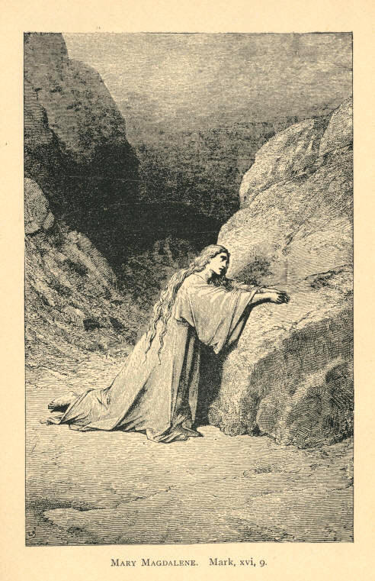
Mary Magdalene. Mark, xvi, 9.
68 MOODY'S ANECDOTES Christ Saves.

Lady Ann Erskine and Rowland Hill.

There is a very good story told of Rowland Hill and Lady Ann Erskine. You have seen it, perhaps, in print, but I would like to tell it to you. While he was preaching in a park in London to a large assemblage, she was passing in her carriage. She said to her footman when she saw Rowland Hill in the midst of the people, "Why, who is that man?" That is Rowland Hill, my lady." She had heard a good deal about the man, and she thought she would like to see him, so she directed her coachman to drive her near the platform. When the carriage came near he saw the insignia of nobility, and he asked who that noble lady was. Upon being told, he said, "Stop, my friends, I have got something to sell." The idea of a preacher becoming suddenly an auctioneer made the people wonder, and in the midst of a dead silence he said: "I have more than a title to sell--I have more than a crown of Europe to sell; it is the soul of Lady Ann Erskine. Is there anyone here who bids for it? Yes, I hear a bid. Satan, Satan, what will you give? 'I will give pleasure, honor, riches--yea, I will give the whole world for her soul.' Do you hear another bid? Is there any other one? Do I hear another bid? Ah, I thought so; I hear another bid. The Lord Jesus Christ, what will You give for this soul? 'I will give peace, joy, comfort, that the world knows not of--yea, I will give eternal life.' Lady Ann Erskine, you have heard the two bidders for your soul, which will you accept? And she ordered the door of her carriage to be opened, and came weeping from it, and accepted the Lord Jesus Christ. He, the great and mighty Saviour, is a bidder for your soul to-night. He offers you riches and comfort, and joy, peace here, and eternal life hereafter, while Satan offers you what he cannot give. Poor lost soul, which will you have?
Christ Saves. AND ILLUSTRATIONS. 69

He will ransom your soul if you but put your burden upon Him. Twenty-one years ago I made up my mind that Jesus would have my soul, and I have never regretted the step, and no man has ever felt sorry for coming to Him. When we accept Him we must like Him. Your sins may rise up as a mountain, but the Son of Man can purge you of all evil, and take you right into the palaces of Heaven, if you will only allow Him to Save you.

The Czar and the Soldier.

I remember hearing a few years ago a story about a young man away off in Russia. He was a wild, reckless dissipated youth. His father, thinking that if he could get him away from his associates, a reform would be worked, procured a commission in the army for him. And this is a mistake a great many Christian people fall into in dealing with their sons. It is not a change of place they require, it is a change of heart, A change of place will not take them away from the tempter. Well, off to the army this young man went, and, instead of reforming, he gambled and borrowed, and took to drinking as vigorously as ever. At length he had borrowed all the money he could, and, as we say he "had come to the end of his rope." A certain sum of money had to be paid the next day, and he did not see how it could be done without selling his commission, and if he did that he would be compelled to leave the army and go home to his father disgraced. The laws were very rigid in Russia upon the matter of debt, and if he couldn't pay he knew he would have to go to prison.
That night as he sat in his barracks, heart-broken at the prospect before him, he thought he would take up a paper and figure up his debts, and see how he stood. And here, let me say, it would be well if the sinner would pause occasionally, and try and figure up his sins, and see where he stood with God. Well, this young man put down one debt after another, until they made a long column. The total completely disheartened him; and he just put at the bottom of his figures, "Who is to pay this"? He laid his head upon his desk wearied, and fell asleep. That night the Czar, according to his custom, was walking through the barracks while the soldiers slept, and happened to come to that spot where the young soldier slept.
70 MOODY'S ANECDOTES Christ Saves.

He saw upon the desk the column of debts, and when he came to the bottom saw the question: "Who's to pay them?" and wrote underneath the name "Nicholas." When the young man awoke he took up the paper and found written at the bottom the signature of the Czar of all the Russias. What did it mean? Had an angel dropped down and canceled the debt? It was too good to be true. He couldn't believe it. But by and by the money came from the Emperor himself. This story may be true or not. I don't care whether it is or not; but there is one thing I do know is true, and that is that the great Emperor of heaven is here, and if you put down all your sins and multiply them by ten thousand, He will pay it and shelter you underneath the blood of Jesus Christ, which cleanseth us from all sin.

The Artist and the Beggar.

I have read of an artist who wanted to paint a picture of the Prodigal Son. He searched through the madhouse, and the poor houses, and the prisons, to find a man wretched enough to represent the prodigal, but he could not find one. One day he was walking down the streets and met a man whom he thought would do. He told the poor beggar he would pay him well if he came to his room and sat for the portrait. The beggar agreed, and the day was appointed for him to come. The day came, and a man put in his appearance at the artist's room. "You made an appointment with me," he said, when he was shown into the studio. The artist looked at him, "I never saw you before," he said; "you cannot have an appointment with me." "Yes," he said, "I agreed to meet you to-day at ten o'clock." "You must be mistaken; it must have been some other artist; I was to see a beggar here at this hour." "Well," says the beggar, "I am he." "You?" "Yes." "Why, what have you been doing?" "Well, I thought I would dress myself up a bit before I got painted." "Then," said the artist, "I do not want you; I wanted you as you were; now, you are no use to me."
Christ Saves. AND ILLUSTRATIONS. 71

That is the way Christ wants every poor sinner, just as he is. It is only the ragged sinners that open God's wardrobe. I remember a boy to whom I gave a pair of boots, and I found him shortly after in his bare feet again. I asked him what he had done with them, and he replied that when he was dressed up it spoiled his business; when he was dressed up no one would give anything. By keeping his feet naked he got as many as five pairs of boots a day. So if you want to come to God don't dress yourself up. It is the naked sinner God wants to save.

A Commercial Traveler.

I remember when preaching in New York City, at the Hippodrome, a man coming up to me and telling me a story that thrilled my soul. One night, he said he had been gambling; had gambled all the money away he had. When he went home to the hotel that night he did not sleep much. The next morning happened to be Sunday. He got up, felt bad, couldn't eat anything, didn't touch his breakfast, was miserable, and thought about putting an end to his existence. That afternoon he took a walk up Broadway, and when he came to the Hippodrome he saw great crowds going in and thought of entering too. But a policeman at the door told him he couldn't come in as it was a woman's meeting. He turned from it and strolled on; came back to his hotel and had dinner. At night he walked up the street until he reached the Hippodrome again, and this time he saw a lot of men going in. When inside he listened to the singing and heard the text, "Where art thou?" and he thought he would go out. He rose to go, and the text came upon his ears again, "Where art thou?" This was too personal, he thought, it was disagreeable, and he made for the door, but as he got to the third row from the entrance, the words came to him again. "Where art thou?" He stood still, for the question had come to him with irresistible force, and God had found him right there. He went to his hotel and prayed all that night, and now he is a bright and shining light. And this young man, who was a commercial traveler, went back to the village in which he had been reared, and in which he had been one of the fastest young men--went back there, and went around among his friends and acquaintances and testified for Christ, as earnestly and beneficially for him as his conduct had been against Him.
72 MOODY'S ANECDOTES Christ Saves.

Governor Pollock and the Condemned Criminal.

When I was East a few years ago, Mr. Geo. H. Stewart told me of a scene that occurred in a Pennsylvania prison, when Governor Pollock, a Christian man, was Governor of the State. A man was tried for murder, and the judge had pronounced sentence upon him. His friends had tried every means in their power to procure his pardon. They had sent deputation after deputation to the Governor, but he had told them all that the law must take its course. When they began to give up hope, the Governor went down to the prison and asked the sheriff to take him to the cell of the condemned man. The Governor was conducted into the presence of the criminal, and he sat down by the side of his bed and began to talk to him kindly--spoke to him of Christ and heaven, and showed him that although he was condemned to die on the morrow by earthly judges, he would receive eternal life from the Divine Judge if he would accept salvation. He explained the plan of salvation, and when he left him he committed him to God. When he was gone the sheriff was called to the cell by the condemned man. "Who was that man?" asked the criminal, "who was in here and talked so kind to me?" "Why," said the sheriff, "that was Governor Pollock." "Was that Governor Pollock? O Sheriff, why didn't you tell me who it was? If I had known that was him, I wouldn't have let him go out till he had given me pardon. The Governor has been here--in my cell--and I didn't know it," and the man wrung his hands and wept bitterly. My friends, there is one greater than a Governor here to-night. He sent His Son to redeem you--to bring you out of the prison home of sin. I come to-night to tell you He is here.
Christ Saves. AND ILLUSTRATIONS. 73

A Man who would not Speak to his Wife.

I remember while in Philadelphia, a man with his wife came to our meetings. When he went out he wouldn't speak to his wife. She thought it was very queer, but said nothing, and went to bed thinking that in the morning he would be all right. At breakfast, however, he would not speak a word. Well, she thought this strange, but she was sure he would have got all over whatever was wrong with him by dinner. The dinner hour arrived, and it passed away without his saying a word. At supper not a word escaped him, and he would not go with her to the meeting. Every day for a whole week the same thing went on. But at the end of the week he could not stand it any longer, and he said to his wife: "Why did you go and write to Mr. Moody and tell him all about me?" "I never wrote to Mr. Moody in my life," said the wife. "You did," he answered. "You're mistaken; why do you think that?" "Well, then, I wronged you; but when I saw Mr. Moody picking me out among all those people, and telling all about me, I was sure you must have written to him." It was the Son of Man seeking for him, my friends, and I hope there will be a man here to-night--that man in the gallery yonder, that one before me--who will feel that I am talking personally to him. May you feel that you are lost, and that the Lord is seeking for you, and when you feel this there is some chance of your being saved.

GOLD.

-- There was never a sermon which you have listened to but in it Christ was seeking for you. I contend that a man cannot but find in every page of this book that Jesus Christ is seeking him through His blessed Word. This is what the Bible is for--to seek out the lost.
-- No man in the world should be so happy as a man of God. It is one continual source of gladness. He can look up and say, "God is my Father, Christ is my Saviour, and the Church is my mother."
74 MOODY'S ANECDOTES Christ Saves.

--There is no other way to the Kingdom of God but by the way of the cross, and it will be easier for you to take it now than it will be afterward.
--Everything has to be tried by the sinner before he will come to Christ. He has to feel that there is nothing that can save him but Christ, then he will come.
--Have not some of you heard a sermon in which you were offered as a sinner to the Lord Jesus Christ, and your conscience was troubled? You went away, but you came back again, and the Spirit of God came upon you again and again, and you were troubled. Haven't you passed through that experience? Don't you remember something like that happening to you? That was the Son of God seeking for your soul.
--The Son of God has come into the world to bless us. Look at that Sermon on the Mount. It is filled with the word blessed, blessed, blessed. I think it occurs nine times. His heart was full of blessings for the people. He had to get it out before He gave His sermon.
--A rule I have had for years is to treat the Lord Jesus Christ as a personal friend. His is not a creed, a mere empty doctrine, but it is He himself we have. The moment we have received Christ we should receive Him as a friend. When I go away from home I bid my wife and children good-by, I bid my friends and acquaintances good-by, but I never heard of a poor backslider going down on his knees and saying: "I have been near You for ten years; Your service has become tedious and monotonous; I have come to bid You farewell; good-by, Lord Jesus Christ." I never heard of one doing this. I will tell you how they go away; they just run away.

AND ILLUSTRATIONS. 75

CHRISTIAN WORK.

How Moody was Encouraged.

I remember a few years ago I got discouraged, and could not see much fruit of my work; and one morning, as I was in my study, cast down, one of my Sabbath-school teachers came in and wanted to know what I was discouraged about, and I told him because I could see no result from my work; and speaking about Noah, he said: "By the way, did you ever study up the character of Noah?" I felt that I knew all about that, and told him that I was familiar with it, and he said, "Now, if you never studied that carefully, you ought to do it, for I cannot tell you what a blessing it has been to me." When he went out I took down my Bible and commenced to read about Noah, and the thought came stealing over me, "Here is a man that toiled and worked a hundred years and didn't get discouraged; if he did, the Holy Ghost didn't put it on record," and the clouds lifted, and I got up and said, if the Lord wants me to work without any fruit I will work on. I went down to the noon prayer-meeting, and when I saw the people coming to pray I said to myself, "Noah worked a hundred years and he never saw a prayer-meeting outside of his own family." Pretty soon a man got up right across the aisle where I was sitting, and said he had come from a little town where there had been a hundred uniting with the Church of God the year before. And I thought to myself, "What if Noah had heard that! He preached so many, many years, and didn't get a convert, yet he was not discouraged." Then a man got up right behind me, and he trembled as he said, "I am lost. I want you to pray for my soul." And I said, "What if Noah had heard that! He worked a hundred and twenty years, and never had a man come to him and say that; and yet he didn't get discouraged." And I made up my mind then, that, God helping me, I would never get discouraged. I would do the best I could, and leave the result with God, and it has been a wonderful help to me.
76 MOODY'S ANECDOTES Christian Work.

"We Will Never Surrender."

There's a story told in history in the ninth century, I believe, of a young man that came up with a little handful of men to attack a king who had a great army of three thousand men. The young man had only five hundred, and the king sent a messenger to the young man, saying that he need not fear to surrender, for he would treat him mercifully. The young man called up one of his soldiers and said: "Take this dagger and drive it to your heart;" and the soldier took the dagger and drove it to his heart. And calling up another, he said to him, "Leap into yonder chasm," and the man leaped into the chasm. The young man then said to the messenger, "Go back and tell your King I have got five hundred men like these. We will die, but we will never surrender. And tell your King another thing; that I will have him chained with my dog inside of half an hour." And when the King heard that he did not dare to meet them, and his army fled before them like chaff before the wind, and within twenty-four hours he had that King chained with his dog. That is the kind of zeal we want. "We will die, but we will never surrender." We will work until Jesus comes, and then we will rise with Him.

The Faithful Aged Woman.

An old woman who was seventy-five years old had a Sabbath-school two miles away among the mountains. One Sunday there came a terrible storm of rain, and she thought at first she would not go that day, but then she thought, "What if some one should go and not find me there?" Then she put on her waterproof, and took her umbrella and overshoes, and away she went through the storm, two miles away, to the Sabbath-school in the mountains.
Christian Work. AND ILLUSTRATIONS. 77

When she got there she found one solitary young man, and taught him the best she knew how all the afternoon. She never saw him again, and I don't know but the old woman thought her Sabbath-school had been a failure. That week the young man enlisted in the army, and in a year or two after the old woman got a letter from the soldier thanking her for going through the storm that Sunday. This young man thought that stormy day he would just go and see if the old woman was in earnest, and if she cared enough about souls to go through the rain. He found she came and taught him as carefully as if she was teaching the whole school, and God made that the occasion of winning the young man to Christ. When he lay dying in a hospital he sent the message to the old woman that he would meet her in heaven. Was it not a glorious thing that she did not get discouraged because she had but one Sunday-school scholar? Be willing to work with one.

A Dream.

I heard of a Christian who did not succeed in his work so well as he used to, and he got homesick and wished himself dead. One night he dreamed that he had died, and was carried by the angels to the Eternal City. As he went along the crystal pavement of heaven, he met a man he used to know, and they went walking down the golden streets together. All at once he noticed everyone looking in the same direction, and saw One coming up who was fairer than the sons of men. It was his blessed Redeemer. As the chariot came opposite, He came forth, and beckoning the one friend, placed him in His own chariot-seat, but himself He led aside, and pointing over the battlements of heaven, "Look over yonder," He said, "What do you see?" "It seems as if I see the dark earth I have come from." "What else?" "I see men as if they were blindfolded, going over a terrible precipice into a bottomless pit." "Well," said He, "Will you remain up here, and enjoy these mansions that I have prepared, or go back to yon dark earth, and warn these men, and tell them about Me and my kingdom, and the rest that remaineth for the people of God?" That man never wished himself dead again. He yearned to live as long as ever he could, to tell men of heaven and of Christ.
78 MOODY'S ANECDOTES Christian Work.

The Faithful Missionary.

When I was going to Europe in 1867, my friend Mr. Stuart, of Philadelphia, said, "Be sure to be at the General Assembly in Edinburgh, in June. I was there last year," said he, "and it did me a world of good." He said that a returned missionary from India was invited to speak to the General Assembly, on the wants of India. This old missionary, after a brief address, told the pastors who were present, to go home and stir up their churches and send young men to India to preach the gospel. He spoke with such earnestness, that after a while he fainted, and they carried him from the hall. When he recovered he asked where he was, and they told him the circumstances under which he had been brought there. "Yes," he said, "I was making a plea for India, and I didn't quite finish my speech, did I?" After being told that he did not, he said, "Take me back and let me finish it." But they said, "No, you will die in the attempt." "Well," said he, "I will die if I don't," and the old man asked again that they would allow him to finish his plea. When he was taken back the whole congregation stood as one man, and as they brought him on the platform, with a trembling voice he said: "Fathers and mothers of Scotland, is it true that you will not let your sons go to India? I spent twenty-five years of my life there. I lost my health and I have come back with sickness and shattered health. If it is true that we have no strong grandsons to go to India, I will pack up what I have and be off to-morrow, and I will let those heathens know that if I cannot live for them I will die for them." The world will say that old man was enthusiastic. Well, that is just what we want.
Christian Work. AND ILLUSTRATIONS. 79

Forty-One Little Sermons.

A man was preaching about Christians recognizing each other in heaven, and some one said, "I wish he would preach about recognizing each other on earth." In one place where I preached, I looked over the great hall of the old circus building where it was held, and saw men talking to other men here and there. I said to the Secretary of the Young Men's Christian Association who got up the meeting, "Who are these men?" He said, "They are a band of workers." They were all scattered through the hall, and preaching and watching for souls. Out of the fifty of them, forty-one of their number had got a soul each and were talking and preaching with them. We have been asleep long enough. When the laity wake up and try and help the minister the minister will preach better.

GOLD.

-- It is the greatest pleasure of living to win souls to Christ.
-- I believe in what John Wesley used to say, "All at it, and always at it," and that is what the Church wants to-day.
-- If we were all of us doing the work that God has got for us to do, don't you see how the work of the Lord would advance?
-- There is no man living that can do the work that God has got for me to do. No one can do it but myself. And if the work ain't done we will have to answer for it when we stand before God's bar.
-- What makes the Dead Sea dead? Because it is all the time receiving, never giving out anything. Why is it that many Christians are cold? Because they are all the time receiving, never giving out an anything.
80 MOODY'S ANECDOTES

CHRISTIAN ZEAL.

Satan's Match.

If you will allow me an expression, Satan got a match when he got Paul. He tried to get him away from God, but he never switched off. Look how they tortured him. Look how they stripped and beat him. Not only did the Romans do this, but the Jews also. How the Jews tried to drag him from his high calling. How they stripped him and laid upon the back of the apostle blow after blow. And you know that the scourge in those days was no light thing. Sometimes men died under that punishment. If one of us got one of the stripes that Paul got, how the papers would talk about it. But it was nothing to Paul. He just looked at it as if it were a trivial thing--as if it were a light affliction. When he was stripped and scourged by his persecutors you might have gone and asked him: "Well, Paul, what are you going to do now?" "Why, press toward the mark of the high calling of God in Christ Jesus;" Take your stand before Him and ask him as they bring the rod down upon his head, "What are you going to do now, Paul?" "Do? I am going to press toward the mark of the high calling of God in Christ Jesus." He had one idea, and that was it. Look at him as they stoned him. The Jews took up great stones to throw upon the great apostle. They left him for dead, and I suppose he was dead, but God raised him up. Come up and look at him all bruised and bleeding as he lies. "Well, Paul, you've had a narrow escape this time. Don't you think you had better give up? Go off into Arabia and rest for six weeks. What will you do if you remain here? They mean to kill you." "Do!" he cries as he raises himself like a mighty giant, "I am going to press toward the mark of the high calling of God."
Christian Zeal. AND ILLUSTRATIONS. 81

And he goes forth and preaches the gospel. I am ashamed of Christianity in the nineteenth century when I think of those early Christians. Why, it would take all the Christians in the Northwest to make one Paul. Look at his heroism everywhere he went. Talk about your Alexanders; why, the mighty power of God rested upon Paul. "Why," said he, "thrice was I shipwrecked while going off to preach the gospel." What did he care about that? Cold churches wouldn't trouble him, although they trouble us. What would lying elders and false deacons be to him? That wouldn't stop him. He had but one idea, and over all obstacles he triumphed for that one idea. Look at him as he comes back from his punishment. He goes up some side street and gets lodgings. He works during the day and preaches at night on the street. He had no building like this, no committee to wait on him, no carriage to carry him from the meeting, no one to be waiting to pay his board bills. There he was toiling and preaching, and, after preaching for eighteen months, they say, "We'll have to pay you for all this preaching, Paul," and they take him to the corner of the street and pay him with thirty-nine stripes! That is the way they paid him. Oh, my friends, when you look at the lives of such men don't it make you feel ashamed of yourselves. I confess I feel like hanging my head. Go to him in the Philippian jail and ask him what he is going to do now. "Do? press forward for the mark of my high calling." And so he went on looking toward one point, and no man could stand before him.

Saved and Saving.

One day I saw a steel engraving that I liked very much. I thought it was the finest thing I ever had seen, at the time, and I bought it. It was a picture of a woman coming out of the water, and clinging with both arms to the cross. There she came out of the drowning waves with both arms around the cross perfectly safe. Afterwards, I saw another picture that spoiled this one for me entirely, it was so much more lovely. It was a picture of a person coming out of the dark waters, with one arm clinging to the cross and with the other she was lifting some one else out of the waves. That is what I like. Keep a firm hold upon the cross, but always try to rescue another from the drowning.
82 MOODY'S ANECDOTES Christian Zeal.

A Story Moody "Never will Forget."

A few years ago, in a town somewhere in this state, a merchant died, and while he was lying a corpse I was told a story I will never forget. When the physician that attended him saw there was no chance for him here, he thought it would be time to talk about Christ to the dying man. And there are a great many Christians just like this physician. They wait till a man is just entering the other world, just till he is about nearing the throne, till the sands of life are about run out, till the death rattle is in his throat, before they commence to speak of Christ. The physician stepped up to the dying merchant and began to speak of Jesus, the beauties of Christianity, and the salvation he had offered to all the world. The merchant listened quietly to him, and then asked him, "How long have you known of these things?" "I have been a Christian since I came from the East," he replied. "You have been a Christian so long and have known all this, and have been in my store every day. You have been in my house; have associated with me; you knew all these things, and why didn't you tell me before?" The doctor went home and retired to rest, but could not sleep. The question of the dying man rang in his ears. He could not explain why he had not spoken before, but he saw he had neglected his duty to his principles. He went back to his dying friend, intending to urge upon him the acceptance of Christ's salvation, but when he began to speak to him the merchant only replied in a sad whisper, "Oh, why didn't you tell me before?" Oh, my friends, how many of us act like this physician? If we don't practice in every particular the professions we make, and try to influence the lives of others, and lead the lives of Christians according to Christian precept, the world will go on stumbling over us.
Christian Zeal. AND ILLUSTRATIONS. 83

The Missing Stone.

I remember hearing of a man's dream, in which he imagined that when he died he was taken by the angels to a beautiful temple. After admiring it for a time, he discovered that one stone was missing. All finished but just one little stone; that was left out. He said to the angel, "What is this stone left out for?" The angel replied, "That was left out for you, but you wanted to do great things, and so there was no room left for you." He was startled and awoke, and resolved that he would become a worker for God, and that man always worked faithfully after that.

Sad Lack of Zeal.

Two young men came into our inquiry room here the other night, and after a convert had talked with them, and showed them the way, the light broke in upon them. They were asked, "Where do you go to church?" They gave the name of the church where they had been going. Said one, "I advise you to go and see the minister of that church." They said, "We don't want to go there any more; we have gone there for six years and no one has spoken to us."

A Zealous Young Lady.

I was very much interested some time ago in a young lady that lived in the city. I don't know her name, or I have forgotten it. She was about to go to China as the wife of a missionary on his way to some heathen field. She had a large Sabbath-school class in the city and succeeded in getting a blessing upon many of her scholars through her efforts. She was very anxious to get some one who would look after her little flock and take care of them while she was gone. She had a brother who was not a Christian, and her heart was set on his being converted and taking her place as leader of the class. The young man--perhaps he is in the audience to-day--refused to accept of Christ, but away in her closet alone she pleaded with God that her brother might be converted and take her place. She wanted to reproduce herself and that is what every Christian ought to do--get somebody else converted to take up your work.
84 MOODY'S ANECDOTES Christian Zeal.

Well, the last morning came, and around the family altar as the moment drew near for the lady's departure, and they did not know when they should see her again, the father broke down, and the boy went up stairs. Just before she left for the train the boy came down, and putting his arms around his sister's neck, said to her, "My dear sister, I will take your Saviour for mine, and I will take care of your class for you," and the young man took her class, and the last I heard of him he was filling her place. There was a young lady established in good work.

How Moody Treated the Committees.

I remember when I was in Chicago before the fire, I was on some ten or twelve committees. My hands were full. If a man came to me to talk about his soul I would say I haven't time; got a committee to attend to. But now I have turned my hack on everything--turned my attention to saving souls, and God has blessed me and made me an instrument to save more souls during the last four or five years than during all my previous life. And so if a minister will devote himself to this undivided work, God will bless him. Take that motto of Paul's: "One thing I do, forgetting those things which are behind, and reaching forth unto those things which are before, I press toward the mark for the prize of the high calling of God in Christ Jesus."

Fourscore and Five.

When we went to London there was an old woman eighty-five years old, who came to the meetings and said she wanted a hand in that work. She was appointed to a district, and called on all classes of people. She went to places where we would probably have been put out, and told the people of Christ. There were none that could resist her. When the old woman, eighty-five years old, came to them and offered to pray for them, they all received her kindly--Catholics, Jews, Gentiles--all. That is enthusiasm. That is what we want.
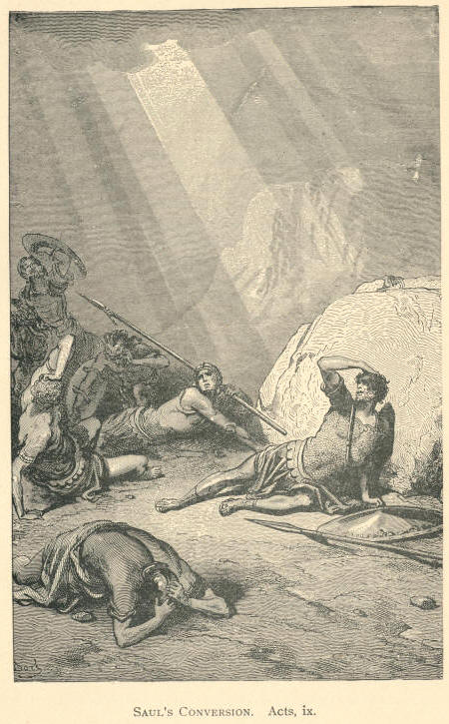
Saul's Conversion. Acts, ix.
AND ILLUS0TRATIONS. 85

CONFESSING CHRIST.

What a Woman Did.

One place we were in, in England, I recollect a Quakeress came in. The meeting was held in a Methodist Church, and the Spirit of God was there--souls were being saved: multitudes were pressing into the kingdom. She had a brother who was a drinker and a nephew who had just come to the city, and he was in a critical state, too. They came to the meeting with her. Everything appeared strange to her, and when she went home she did not know really what to say. She and her brother and nephew went up stairs, and coming down she thought, it may be that the destiny of their souls depends on what I say now. When she entered the parlor she found them laughing and joking about the meeting. She put on a serious face and said, "I don't think we should laugh at it. Suppose Mr. Moody had come to you and asked you if you were converted, what would you have told him?" "I would have told him to mind his own business," replied one of them. "I think it is a very important question, and a question a Christian ought to put to any one; Mr. Moody, as a Christian, has a right to ask any one." She talked with them, and when that brother went to bed, he began thinking and thinking. He had tickets for the theater next night, but when next night came he said he would go to the meeting with his sister, and, to make a long story short, he came and was converted. He came to me--he was a mechanic--and asked me to talk to the laborers and have them come to the meetings. He had got such a blessing himself that he wanted them to share it.
That man brought me a list of the names of the mechanics about half as long as this room, and we got up a meeting in the theater, and we had that theater packed. That was the first meeting of working men I ever had, and the work of grace broke out among them.
86 MOODY'S ANECDOTES Confessing Christ.

This was but the result of the woman taking her stand. She went into the inquiry-room and became an earnest worker. I get letters from her frequently now, and I do not believe there is a happier woman in all England. If she had taken another course she might have been the means of ruining these young men. There is one thing that Christians ought to ask themselves. Ask your heart, "Is this the work of the devil?" That is the plain question. If it's the work of the devil turn your back against it. I would if I thought it was. If it is the work of God, be careful what you do. My friends, it is a terrible thing to fight against God. If it is the Lord's wish, come out and take your stand, and let there be one united column of people coming up to heaven. Let every man, woman and child, be not afraid to confess the Lord Jesus Christ.

A Business Man Confessing Christ.

When I was in Ireland I heard of a man who got great blessings from God. He was a business man--a landed proprietor. He had a large family, and a great many men to work for him taking care of his home. He came up to Dublin and there he found Christ. And he came boldly out and thought he would go home and confess Him. He thought that if Christ had redeemed him with his precious blood, the least he could do would be to confess Him, and tell about it sometimes. So he called his family together and his servants, and with tears running down his cheeks he poured out his soul to them, and told them what Christ had done for him. He took the Bible down from its resting-place and read a few verses of gospel. Then he went down on his knees to pray, and so greatly was the little gathering blessed that four or five out of that family were convicted of sin; they forsook the ways of the world, and accepted Christ and eternal life. It was like unto the household of Cornelius, which experienced the working of the Holy Spirit. And that man and his family were not afraid to follow out their profession.
Confessing Christ. AND ILLUSTRATIONS. 87

Two Young Men.

I heard a story about two young men who came to New York City from the country on a visit. They went to the same boarding-house to stay and took a room together. Well, when they came to go to bed each felt ashamed to go down on his knees before his companion first. So they sat watching each other. In fact, to express the situation in one word, they were both cowards--yes, cowards! But at last one of them mustered up a little courage, and with burning blushes, as if he was about to do something wrong and wicked, he sunk down on his knees to say his prayers. As soon as the second saw that, he also knelt. And then, after they had said their prayers, each waited for the other to get up. When they did manage to get up one said to the other: "I really am glad to see that you knelt; I was afraid of you." "Well," said the other, "and I was afraid of you." So it turned out that both were Christians, and yet they were afraid of each other. You smile at that, but how many times have you done the same thing--perhaps not in that way, but the same thing in effect. Henceforth, then, be not ashamed, but let everyone know you are His.

The Little Tow-Headed Norwegian.

I remember while in Boston I attended one of the daily prayer meetings. The meetings we had been holding had been almost always addressed by young men. Well, in that meeting a little tow-headed Norwegian boy stood up. He could hardly speak a word of English plain, but he got up and came to the front. He trembled all over and the tears were all trickling down his cheeks, but he spoke out as well as he could and said: "If I tell the world about Jesus, then will He tell the Father about me." He then took his seat; that was all he said, but I tell you that in those few words he said more than all of them, old and young together. Those few words went straight down into the heart of everyone present. "If I tell the world"--yes, that's what it means to confess Christ.
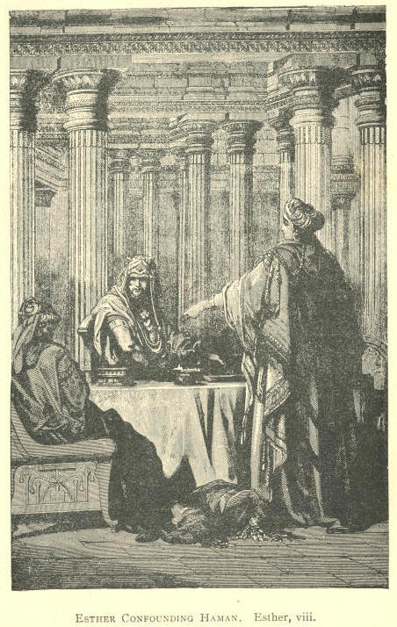
Esther Confounding Haman. Esther, viii.
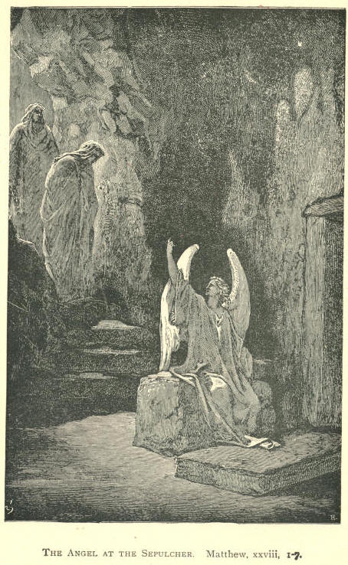
The Angel at the Sepulcher. Matthew, xxviii, 1-7.
88 MOODY'S ANECDOTES Confessing Christ.

The Family that Hooted at Moody.

I remember a family in Chicago that used to hoot at me and my scholars as we passed their house sometimes. One day one of the boys came into the Sunday-school and made light of it, As he went away, I told him I was glad to see him there and hoped he would come again. He came and still made a noise, but I urged him to come the next time, and finally one day he said: "I wish you would pray for me, boys." That boy came to Christ. He went home and confessed his faith, and it wasn't long before that whole family had found the way into the Kingdom of God.

Peter's Confession.

One day He said, "Whom do men say that I am?" He wanted them to confess Him. But one said, "They say thou art Elias," and another "that thou art Jeremiah;" and another "Thou art St. John the Baptist." But He asked, "Whom do you say that I am?"--turning to His disciples. And Peter answers, "Thou art the Son of the living God." Then our Lord exclaimed, "Blessed art thou, Simon Barjonas." Yes, He blessed him right there because he confessed Him to be the Son of God. He was hungry to get some one to confess him. Let everyone take his stand on the side of the Lord.

The Blind Beggar.

Here is a whole chapter in John (ix) of forty-one verses, just to tell how the Lord blessed that blind beggar. It was put in this book, I think, just to bring out the confession of that man. "The neighbors, therefore, and they which before had seen him which was blind, said, Is not this he that sat and begged? Some said, This is he; others said, He is like him; but he said, I am he." If it had been our case I think we would have kept still; we would have said, "There is a storm brewing among the Pharisees, and they have said, 'If any man acknowledges Christ we will put him out of the Synagogue.' Now I don't want to be put out of the Synagogue." I am afraid we would have said that; that is the way with a good many of the young converts. What did the young convert here?
Confessing Christ. AND ILLUSTRATIONS. 89

He said, "I am he." And bear in mind he only told what he knew; he knew the Man had given him his eyes. "Some said, He is like him; but he said, I am he." So, young converts, open your lips and tell what Christ has done for you. If you can't do more than that, open your lips and do that. "Therefore, said they unto him, How were thine eyes opened? He answered and said, A man that is called Jesus made clay, and anointed mine eyes, and said unto me, Go to the pool of Siloam, and wash; and I went and washed, and I received sight." He said, "He anointed my eyes with clay, and I went to the pool and washed, and whereas I had no eyes, I have now got two good eyes." Some skeptic might ask, "What is the philosophy of it?" But he couldn't tell that. "Then said they unto him, Where is he? He said, I know not. They brought to the Pharisees him that aforetime was blind. And it was the Sabbath day when Jesus made the clay and opened his eyes. Then again the Pharisees also asked him how he had received his sight. He said unto them, He put clay upon mine eyes and I washed and do see." He wasn't afraid to tell his experience twice; he had just told it once. "Therefore, said some of the Pharisees, This man is not of God, because he keepeth not the Sabbath day. Others said, How can a man that is a sinner do such miracles? and there was a division among them." Now I am afraid if it had been us, we would have kept still and said, "There is a storm brewing." "They say unto the blind man again, What sayest thou of Him, that He hath opened thine eyes? He said, He is a prophet." Now you see he has got to talking of the Master, and that is a grand good thing.

The Young Convert.

A young convert got up in one of our meetings and tried to preach; he could not preach very well either, but he did the best he could--but some one stood up and said, "Young man, you cannot preach; you ought to be ashamed of yourself." Said the young man, "So I am, but I am not ashamed of my Lord." That is right. Do not be ashamed of Christ--of the man that bought us with His own blood.
90 MOODY'S ANECDOTES Confessing Christ.

GOLD.

-- If Christ comes into our hearts we are not ashamed.
-- I wish we had a few more women like the woman of Samaria, willing to confess what the Lord Jesus Christ had done for their souls.
-- Believing and confessing go together; and you cannot be saved without you take them both. "With the mouth confession is made unto salvation." If you ever see the kingdom of heaven you have to take this way.
-- Satan puts straws across our path and magnifies it and makes us believe it is a mountain, but all the devil's mountains are mountains of smoke; when you come up to them they are not there.
-- I do not know anything that would wake up Chicago better than for every man and woman here who loves Him to begin to talk about Him to their friends, and just to tell them what He has done for you. You have got a circle of friends. Go and tell them of Him.
-- I can't help thinking of the old woman who started out when the war commenced with a poker in her hand. When asked what she was going to do with it she said: "I can't do much with it, but I can show what side I'm on." My friends, even if you can't do much, show to which side you belong.
-- I may say with truth that there is only about one in ten who professes Christianity who will turn round and glorify God with a loud voice. Nine out of ten are still born Christians. You never hear of them. If you press them hard with the question whether they are Christians they might say, "Well, I hope so." We never see it in their actions; we never see it in their lives. They might belong to the church you go to, but you never see them at the prayer-meetings or taking any interest in the church affairs. They don't profess it among their fellows or in their business, and the result is that there are hundreds going on with a half hope, not sure whether their religion will stand them or not.

AND ILLUSTRATIONS. 91

CONVERSION.

Mr. Moody's First Impulse in Converting Souls.

I want to tell you how I got the first impulse to work solely for the conversion of men. For a long time after my conversion I didn't accomplish anything. I hadn't got into my right place; that was it. I hadn't thought enough of this personal work. I'd get up in prayer meeting, and I'd pray with the others, but just to go up to a man and take hold of his coat and get him down on his knees, I hadn't yet got round to that. It was in 1860 the change came. In the Sunday school I had a pale, delicate young man as one of the teachers. I knew his burning piety, and assigned him to the worst class in the school. They were all girls, and it was an awful class. They kept gadding around in the school-room, and were laughing and carrying on all the while. And this young man had better success than anyone else. One Sunday he was absent, and I tried myself to teach the class, but couldn't do anything with them; they seemed farther off than ever from any concern about their souls. Well, the day after his absence, early Monday morning, the young man came into the store where I worked, and, tottering and bloodless, threw himself down on some boxes. "What's the matter?" I asked, "I have been bleeding at the lungs, and they have given me up to die," he said. "But you are not afraid to die?" I questioned, "No," said he, "I am not afraid to die, but I have got to stand before God and give an account of my stewardship, and not one of my Sabbath-school scholars has been brought to Jesus. I have failed to bring one, and haven't any strength to do it now."
He was so weighed down that I got a carriage and took that dying man in it, and we called at the homes of everyone of his scholars, and to each one he said, as best his faint voice would let him, "I have come to just ask you to come to the Saviour," and then he prayed as I never heard before.
92 MOODY'S ANECDOTES Conversion.

And for ten days he labored in that way, sometimes walking to the nearest houses. And at the end of that ten days everyone of that large class had yielded to the Saviour. Full well I remember the night before he went away (for the doctors said he must hurry to the South), how we held a true love-feast. It was the very gate of heaven, that meeting. He prayed, and they prayed; he didn't ask them, he didn't think they could pray; and then we sung, "Blest be the tie that binds." It was a beautiful night in June that he left on the Michigan Southern, and I was down to the train to help him off. And those girls everyone gathered there again, all unknown to each other; and the depot seemed a second gate to heaven, in the joyful, yet tearful, communion and farewells between these newly redeemed souls and him whose crown of rejoicing it will be that he led them to Jesus. At last the gong sounded, and, supported on the platform, the dying man shook hands with each one, and whispered, "I will meet you yonder."

Very Hard, yet Very Easy.

The hardest thing, I will admit, ever a man had to do is to become a Christian, and yet it is the easiest. This seems to many to be a paradox, but I will repeat it, it is the most difficult thing to become a Christian, and yet it is the easiest. I have a little nephew in this city. When he was about three or four years of age, he threw that Bible on the floor. I think a good deal of that Bible, and I don't like to see this. His mother said to him, "Go pick up uncle's Bible from the floor." "I won't," he replied. "Go and pick up that Bible directly." "I won't." "What did you say?" asked his mother. She thought he didn't understand. But he understood well enough, and had made up his mind that he wouldn't. She told the boy she would have to punish him if he didn't, and then he said he couldn't, and by and by he said he didn't want to. And that is the way with the people in coming to Christ. At first they say they won't, then they can't, and then they don't want to. The mother insisted upon the boy picking up the Bible, and he got down and put his arms around it and pretended he couldn't lift it.
Conversion AND ILLUSTRATIONS. 93

He was a great, healthy boy, and he could have picked it up easily enough. I was very anxious to see the fight carried on because she was a young mother, and if she didn't break that boy's will he was going to break her heart by and by. So she told him again if he didn't pick it up she would punish him, and the child just picked it up. It was very easy to do it when he made up his mind. So it is perfectly easy for men to accept the gospel. The trouble is they don't want to give up their will. If you want to be saved you must just accept that gospel--that Christ is your Saviour, that he is your Redeemer, and that he has rescued you from the curse of the law. Just say "Lord Jesus Christ, I trust you from this hour to save me," and the moment you take that stand he will put his loving arms around you and wrap about you the robe of righteousness.

The Arrows of Conviction.

I remember while preaching in Glasgow, an incident occurred which I will relate. I had been preaching there several weeks, and the night was my last one, and I pleaded with them as I had never pleaded there before. I urged the people to meet me in that land. It is a very solemn thing to stand before a vast audience for the last time and think you may never have another chance of asking them to come to Christ. I told them I would not have another opportunity, and urged them to accept, and just asked them to meet me at that marriage supper. At the conclusion I soon saw a tall young lady coming into the inquiry room. She had scarcely come in when another tall young lady came in, and she went up to the first and put her arms around her and wept. Pretty soon another young lady came and went up to the first two and just put her arms around both of them. They were three sisters and I found that although they had been sitting in different parts of the building, the sure arrow of conviction went down to their souls, and brought them to the inquiry room. Another young lady came down from the gallery and said: "Mr. Moody, I want to become a Christian."
94 MOODY'S ANECDOTES Conversion.

I asked a young Christian to talk to her, and when she went home that night about 10 o'clock--her mother was sitting up for her--she said: "Mother, I have accepted the invitation to be present at the marriage supper of the Lamb." Her mother and father laid awake that night talking about the salvation of their child. That was Friday night, and next day (Saturday) she was unwell, and before long her sickness developed into scarlet fever, and a few days after I got this letter:
"Mr. Moody--Dear Sir: It is now my painful duty to intimate to you that the dear girl concerning whom I wrote to you on Monday, has been taken away from us by death. Her departure, however, has been signally softened to us, for she told us yesterday she was "going home to be with Jesus," and after giving messages to many, told us to let Mr. Moody and Mr. Sankey know that she died a happy Christian."

How a Citizen Became a Soldier.

One day I was walking through the streets of York, in England. I saw a little way ahead a soldier coming toward me. He had the red uniform on of the infantry--the dress of the army. I knew at once when I saw him that he was a soldier. When he came near me I stopped him. I said, "My good man, if you have no objection I would like to ask you a few questions." "Certainly, sir," said he. "Well, then, I would like to know how you first became a soldier." "Yes, sir, I will tell you. You see, sir, I wanted to become a soldier, and the recruiting officer was in our town, and I went up to him and told him I wanted to enlist. "Well, sir, he said, 'All right,' and the first thing he did, sir, he took an English shilling out of his pocket, sir, and put it into my hand. The very moment, sir, a recruiting-sergeant puts a shilling into your hand, sir, you are a soldier." I said to myself, "That is the very illustration I want."
That man was a free man at one time--he could go here and there; do just what he liked; but the moment the shilling was put into his hand he was subject to the rules of war, and Queen Victoria could send him anywhere and make him obey the rules and regulations of the army.
Conversion. AND ILLUSTRATIONS. 95

He is a soldier the very minute he takes the shilling. He has not got to wait to put on the uniform. And when you ask me how a man may be converted at once, I answer, just the same as that man became a soldier. The citizen becomes a soldier in a minute, and from being a free man becomes subject to the command of others. The moment you take Christ into your heart, that moment your name is written in the roll of Heaven.

Moody a Young Convert.

I remember soon after I got converted a pantheist got hold of me, and just tried to draw me back to the world. Those men who try to get hold of a young convert are the worst set of men. I don't know a worse man than he who tries to pull young Christians down. He is nearer the borders of hell than any man I know. When this man knew I had found Jesus he just tried to pull me down. He tried to argue with me, and I did not know the Bible very well then, and he got the best of me. The only way to get the best of those atheists, pantheists, or infidels, is to have a good knowledge of the Bible. Well, this pantheist told me God was everywhere--in the air, in the sun, in the moon, in the earth, in the stars, but really he meant nowhere. And the next time I went to pray, it seemed as if I was not praying anywhere or to anyone. We have ample evidence in the Bible that there is such a place as heaven, and we have abundant manifestations that His influence from heaven is felt among us.

"Free."

You will remember when we had slavery we used to have men come up from Kentucky, Tennessee, and other slave states in order to escape from slavery. I hope if there are any Southern people here they will not think in this allusion I am trying to wound their feelings. We all remember when these colored men came here how they used to be afraid lest some one should come and take them back. Why, I remember in the store we had a poor fugitive, and he used to be quaking all the time. Sometimes a customer would come in, and he would be uneasy all the time.
96 MOODY'S ANECDOTES Conversion.

He was afraid it was some one to take him back to slavery. But somebody tells him if he was in Canada he would be perfectly safe, and he says: "If I could only get into Canada; if I could only get under the Union Jack I would be free." There are no slaves under the Union Jack he has been told--that is the flag of freedom; the moment he gets under it he is a free man. So he starts. We'll say there are no railways, and the poor fellow has got ten miles ahead when his master comes up, and he hears that his slave has fled for Canada and sets off in pursuit. Some one tells the poor fugitive that his master is after him. What does the poor fugitive do? What does he do? He redoubles his exertions and presses on, on, on, on. He is a slave born, and he knows a slave belongs to his master. Faster he goes! He knows his master is after him and he will be taken if he comes up with him before he reaches the lines. He says, "If I can only hold out and get under the English flag, the English government will protect me." The whole English army will come to protect me if need be. On he presses. He is now nearing the boundary line. One minute he is a slave, and in an instant he is a free man. My friends, don't mistake. These men can be saved tonight if they cross the line.

An Irishman Leaps Into the Life-Boat.

While I was in New York, an Irishman stood up in a young converts' meeting and told how he had been saved. He said in his broken Irish brogue that I used an illustration, and that illustration saved him. And I declare that that is the only man I ever knew who was converted without being spoken to. He said I used an illustration of a wrecked vessel, and said that all would perish unless some assistance came. Presently a life-boat came alongside and the captain shouted, "Leap into the life-boat--leap for your lives, or you will perish," and when I came to the point I said, "Leap into the life-boat; Christ is your life-boat of salvation," and he leaped and was saved.
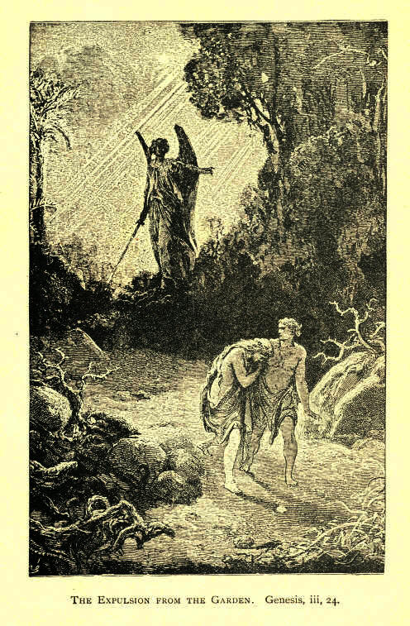
The Expulsion from the Garden. Genesis, iii, 24.
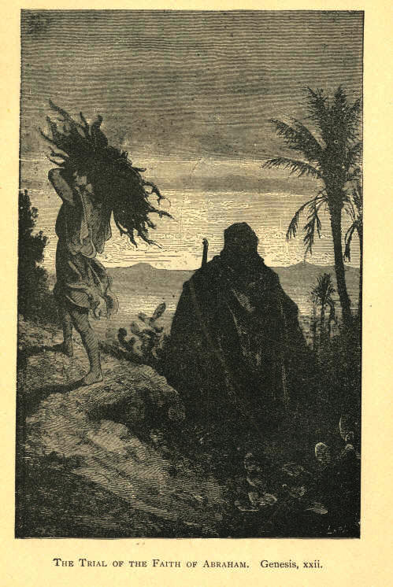
The Trial Of The Faith Of Abraham. Genesis, xxii.
Conversion. AND ILLUSTRATIONS. 97

Safe in the Ark.

When the voice came down from heaven to Noah, "Come thou and all thy house into the ark, for thee have I seen righteous before me in this generation," now; there was a minute when Noah was outside the ark, and another when he was inside, and by being inside he was saved. As long as he was outside of the ark he was exposed to the wrath of God just like the rest of those antediluvians. If he stayed out, and remained with those antediluvians, he would have been swept away, as they were. It was not his righteousness; it was not his faith nor his works that saved him; it was the ark. And, my friends, we have not, like Noah, to be one hundred and twenty years making an ark for our safety. God has provided an ark for us, and the question is: Are you inside or outside this ark? If you are inside you are safe; if you are outside you are not safe.

GOLD.

--It is our privilege to know that we are saved.
--We shall draw the world to Christ when we are filled with religion.
--He that overcometh shall inherit all things. God has no poor children.
--I hold to the doctrine of sudden conversion as I do to my life, and I would as quickly give up my life as give up this doctrine, unless it can be proved that it is not according to the word of God. Now, I will admit that light is one thing and birth is another. A soul must be born before it can see light. A child must be born before it can be taught; it must be born before it can walk; it must be born before it can be educated.

7
98 MOODY'S ANECDOTES

DECISION.

Moody's Mistake.

The last time I preached upon this question was in old Farwell Hall. I had been for five nights preaching upon the life of Christ. I took him from the cradle and followed Him up to the judgment hall, and on that occasion I consider I made as great a blunder as ever I made in my life. If I could recall my act I would give this right hand. It was upon that memorable night in October, and the Court House bell was sounding an alarm of fire, but I paid no attention to it. You know we were accustomed to hear the fire bell often, and it didn't disturb us much when it sounded. I finished the sermon upon "What shall I do with Jesus?" And I said to the audience, "Now, I want you to take the question with you and think over it, and next Sunday I want you to come back and tell me what you are going to do with it." What a mistake! It seems now as if Satan was in my mind when I said this. Since then I never have dared give an audience a week to think of their salvation. If they were lost they might rise up in judgment against me. "Now is the accepted time." We went down stairs to the other meeting, and I remember when Mr. Sankey was singing, and how his voice rang when he came to that pleading verse:

To-day the Saviour calls;
For refuge fly.
The storm of justice falls,
And death is nigh.

After the meeting we went home. I remember going down La Salle street with a young man who is probably in the hall to-night, and saw the glare of flames. I said to the young man: "This means ruin to Chicago." About one o'clock, Farwell Hall went; soon the church in which I had preached went down, and everything was scattered.
Decision. AND ILLUSTRATIONS. 99

I never saw that audience again. My friends, we don't know what may happen to-morrow, but there is one thing I do know, and that is, if you take the gift you are saved. If you have eternal life you need not fear fire, death, or sickness. Let disease or death come, you can shout triumphantly over the grave if you have Christ. My friends, what are you going to do with Him to-night? Will you decide now?

"A Day of Decision."

I believe there is a day of decision in our lives--a day upon which the crisis of our lives occurs. There is a day when the Son of Man comes and stands at our heart and knocks and knocks for the last time and leaves us forever. I can imagine when Pilate was banished how this recollection troubled him day and night. He remembered how that Saviour had looked on him--how innocent He was; he remembered how, when the Jews were clamoring for His death, and the cry echoed through the streets of Jerusalem, "Crucify Him! crucify Him!" It seemed as if He had nothing but love for them. Probably some one told him the story of the crucifixion, and how when nailed to the cross and the howling mob around Him, He cried, "Father, forgive them; they know not what they do;" he remembered how they clamored for his life, and how he hadn't the moral courage to stand up for the despised Nazarene, and that preyed upon his mind, and he put an end to his miserable existence.

Moody Puts a Man in his "Prophet's Room."

A few years ago as I stood at the door of a church giving out invitations to a meeting to take place that evening, a young man to whom I offered one said, "I want something more than that. I want something to do!" I urged him to come into the meeting, and after some remonstrance he consented. After the meeting I took him home, and after dinner I told him there was a room which I called the "Prophet's Room," and up stairs was another which I called the "Unbeliever's Room," and I would give him till night to decide which he would take.
100 MOODY'S ANECDOTES Decision.

He was able by night to take the first, and the next day was at work urging young men to attend the noonday prayer-meeting. When I was burned out in the great fire and was left perfectly destitute, I received a letter with some money from this young man in Boston, who said:
"You helped me and took me in your home, keeping me six weeks and refused to take anything for it, and I have never forgotten your kindness." I had lost sight of him, but he had remembered that as a turning-point in his existence.

GOLD.

-- If you receive Him it will be well; if you reject Him and are lost it will be terrible.
-- Thanks be to God, there is hope to-day; this very hour you can choose Him and serve Him.
-- Now just think a moment and answer the question, "'What shall I do with Jesus who is called Christ?"
-- I believe in my soul that there are more at this day being lost for want of decision than for any other thing.
-- One of two things you must do; you must either receive Him or reject Him. You receive Him here and He will receive you there; you reject Him here and He will reject you there.
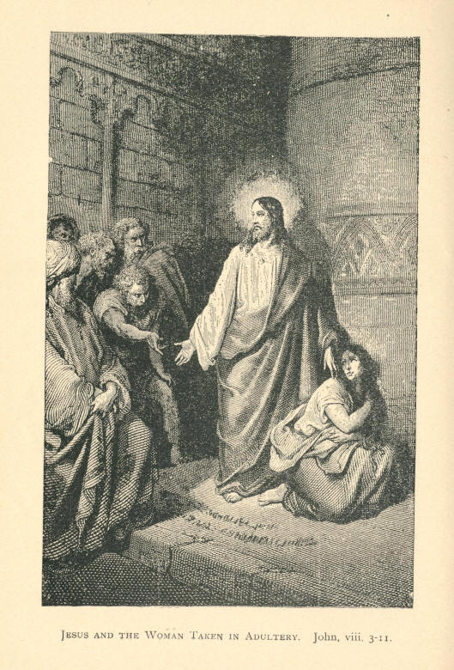
Jesus And The Woman Taken In Adultery. John, viii, 3-11
AND ILLUSTRATIONS. 101

DELIVERANCE.

The Scotch Lassie.

There is a story told of an incident that occurred during the last Indian mutiny. The English were besieged in the city of Lucknow, and were in momentary expectation of perishing at the hands of the fiends that surrounded them. There was a little Scotch lassie in this fort, and, while lying on the ground, she suddenly shouted, her face aglow with joy, "Dinna ye hear them comin'; dinna ye hear them comin'?" "Hear what?" they asked, "Dinna ye hear them comin?" And she sprang to her feet. It was the bagpipes of her native Scotland she heard. It was a native air she heard that was being played by a regiment of her countrymen marching to the relief of those captives, and these deliverers made them free. Oh, my friends, don't you hear Jesus Christ crying to you to-night?

Geo. H. Stewart Visits a Doomed Criminal.

I remember hearing a story of Mr. George Stewart. One day the Governor of Pennsylvania came to him and said, "Mr. Stewart, I want you to go to such a prison and tell that man for whose execution I signed the warrant the other day, that there is not a ray of hope for him. When the day and hour comes he must be executed. His mother has been tormenting the life out of me; and all his friends have been running after me day and night, and they are giving the poor fellow a false hope." "That is a very disagreeable thing to do, Governor," answered Mr. Stewart. "Well, I want you to go and tell him, so that he can be settled in his mind." The story goes that when the doors of the cell were opened, that prisoner seized Mr. Stewart's hands, and in his joy cried, "You are a good man. I know you have come with a pardon from the Governor."
102 MOODY'S ANECDOTES Deliverance.

But when Mr. Stewart told him the Governor had sent him to say there was not a ray of hope for him, that upon the day and hour he must be executed, the man completely broke down and fainted away. The thought that at such a day and such an hour he was going to be ushered into eternity, was too much for the poor fellow. Suppose I come to you to-night and tell you there is not a ray of hope--that you have broken the law of pardon. How many would say, "I know a great deal better. The blackest sinner on earth Christ can save. He says so." But, my friends, there is no hope without the deliverance to be free from the bondage of sin.

The Demoniac.

When this man found himself delivered he wanted to go with the Saviour. That was gratitude; Christ had saved him, had redeemed him. He had delivered him from the hand of the enemy. And this man cried: "Let me follow You around the world; where You go I will go." But the Lord said, "You go home and tell your friends what good things the Lord has done for you." And he started home. I would like to have been in that house when he came there. I can imagine how the children would look when they saw him, and say, "Father is coming." "Shut the door," the mother would cry; "look out! fasten the window; bolt every door in the house." Many times he very likely had come and abused his family and broken the chairs and tables and turned the mother into the street and alarmed all the neighbors. They see him now coming down the street. Down he comes till he gets to the door, and then gently knocks. You don't hear a sound as he stands there. At last he sees his wife at the window and he says, "Mary!" "Why," she says, "why he speaks as he did when I first married him; I wonder if he has got well?" So she looks out and asks: "John, is that you?" "Yes, Mary," he replies, "it's me, don't be afraid any mare, I'm well now." I see that mother, how she pulls back the bolts of that door, and looks at him. The first look is sufficient, and she springs into his arms and clings about his neck. She takes him in and asks him a hundred questions--how it all happened--all about it.
Deliverance. AND ILLUSTRATIONS. 103

"Well, just take a chair and I'll tell you how I got cured." The children hang back and look amazed. He says: "I was there in the tombs, you know, cutting myself with stones, and running about in my nakedness, when Jesus of Nazareth came that way. Mary, did you ever hear of Him? He is the most wonderful man; I've never seen a man like Him. He just ran in and told those devils to leave me, and they left me. When He had cured me I wanted to follow Him, but He told me to come home and tell you all about it." The children by and by gather about his knee, and the elder ones run to tell their playmates what wonderful things Jesus has done for their father. Ah, my friends, we have got a mighty deliverer, I don't care what affliction you have, He will deliver you from it. The Son of God who cast out those devils can deliver you from your besetting sin.

Spurgeon's Parable.

Mr. Spurgeon, a number of years ago, made a parable. He thought he had a right to make one, and he did it. He said: "There was once a tyrant who ordered one of his subjects into his presence, and ordered him to make a chain. The poor blacksmith--that was his occupation--had to go to work and forge the chain. When it was done he brought it into the presence of the tyrant, and he was ordered to take it away and make it twice the length. He brought it again to the tyrant, and again he was ordered to double it. Back he came when he had obeyed the order, and the tyrant looked at it, and then commanded the servants to bind the man hand and foot with the chain he had made and cast him into prison. "And," Mr. Spurgeon said, "that is what the devil does with man." He makes them forge their own chain, and then binds them hand and foot with it, and casts them into outer darkness." My friends, that is just what these drunkards, these gamblers, these blasphemers--that is just what every sinner is doing. But, thank God, we can tell you of a deliverer. The Son of God has power to break everyone of these fetters if you will only come to Him.
104 MOODY'S ANECDOTES Deliverance.

GOLD.

-- The mightiest man that ever lived could not deliver himself from his sins. If a man could have saved himself, Christ would never have come into the world.
-- He came to deliver us from our sinful dispositions, and create in us pure hearts, and when we have Him with us it will not be hard for us. Then the service of Christ will be delightful.
-- If you are under the power of evil, and you want to get under the power of God, cry to Him to bring you over to His service; cry to Him to take you into His army. He will hear you; He will come to you, and, if need be, He will send a legion of angels to help you to fight your way up to heaven. God will take you by the right hand and lead you through this wilderness, over death, and take you right into His kingdom. That's what the Son of Man came to do. He has never deceived us; just say here: "Christ is my deliverer."

AND ILLUSTRATIONS. 105

EXCUSES.

"I Have Intellectual Difficulties."

There is another voice coming down from the gallery yonder: "I have intellectual difficulties; I cannot believe." A man came to me sometime ago and said, "I cannot." "Cannot what?" I asked. "Well," said he, "I cannot believe." "Who?" "Well," he repeated, "I cannot believe." "Who?" I asked. "Well--I--can't--believe--myself." "Well, you don't want to." [Laughter.] Make yourself out false every time, but believe in the truth of Christ. If a man says to me, "Mr. Moody, you have lied to me; you have dealt falsely with me," it may be so, but no man on the face of the earth can say that God ever dealt unfairly, or that He lied to him. If God says a thing it is true. We don't ask you to believe in any man on the face of the earth, but we ask you to believe in Jesus Christ, who never lied--who never deceived any one. If a man says he cannot believe Him, he says what is untrue.

I Am Not All Right.

I had to notice during the war, when enlisting was going on, sometimes a man would come up with a nice silk hat on, patent-leather boots, nice kid gloves, and a fine suit of clothes, which, probably, cost him $100; perhaps the next man who came along would be a hod-carrier, dressed in the poorest kind of clothes. Both had to strip alike and put on the regimental uniform. So when you come and say you ain't fit, haven't got good clothes, haven't got righteousness enough, remember that He will furnish you with the uniform of Heaven, and you will be set down at the marriage feast of the Lamb. I don't care how black and vile your heart may be, only accept the invitation of Jesus Christ and He will make you fit to sit down with the rest at that feast.
106 MOODY'S ANECDOTES Excuses.

"Those Hypocrites."

"I won't accept this invitation because of those hypocrites in the churches." My friend, you will find very few there if you get to heaven. There won't be a hypocrite in the next world, and if you don't want to be associated with hypocrites in the next world, you will take this invitation. Why, you will find hypocrites everywhere. One of the apostles was himself the very prince of hypocrites, but he didn't get to heaven. You will find plenty of hypocrites in the church. They have been there for the last one thousand eight hundred years, and will probably remain there. But what is that to you? This is an individual matter between you and your God.

"I Can't Feel."

"I can't feel," says one. That is the very last excuse. When a man comes with that excuse he is getting pretty near the Lord. We are having a body of men in England giving a new translation of the Scriptures. I think we should get them to put in a passage relating to feeling. With some people it is feel, feel, feel all the time. What kind of feeling have you got? Have you got a desire to be saved, have you got a desire to be present at the marriage supper? Suppose a gentleman asked me to dinner, I say, "I will see how I feel." "Sick?" he might ask. "No; it depends on how I feel." That is not the question--it is whether I will accept the invitation or not. The question with us is, will we accept salvation--will you believe? There is not a word about feelings in the Scriptures. When you come to your end, and you know that in a few days you will be in the presence of the Judge of all the earth, you will remember this excuse about feelings. You will be saying, "I went up to the Tabernacle, I remember, and I felt very good, and before the meeting was over I felt very bad, and I didn't feel I had the right kind of feeling to accept the invitation." Satan will then say, "I made you feel so." Suppose you build your hopes and fix yourself upon the Rock of Ages, the devil cannot come to you. Stand upon the Word of God and the waves of unbelief cannot touch you, the waves of persecution cannot assail you; the devil and all the fiends of hell cannot approach you if you only build your hopes upon God's Word. Say, I will trust Him, though He slay me--I will take God at His word.
Excuses. AND ILLUSTRATIONS. 107

I Am Not "One of the Elect."

I can imagine some men saying, "Mr. Moody has not touched my case at all. That is not the reason why I won't accept Christ. I don't know as I am one of the elect." How often I am met with this excuse--how often do I hear it in the inquiry room! How many men fold their arms and say, "If I am one of the elect I will be saved, and if I ain't I won't. No use of your bothering about it." Why don't some of those merchants say, "If God is going to make me a successful merchant in Chicago I will be one whether I like it or not, and if he isn't I won't." If you are sick, and a. doctor prescribes for you, don't take the medicine, throw it out the door, it don't matter, for if God has decreed you are going to die, you will: if he hasn't, you will get better. If you use that argument you may as well not walk home from this tabernacle. If God has said you'll get home, you'll get home--you'll fly through the air; if you have been elected to go home. I have an idea that the Lord Jesus saw how men were going to stumble over this doctrine, so after He had been thirty or forty years in heaven, He came down and spoke to John. One Lord's day in Patmos, He said to him, "Write these things to the churches." John kept on writing. His pen flew very fast. And then the Lord, when it was nearly finished said, "John, before you close the book, put in this: 'The Spirit and the Bride say, Come; and let him that heareth say; Come.' But there will be some that are deaf, and they cannot hear, so add, 'Let him that is athirst, Come;' and in case there should be any that do not thirst, put it still broader, 'Whosoever will, let him take of the water of life freely.' '' What more can you have than that? And the Book is sealed, as it were, with that. It is the last invitation in the Bible.
108 MOODY'S ANECDOTES Excuses.

"Whosoever will, let him take of the water of life freely." You are thirsty. You want water. I hold out this glass to you, and say, "Take it." You say, "If I am decreed to have it, I am not going to put myself to the trouble of taking it." Well, you will never get it. And if you are ever to have salvation, you must reach out the hand and take it. "I will take the cup of salvation, and call upon the name, of the Lord."

Why did he not take his Wife along?

Take the excuses. There wasn't one that wasn't a lie. The devil made them all; and if the sinner hadn't one already the devil was there at his elbow to suggest one, about the truth of the Bible, or something of that sort. One of the excuses mentioned was that the man invited had bought a piece of ground, and had to look at it. Real estate and corner lots are keeping a good many men out of God's kingdom. It was a lie to say that he had to go and see it then, for he ought to have looked at it before he bought it. Then the next man said he'd bought some oxen, and must prove them. That was another lie; for if he hadn't proved them before he bought them he ought to have done so, and could have done it after supper just as well as before it. But the third man's excuse was the most ridiculous of them all. "I have married a wife and therefore cannot come." Why did he not take his wife along with him? Who likes to go to a feast better than a young bride? He might have asked her to go too; and if she were not willing, then let her stay at home. The fact was, he did not want to go.

A Good Excuse.

If you have got a good excuse don't give it up for anything I have said; don't give it up for anything your mother may have said; don't give it up for anything your friend may have said. Take it up to the bar of God and state it to Him; but if you have not got a good excuse--an excuse that will stand in eternity--let it go to-night, and flee to the arms of a loving Saviour.
Excuses. AND ILLUSTRATIONS. 109

Excused at Last.

It is a very solemn thought that God will excuse you if you want to be excused. He does not wish to do it, but He will do it. "As I live, saith the Lord, I have no pleasure in the death of the wicked; but that the wicked turn from his way and live. Turn ye, turn ye from your evil ways; for why will ye die, O house of Israel." Look at the Jewish nation. They wanted to be excused from the feast. They despised the grace of God and trampled it under foot, and look at them to-day! Yes, it is easy enough to say, "I pray Thee have me excused;" but by and by God may take you at your word, and say, "Yes, I will excuse you." And in that lost world, while others who have accepted the invitation sit down to the marriage supper of the Lamb, amid shouts and hallelujahs in heaven, you will be crying in the company of the lost, "The harvest is past; the summer is ended, and I am not saved."

The Invitation.

Suppose we should write out here to-night this excuse, how would it sound? To the King of Heaven:--While sitting in the Tabernacle in the City of Chicago, January--, 1877, I received a very pressing invitation from one of your servants to be present at the marriage supper of your only-begotten Son. I PRAY THEE HAVE ME EXCUSED." Would you sign that, young man? Would you, mother? Would you come up to the reporters' table, take up a pen and put your name down to such an excuse? You would say, "Let my right hand forget its cunning, and my tongue cleave to the roof of my mouth, if I sign that."
Just let me write out another answer: "To the King of Heaven;--While sitting in the Tabernacle, January---, 1877, I received a pressing invitation from one of your messengers to be present at the marriage supper of your only-begotten Son. I hasten to reply: BY THE GRACE OF GOD I WILL BE PRESENT." Who will sign that? Is there one who will put his name to it? Is there no one who will say, "By the grace of God I will accept the invitation now"?
110 MOODY'S ANECDOTES Excuses.

GOLD.

-- There is not an excuse but is a lie.
-- God's service a hard one! How will that sound in the judgment?
-- It is easy enough to excuse yourself to hell, but you cannot excuse yourself to heaven.
-- When a man prepares a feast, men rush in, but when God prepares one they all begin to make excuses, and don't want to go.
-- My friends, to accept this invitation is more important than anything else in this world. There is nothing in the world that is so important as the question of accepting the invitation.
-- If everybody could understand everything the Bible said it wouldn't be God's book; if Christians, if theologians, had studied it for forty, fifty, sixty years, and then only began to understand it, how could a man expect to understand it by one reading?
-- If God were to take men at their word about these excuses, and swept everyone into his grave who had an excuse, there would be a very small congregation in the Tabernacle next Sunday; there would be little business in Chicago, and in a few weeks the grass would be growing on these busy streets.

AND ILLUSTRATIONS. 111

FAITH.

How Moody's Faith Saved an Infidel.

When I was in Edinburgh, at the inquiry meeting in Assembly Hall, one of the ushers came around and said, "Mr. Moody, I'd like to put that man out; he's one of the greatest infidels in Edinburgh." He had been the chairman of an infidel club for years, I went around to where he was and sat down by him. "How is it with you, my friend?" I asked, and then he laughed and said, "You say God answers prayer; I tell you He doesn't. I don't believe in a God. Try it on me." "Will you get down with me and pray?" I asked him; but he wouldn't. So I got down on my knees beside him and prayed. Next night he was there again. I prayed, and quite a number of others prayed for him. A few months after that, away up in the north of Scotland, at Wick, I was preaching in the open air, and while I stood there I saw the infidel standing on the outskirts of the crowd. I went up to him at the close of the meeting and said: "How is it with you, my friend?" He laughed and said, "I told you your praying is all false; God hasn't answered your prayers; go and talk to these deluded people." He had just the same spirit as before, but I relied on faith. Shortly after I got a letter from a barrister--a Christian. He was preaching one night in Edinburgh, when this infidel went up to him and said: "I want you to pray for me; I am troubled." The barrister asked, "What is the trouble?" and he replied: "I don't know what's the matter, but I don't have any peace, and I want you to pray for me." Next day he went around to that lawyer's office and he said that he had found Christ.
This man now is doing good work, and I heard that out of thirty inquirers there, ten or twelve of his old associates and friends were among them. So, if you have God with you, and you go to work for Him, and you meet infidels and skeptics, just bear in mind that you can win through faith. When Christ saw the faith of those four men, He said to the man: "Thy sins are forgiven you." My friends, if you have faith all things are possible.
112 MOODY'S ANECDOTES Faith.

Taking "the Prince at his Word."

Some time ago I remember reading of an incident that occurred between a prince in a foreign land and one of his subjects. This man for rebellion against the government was going to be executed. He was taken to the guilotine block. When the poor fellow reached the place of execution he was trembling with fear. The prince was present and asked him if he wished anything before judgment was carded out. The culprit replied: "A glass of water." It was brought to him, but he was so nervous he couldn't drink it. "Do not fear," said the prince to him, "judgment will not be carried out till you drink that water," and in an instant the glass was dashed to the ground and broken into a thousand pieces. He took that prince at his word.

A Wife's Faith.

In one of the towns in England there is a beautiful little chapel, and a very touching story is told in connection with it. It was built by an infidel. He had a praying wife, but he would not listen to her, would not allow her pastor even to take dinner with them; would not look at the Bible, would not allow religion even to be talked of. She made up her mind, seeing she could not influence him by her voice, that every day she would pray to God at twelve o'clock for his salvation. She said nothing to him; but every day at that hour she told the Lord about her husband. At the end of twelve months there was no change in him. But she did not give up. Six months more went past. Her faith began to waver, and she said, "Will I have to give him up at last? Perhaps when I am dead He will answer my prayers." When she had got to that point, it seemed just as if God had got her where he wanted her.
Faith. AND ILLUSTRATIONS. 113

The man came home to dinner one day. His wife was in the dining-room waiting for him, but he didn't come in. She waited some time, and finally looked for him, all through the house. At last she thought of going into the little room where she had prayed so often. There he was, praying at the same bed with agony, where she had prayed for so many months, asking forgiveness for his sins. And, this is a lesson to you wives who have infidel husbands. The Lord saw that woman's faith and answered her prayers.

Mr. Morehouse's Illustration.

I remember Mr. Morehouse, while here four years ago, used an illustration which has fastened itself on my mind. He said, suppose you go up the street and meet a man whom you have known for the last ten years to be a beggar, and you notice a change in his appearance, and you say, "Halloo, beggar, what's come over you?" "I ain't no beggar. Don't call me beggar." "Why," you say, "I saw you the other day begging in the street." "Ah, but a change has taken place," he replies. "Is that so? how did it come about?" you inquire. "Well," he says, "I came out this morning and got down here intending to catch the business men and get all the money out of them, when one of them came up to me and said there was $10,000 deposited for me." "How do you know this is true?" you say. "I went to the bank and they put the money in my hand." "Are you sure of that?" you ask; "how do you know it was the right kind of a hand?" But he says; "I don't care whether it was the right kind of a hand or not; I got the money, and that's all I wanted." And so people are looking to see if they've got the right kind of a hand before they accept God by it. They have but to accept his testimony and they are saved, for, as John says, "He that hath received His testimony hath set his seal that God is true." Is there a man in this assemblage who will receive His testimony and set his seal that God is true? Proclaim that God speaks the truth. Make yourself a liar, but make God's testimony truthful. Take Him at His word.

8
114 MOODY'S ANECDOTES Faith.

Faith More Powerful than Gunpowder.

I remember at one of the meetings at Nashville, during the war, a young man came to me, trembling from head to foot. "What is the trouble?" I asked. "There is a letter I got from my sister, and she tells me every night as the sun goes down she goes down on her knees and prays for me." This man was brave, had been in a number of battles; he could stand before the cannon's mouth, but yet this letter completely upset him. "I have been trembling ever since I received it." Six hundred miles away the faith of this girl went to work, and its influence was felt by the brother. He did not believe in prayer; he did not believe in Christianity; he did not believe in his mother's Bible. This mother was a praying woman, and when she died she left on earth a praying daughter. And when God saw her faith and heard that prayer, he answered her. How many sons and daughters could be saved if their mothers and fathers had but faith.

GOLD.

-- God will honor our faith.
-- There is nothing on this earth that pleases Christ so much as faith.
-- Faith is the foundation of all society. We have only to look around and see this.
-- I believe there is no man in the world so constituted but he can believe in God's word. He simply tells you to believe in Him, and He will save you.
-- When I was converted twenty years ago I felt a faith in God; but five years after I had a hundred times more faith, and five years ago I had more than ever, because I became better acquainted with Him. I have read up the Word, and I see that the Lord has done so and so, and then I have turned to where He has promised to perform it, and when I see this I have reason to believe in Him.

AND ILLUSTRATIONS. 115

FORGIVENESS.

How Moody's Mother Forgave her Prodigal Son.

I can give you a little experience of my own family. Before I was fourteen years old the first thing I remember was the death of my father. He had been unfortunate in business, and failed. Soon after his death the creditors came in and took everything. My mother was left with a large family of children. One calamity after another swept over the entire household. Twins were added to the family, and my mother was taken sick. The eldest boy was fifteen years of age, and to him my mother looked as a stay in her calamity, but all at once that boy became a wanderer. He had been reading some of the trashy novels, and the belief had seized him that he had only to go away to make a fortune. Away he went. I can remember how eagerly she used to look for tidings of that boy; how she used to send us to the post office to see if there was a letter from him, and recollect how we used to come back with the sad news, "No letter." I remember how in the evenings we used to sit beside her in that New England home, and we would talk about our father; but the moment the name of that boy was mentioned she would hush us into silence. Some nights when the wind was very high, and the house, which was upon a hill, would tremble at every gust, the voice of my mother was raised in prayer for that wanderer who had treated her so unkindly. I used to think she loved him more than all the rest of us put together, and I believe she did. On a Thanksgiving day--you know that is a family day in New England--she used to set a chair for him, thinking he would return home. Her family grew up and her boys left home. When I got so that I could write, I sent letters all over the country, but could find no trace of him. One day while in Boston the news reached me that he had returned.
116 MOODY'S ANECDOTES Forgiveness.

While in that city, I remember how I used to look for him in every store--he had a mark on his face--but I never got any trace. One day while my mother was sitting at the door, a stranger was seen coming toward the house, and when he came to the door he stopped. My mother didn't know her boy. He stood there with folded arms and great beard flowing down his breast, his tears trickling down his face. When my mother saw those tears she cried, "Oh, it's my lost son," and entreated him to come in. But he stood still. "No, mother," he said, "I will not come in till I hear first you forgive me." Do you believe she was not willing to forgive him? Do you think she was likely to keep him long standing there? She rushed to the threshold and threw her arms around him, and breathed forgiveness. Ah, sinner, if you but ask God to be merciful to you a sinner, ask Him for forgiveness, although your life has been bad--ask Him for mercy, and He will not keep you long waiting for an answer.

A Rich Father visits his Dying Prodigal Son in a Garret and Forgives him.

There is a story told of Mr. William Dawson, which I would like to relate. While preaching in London, one night at the close of his sermon, he said that there was not one in all London whom Christ could not save. In the morning a young lady called upon him and said: "Mr. Dawson, in your sermon last night you said that 'there was no man in all London whom Christ could not save.' I find a young man in my district who says he cannot be saved, and who will not listen to me. Won't you go and see him? I am sure you can do more with him than I can." Mr. Dawson readily assented, and went with the young lady to the East End--up one of those narrow streets there, and at the top of a rickety staircase found a garret, in which a man was stretched upon straw. He bent over him and said, "Friend." "Friend!" said the young man, turning upon him, "you must take me for some other person. I have no friends." "Ah," replied the Christian, "you are mistaken. Christ is the sinner's friend."
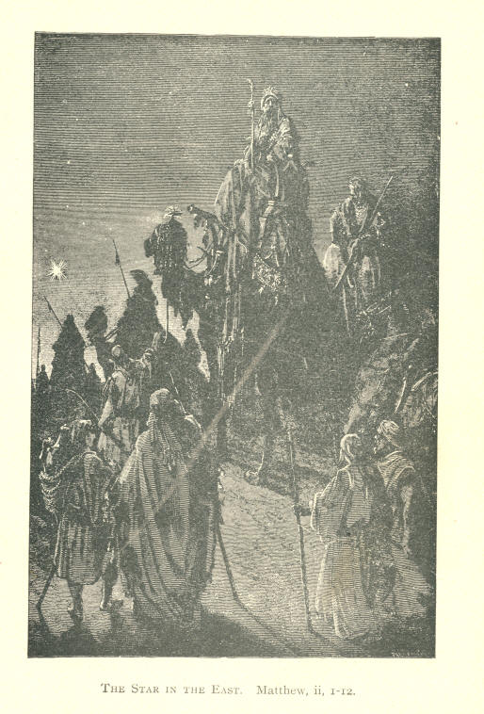
The Star In The East. Matthew, ii, 1-12.
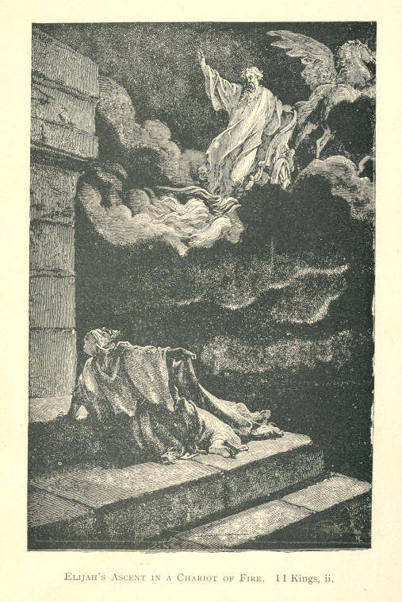
Elijah's Ascent In A Chariot Of Fire. II Kings, ii.
Forgiveness AND ILLUSTRATIONS. 117

The man thought this too good; "Why," said he, "my whole family have cast me off; every friend I had has left me, and no one cares for me." Mr. Dawson spoke to him kindly, and quoted promise after promise--told him what Christ had suffered to give him eternal life. At first his efforts were fruitless, but finally the light of the gospel began to break in on the young man, and the first sign was his heart went out to those he had injured. And, my friends, this is one of the first indications of the acceptance of Christ with the sinner. He said: "I could die in peace now if my father would but forgive me." "Well," replied the man of God, "I will go and see your father and ask him for his forgiveness." "No, no," was the sad answer of the young man, "you cannot go near him. My father has disinherited me; he has taken my name from the family records; he has forbidden the mention of my name in his house by any of the family or servants in his presence, and you needn't go."
However, Mr. Dawson obtained the address, and went away to the West End of London; ascended the steps of a beautiful villa, and rang the bell. A servant in livery came to the door and conducted him to the drawing-room. There was everything in that house for comfort and luxury that money could purchase. He could not help contrasting the scene of poverty in that garret with the scene of luxuriant elegance everywhere around him. Presently a proud, haughty-looking merchant came in, and as he stepped forward to shake hands with Mr. Dawson that gentleman said: "I believe you have a son named Joseph?" and the merchant threw back his hand and drew himself up. "If you come to speak of him--that reprobate--I want you to go away. I have no son of that name. I disown him. If he has been talking to you he has been only deceiving you." "Well," replied Mr. Dawson, "he is your boy now, but he won't be long." The father stood for a minute looking at the Christian, and then asked: "Is Joseph sick?" "Yes," was the reply, "he is at the point of death. I only came to ask your forgiveness for him, that he may die in peace. I don't ask any favor; when he dies we will bury him."
118 MOODY'S ANECDOTES Forgiveness.

The father put his hands to his face and great tears rolled down his cheeks, as he said, "Can you take me to him?" In a very short time he was in that narrow street where his son was dying, and as he mounted the filthy stairs it hardly seemed possible that the boy could be in such a place. When he entered the garret he could hardly recognize his son, and when he bent over him the boy opened his eyes and said: "O, father, can you--will you forgive me?" and the father answered: "O Joseph, I would have forgiven you long ago if you had wanted me to." That haughty man laid his boy's head on his bosom and the son told him what Christ had done for him; how He had forgiven his sins, brought peace to his soul; how that Son of God had found him in that poor garret, and had done all for him. The father wanted the servant to take him home. "No, father," said the boy, "I have but a short time to live, and I would rather die here." He lingered a few hours, and passed from that garret in the East End to the everlasting hills.

Moody in a Billiard Hall.--A Remarkable Story.

In a meeting recently a man got up. I didn't know him at first. When I was here he was a rumseller, and broke up his business and went to the mountains. This is how it happened. When I was here before, he opened a saloon and a grand billiard hall. It was one of the most magnificent billiard halls in Chicago, all elegantly gilded and frescoed. For the opening he sent me an invitation to be present, which I accepted, and went around before he opened it. I saw the partners and asked them if they would allow me to bring a friend. They said certainly, but asked me who it was. Well, I said it wasn't necessary to tell who it was, but said I, "I never go without him." They began to mistrust me. "Who is it?" they again inquired. "Well, I'll come with him and if I see anything wrong I'll ask him to forgive you." "Come," said they, "we don't want any praying." "You've given me an invitation, and I am going to come." "But if you do come you needn't pray." "Well," said I, "I'll tell you what we'll do, we'll compromise the matter, and if you don't want me to come and pray for you when you open, let me pray for both of you now," which they agreed to.
Forgiveness. AND ILLUSTRATIONS, 119

It turned out that one of them had a praying mother, and the prayer touched his heart, and the other had a sister in heaven. I asked God to bless their souls, and just to break their business to pieces. In a few months their business did go all to pieces. The man who got up in the prayer meeting told me a story that touched my soul. He said with his business he hadn't prospered--he failed, and went away to the Rocky Mountains. Life became a burden to him and he made up his mind that he would go to some part of the mountains and put an end to his days. He took a sharp knife with him which he proposed driving into his heart. He sought a part of the mountains to kill himself. He had the knife ready to plunge into his heart, when he heard a voice--it was the voice of his mother. He remembered her words when she was dying, even though he was a boy. He heard her say, "Johnny, if you get into trouble, pray." That knife dropped from his hand, and he asked God to be merciful to him. He was accepted, and he came back to Chicago and lifted up his voice for Him. He may be in this Tabernacle to-night. Just the moment he cried for mercy he got it. If you only cry, "God, be merciful to me a sinner," He will hear you.

Moody and the Judge.

A number of years ago as I was coming out of a daily prayer meeting in one of our Western cities, a lady came up to me and said: "I want to have you see my husband and ask him to come to Christ." She says, "I want to have you go and see him." She told me his name, and it was a man I had heard of before. "Why," said I, "I can't go and see your husband. He is a booked infidel. I can't argue with him. He is a good deal older than I am, and it would be out of place. Then I am not much for infidel argument." "Well, Mr. Moody," she says, "that ain't what he wants. He's got enough of that. Just ask him to come to the Saviour." She urged me so hard and so strong, that I consented to go. I went to the office where the judge was doing business, and told him what I had come for. He laughed at me. "You are very foolish," he said, and began to argue with me. I said, "I don't think it will be profitable for me to hold an argument with you. I have just one favor I want to ask of you, and that is, that when you are converted you will let me know." "Yes," said he, "I will do that. When I am converted I will let you know"--with a good deal of sarcasm.
120 MOODY'S ANECDOTES Forgiveness.

I went off, and requests for prayer were sent here and to Fulton street, New York, and I thought the prayers there and of that wife would be answered if mine were not. A year and a half after, I was in that city, and a servant came to the door and said: "There is a man in the front parlor who wishes to see you." I found the Judge there; he said: "I promised I would let you know when I was converted." "Well," said I, "tell me all about it." I had heard it from other lips, but I wanted to hear it from his own. He said his wife had gone out to a meeting one night and he was home alone, and while he was sitting there by the fire he thought: "Supposing my wife is right, and my children are right; suppose there is a heaven and a hell, and I shall be separated from them." His first thought was, "I don't believe a word of it." The second thought came, "You believe in the God that created you, and that the God that created you is able to teach you. You believe that God can give you life." "Yes, the God that created me can give me life. I was too proud to get down on my knees by the fire, and said, 'O God, teach me.' And as I prayed, I don't understand it, but it began to get very dark, and my heart got very heavy. I was afraid to tell my wife, and I pretended to be asleep. She kneeled down beside that bed, and I knew she was praying for me. I kept crying, 'O God, teach me.' I had to change my prayer, 'O God save me; O God, take away this burden.' But it grew darker and darker, and the load grew heavier and heavier. All the way to my office I kept crying, 'O God, take away this load of guilt; I gave my clerks a holiday, and just closed my office and locked the door. I fell down on my face; I cried in agony to my Lord, 'O Lord, for Christ's sake take away this guilt.' I don't know how it was, but it began to grow very light. I said, I wonder if this isn't what they call conversion. I think I will go and ask the minister if I am not converted. I met my wife at the door and said, 'My dear, I've been converted.' She looked in amazement. 'Oh it's a fact; I've been converted! We went into that drawing-room and knelt down by the sofa and prayed to God to bless us." The old Judge said to me, the tears trickling down his cheeks, "Mr. Moody, I've enjoyed life more in the last three months than in all the years of my life put together." If there is an infidel here--if there is a skeptical one here, ask God to give you wisdom to come now. Let us reason together, and if you become acquainted with God the day will not go before you receive light from Him.
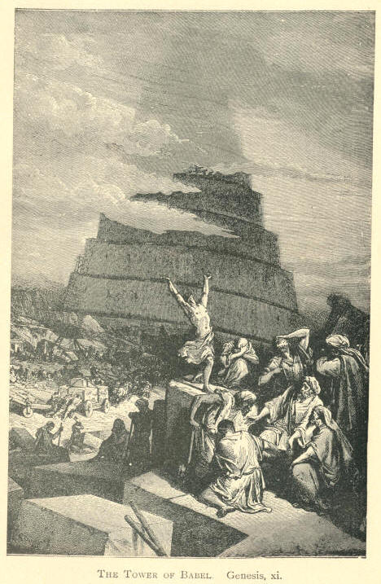
The Tower of Bable. Genesis, xi.
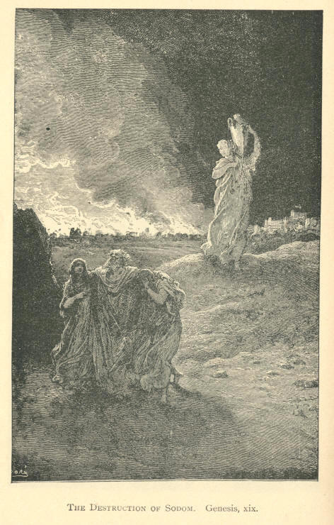
The Destruction of Sodom. Genesis, xix.
Forgiveness. AND ILLUSTRATIONS. 121

Reuben Johnson Pardoned.

I want to tell you a scene that occurred some time ago. Our Commissioner went to the Governor of the State and asked him if he wouldn't pardon out five men at the end of six months who stood highest on the list for good behavior. The Governor consented, and the record was to be kept secret; the men were not to know anything about it. The six months rolled away and the prisoners were brought up--1,100 of them--and the President of the commission came up and said: "I hold in my hand pardons for five men." I never witnessed anything like it. Every man held his breath, and you could almost hear the throbbing of every man's heart. "Pardon for five men," and the Commissioner went on to tell the men how they had got these pardons--how the Governor had given them, but the Chaplain said the surprise was so great that he told the Commissioner to read the names first and tell the reason afterward. The first name was called--'Reuben Johnson'--and he held out the pardon, but not a man moved. He looked all around, expecting to see a man spring to his feet at once; but no one moved. The Commissioner turned to the officer of the prison and inquired: "Are all the convicts here?" "Yes," was the reply, "Reuben Johnson, come forward and get your pardon; you are no longer a criminal." Still no one moved.

122 MOODY'S ANECDOTES Forgiveness.

The real Reuben Johnson was looking all the time behind him, and around him to see where Reuben was. The Chaplain saw him standing right in front of the Commissioner, and beckoned to him; but he only turned and looked around him, thinking that the Chaplain might mean some other Reuben. A second time he beckoned to Reuben and called to him, and a second time the man looked around. At last the Chaplain said to him: "You are the Reuben." He had been there for nineteen years, having been placed there for life, and he could not conceive it would be for him. At last it began to dawn upon him, and he took the pardon from the Commissioner's hand, saw his name attached to it, and wept like a child. This is the way that men make out pardons for men; but, thank God, we have not to come to-night and say we have pardons for only five men--for those who have behaved themselves. We have assurance of pardon for every man. "Whosoever will, let him take the water of life freely."

GOLD.

-- All you have got to do is to prove that you are a sinner, and I will prove that you have got a Saviour.
-- Do you believe the Lord will call a poor sinner, and then cast him out? No! his word stands forever, "Him that cometh unto Me I will in no wise cast out."
-- If God put Adam out of this earthly Eden on account of one sin, do you think He will let us into the Paradise above with our tens of thousands sins upon us.
-- The only charge they could bring against Christ down here was, that He was receiving bad men. They are the very kind of men He is willing to receive.
-- "Lord, you don't really mean that we shall preach the Gospel to those men that murdered you, to those men that took your life?" "Yes," says the Lord, "go and preach the Gospel to those Jerusalem sinners." I can imagine Him saying: "Go and hunt up that man that put the cruel crown of thorns upon My brow, and preach the Gospel to him. Tell him he shall have a crown in My kingdom without a thorn in it."

AND ILLUSTRATIONS. 123

GRACE.

Moody's First Sermon on Grace.

I remember preaching one night in winter--one of the coldest winters we had--the winter after the Chicago fire. I had been studying up grace, and it was the first time I had spoken of it, and I was just full of it. I started out of the house, I remember, and the first man I met I asked him if he knew anything about the grace of God, and I tried to preach to him. This man thought I was crazy. I ran on and met another, and finally got up to the meeting. That night I thought I was speaking to a lot of people who felt as I did about grace, and when I got through I asked anyone who would like to hear about grace--who had any interest in it, to stay. I expected some would have stayed, but what was my mortification to see the whole audience rise up and go away. They hadn't any interest in grace; they didn't want to learn anything about grace. I put my coat and hat on and was going out of the hall, when I saw a poor fellow at the back of the furnace crying. "I want to hear about the grace of God," said he. "You're the man I want, then," said I. "Yes," the poor fellow said, "you said in your sermon that it was free, and I want you to tell me something about it." Well, I got to talking to him, and he told me a pitiful story. He had drank away twenty thousand dollars, his home had been broken up, and his wife and children had left him. I spoke to him, and it was not long before we were down together praying. That night I got him a night's lodging in the Bethel, and next day we got him on his feet, and when I went to Europe he was one of the most earnest workers we had. He was just a partaker of grace--believed that the peace of God was sufficient for him, and he took God at his word and he was a saved man.
124 MOODY'S ANECDOTES Grace.

Dr. Arnott's Dog "Rover."

I remember when Dr. Arnott, who has gone to God, was delivering a sermon, he used this illustration. The sermon and text have all gone, but that illustration is fresh upon my mind to-night and brings home the truth. He said: "You have been sometimes out at dinner with a friend, and you have seen the faithful household dog standing watching every mouthful his master takes. All the crumbs that fall on the floor he picks up, and seems eager for them, but when his master takes a plate of beef and puts it on the floor and says, 'Rover, here's something for you,' he comes up and smells of it, looks at his master, and goes away to a corner of the room. He was willing to eat the crumbs, but he wouldn't touch the roast beef--thought it was too good for him." That is the way with a good many Christians. They are willing to eat the crumbs, but not willing to take all God wants. Come boldly to the throne of grace and get the help we need; there is an abundance for every man, woman and child in the assemblage.

Young Moody Penniless in Boston is Warned by his Sister to "Beware of Pickpockets."

I remember when I was a boy and went to Boston, I went to the postoffice two or three times a day to see if there was a letter for me. I knew there was not, as there was but one mail a day. I had not had any employment and was very homesick, and so went constantly to the postoffice, thinking perhaps when the mail did come in my letter had been mislaid. At last, however, I got a letter. It was from my youngest sister, the first letter she ever wrote to me. I opened it with a light heart thinking there was some good news from home, but the burden of the whole letter was that she had heard there were pickpockets in Boston, and warned me to take care of them. I thought I had better get some money in hand first, and then I might take care of pickpockets. And so you must take care to remember salvation is a gift. You don't work for salvation; but work day and night after you have got it.
Grace. AND ILLUSTRATIONS. 125

Get it first before you do anything, but don't try to get it yourself. Look at what Paul says in Ephesians: "For by grace are ye saved through faith, and that not of yourself, it is the gift of God"--it is the gift of God--"Not of works, lest any man should boast." There is one thing we know: We have all got to get into heaven the same way. We cannot work our way there; we have to take our salvation from God.

A Heavy Draw on Alexander the Great.

There is a story told of Alexander the Great. A general in his army was a great favorite with him, and he told him to draw anything from his treasury that he wanted. Well, he presented a bill to the treasurer, and the treasurer wouldn't honor it. It was for such an enormous amount that the treasurer was astonished. The General went rushing to the Emperor and told him, and he called the treasurer and said, "Didn't I tell you to honor the draft of the General." "But," replied the treasurer, "do you understand its amount?" "Never mind what it is," replied the Emperor, "he honors me and my kingdom by making a great draft." And so we honor God by asking for grace in abundance. I tell you, my friends, it is a pity there are so many half-starved, mean Christians around when God says, "Come and get all you want."

A Long Ladder Tumbles to the Ground.

I remember hearing of a man who dreamt that he built a ladder from earth to heaven, and when he did a good deed up went his ladder a few feet. When he did a very good deed his ladder went higher, and when he gave away large sums of money to the poor up it went further still. By and by it went out of sight, and years rolled on, and it went up, he thought, past the clouds, clear into heaven. When he died he thought he would step off his ladder into heaven, but he heard a voice roll out from paradise, "He that climbeth up another way, the same is a thief and a robber." and down he came, ladder and all, and he awoke. He said if he wanted to get salvation he must get it another way than by good deeds, and he took the other way.
126 MOODY'S ANECDOTES Grace.

GOLD.

-- We must not limit the mighty grace of God.
-- Grace means undeserved kindness. It is the gift of God to man the moment he sees he is unworthy of God's favor.
-- A man does not get grace till he comes down to the ground, till he sees he needs grace. When a man stoops to the dust and acknowledges that he needs mercy, then it is that the Lord will give him grace.
-- If you are ready to partake of grace you have not to atone for your sins--you have merely to accept of the atonement. All that you want to do is to cry, "God have mercy upon me," and you will receive the blessing.
-- "The grace of God hath power to bring salvation to all men," and if a man is unsaved it is because he wants to work it out; he wants to receive salvation in some other way than God's way; but we are told that "he that climbeth up another way, the same is a thief and a robber."
-- When we get full of this grace we want to see everyone blessed--we want to see all the churches blessed, not only all the churches here, but in the whole country. That was the trouble with Christ's disciples. He had hard work to make them understand that His gospel was for everyone, that it was a stream to flow out to all nations of the earth. They wanted to confine it to the Jews, and He had to convince them that it was for every living being.
AND ILLUSTRATIONS. 127

HEAVEN.

Moody in a California Sunday School.

I remember when I went to California just to try and get a few souls saved on the Pacific coast, I went into a school there and asked, "Have you got some one who can write a plain hand?" "Yes." Well, we got up the blackboard, and the lesson upon it proved to be the very text we have to-night. "Lay up for yourselves treasures in heaven." And I said, "Suppose we write upon that board some of the earthly treasures? And we will begin with 'gold.' " The teacher readily put down gold, and they all comprehended it, for all had run to that country in the hope of finding it. "Well, we will put down 'houses' next, and then 'land.' Next we will put down 'fast horses.' " They all understood what fast horses were--they knew a good deal more about fast horses than they knew about the kingdom of God. Some of them, I think, actually made fast horses serve as Gods. "Next we will put down 'tobacco.' " The teacher seemed to shrink at this. "Put it down," said I, "many a man thinks more of tobacco than he does of God. Well, then, we will put down 'rum.' " He objected to this--didn't like to put it down at all. "Down with it. Many a man will sell his reputation, will sell his home, his wife, his children, everything he has, for rum. It is the God of some men. Many here in Chicago will sell their present and then eternal welfare for it. Put it down," and down it went. "Now," said I, "suppose we put down some of the heavenly treasures. Put down 'Jesus' to head the list, then 'heaven,' then 'River of Life,' then 'Crown of Glory,' and went on till the column was filled, and then just drew a line and showed the heavenly and the earthly things in contrast. My friends, they could not stand comparison. If a man just does that, he cannot but see the superiority of the heavenly over the earthly treasures. Well, it turned out that the teacher was not a Christian.
128 MOODY'S ANECDOTES Heaven.

He had gone to California on the usual hunt--gold; and when he saw the two columns placed side by side, the excellence of the one over the other was irresistible, and he was the first soul God gave me on that Pacific coast. He accepted Christ, and that man came to the station when I was coming away and blessed me for coming to that place.

Mothers are Looking Down from Heaven.

I remember in the Exposition building in Dublin, while I was speaking about Heaven, I said something to the effect that at this moment a mother is looking down from Heaven expecting the salvation of her daughter here to-night, and I pointed down to a young lady in the audience. Next morning I received this letter:
"On Wednesday, when you were speaking of heaven, you said, 'It may be this moment there is a mother looking down from heaven expecting the salvation of her child who is here.' You were apparently looking at the very spot where my child was sitting. My heart said, 'That is my child. That is her mother.' Tears sprang to my eyes. I bowed my head and prayed, 'Lord, direct that word to my darling child's heart; Lord save my child.' I was then anxious till the close of the meeting, when I went to her. She was bathed in tears. She rose, put her arms around me, and kissed me. When walking down to you she told me it was that same remark--about the mother looking down from heaven--that found the way home to her, and asked me, 'Papa, what can I do for Jesus?' "

The Rich Man Poor.

I heard of a farmer who, when a friend of mine called upon him to give something for the Christian Commission, promptly drew a check for ten thousand dollars. He wanted the agent to have dinner with him, and after they had dined the farmer took the man out on the verandah and pointed to the rich lands sweeping far away, laden with rich products.
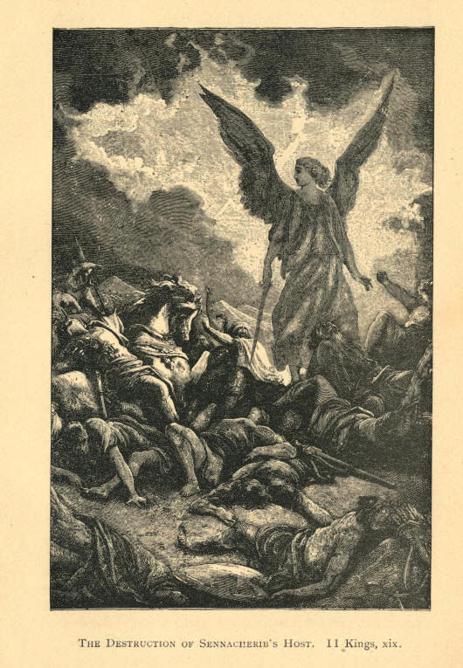
The Destruction Of Sennacherib's Host. II Kings xix.
Heaven. AND ILLUSTRATIONS. 129

"Look over these lands," said the farmer, "They are all mine." He took him to the pasture and showed the agent the choice stock, the fine horses he had, and then pointed to a little town, and then to a large hall where he lived; he drew himself up, and his face lit up with pride as he said, "They are all mine. I came here when a poor boy and I have earned all that you see." When he got through, my friend asked 'him, "Well, what have you got up yonder?" "Where?" replied the farmer, who evidently knew where my friend meant. "What have you got in heaven?" "Well," said the farmer, "I haven't anything there." "What!" replied my friend, "You, a man of your discretion, wisdom, business ability, have made no provision for your future?" He hadn't, and in a few weeks he died--a rich man here and a beggar in eternity. A man may be wise in the eyes of the world to pursue this course, but he is a fool in the sight of God. Wealth to most men proves nothing more or less than a great rock upon which their eternity is wrecked.

The Dying Boy.

But I have another anecdote to tell. It was Ralph Wallace who told me of this one. A certain gentleman was a member of the Presbyterian Church. His little boy was sick. When he went home his wife was weeping, and she said, "Our boy is dying; he has had a change for the worse. I wish you would go in and see him." The father went into the room and placed his hand upon the brow of his dying boy, and could feel that the cold, damp sweat was gathering there; that the cold, icy hand of death was feeling for the chords of life. "Do you know, my boy, that you are dying?" asked the father. "Am I? Is this death? Do you really think I am dying?" "Yes, my son, your end on earth is near." "And will I be with Jesus to-night, father?" "Yes, you will be with the Saviour." "Father, don't you weep, for when I get there I will go right straight to Jesus and tell Him that you have been trying all my life to lead me to Him."

9
130 MOODY'S ANECDOTES Heaven.

God has given me two little children, and ever since I can remember I have directed them to Christ, and I would rather they carried this message to Jesus--that I had tried all my life to lead them to Him--than have all the crowns of the earth; and I would rather lead them to Jesus than give them the wealth of the world. If you have got a child go and point the way. I challenge any man to speak of heaven without speaking of children. "For of such is the kingdom of heaven."

A Sad and Singular Story.

When I was a young boy--before I was a Christian--I was in a field one day with a man who was hoeing. He was weeping, and he told me a strange story, which I have never forgotten. When he left home his mother gave him this text: "Seek first the kingdom of God." But he paid no heed to it. He said when he got settled in life, and his ambition to get money was gratified, it would be time enough then to seek the kingdom of God. He went from one village to another and got nothing to do. When Sunday came he went into a village church, and what was his great surprise to hear the minister give out the text, "Seek first the kingdom of God." He said the text went down to the bottom of his heart. He thought that it was but his mother's prayer following him, and that some one must have written to that minister about him. He felt very uncomfortable, and when the meeting was over he could not get that sermon out of his mind. He went away from that town, and at the end of a week went into another church and he heard the minister give out the same text, "Seek first the kingdom of God." He felt sure this time that it was the prayers of his mother, but he said calmly and deliberately, "No, I will first get wealthy." He said he went on and did not go into a church for a few months, but the first place of worship he went into he heard a third minister preaching a sermon from the same text. He tried to drown--to stifle his feelings; tried to get the sermon out of his mind, and resolved that he would keep away from church altogether, and for a few years did keep out of God's house. "My mother died," he said, "and the text kept coming up in my mind, and I said I will try and become a Christian." The tears rolled down his checks as he said, "I could not; no sermon ever touches me; my heart is as hard as that stone," pointing to one in the field. I couldn't understand what it was all about--it was fresh to me then.
Heaven. AND ILLUSTRATIONS. 131

I went to Boston and got converted, and the first thought that came to me was about this man. When I got back I asked my mother, "Is Mr. L-- living in such a place?" "Didn't I write to you about him?" she asked. "They have taken him to an insane asylum, and to everyone who goes there he points with his finger up there and tells him to "seek first the Kingdom of God." There was that man with his eyes dull with the loss of reason, but the text had sunk into his soul--it had burned down deep. Oh, may the Spirit of God burn the text into your hearts to-night. When I got home again my mother told me he was in her house, and I went to see him. I found him in a rocking chair, with that vacant, idiotic look upon him. Whenever he saw me he pointed at me and said: "Young man, seek first the kingdom of God." Reason was gone, but the text was there. Last month when I was laying my brother down in his grave I could not help thinking of that poor man who was lying so near him, and wishing that the prayer of his mother had been heard, and that he had found the kingdom of God.

The Eleventh Commandment.

There are a great many people who forget that there are eleven commandments. They think there are only ten. The eleventh commandment is: "Lay up for yourselves treasures in heaven." How many of us remember--ah! how many people in Chicago forget the words of the Lord now in his wonderful sermon on the mount: "Lay not up for yourselves treasures upon earth, where moth and rust doth corrupt, and where thieves break through and steal; but lay up for yourselves treasures in heaven, where neither moth nor rust doth corrupt, and where thieves do not break through and steal." How few of our people pay any heed to these words. That's why there are so many broken hearts among us; that's why so many men and women are disappointed and going through the streets with shattered hopes; it's because they have not been laying up treasures in heaven.
132 MOODY'S ANECDOTES Heaven.

"It's Better Higher Up."

Not long ago there lived an old bed-ridden saint, and a Christian lady who visited her found her always very cheerful. This visitor had a lady friend of wealth who constantly looked on the dark side of things, and was always cast down although she was a professed Christian. She thought it would do this lady good to see the bed-ridden saint, so she took her down to the house. She lived up in the garret, five stories up, and when they had got to the first story the lady drew up her dress and said, "How dark and filthy it is!" "It's better higher up," said her friend. They got to the next story, and it was no better; the lady complained again, but her friend replied, "It's better higher up," At the third floor it seemed still worse, and the lady kept complaining, but her friend kept saying, "It's better higher up." At last they got to the fifth story, and when they went into the sick-room, there was a nice carpet on the floor, there were flowering plants in the window, and little birds singing. And there they found this bedridden saint--one of those saints whom God is polishing for his own temple--just beaming with joy. The lady said to her, "It must be very hard for you to lie here." She smiled, and said, "It's better higher up." Yes! And if things go against us, my friends, let us remember that "it's better higher up."

Calling the Roll of Heaven.

A soldier, wounded during our last war, lay dying in his cot. Suddenly the deathlike stillness of the room was broken by the cry, "Here! Here!" which burst from the lips of the dying man. Friends rushed to the spot and asked what he wanted. "Hark," he said, "they are calling the roll of heaven, and I am answering to my name." In a few moments once more he whispered, "Here!" and passed into the presence or the King.

GOLD.

-- The way to heaven is straight as an arrow.
-- Heaven is just as much a place as Chicago. It is a destination.
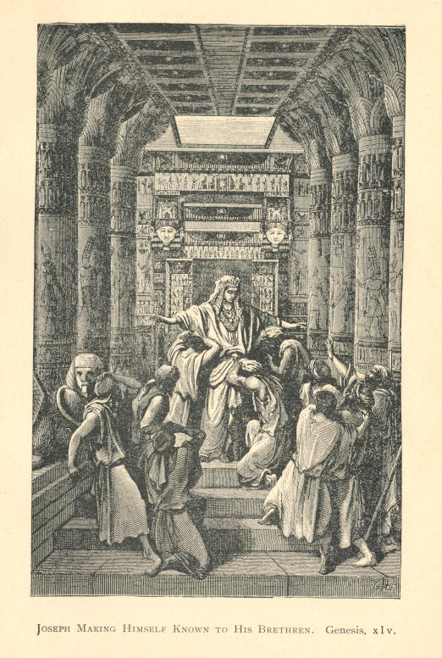
Joseph Makes Himself Known to His Brethern. Genesis, xiv.
AND ILLUSTRATIONS. 133

INFIDELITY

The Young French Nobleman and the Doctor.

In London, when I was there in 1867, I was told a story which made a very deep impression upon me. A young French nobleman came there to see a doctor, bringing letters from the French Emperor. The Emperor Napoleon III. had a great regard for this young man, and the doctor wanted to save him. He examined the young man, and saw there was something on his mind. "Have you lost any property? What is troubling you? You have something weighing upon your mind," said the doctor. "Oh, there is nothing particular." "I know better; have you lost any relations?" asked the doctor. "No, none within the last three years." "Have you lost any reputation in your country?" "No." The doctor studied for a few minutes, and then said, "I must know what is on your mind; I must know what is troubling you." And the young man said, "My father was an infidel; my grandfather was an infidel, and I was brought up an infidel, and for the last three years these words have haunted me, 'Eternity, and where shall it find me?' " "Ah," said the doctor, "you have come to the wrong physician." "Is there no hope for me?" cried the young man. "I walk about in the day time; I lie down at night, and it comes upon me continually: 'Eternity, and where shall I spend it?' Tell me, is there any hope for me?" The doctor said: "Now just sit down and be quiet. A few years ago I was an infidel. I did not believe in God, and was in the same condition in which you are in." The doctor took down his Bible and turned to the fifty-third chapter of Isaiah and read: "He was wounded for our transgressions; He was bruised for our iniquities; the chastisement of our peace was upon Him, and with His stripes we are healed." And he read on through this chapter.
134 MOODY'S ANECDOTES Infidelity.

When he had finished, the young man said: "Do you believe this, that He voluntarily left heaven, came down to this earth, and suffered and died that we might be saved?" "Yes, I believe it. That brought me out of infidelity, out of darkness into light." And he preached Christ and His salvation and told him of heaven and then suggested that they get down on their knees and pray. And when I went there in 1867 a letter had been received from that young nobleman, who wrote to Dr. Whinston in London, telling him that the question of "eternity, and where he should spend it" was settled, and troubled him no more. My friends, the question of eternity, and where we are going to spend it, forces itself upon everyone of us. We are staying here for a little day. Our life is but a fibre and it will soon be snapped. I may be preaching my last sermon. To-night may find me in eternity. By the grace of God say that you will spend it in heaven.

Sambo and the Infidel Judge.

Once there was a Judge who had a colored man. The colored man was very godly, and the Judge used to have him to drive him around in his circuit. The Judge used often to talk with him, and the colored man would tell the Judge about his religious experience, and about his battles and conflicts. One day the Judge said to him, "Sambo, how is it that you Christians are always talking about the conflicts you have with Satan. I am better off than you are. I don't have any conflicts or trouble, and yet I am an infidel and you are a Christian--always in a muss-how's that, Sambo?" This floored the colored man for a while. He didn't know how to meet the old infidel's argument. So he shook his head sorrowfully and said: "I dunno. Massa, I dunno." The Judge always carried a gun along with him for hunting. Pretty soon they came to a lot of ducks. The Judge took his gun and blazed away at them, and wounded one and killed another. The Judge said quickly, "You jump in, Sambo, and get that wounded duck before he gets off," and did not pay any attention to the dead one. In went Sambo for the wounded duck and came out reflecting. The colored man then thought he had an illustration.
Infidelity. AND ILLUSTRATIONS. 135

He said to the Judge: "I hab 'im now, Massa, I'se able to show you how de Christian hab greater conflict den de infidel. Don't you know de moment you wounded dat ar duck, how anxious you was to get 'im out, and you didn't care for de dead duck, but just lef 'im alone!" "Yes," said the Judge. "Well," said Sambo, "ye see as how dat ar dead duck's a sure thing. I'se wounded, and I tries to get away from de debbil. It takes trouble to catch me. But, massa, you are a dead duck--dar is no squabble for you. The debbil have you "sure!" So the devil has no conflict with the infidel.

An Infidel who would not Talk Infidelity before his Daughter.

Not long ago I went into a man's house, and when I commenced to talk about religion he turned to his daughter and said: "You had better go out of the room; I want to say a few words to Mr. Moody." When she had gone he opened a perfect torrent of infidelity upon me. "Why," said I, "did you send your daughter out of the room before you said this?" "Well," he replied, "did not think it would do her any good to hear what I said." My friends, his "rock is not as our rock" Why did he send his daughter out of the room if he believed what he said? When these infidels are in trouble why do not they get some of their infidel friends to administer consolation? When they make a will why do they call in some follower of the Lord Jesus Christ to carry it out? Why, it is because they cannot trust their infidel friends.

A Dying Infidel's Confession.

I want to read to you a letter which I received some time ago. I read this to you because I am getting letters from infidels who say that not an infidel has repented during our meetings. Only about ten days ago I got a letter from an infidel, who accused me of being a liar. He said there had not been an infidel converted during our meetings. My friends, go up to the young converts' meeting any Monday night, and you will see there ten or twelve every night who have accepted Christ.
136 MOODY'S ANECDOTES Infidelity.

Why, nearly every night we meet with a poor infidel who accepts Christ, But let me read this letter. We get many letters every day for prayer, and, my friends, you don't know the stories that lie behind those letters. The letter I am about to read was not received here, but while we were in Philadelphia. When I received it I put it away, intending to use it at a future day:
DEAR SIR: Allow me the privilege of addressing you with a few words. The cause of writing is indeed a serious one. I am the son of an aristocratic family of Germany--was expensively educated, and at college at Leipsic was ruined by drinking, etc.; was expelled for gambling and dishonesty. My parents were greatly grieved at my conduct, and I did not dare return home, but sailed for America. I went to St. Louis and remained there for want of money to get away. I finally obtained a situation as bookkeeper in a dry goods house; heard from home and the death of my parents. This made me more sinful than ever before. I heard one of your sermons, which made a deep impression on me. I was taken sick, and the words of your text came to me and troubled me. I have tried to find peace of God, but have not succeeded. My friends, by reasoning with me that there was no God, endeavored to comfort me. The thought of my sinfulness and approaching the grave, my blasphemy, my bad example, caused me to mourn and weep. I think God is too just to forgive me my sins. My life is drawing to a close. I have not yet received God's favor. Will you not remember me in your prayers, and beseech God to save my soul from eternal destruction? Excuse me for writing this, but it will be the last I shall write this side of the grave.

Infidel Books.

If you stop to ask yourself why you don't believe in Christ, is there really any reason? People read infidel books and wonder, why they are unbelievers, I ask why they read such books. They think they must read both sides. I say that book is a lie, how can it be one side when it is a lie? It is not one side at all.
Infidelity. AND ILLUSTRATIONS. 137

Suppose a man tells right down lies about my family, and I read them so as to hear both sides; it would not be long before some suspicion would creep into my mind. I said to a man once, "Have you got a wife?" "Yes, and a good one." I asked: "Now what if I should come to you and cast out insinuations against her?" And he said, "Well your life would not be safe long if you did." I told him just to treat the devil as he would treat a man who went around with such stories. We are not to blame for having doubts flitting through our minds, but for harboring them. Let us go out trusting the Lord with heart and soul to-day.

How a Little Study Upset the Plans of a few Prominent Infidels.

It is said of West, an eminent man, that he was going to take up the doctrine of the resurrection, and just show the world what a fraud it was, while Lord Lyttleton was going to take up the conversion of Saul, and just show the folly of it. These men were going to annihilate that doctrine and that incident of the gospel. A Frenchman said it took twelve fishermen to build up Christ's religion, but one Frenchman pulled it down. From Calvary this doctrine rolled along the stream of time, through the eighteen hundred years, down to us, and West got at it and began to look at the evidence; but instead of his being able to cope with it he found it perfectly overwhelming--the proof that Christ had risen, that He had come out of the sepulcher and ascended to heaven and led captivity captive. The light dawned upon him, and he became an expounder of the word of God and a champion of Christianity; And Lord Lyttleton, that infidel and skeptic hadn't been long at the conversion of Saul before the God of Saul broke upon his sight, and he too, began to preach.

GOLD.

-- What reason have I for doubting God's own word?
-- I just as much believe that God sent Christ into the world to be the Saviour of the world, as I believe that I exist.
138 MOODY'S ANECDOTES

INTEMPERANCE.

Cast Out But Rescued.

I met a man in New York who was an earnest worker, and I asked him to tell me his experience. He said he had been a drunkard for over twenty years. His parents had forsaken him, and his wife had cast him off and married some one else. He went into a lawyer's office in Poughkeepsie, mad with drink. This lawyer proved a good Samaritan, and reasoned with him, and told him he could be saved. The man scouted the idea. He said: "I must be pretty low when my father and mother, my wife and kindred, have cast me off, and there is no hope for me here or hereafter." But this good Samaritan showed him how it was possible to secure salvation, got him on his feet, got him on his beast, like the good Samaritan of old, and guided his face toward Zion. And this man said to me: "I have not drank a glass of liquor since." He is now leader of a young men's meeting in New York. I asked him to come last Saturday night to Northfield, my native town, where there are a good many drunkards, thinking he might encourage them to seek salvation. He came and brought a young man with him. They held a meeting, and it seemed as if the power of God rested upon that meeting when these two men went on telling what God had done for them--how He had destroyed the works of the devil in their hearts, and brought peace and unalloyed happiness to their souls. These grog shops here are the works of the devil--they are ruining men's souls every hour. Let us fight against them, and let our prayers go up in our battles. It may seem a very difficult thing for us, but it is a very easy thing for God to convert rumsellers.
Intemperance. AND ILLUSTRATIONS. 139

The Way of the Transgressor is Hard.

There was a man whom I knew who was an inveterate drinker. He had a wife and children. He thought he could stop whenever he felt inclined, but he went the ways of most moderate drinkers. I had not been gone more than three years, and when I returned I found that that mother had gone down to her grave with a broken heart, and that man was the murderer of the wife of his bosom. Those children have all been taken away from him, and he is now walking up and down those streets homeless. But four years ago he had a beautiful and a happy home with his wife and children around him. They are gone; probably he will never see them again. Perhaps he has come in here to-night. If he has, I ask him: Is not the way of the transgressor hard?

A Rum-Seller's Son Blows his Brains Out.

Look at that rum-seller. When we talk to him he laughs at us. He tells you there is no hell, no future--there is no retribution. I've got one man in my mind now who ruined nearly all the sons in his neighborhood. Mothers and fathers went to him and begged him not to sell their children liquor. He told them it was his business to sell liquor, and he was going to sell liquor to everyone who came. The saloon was a blot upon the place as dark as hell. But the man had a father's heart. He had a son. He didn't worship God, but he worshiped that boy. He didn't remember that whatsoever a man soweth so shall he reap. My friends, they generally reap what they sow. It may not come soon, but the retribution will come. If you ruin other men's sons some other man will ruin yours. Bear in mind God is a God of equity; God is a God of justice. He is not going to allow you to ruin men and then escape yourself. If we go against his laws we suffer. Time rolled on and that young man became a slave to drink, and his life became such a burden to him that he put a revolver to his head and blew his brains out. The father lived a few years, but his life was as bitter as gall, and then went down to his grave in sorrow. Ah, my friends, it is hard to kick against the pricks.
140 MOODY'S ANECDOTES Intemperance.

A Distiller Interrogates Moody.

In Europe in a place where there was a good deal of whisky distilled, one of the men in the business was a church member, and got a little anxious in his conscience about his business. He came and asked me if I thought that a man could not be an honest distiller. I said, You should do whatever you do for the glory of God. If you can get down and pray about a barrel of whisky, and say, for instance, when you sell it, "O Lord God, let this whisky be blessed to the world," it is probably honest.

The Most Hopeless Man in New York now a Sunday-School Superintendent.

A young man in one of our meetings in New York got up and thrilled the audience with his experience. "I want to tell you," he said, "that nine months ago a Christian came to my house and said he wanted me to become a Christian. He talked to me kindly and encouragingly, pointing out the error of my ways, and I become converted. I had been a hard drinker, but since that time I have not touched a drop of liquor. If anyone had asked who the most hopeless man in town was they would have pointed to me." To-day this man is the superintendent of a Sabbath-school. Eleven years ago, when I went to Boston, I had a cousin who wanted a little of my experience. I gave him all the help I could, and he became a Christian. He did not know how near death was to him: He wrote to his brother and said: "I am very anxious to get your soul to Jesus." The letter somehow went to another city, and lay from the 28th of February till the 28th of March--just one month. He saw it was in his brother's handwriting, and tore it open and read the above words. It struck a chord in his heart, and was the means of converting him. And this was the Christian who led this drunken man to Christ. This young man had a neighbor who had drank for forty years, and he went to that neighbor and told him what God had done for him, and the result was another conversion. I tell you these things to encourage you to believe that the drunkard can be saved.
Intemperance. AND ILLUSTRATIONS. 141

A Remarkable Case.

I may relate a little experience. In Philadelphia, at one of our meetings, a drunken man rose up. Till that time I had no faith that a drunken man could be converted. When any one approached he was generally taken out. This man got up and shouted, "I want to be prayed for." The friends who were with him tried to draw him away, but he shouted only louder, and for three times he repeated the request. His call was attended to and he was converted. God has power to convert a man even if he is drunk.

"O Edward."

I remember going into a young converts' meeting in Philadelphia, where I heard a story that thrilled my soul. A young man said he had been a great drunkard. He had lost one situation after another; till finally he came to the very dregs. He left Philadelphia, and went first to Washington, and then to Baltimore. One night he came back to Philadelphia. He had lost his key and could not get into his home. He was afraid to go into the house while the people were stirring, so he staid outside watching till all had retired. He knew that after that there would be at least one who would hear him and come to the door. He went to the door; he knocked; when he heard the footsteps of his mother. "O Edward," said she, "I am so glad to see you." She did not reprove him; did not rebuke him. He went up stairs and did not come down for two days. When he came to, the servants were walking about the house very softly--everything was quiet. They told him that his mother was at the point of death. His brother was a physician, and he went to him and asked him if it was so. "Yes, Ned," said he, "mother can't live." He immediately went up stairs, and asked his mother's forgiveness, and prayed to his mother's God to have mercy upon him. "And God," said he, "my mother's God, heard my prayers," and the tears trickled down his face and he said: "God has kept me straight these four years in the face of all trials." O sinner, ask for His grace and might; do not turn Him away.
142 MOODY'S ANECDOTES Intemperance.

Moody Asks a Few Questions.

Let me ask you a question. Do you think that those gamblers, thieves, harlots, and drunkards who are trampling the ten commandments under their feet, they who have never given any respect to God's Word or to His instructions--do you think they will be swept into the kingdom of heaven, against their will? Do you think those antedeluvians who were so sinful that God could not let them live on the earth would be swept into Paradise and Noah left to wade through the deluge? Do you think that these people, too corrupt for earth, would go there? As I have said before, an unregenerated man in heaven would make a hell of it. An unregenerated man couldn't stay there. Why, some of you cannot wait an hour here to listen to the Word of God. Before the hour expires you want to go out. Some of you just wish it was over so that you could go and get a drink in some of those saloons. I tell you, from the very depths of my heart, I believe heaven would be a hell to an unregenerated man. "I don't want to be here," he would say. My friends, heaven is a prepared place for prepared people, and no one will ever see the kingdom of God without being born of God.

The Drunken Father and his Praying Child.

I remember when out in Kansas, while holding a meeting, I saw a little boy who came up to the window crying. I went to him and said: "My little boy, what is your trouble?" "Why, Mr. Moody, my mother's dead, and my father drinks, and they don't love me, and the Lord won't have anything to do with me because I am a poor drunkard's boy." "You have got a wrong idea, my boy, Jesus will love you and save you and your father too," and I told him a story of a little boy in an Eastern city. The boy said his father would never allow the canting hypocrites of Christians to come into his house, and would never allow his child to go to Sunday-school. A kind-hearted man got his little boy and brought him to Christ. When Christ gets into a man's heart he cannot help but pray. This father had been drinking one day and coming home he heard that boy praying. He went to him and said: "I don't want you to pray any more. You've been along with some of those Christians. If I catch you praying again I'll flog you."
Intemperance. AND ILLUSTRATIONS. 143

But the boy was filled with God and he couldn't help praying. The door of communication was opened between him and Christ, and his father caught him praying again. He went to him. "Didn't I tell you never to pray again? If I catch you at it once more you leave my house." He thought he would stop him. One day the old tempter came upon the boy, and he did something wrong and got flogged. When he got over his mad fit he forgot the threats of his father and went to pray. His father had been drinking more than usual, and coming in found the boy offering a prayer. He caught the boy with a push and said, "Didn't I tell you never to pray again? Leave this house. Get your things packed up and go." The little fellow hadn't many things to get together--a drunkard's boy never has, and went up to his mothers room. "Good-by, mother." "Where are you going?" "I don't know where I'll go, but father says I cannot stay here any longer; I've been praying again," he said. The mother knew it wouldn't do to try to keep the boy when her husband had ordered him away, so she drew him to her bosom and kissed him, and bid him good-by. He went to his brothers and sisters and kissed them good-by. When he came to the door his father was there and the little fellow reached out his hand--"Good-by, father; as long as I live I will pray for you," and left the house. He hadn't been gone many minutes when the father rushed after him. "My boy, if that is religion, if it can drive you away from father and mother and home; I want it." Yes, may be some little boy here to-night has got a drinking father and mother. Lift your voice to heaven, and the news will be carried up to heaven, "He prays."

GOLD.

-- The drunkard, the open blasphemer, the worst sinners, are precisely the ones that need Jesus most. The well don't need Him at all.
-- There is many a gem in these billiard halls that only needs the way pointed out to fill their souls with the love of Christ.
144 MOODY'S ANECDOTES

LIBERTY.

Old Samba and "Massa."

A friend of mine said he was down in Natchez before the war, and he and a friend of his went out riding one Saturday--they were teaching school through the week--and they drove out back from Natchez. It was a beautiful day, and they saw an old slave coming up, and they thought they would have a little fun. They had just come to a place where there was a fork in the road, and there was a sign-post which read, "40 miles to Liberty." One of the young men said to the old darkey driver, "Samba, how old are you?" "I don't know, massa. I guess I'se about eighty." "Can you read?" "No, sah; we don't read in dis country. It's agin the law." "Can you tell what is on that sign-post?" "Yes, sah; it says 40 miles to Liberty." "Well, now," said my friend, "why don't you follow that road and get your liberty. It says there, 'only 40 miles to Liberty.' Now, why don't you take that road and go there?" The old man's countenance changed, and he said, "Oh, young massa, that is all a sham. If the post pointed out the road to the liberty that God gives, we might try it. There could be no sham in that." My friend said he had never heard anything more eloquent from the lips of a preacher. God wants all his sons to have liberty.

"Liberty Now and Forever."

When Miss Smiley went down South to teach, she went to a hotel and found everything covered with dirt. The tables were dirty, dishes dirty, beds were dirty. So she called an old colored woman who was in the house, and said, "Now you know that the Northern people set you at liberty. I came from the North and I don't like dirt, so I want you to clean the house." The old colored woman set to work, and it seemed as if she did more work in that half day than she had done in a month before.
Liberty. AND ILLUSTRATIONS. 145

When the lady got back the colored woman came to her and said, "Now, is I free or ben't I not? When I go to my old massa he says I ain't free, and when I go to my own people they say I is, and I don't know whether I'm free or not. Some people told me Abraham Lincoln signed a proclamation, but massa says he didn't; he hadn't any right to." So Christian people go along, not knowing whether they are free or not. Why, when they have the Spirit they are as free as air. Christ came for that. He didn't come to set us free and then leave us in servitude. He came to give us liberty now and forever.

Out of Libby Prison.

There was a story told me while I was in Philadelphia, by Capt. Trumbull. He said when he was in Libby prison the news came that his wife was in Washington, and his little child was dying: and the next news that came was that his child was dead, and the mother remained in Washington in hopes that her husband could come with her and take that child off to New England and bury it; but that was the last he heard. One day the news came into the prison that there was a boat up from City Point, and there were over nine hundred men in the prison rejoicing at once. They expected to get good news. Then came the news that there was only one man in that whole number that was to be let go, and they all began to say, "Who is it?" It was some one who had some influential friend at Washington that had persuaded the government to take an interest in him and get him out. The whole prison was excited. At last an officer came and shouted at the top of his voice, "Henry Clay Trumbull!" The chaplain told me his name never sounded so sweet to him as it did that day. That was election, but you can't find any Henry Clay Trumbull in the Bible. There is no special case in the Bible. God's proclamations are to all sinners. Everybody can get out of prison that wants to. The trouble is, they don't want to go. They had rather be captives to some darling sin.

10
146 MOODY'S ANECDOTES Liberty.

An Emperor Sets Forty Million Slaves Free.

Once the Emperor of Russia had a plan by which he was to liberate the serfs of that country. There were forty millions of them. Of some of them, their whole time was sold, of others, only a part. The Emperor called around him his council, and wanted to have them devise some way to set the slaves at liberty. After they had conferred about it for six months, one night the council sent in their decision, sealed, that they thought it was not expedient. The Emperor went down to the Greek Church that night and partook of the Lord's Supper, and he set his house in order, and the next morning you could hear the tramp of soldiers in the streets of St. Petersburgh. The Emperor summoned his guard, and before noon sixty-five thousand men were surrounding that palace. Just at midnight there came out a proclamation that every slave in Russia was forever set free. The proclamation had gone forth, and all the slaves of the realm believed it. They have been free ever since. Suppose they had not believed it? They never then would have got the benefit of it. If one man can liberate forty millions, has not God got the power to liberate every captive?

Moody on "Duty"--How He Loves His Mother.

I have an old mother away down in the Connecticut mountains, and I have been in the habit of going to see her every year for twenty years. Suppose I go there and say, "Mother, you were very kind to me when I was young--you were very good to me; when father died you worked hard for us all to keep us together, and so I have come to see you because it is my duty." I went then only because it was my duty. Then she would say to me, "Well, my son, if you only come to see me because it is your duty, you need not come again." And that is the way with a great many of the servants of God. They work for Him because it is their duty--not for love. Let us abolish this word duty, and feel that it is only a privilege to work for God, and let us try to remember that what is done merely from a sense of duty is not acceptable to God.
Liberty. AND ILLUSTRATIONS. 147

Moody with Gen. Grant's Army in Richmond.

It was my privilege to go to Richmond with Gen. Grant's army. Now just let us picture a scene. There are a thousand poor captives, and they are lawful captives, prisoners in Libby Prison. Talk to some of them that have been there for months and hear them tell their story. I have wept for hours to hear them tell how they suffered, how they could not hear from their homes and their loved ones for long intervals, and how sometimes they would get messages that their loved ones were dying and they could not get home to be with them in their dying hours. Let us, for illustration, picture a scene. One beautiful day in the Spring they are there in the prison. All news has been kept from them. They have not heard what has been going on around Richmond, and I can imagine one says one day, "Ah, boys, listen! I hear a band of music, and it sounds as if they were playing the old battle cry of the Republic. It sounds as if they were playing "The star spangled banner! long may it wave o'er the land of the free and the home of the brave!" And the hearts of the poor fellows begin to leap for joy. "I believe Richmond is taken. I believe they are coming to deliver us," and every man in that prison, is full of joy, and by and by the sound comes nearer and they see it is so. It is the Union army! Next the doors of the prison are unlocked; they fly wide open, and those thousand men are set free. Wasn't that good news to them? Could there have been any better news? They are out of prison, out of bondage, delivered. Christ came to proclaim liberty to the captive.

Condemned to be Shot.

There was a man came from Europe to this country a year or two ago, and he became dissatisfied and went to Cuba in 1867 when they had that great civil war there. Finally he was arrested for a spy, court-martialed, and condemned to be shot. He sent for the American Consul and the English Consul, and went on to prove to them that he was no spy. These two men were thoroughly convinced that the man was no spy, and they went to one of the Spanish officers and said, "This man you have condemned to be shot is an innocent man."
148 MOODY'S ANECDOTES. Liberty.

"Well," the Spanish officer says, "the man has been legally tried by our laws and condemned, and the law must take its course and the man must die." And the next morning the man was led out; the grave was already dug for him, and the black cap was put on him, and the soldiers were there ready to receive the order, "Fire," and in a few moments the man would be shot and put in that grave and covered up, when who should rise up but the American Consul, who took the American flag and wrapped it around him, and the English Consul took the English flag and wrapped it around him; and they said to those soldiers, "Fire on those flags if you dare!" Not a man dared; there were two great governments behind those flags. And so God says, "Come under my banner, come under the banner of love, come under the banner of heaven." God will take care of all that will come under His banner.

Snapping the Chains.

In the North there was a minister talking to a man in the inquiry-room. The man says, "My heart is so hard, it seems as if it was chained, and I cannot come." "Ah," says the minister, "come along, chain and all," and he just came to Christ hard-hearted, chain and all, and Christ snapped the fetters, and set him free right there. So come along. If you are bound hand and foot by Satan, it is the work of God to break the fetters; you cannot break them.

Napoleon and the Conscript.

There is a well-known story told of Napoleon the First's time. In one of the conscriptions, during one of his many wars, a man was balloted as a conscript who did not want to go, but he had a friend who offered to go in his place. His friend joined the regiment in his name, and was sent off to the war. By and by a battle came on, in which he was killed, and they buried him on the battle-field. Some time after the Emperor wanted more men, and by some mistake the first man was balloted a second time.
Liberty. AND ILLUSTRATIONS. 149

They went to take him but he remonstrated. You cannot take me." "Why not?" "I am dead," was the reply. "You are not dead; you are alive and well." "But I am dead," he said "Why, man, you must be mad. Where did you die?" "At such a battle, and you left me buried on such a battlefield." "You talk like a mad man," they cried; but the man stuck to his point that he had been dead and buried some months. "You look up your books," he said, "and see if it is not so." They looked, and found that he was right. They found the man's name entered as drafted, sent to the war, and marked off as killed. "Look here," they said, "you didn't die; you must have got some one to go for you; it must have been your substitute." "I know that," he said; "he died in my stead. You cannot touch me: I died in that man, and I go free. The law has no claim against me." They would not recognize the doctrine of substitution, and the case was carried to the Emperor. But he said that the man was right, that he was dead and buried in the eyes of the law, and that France had no claim against him. This story may or may not be true but one thing I know is true; Jesus Christ suffered death for the sinner, and those who accept Him are free from the law.

The King's Pardon.

A man was once being tried for a crime, the punishment of which was death. The witnesses came in one by one and testified to his guilt; but there he stood, quite calm and unmoved. The judge and the jury were quite surprised at his indifference; they could not understand how he could take such a serious matter so calmly. When the jury retired, it did not take them many minutes to decide on a verdict "Guilty;" and when the judge was passing the sentence of death upon the criminal he told him how surprised he was that he could be so unmoved in the prospect of death. When the judge had finished, the man put his hand in his bosom, pulled out a document, and walked out of the dock a free man. Ah, that was how he could be so calm; it was a free pardon from his king, which he had in his pocket all the time. The king had instructed him to allow the trial to proceed, and to produce the pardon only when he was condemned. No wonder, then, that he was indifferent as to the result of the trial. Now that is just what will make us joyful in the great day of judgment: we have got a pardon from the Great King, and it is sealed with the blood of His Son.
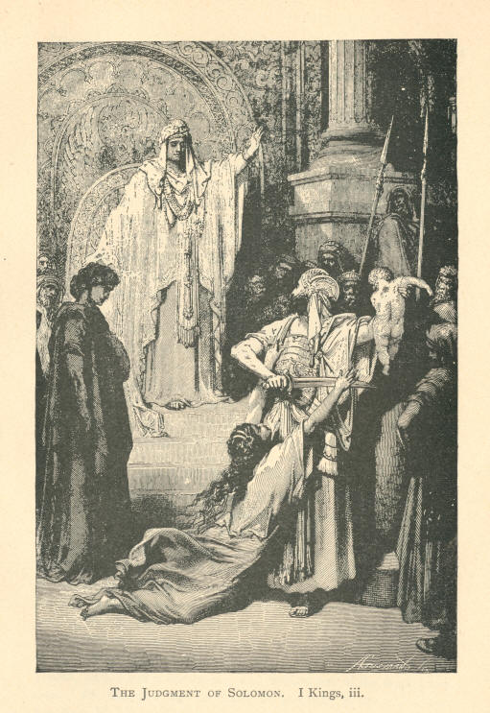
The Judgement of Solomon. 1 Kings, iii.
150 MOODY'S ANECDOTES Liberty.

GOLD.

-- If you believe on the Lord Jesus Christ you are free.
-- There is no sin in the whole catalogue of sins you can name but Christ will deliver you from it perfectly.
-- We are led on by an unseen power that we have not got strength to resist, or else we are led on by the loving Son of God.
-- The trouble is, people do not know that Christ is a Deliverer. They forget that the Son of God came to keep them from sin as well as to forgive it.
-- You say "I am afraid I cannot hold out." Well, Christ will hold out for you. There is no mountain that He will not climb with you if you will; He will deliver you from your besetting sin.
-- Satan rules all men that are in his kingdom. Some he rules through lust. Some he rules through covetousness. Some he rules through appetite. Some he rules by their temper, but he rules them. And none will ever seek to be delivered until they get their eyes open and see that they have been taken captive.
-- When Christ was on the earth there was a woman in the temple who was bowed almost to the ground with sin. Satan had bound her for eighteen years; but after all these years of bondage Christ delivered her. He spoke one word and she was free. She got up and walked home. How astonished those at home must have been to see her walking in.

AND ILLUSTRATIONS. 151

LITTLE FOLKS.

The Little Child and the Big Book.

I like to think of Christ as a burden bearer. A minister was one day moving his library up stairs. As the minister was going up stairs with his load of books his little boy came in and was very anxious to help his father. So his father just told him to go and get an armful and take them up stairs. When the father came back he met the little fellow about half way up the stairs tugging away with the biggest in the library. He couldn't manage to carry it up. The book was too big. So he sat down and cried. His father found him, and just took him in his arms, book and all, and carried him up stairs. So Christ will carry you and all your burdens.

The Horse that was Established.

There was a little boy converted and he was full of praise. When God converts boy or man his heart is full of joy--can't help praising. His father was a professed Christian. The boy wondered why he didn't talk about Christ, and didn't go down to the special meetings. One day, as the father was reading the papers, the boy came to him and put his hand on his shoulder and said: "Why don't you praise God? Why don't you sing about Christ? Why don't you go down to these meetings that are being held?" The father opened his eyes, and looked at him and said, gruffly: "I am not carried away with any of these doctrines. I am established." A few days after they were getting out a load of wood. They put it on the cart. The father and the boy got on lop of the load, and tried to get the horse to go. They used the whip, but the horse wouldn't move. They got off and tried to roll the wagon along, but they could move neither the wagon nor the horse. "I wonder what's the matter?" said the father. "He's established," replied the boy. You may laugh at that, but this is the way with good many Christians.
152 MOODY'S ANECDOTES. Little Folks.

The Scotch Lassie and Dr. Chalmers.

There is a story of Dr. Chalmers. A lady came to him and said: "Doctor, I cannot bring my child to Christ. I've talked, and talked, but it's of no use." The Doctor thought she had not much skill, and said, "Now you be quiet and I will talk to her alone." When the Doctor got the Scotch lassie alone he said to her, "They are bothering you a good deal about this question; now suppose I just tell your mother you don't want to be talked to any more upon this subject for a year. How will that do?" Well, the Scotch lassie hesitated a little, and then said she "didn't think it would be safe to wait for a year. Something might turn up. She might die before then." "Well, that's so," replied the doctor, "but suppose we say six months." She didn't think even this would be safe. "That's so," was the doctors reply; "well, let us say three months." After a little hesitation, the girl finally said, "I don't think it would be safe to put it off for three months--don't think it would be safe to put it off at all," and they went down on their knees and found Christ.

Johnny, Cling Close to the Rock

Little Johnny and his sister were one day going through a long, narrow railroad tunnel. The railroad company had built small clefts here and there through the tunnel, so that if any one got caught in the tunnel when the train was passing, they could save themselves. After this little boy and girl had gone some distance in the tunnel they heard a train coming. They were frightened at first, but the sister just put her little brother in one cleft and she hurried and hid in another. The train came thundering along, and as it passed, the sister cried out: "Johnny, cling close to the rock! Johnny, cling close to the rock!" and they were safe. The "Rock of Ages" may be beaten by the storms and waves of adversity, but "cling close to the rock, Christians, and all will be well." The waves don't touch the Christian; he is sheltered by the Rock "that is higher than I," by the One who is the strong arm, and the Saviour who is mighty and willing to save.
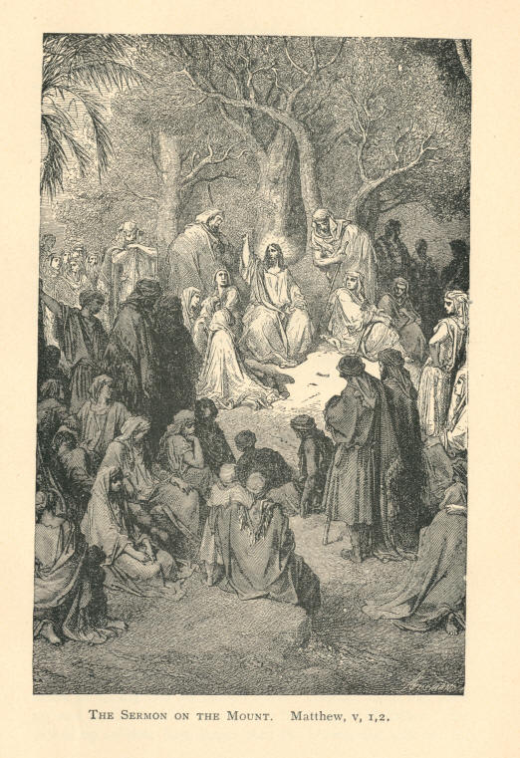
The Sermon on the Mount. Matthew, v.
Little Folks. AND ILLUSTRATIONS. 153

Obedience.

Suppose I say to my boy, "Willie, I want you to go out and bring me a glass of water." He says he doesn't want to go. "I didn't ask you whether you wanted to go or not, Willie; I told you to go." "But I don't want to go," he says. "I tell you, you must go and get me a glass of water." He does not like to go. But he knows I am very fond of grapes, and he is very fond of them himself, so he goes out, and some one gives him a beautiful cluster of grapes. He comes in and says, "Here, papa, here is beautiful cluster of grapes for you." "But what about the water?" "Won't the grapes be acceptable, papa?" "No, my boy, the grapes are not acceptable; I won't take them; I want you to get me a glass or water." The little fellow doesn't want to get the water, but he goes out, and this time some one gives him an orange. He brings it in and places it before me. "Is that acceptable?" he asks. "No, no, no!" I say; "I want nothing but water; you cannot do anything to please me until you get the water." And so, my friends, to please God you must first obey Him.

Jumping into Father's Arms.

I remember, while in Mobile attending meetings, a little incident occurred which I will relate. It was a beautiful evening, and just before the meeting some neighbors and myself were sitting on the front piazza enjoying the evening. One of the neighbors put one of his children upon a ledge eight feet high, and put out his hands and told him to jump. Without the slightest hesitation he sprang into his father's arms. Another child was lifted up, and he, too, readily sprang into the arms of his father. He picked up another boy, larger than the others, and held out his arms, but he wouldn't jump.
154 MOODY'S ANECDOTES. Little Folks.

He cried and screamed to be taken down. The man begged the boy to jump, but it was of no use; he couldn't be induced to jump. The incident made me curious, and I stepped up to him and asked, "How was it that those two little fellows jumped so readily into your arms and the other boy wouldn't?" "Why," said the man, "those two boys are my children and the other boy isn't, he don't know me."

How Three Sunday School Children Met Their Fate.

When the Lawrence Mills were on fire a number or years ago--I don't mean on fire, but when the mill fell in--the great mill fell in, and after it had fallen in, the ruins caught fire. There was only one room left entire, and in it were three Mission Sunday-school children imprisoned. The neighbors and all hands got their shovels and picks and crowbars, and were working to set the children free. It came on night and they had not yet reached the children. When they were near them, by some mischance a lantern broke, and the ruins caught fire. They tried to put it out, but could not succeed. They could talk with the children, and even pass to them some coffee and some refreshments, and encourage them to keep up. But, alas, the flames drew nearer and nearer to this prison. Superhuman were the efforts made to rescue the children; the men bravely fought back the flames; but the fire gained fresh strength and returned to claim its victims. Then piercing shrieks arose when the spectators saw that the efforts of the firemen were hopeless. The children saw their fate. They then knelt down and commenced to sing the little hymn we have all been taught in our Sunday-school days, Oh! how sweet--: "Let others seek a home below which flames devour and waves overflow." The flames had now reached them; the stifling smoke began to pour into their little room, and they began to sink, one by one, upon the floor. A few moments more and the fire circled around them and their souls were taken into the bosom of Christ. Yes, let others seek a home below if they will, but seek ye the Kingdom of God with all your hearts.

AND ILLUSTRATIONS. 155

PARENTAL.

A Father's Love Trampled Under Foot.

I once heard of a father who had a prodigal boy, and the boy had sent his mother down to the grave with a broken heart, and one evening the boy started out as usual to spend the night in drinking and gambling, and his old father, as he was leaving, said: "My son, I want to ask a favor of you to-night. You have not spent an evening with me since your mother died. Now won't you gratify your old father by staying at home with him?" "No," said the young man, "it is lonely here, and there is nothing to interest me, and I am going out." And the old man prayed and wept, and at last said: "My boy, you are just killing me as you have killed your mother. These hairs are growing white, and you are sending me, too, to the grave." Still the boy would not stay, and the old man said: "If you are determined to go to ruin, you must go over this old body to-night. I can not resist you. You are stronger than I, but if you go out you must go over this body." And he laid himself down before the door, and that son walked over the form of his father, trampled the love of his father under foot, and went out.

"That is the Price of My Soul"

I heard a story of a young lady who was deeply concerned about her soul. Her father and mother, however, were worldly people. They thought lightly of her serious wishes; they did not sympathize with her state of mind. They made up their minds that she should not become a Christian, and tried every way they could to discourage her notions about religion. At last they thought they would get up a large party--thus with gayety and pleasure win her back to the world.
156 MOODY'S ANECDOTES Parental

So they made every preparation for a gay time; they even sent to neighboring towns and got all her most worldly companions to come to the house; they bought her a magnificent silk dress and jewelry, and decked her out in all the finery of such an occasion. The young lady thought there would be no harm in attending the party; that it would be a trifling affair, a simple thing, and she could, after it was over, think again of the welfare of her soul. She went decked out in all her adornments, and was the belle of the ball Three weeks from that night she was on her dying bed. She asked her mother to bring her ball dress in. She pointed her finger at it, and, bursting into tears, said, "That is the price of my soul." She died before dawn. Oh, my friends, if you are anxious about your soul, let everything else go; let parties and festivals pass.

The Two Fathers.

Whenever I think about this subject, two fathers come before me. One lived on the Mississippi river. He was a man of great wealth. Yet he would have freely given it all could he have brought back his eldest boy from his early grave. One day that boy had been borne home unconscious. They did everything that man could do to restore him, but in vain. "He must die," said the doctor. "But, doctor," said the agonized father, "can you do nothing to bring him to consciousness, even for a moment?" "That may be," said the doctor; "'but he can never live." Time passed, and after a terrible suspense, the fathers wish was gratified. "My son," he whispered, "the doctor tells me you are dying." "Well," said the boy, "you never prayed for me, father; won't you pray for my lost soul now?" The father wept. It was true he had never prayed. He was a stranger to God. And in a little while that soul, unprayed for, passed into its dark eternity. Oh, father! if your boy was dying, and he called on you to pray, could you lift your burdened heart to heaven? Have you learned this sweetest lesson of heaven on earth, to know and hold communion with your God? And before this evil world has marked your dearest treasures for its prey, have you learned to lead your little ones to a children's Christ?
Parental. AND ILLUSTRATIONS. 157

What a contrast is the other father? He, too, had a lovely boy, and one day he came home to find him at the gates of death. "A great change has come over our boy," said the weeping mother; "he has only been a little ill before, but it seems now as if he were dying fast." The father went into the room, and placed his hand on the forehead of the little boy. He could see the boy was dying. He could feel the cold damp of death. "My son, do you know you are dying?" "No, am I?" "Yes; you are dying." "And shall I die to-day?" "Yes, my boy, you cannot live till night." "Well, then, I shall be with Jesus to-night, won't I, father?" "Yes, my son, you will spend to-night with the Saviour." Mothers and fathers, the little ones may begin early; be in earnest with them now. You know not how soon you may be taken from them, or they may be taken from you. Therefore let this impression be made upon their minds--that you care for their souls--a million times more than for their worldly prospects.

The Stolen Boy--A Mother's Love.

There was a boy a great many years ago, stolen in London, the same as Charley Ross was stolen here. Long months and years passed away, and the mother had prayed and prayed, as the mother of Charley Ross prayed, I suppose, and all her efforts had failed and they had given up all hope; but the mother did not quite give up her hope. One day a little boy was sent up to the neighboring house to sweep the chimney, and by some mistake he got down again through the wrong chimney. When he came down, he came in by the sitting-room chimney. His memory began at once to travel back through the years that had passed. He thought that things looked strangely familiar. The scenes of the early days of youth were dawning upon him; and as he stood there surveying the place, his mother came into the room. He stood there covered with rags and soot. Did she wait until she sent him to be washed before she rushed and took him in her arms? No, indeed; it was her own boy. She took him to her arms all black and smoke, and hugged him to her bosom, and shed tears of joy upon his head.
158 MOODY'S ANECDOTES. Parental.

The Repentant Father.

Not long ago a young man went home late. He had been in the habit of going home late, and the father began to mistrust that he had gone astray. He told his wife to go to bed, and dismissed the servants, and said he would sit up till his son came home. The boy came home drunk, and the father in his anger gave him a push into the street and told him never to enter his house again, and shut the door. He went into the parlor and sat down, and began to think: "Well, I may be to blame for that boy's conduct, after all. I have never prayed with him. I have never warned him of the dangers of the world." And the result of his reflections was that he put on his overcoat and hat, and started out to find his boy. The first policeman he met he asked eagerly, "Have you seen my boy?" "No." On he went till he met another. "Have you seen anything of my son?" He ran from one to another all that night, but not until the morning did he find him. He took him by the arm and led him home, and kept him till he was sober. Then he said: "My dear boy, I want you to forgive me; I've never prayed for you; I've never lifted up my heart to God for you; I've been the means of leading you astray, and I want your forgiveness." The boy was touched, and what was the result? Within twenty-four hours that son became a convert, and gave up that cup. It may be that some father here has a wayward son. Go to God, and on your knees confess it. Let the voice of Jesus sink down in your heart; "Bring him unto Me."

The Sleep of Death.

I read some time ago of a vessel that had been off on a whaling voyage and had been gone about three years. I saw the account in print somewhere lately, but it happened a long time ago. The father of one of those sailors had charge of the lighthouse, and he was expecting his boy to come home. It was time for the whaling vessel to return. One night there came up a terrible gale, and this father fell asleep, and while he slept his light went out. When he awoke he looked toward the shore and saw there had been a vessel wrecked.
Parental. AND ILLUSTRATIONS. 159

He at once went to see if he could not yet save some one who might be still alive. The first body that came floating toward the shore was, to his great grief and surprise, the body of his own boy! He had been watching for that boy for many days, and he had been gone for three years. Now the boy had at last come in sight of home and had perished because his father had let his light go out! I thought, what an illustration of fathers and mothers to-day that have let their lights go out! You are not training your children for God and eternity. You do not live as though there were anything beyond this life at all. You keep your affections set upon things on the earth instead of on things above, and the result is that the children do not believe there is anything in it. Perhaps the very next step they take may take them into eternity: the next day they may die without God and without hope.

A Defaulter's Confession.

One week ago I preached on the text, "Christ came to heal the broken-hearted." I told you just before I came down that I had received a letter from a broken-hearted wife. Her husband one night came in, to her surprise, and said he was a defaulter and must flee, and he went, she knew not where. He forsook her and two children. It was a pitiful letter, and the wail of that poor woman seems to ring in my ears yet. That night up in that gallery was a man whose heart began to beat when I told the story, thinking it was him I meant, till I came to the two children. When I got through I found that he had taken money which did not belong to him, intending to replace it, but he failed to do so, and fled. He said: "I have a beautiful wife and three children, but I had to leave her and come to Chicago, where I have been hiding. The Governor of the State has offered a reward for me." My friends, a week ago this poor fellow found out the truth of this text. He was in great agony. He felt as if he could not carry the burden, and he said, "Mr. Moody, I want you to pray with me. Ask God for mercy for me." And down we went on our knees. I don't know as I ever felt so bad for a man in my life.
160 MOODY'S ANECDOTES. Parental.

He asked me if I thought he should go back. I told him to ask the Lord, and we prayed over it. That was Sunday evening, and I asked him to meet me on the Monday evening. He told how hard it was to go back to that town and give himself up and disgrace his wife and children. They would give him ten years. Monday came and he met me and said, "Mr. Moody, I have prayed over this matter, and I think that Christ has forgiven me, but I don't belong to myself. I must go back and give myself up. I expect to be sent to the penitentiary; but I must go." He asked me to pray for his wife and children, and he went off. He will be there to-day in the hands of justice. My friends, don't say the way of the transgressor is not hard.

Divided We Fall.

I remember one mother who heard that her boy was impressed at our meeting. She said her son was a good enough boy, and he didn't need to be converted. I pleaded with that mother, but all my pleading was of no account. I tried my influence, with the boy; but while I was pulling one way she was pulling the other, and of course her influence prevailed. Naturally it would. Well, to make a long story short, some time after I happened to be in the County Jail, and I saw him there. "How did you come here?" I asked; "does your mother know where you are?" "No, don't tell her; I came in under an assumed name, and I am going to Joliet for four years. Do not let my mother know of this," he pleaded; "she thinks I am in the army." I used to call on that mother, but I had promised her boy I would not tell her, and for four years she mourned over that boy, She thought he had died on the battlefield or in a Southern hospital. What a blessing he might have been to that mother, if she had only helped us to bring him to Christ. But that mother is only a specimen of hundreds and thousands of parents. If we would have more family altars in our homes, and train them to follow Christ, the Son of God would lead them into "green pastures," and instead of having sons who curse the mothers who gave them birth, they would bless their fathers and mothers.
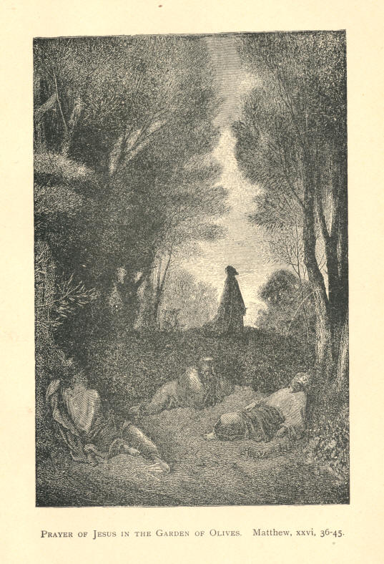
Prayer of Jesus in the Garden of Olives. Matthew, xxvi, 36-45
Parental. AND ILLUSTRATIONS. 161

The Faithful London Lady.

When I was in London, there was one lady dressed in black up in the gallery. All the rest were ministers. I wondered who that lady could be. At the close of the meeting I stepped up to her, and she asked me if I did not remember her. I did not, but she told me who she was, and her story came to my mind. When we were preaching in Dundee, Scotland, a mother came up with her two sons, 16 and 17 years old. She said to me, "Will you talk to my boys?" I asked her if she would talk to the inquirers, as there were more inquirers than workers. She said she was not a good enough Christian--was not prepared enough. I told her I could not talk to her then. Next night she came to me and asked me again, and the following night she repeated her request. Five hundred miles she journeyed to get God's blessing for her boys, Would to God we had more mothers like her. She came to London, and the first night I was there I saw her in the Agricultural Hall. She was accompanied by only one of her boys--the other had died. Toward the close of the meeting I received this letter from her:
"DEAR MR. MOODY: For months I have never considered the day's work ended unless you and your work had been specially prayed for. Now it appears before us more and more. What in our little measure we have found has no doubt been the happy experience of many others in London. My husband and I have sought as our greatest privilege to take unconverted friends one by one to the Agricultural hall, and I thank God that, with a single exception, those brought under the preaching from your lips have accepted Christ as their Savior, and are rejoicing in his love."
That lady was a lady of wealth and position. She lived a little way out of London; gave up her beautiful home and took lodgings near Agricultural Hall, so as to be useful in the inquiry room. When we went down to the Opera House she was there; when we went down to the east end, there she was again, and when I left London she had the names of 150 who had accepted Christ from her. Some have said that our work in London was a failure. Ask her if the work was a failure, and she will tell you. If we had a thousand such mothers in Chicago we would lift it. Go and bring your friends here to the meetings. Think of the privilege, my friends, of saving a soul. If we are going to work for good, we must be up and about it.

11
162 MOODY'S ANECDOTES. Parental.

Arthur P. Oxley! Your Mother Wishes to See You.

There was a lady that came down to Liverpool to see us privately; it was just before we were about to leave that city to go to London to preach. With tears and sobs she told a very pitiful story. It was this: She said she had a boy nineteen years of age who had left her. She showed me his photograph, and asked me to put it in my pocket. "You stand before many and large assemblies, Mr. Moody. My boy may be in London, now. Oh, look at the audience to whom you will preach; look earnestly. You may see my dear boy before you. If you see him, tell him to come back to me. Oh, implore him to come to his sorrowing mother, to his deserted home. He may be in trouble; he may be suffering; tell him for his loving mother that all is forgiven and forgotten, and he will find comfort and peace at home." On the back of this photograph she had written his full name and address; she had noted his complexion, the color of his eyes and hair; why he had left home, and the cause of his so doing. "When you preach, Mr. Moody, look for my poor boy," were the parting words of that mother. That young man may be in this hall to-night. If he is, I want to tell him that his mother loves him still. I will read out his name, and if any of you ever hear of that young man, just tell him that his mother is waiting with a loving heart and a tender embrace for him. His name is Arthur P. Oxley, of Manchester, England.

The Cruel Mother--Hypothetical.

Suppose a mother should come in here with a little child, and after she has been here a while the child begins to cry, and she says, "Keep still," but the child keeps on crying, and so she turns him over to the police and says, "Take that child, I don't want him."
Parental. AND ILLUSTRATIONS. 163

What would you say of such a mother as that? Teach a child that God loves him only so long as he is good, and that when he is bad the Lord does not love him, and you will find that when he grows up, if he has a bad temper he will have the idea that God hates him because he thinks God don't love him when he has got a bad temper, and as he has a bad temper all the time, of course God does not love him at all, but hates him all the time. Now God hates sin, but He loves the sinner, and there is a great difference between the love of God and our love.

The Loving Father.

I remember my little girl had a habit of getting up in the morning very cross. I don't know whether your children are like that. She used to get up in the morning speaking cross, and made the family very uncomfortable. So I took her aside one morning and said to her, "Emma, if you go on that way I shall have to correct you; I don't want to do it, but I will have to." She looked at me for a few moments--I had never spoken to her that way before--and she went away. She behaved herself for a few weeks all right, but one morning she was as cross as ever, and when she came to me to be kissed before going to school, I wouldn't do it. Off she went to her mother, and said: "Mamma, Papa refused to kiss me: I cannot go to school because he won't kiss me." Her mother came in, but she didn't say much. She knew the child had been doing wrong. The little one went off and as she was going down stairs I heard her weeping, and it seemed to me as if that child was dearer to me than ever she had been before. I went to the window and saw her going down the street crying, and as I looked on her I couldn't repress my tears. That seemed to be the longest day I ever spent in Chicago. Before the closing of the school I was at home, and when she came in her first words were: "Papa, won't you forgive me?" and I kissed her and she went away singing. It was because I loved her that I punished her. My friends, don't let Satan make you believe when you have any trouble, that God does not love you.
164 MOODY'S ANECDOTES.

PRAISE.

"Three Cheers."

Once, when a great fire broke out at midnight and people thought that all the inmates had been taken out, way up there in the fifth story, was seen a little child, crying for help. Up, went a ladder, and soon a fireman was seen ascending to the spot. As he neared the second story the flames burst in fury from the windows, and the multitude almost despaired of the rescue of the child. The brave man faltered, and a comrade at the bottom cried out, "Cheer him!" and cheer upon cheer arose from the crowd. Up the ladder he went and saved the child, because they cheered him. If you cannot go into the heat of the battle yourself, if you cannot go into the harvest field and work day after day, you can cheer those that are working for the Master. I see many old people in their old days, get crusty and sour, and they discourage everyone they meet by their fault finding. That is not what we want. If we make a mistake, come and tell us of it, and we will thank you. You don't know how much you may do by just speaking kindly to those that are willing to work.

Always Happy.

There was a man converted here some years ago, and he was just full of praise. He was living in the light all the time. We might be in the darkness, but he was always in the light. He used to preface everything he said in the meeting with "praise God." One night he came to the meeting with his finger all bound up. He had cut it, and cut it pretty bad, too. Well, I wondered how he would praise God for this; but he got up and said, "I have cut my finger, but, praise God, I didn't cut it off." And so, if things go against you, just think they might be a good deal worse.
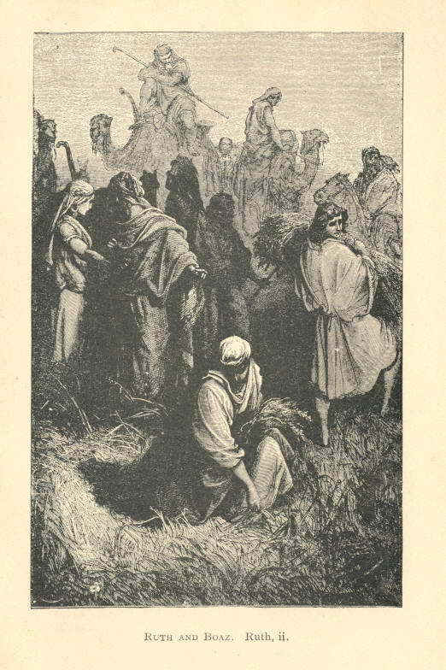
Ruth and Boaz. Ruth, ii.
Praise. AND ILLUSTRATIONS. 165

Ten Years in a Sick Bed, yet Praising God.

I have found people who were poor in this world's goods, in bad health, and yet continually praising God. I can take you to a poor, burdened one who has not been off her bed for ten years, and yet she praising Him more than hundreds of thousands of Christians. Her chamber seems to be just the ante-room of heaven. It seems as if that woman had just all the secrets of heaven. Her soul is full of the love of God, full of gladness, and she is poor. Like Elijah at the brook of Cherith, she is just fed by the Almighty; God provides for all her wants. Any man that knows God can trust Him and praise Him. He knows that the word of God is true, and he knows that He will care for him. He who cares for the lilies of the field, He, without whose knowledge not a sparrow can fall to the ground, He who knows every hair of our heads, any man that knows this, cannot he rejoice? Is there anyone here, who, although he is poor, can find no reason to praise God? Some of those Christians who are so poor, but who have the love of God, would not give up their place for that of princes.

GOLD.

--Praise is not only speaking to the Lord on our own account, but it is praising Him for what He has done for others.
--If we have a praise church we will have people converted. I don't care where it is, what part of the world it's in, if we have a praise church we'll have successful Christianity.
--Every good gift that we have had from the cradle up has come from God. If a man just stops to think what he has to praise God for, he will find there is enough to keep him singing praises for a week.
--We have in our churches a great deal of prayer, but I think it would be a good thing if we had a praise meeting occasionally. If we could only get people to praise God for what He has done, it would be a good deal better than asking Him continually for something.
166 MOODY'S ANECDOTES

PRAYER.

A Voice from the Tomb.

The other day I read of a mother who died, leaving her child alone and very poor. She used to pray earnestly for her boy, and left an impression upon his mind that she cared more for his soul than she cared for anything else in the world. He grew up to be a successful man in business, and became very well off. One day not long ago, after his mother had been dead for twenty years, he thought he would remove her remains and put her into his own lot in the cemetery, and put up a little monument to her memory. As he came to remove them and to lay her away the thought came to him, that while his mother was alive she had prayed for him, and he wondered why her prayers were not answered. That very night that man was saved. After his mother had been buried so long a time, the act of removing her body to another resting place, brought up all the recollections of his childhood, and he became a Christian. O, you mothers!

Prayer Answered.

Only a few years ago in the City of Philadelphia there was a mother that had two sons. They were just going as fast as they could to ruin. They were breaking her heart, and she went into a little prayer-meeting and got up and presented them for prayer. They had been on a drunken spree or had just got started in that way, and she knew that their end would be a drunkard's grave, and she went among these Christians and said, "Won't you just cry to God for my two boys?" The next morning those two boys had made an appointment to meet each other on the corner of Market and Thirteenth streets--though not that they knew anything about our meeting--and while one of them was there at the corner, waiting for his brother to come, he followed the people who were flooding into the depot building, and the spirit of the Lord met him, and he was wounded and found his way to Christ.
Prayer. AND ILLUSTRATIONS. 167

After his brother came he found the place too crowded to enter, so he too went curiously into another meeting and found Christ, and went home happy; and when he got home he told his mother what the Lord had done for him, and the second son came with the same tidings. I heard one of them get up afterwards to tell his experience in the young converts' meeting, and he had no sooner told the story than the other got up and said: "I am that brother, and there is not a happier home in Philadelphia than we have got."

The Praying Mother.

I remember being in the camp and a man came to me and said, "Mr. Moody, when the Mexican war began I wanted to enlist. My mother, seeing I was resolved, said if I became a Christian I might go. She pleaded and prayed that I might become a Christian, but I wouldn't. I said when the war was over I would become a Christian, but not till then. All her pleading was in vain, and at last, when I was going away, she took out a watch and said: 'My son, your father left this to me when he died. Take it, and I want you to remember that every day at 12 o'clock your mother will be praying for you.' Then she gave me her Bible, and marked out passages, and put a few different references in the fly-leaf. I took the watch and the Bible just because my mother gave them. I never intended to read the Bible. I went off to Mexico, and one day while on a long, weary march, I took out my watch, and it was 12 o'clock. I had been gone four months, but I remembered that my mother at that hour was praying for me. Something prompted me to ask the officer to relieve me for a little while, and I stepped behind a tree away out on those plains of Mexico, and cried to the God of my mother to save me." My friends, God saved him, and he went through the Mexican war, "and now," he said, "I have enlisted again to see if I can do any good for my Master's cause."
168 MOODY'S ANECDOTES Prayer.

The Sinner's Prayer Heard.

There was a man at one of our meetings in New York City who was moved by the Spirit of God. He said, "I am going home, and I am not going to sleep to-night till Christ takes away my sins, if I have to stay up all night and pray. I'll do it." He had a good distance to walk, and as he went along he thought, "Why can't I pray now as I go along, instead of waiting to go home?" But he did not know a prayer. His mother had taught him to pray, but it was so long since he had uttered a prayer that he had forgotten. However, the publican's prayer came to his mind. Everybody can say this prayer. That man in the gallery yonder, that young lady over there: "God be merciful to me a sinner." May God write it on your hearts to-night. If you forget the sermon, don't forget that prayer. It is a very short prayer, and it has brought joy--salvation--to many a soul. Well, this prayer came to the man, and he began, "God be merciful to me a--," but before he got to "sinner" God blessed him.

Black-balled by Man, Saved by Christ.

At the Fulton street prayer-meeting a man came in, and this was his story. He said he had a mother who prayed for him; he was a wild, reckless prodigal. Some time after his mother's death he began to be troubled. He thought he ought to get into new company, and leave his old companions. So he said he would go and join a secret society; he thought he would join the Odd Fellows. They went and made inquiry about him, and they found he was a drunken sailor, so they black-balled him. They would not have him. He then went to the Freemasons; he had nobody to recommend him, so they inquired and found there was no good in his character, and they, too, black-balled him. They didn't want him. One day, some one handed him a little notice in the street about the prayer-meeting, and he went in. He heard that Christ had come to save sinners. He believed Him; he took Him at his word; and, in reporting the matter, he said he "came to Christ without a character, and Christ hadn't black-balled him." My friends, that is Christ's way.

Prayer. AND ILLUSTRATIONS. 169

The Praying Cripple.

I once knew a little cripple who lay upon her death-bed. She had given herself to God, and was distressed only because she could not labor for Him actively among the lost. Her clergyman visited her, and hearing her complaint, told her that there from her sick-bed she could offer prayers for those whom she wished to see turning to God. He advised her to write the names down, and then to pray earnestly; and then he went away and thought of the subject no more. Soon a feeling of great religious interest sprang up in the village, and the churches were crowded nightly. The little cripple heard of the progress of the revival, and inquired anxiously for the names of the saved. A few weeks later she died, and among a roll of papers that was found under her little pillow, was one bearing the names of fifty-six persons, every one of whom had in the revival been converted. By each name was a little cross, by which the poor crippled saint had checked off the names of the converts as they had been reported to her.

A Child's Prayer Answered.

I remember a child that lived with her parents in a small village. One day the news came that her father had joined the army (it was at the beginning of our war), and a few days after the landlord came to demand the rent. The mother told him she hadn't got it, and that her husband had gone into the army. He was a hard hearted wretch, and he stormed and said that they must leave the home; he wasn't going to have people who couldn't pay the rent. After he was gone, the mother threw herself into the arm-chair, and began to weep bitterly. Her little girl whom she had taught to pray in faith (but it is more difficult to practice than to preach), came up to her, and said, "What makes you cry, mamma? I will pray to God to give us a little house, and won't He?" What could the mother say? So the little child went into the next room and began to pray. The door was open, and the mother could hear every word. "O God, you have come and taken away father, and mamma has got no money, and the landlord will turn us out because we can't pay, and we will have to sit on the doorstep, and mamma will catch cold.
170 MOODY'S ANECDOTES. Prayer.

Give us a little home." Then she waited, as if for an answer, and then added, "Won't you, please, God?" She came out of that room quite happy, expecting a house to be given them. The mother felt reproved. I can tell you, however, she has never paid any rent since, for God heard the prayer of that little one, and touched the heart of the cruel landlord. God give us the faith of that little child, that we may likewise expect an answer, "nothing wavering."

The Orphan's Prayer.

A little child whose father and mother had died, was taken into another family. The first night she asked if she could pray, as she used to do. They said "Oh yes." So she knelt down, and prayed as her mother taught her; and when that was ended she added a little prayer of her own: "Oh God, make these people as kind to me as father and mother were." Then she paused and looked up, as if expecting the answer, and added: "Of course He will." How sweetly simple was that little one's faith; she expected God to "do," and, of course, she got her request.

GOLD.

-- All should work and ask God's guidance.
-- The world knows little of the works wrought by prayer.
-- Let us pray, and as we pray, let us make room for Jesus in our hearts.
-- Unless the Spirit of God is with us, we cannot expect that our prayers will be answered.
-- David was the last one we would have chosen to fight the giant, but he was chosen of God.
-- Every one of our children will be brought into the ark, it we pray and work earnestly for them.
-- The impression that a praying mother leaves upon her children is life-long. Perhaps when you are dead and gone your prayer will be answered

AND ILLUSTRATIONS. 171

REAPING.

Sad Ending of a Life that Might have been Otherwise.

I remember a few years ago I felt very anxious for a man who was present at a meeting like this. At the close of the meeting I asked all to rise, and he rose among the others. I took him aside and said, "Now you are going to become a Christian--you will come out for the Lord now?" He said he was wanting to very much. The man was trembling from head to foot, and I thought surely he was going to accept Him. I spoke to him in his hesitating condition, and found out what was standing between him and Christ. He was afraid of his companions. Nearly every day and night news came to me that some of these employers and clerks make light of these meetings, and make fun of all who attend them, and so many give the same reason that this man did. I said to him: "If heaven is what we are led to believe it is, I would be willing to accept it and bear their fun." I talked with him, but he wouldn't accept it. He went off, but for weeks he came every night, and went away as he came, without accepting it. One day I received a message to come and see him. He was sick, and I went to his chamber. He wanted to know if there was hope for him in the eleventh hour? I spoke to him, and gave him every hope I could. Day after day I visited him, and, contrary to all expectation, I saw him gradually recovering. When he got pretty well he was sitting on the front porch, and I sat down by him and said: "You will be going now to confess Christ; you'll be going to take your stand for him now?" "Well," said he, "Mr. Moody, I promised God on my sick bed that I would; but I will wait a little. I am going over to Michigan, where I am going to buy a farm and settle down, and then I'll become a Christian." "If God cannot make you a Christian here he cannot do it there," I replied. I tried to get him to make an unconditional surrender, but he wouldn't; he would put it off till the next spring.
172 MOODY'S ANECDOTES Reaping.

"Why," I said, "you may not live till next spring." "Don't you see I am getting quite well?" "But are you willing to take the risk till next spring?" "Oh, yes, I'll take it; Mr. Moody, you needn't trouble yourself any more about my soul; I'll risk it; you can just attend to your business, and I will to mine, and if I lose my soul, no one will be to blame but myself--certainly not you, for you've done all you could." I went away from that house then with a heavy heart.
I well remember the day of the week, Thursday, about noon, just one week from that very day, when his wife sent for me. When I went to their home I found her in great trouble, and learned that he had had a relapse. I asked if he had expressed a desire to see me. She said "No; he is always saying 'there is no hope,' and I cannot bear to have him die in that condition." I went into the room. He did not speak to me, but I went around to the foot of the bed and looked in his face and said, "Won't you speak to me?" and at last he fixed that terrible deathly look upon me and said, "Mr. Moody, you need not talk to me any more. It is too late; there is no hope for me now. Go talk to my wife and children; pray for them; but my heart is as hard as the iron in that stove there. When I was sick He came to the door of my heart, and I promised to serve Him, but I broke that promise, and now I must die without Him." I got down to pray. "You needn't pray for me," he said. I prayed, but it seemed as if my prayer went no higher than my head. He lingered till that night, repeating, "The harvest is past, the summer is ended, and I am not saved." There he lay in agony, every few minutes this lamentation breaking from him. Just as the sun was going down behind those Western prairies, his wife leaned over him, and in an almost inaudible voice, he whispered, "The harvest is past, the summer is ended, and I am not saved," and he died. He had lived a Christless life, he died a Christless death, he was wrapped in a Christless shroud, and he was buried in a Christless grave. Oh, how dark and sad! Dear friends, the harvest is passing; the summer will soon be ended; won't you let Him redeem you?

Reaping. AND ILLUSTRATIONS. 173

By the Wayside.

I went down past the corner of Clark and Lake streets one day, and, fulfilling my vow, on seeing a man leaning up against a lamp-post, I went up to him and said: "Are you a Christian?" He damned me and cursed me, and told me to mind my own business. He knew me, but I didn't know him. He said to a friend of his that afternoon that he had never been so insulted in his life, and told him to say to me that I was damning the cause I pretended to represent. Well, the friend came and delivered his message. "May be I am doing more hurt than good," I said; "may be I'm mistaken, and God hasn't shown me the right way." That was the time I was sleeping and living in the Young Men's Christian Association rooms, where I was then President, Secretary, janitor, and everything else. Well one night, after midnight I heard a knock at the door. And there on the step leading into the street stood this stranger I had made so mad at the lamp-post, and said he wanted to talk to me about his soul's salvation. He said: "Do you remember the man you met about three months ago at the lamp-post, and how he cursed you? I have had no peace since that night; I couldn't sleep. Oh, tell me what to do to be saved." And we just fell down on our knees, and prayed, and that day he went to the noon prayer meeting and openly confessed the Saviour, and soon after went to the war a Christian man. I do not know but he died on some Southern battle-field or in a hospital, but I expect to see him in the kingdom of God.

Sowing the Tares.

I was at the Paris Exhibition in 1867, and I noticed there a little oil painting, only about a foot square, and the face was the most hideous I have ever seen. On the paper attached to the painting were the words "Sowing the tares," and the face looked more like a demon's than a man's. As he sowed these tares, up came serpents and reptiles, and they were crawling up his body, and all around were woods with wolves and animals prowling in them. I have seen that picture many times since. Ah! the reaping time is coming. If you sow to the flesh you must reap the flesh.
174 MOODY'S ANECDOTES Reaping.

What Moody Saw in the Chamber of Horror.

When I was in London I went into a wax work there--Tassands--and I went into the chamber of Horror. There were wax figures of all kinds of murderers in that room. There was Booth who killed Lincoln, and many of that class: but there was one figure I got interested in, who killed his wife because he loved another woman, and the law didn't find him out. He married this woman and had a family of seven children. And twenty years passed away. Then his conscience began to trouble him. He had no rest; he would hear his murdered wife pleading continually for her life. His friends began to think that that he was going out of his mind; he became haggard and his conscience haunted him till, at last he went to the officers of the law and told them that he was guilty of murder. He wanted to die, life was so much of an agony to him. His conscience turned against him. My friends if you have done wrong, may your conscience be woke up, and may you testify against yourself. It is a great deal better to judge our own acts and confess them, than go through this world with the curse upon you.

Reaping the Whirlwind.

I remember in the north of England a prominent citizen told a sad case that happened there in the city of Newcastle-on-Tyne. It was about a young boy. He was very young. He was an only child. The father and mother thought everything of him and did all they could for him. But he fell into bad ways. He took up with evil characters, and finally got to running with thieves. He didn't let his parents know about it. By and by the gang he was with broke into the house, and he with them. Yes, he had to do it all. They stopped outside of the building, while he crept in and started to rob the till. He was caught in the act, taken into court, tried, convicted, and sent to the penitentiary for ten years. He worked on and on in the convict's cell, till at last his term was out. And at once he started for home. And when he came back to the town he started down the street where his father and mother used to live. He went to the house and rapped.
Reaping. AND ILLUSTRATIONS. 175

A stranger came to the door and stared him in the face. "No, there's no such person lives here, and where your parents are I don't know," was the only welcome he received. Then he turned through the gate, and went down the street, asking even the children that he met about his folks, where they were living, and if they were well. But everybody looked blank. Ten years rolled by and though that seemed perhaps a short time, how many changes had taken place! There where he was born and brought up he was now an alien, and unknown even in the old haunts. But at last he found a couple of townsmen that remembered his father and mother, but they told him the old house had been deserted long years ago, that he had been gone but a few months before his father was confined to his house; and very soon after died broken-hearted, and that his mother had gone out of her mind. He went to the mad-house where his mother was, and went up to her and said, "Mother, mother, don't you know me? I am your son." But she raved and slapped him on the face and shrieked, "You're not my son," and then raved again and tore her hair. He left the asylum more dead than alive, so completely broken-hearted that he died in a few months. Yes the fruit was long growing, but at the last it ripened to the harvest like a whirlwind.

Madness and Death.

I was coming along north Clark street one evening when a man shot past me like an arrow. But he had seen me, and turned and seized me by the arm. Saying eagerly, "Can I be saved to-night. The devil is coming to take me to hell at 1 o'clock tonight." "My friend, you are mistaken." I thought the man was sick. But he persisted that the devil had come and laid his hand upon him, and told him he might have till 1 o'clock, and said he: "Won't you go up to my room and sit with me." I got some men up to his room to see to him. At 1 o'clock the devils came into that room, and all the men in that room could not hold him. He was reaping what he had sown. When the Angel of Death came and laid his cold hand on him, oh how he cried for mercy.
176 MOODY'S ANECDOTES

SAVED.

A London Doctor Saved after Fifty Years of Prayer.

When I was in London there was a leading doctor in that city, upwards of seventy years of age, wrote me a note to come and see him privately about his soul. He was living at a country seat a little way out of London, and he came into town only two or three times a week. He was wealthy and was nearly retired. I received the note right in the midst of the London work, and told him I could not see him. I received a note a day or two after from a member of his family, urging me to come. The letter said his wife had been praying for him for fifty years, and all the children had become Christians by her prayers. She had prayed for him all those years, but no impression had been made upon him. Upon his desk they had found the letter from me, and they came up to London to see what it meant, and I said I would see him. When we met I asked him if he wanted to become a Christian, and he seemed every way willing, but when it came to confession to his family, he halted. "I tell you," said he, "I cannot do that; my life has been such that I would not like to confess before my family." "Now there is the point; if you are not willing to confess Christ, He will not confess you; you cannot be His disciple." We talked for some time, and he accepted. I found while I had been in one room his daughter and some friends, anxious for the salvation of that aged father, were in the other room praying to God, and when he started out willing to go home and confess Christ, I opened the door of the other room, not knowing the daughter was there, and the first words she said were: "Is my father saved?" "Yes, I think he is," I answered, and ran down to the front door and called him back. "Your daughter is here," I said; "this is the time to commence your confession." The father, with tears trickling down his cheeks, embraced his child, "My dear daughter, I have accepted Christ," and a great flood of light broke upon him at that confession.
Sowed. AND ILLUSTRATIONS. 177

Angry at First, Saved at Last.

In Dublin I was speaking to a lady in the inquiry-room, when I noticed a gentlemen walking up and down before the door. I went forward, and said: "Are you a Christian?" He was very angry, and turned on his heel and left me. The following Sunday night I was preaching about "receiving." and I put the question: "Who'll receive Him now?" That young man was present, and the question sank into his heart. The next day he called upon me--he was a merchant in that city--and said: "Do you remember me?" "No, I don't." "Do you remember the young man who answered you so roughly the other night?" "Yes, I do." "Well, I've come to tell you that I am saved." "How did it happen?" "Why, I was listening to your sermon last night, and when you asked, 'Who'll receive Him now?' God put it into my heart to say: 'I will;' and He has opened my eyes to see His Son now."

Removing the Difficulties.

I was speaking to a young lady in the inquiry-room some time ago, and she was in great distress of mind. She seemed really anxious to be saved, and I could not find out what was the trouble between God and her. I saw there was something that was keeping her back. I quoted promise after promise, but she didn't seem to take hold on any of them. Then we got down on our knees, but still there was no light. Finally I said: "Is there anyone against whom you have bitter feelings?" "Yes; there's a young lady on the other side of the room, talking to your wife, whom I can't forgive." "Ah I've got it now; that's why the blessing won't come to you." "Do you mean to tell me," said the young lady, looking up in my face, "that I can't be saved until I forgive her?"

12
178 MOODY'S ANECDOTES Saved.

"No you can't! and, if there are any others whom you hate, you must forgive them also." She paused a moment, and then she said: "I will go." It seems that my wife and the other young lady had been going over the same ground, and just at that time the other young lady had resolved to come to ask this one's forgiveness. So they met in the middle of the room, both saying at once: "Will you forgive me?" Oh, what a meeting it was! They knelt together, and joy beamed on their souls, and their difficulties vanished. In a little while they went out of the room with their arms around each other, and their faces lit up with a heavenly glow.

"Saved."

I remember while in a town East at the time of the loss of the Atlantic on the banks of Newfoundland, there was a business man in the town who was reported lost. His store was closed, and all his friends mourned him as among those who went down on that vessel. But a telegram was received from him by his partner with the word "saved," and that partner was filled with joy. The store was opened and the telegram was framed, and if you go into that store to-day you will see that little bit of paper hanging on the wall, with the word "saved" upon it. Let the news go over the wires to heaven to-night from you. Let the word "Saved" go from everyone of you, and there will be joy in heaven. You can be saved--the Son of man wants to save you.

Terribly in Earnest.

I read a number of years ago of a vessel that was wrecked. The life-boats were not enough to take all the passengers. A man who was swimming in the water swam up to one of the life-boats that was full and seized it with his hand. They tried to prevent him, but the man was terribly in earnest about saving his life, and one of the men in the boat just drew a sword and cut off his hand. But the man didn't give up: he reached out the other hand. He was terribly in earnest. He wanted to save his life. But the man in the boat took the sword and cut off his other hand. But the man did not give up. He swam up to the boat and seized it with his teeth. Some of them said, "Let us not cut his head off," and they drew him in. That man was terribly in earnest, and, my friends, if you want to get into the kingdom of God, be in earnest.
Saved. AND ILLUSTRATIONS. 179

"The Moody and Sankey Humbug."

There was a man, while we were in London, who got out a little paper called "The Moody and Sankey Humbug." He used to have it to sell to the people coming into the meeting. After he had sold a great many thousand copies of that number, he wanted to get out another number; so he came to the meeting to get something to put into the paper; but the power of the Lord was present. It says here in this chapter (Luke 5) that the Pharisees, scribes, and doctors, were watching the words of Christ in that house in Capernaum, and that the power of the Lord was present to heal. It don't say they were healed. They did not come to be healed. If they had, they would have been healed. But sometimes there is a prayer of faith going up to God from some one, that brings down blessings. And so this man came into that meeting. The power of the Lord was present, and the arrow of conviction went down deep into his heart. He went out, not to write a paper, but to destroy his paper that he had written, and so to tell what the Holy Ghost had done for him.

The Reporter's Story.

One of the most conspicuous persons at the Brooklyn Rink was a man of over fifty years, a reporter, apparently of a sensational sort. One of my friends entered into conversation with him the second evening, and found him partially intoxicated, ribald, sneering, and an infidel. Inquiring further concerning him, we found that he had been several times in the city jail for drunken brawls, although originally a man of culture and polish. Time passed, and on our last day at Brooklyn the same man, conspicuous by his commanding figure, sat in a back seat in the Simpson Church. My friend accosted him once more, and this was the answer: "I am waiting to thank Mr. Moody, who, under God, has been the greatest blessing of my life to me. I have given up my engagement, the temptations of which are such as no Christian can face.
180 MOODY'S ANECDOTES Saved.

And I am a Christian--a new creature; not reformed; you cannot reform a drunkard; I have tried that a hundred times; but I am regenerated, born again by the grace and power of God. I have reported sermons many a time, simply to ridicule them, but never had the least idea what true religion meant till I heard Mr. Moody's address on 'Love and Sympathy,' ten days ago, and I would not have believed there could be so much sweetness in a lifetime as has been condensed into those ten days. My children knew the change; my wife knew it; I have set up the family altar, and the appetite for liquor has been utterly taken away, that I only loathe what I used to love." "Let him that standeth take heed lest he fall," suggested my friend. "No, not while I stand so close to the cross as I do to-day;" and he opened a small hymn-book, on the fly-leaf of which was written: "I have set my face like a flint, and I know that I shall not be ashamed."

The Skeptical Lady.

When Mr. Sankey and I were in the north of England, I was preaching one evening, and before me sat a lady who was a skeptic. When I had finished, I asked all who were anxious, to remain. Nearly all remained, herself among the number. I asked her if she was a Christian, and she said she was not, nor did she care to be. I prayed for her there. On inquiry, I learned that she was a lady of good social position, but very worldly. She continued to attend the meetings, and in a week after I saw her in tears. After the sermon, I went to her and asked if she was of the same mind as before. She replied that Christ had come to her and she was happy. Last Autumn I had a note from her husband saying she was dead, that her love for the Master had continually increased. When I read that note, I felt paid for crossing the Atlantic. She worked sweetly after her conversion, and was the means of winning many of her fashionable friends to Christ. O, may you seek the Lord while He may be found, and may you call upon Him while He is near.
Saved. AND ILLUSTRATIONS. 181

GOLD.

-- I would rather go into the kingdom of heaven through the poor house than go down to hell in a golden chariot.
-- I believe there are more young men who come to Boston who are lost because they cannot say no, than for any other reason.
-- It ain't necessary to leave the things of this life when you follow Him. It is not necessary to give up your business, if it's a legitimate one, in order to accept Christ. But you mustn't set your heart on the old nets by a good deal.
-- A great many people want to bring their faith, their works, their good deeds to Him for salvation. Bring your sins, and He will bear them away into the wilderness of forgetfulness, and you will never see them again.
-- Do you believe that He would send those men out to preach the gospel to every creature unless he wanted every creature to be saved? Do you believe He would tell them to preach it to people without giving people the power to accept it? Do you believe the God of heaven is mocking men by offering them his gospel and not giving them the power to take hold of it? Do you believe He will not give men power to accept this salvation as a gift? Man might do that, but God never mocks men. And when he says "Preach the gospel to every creature," every creature can be saved if he will.
-- Lift your eyes from off these puny Christians--from off these human ministers, and look to Christ. He is the Saviour of the world. He came from the throne to this earth: He came from the very bosom of the Father. God gave Him up freely for us, and all we have to do is to accept him as our Saviour. Look at Him at Gethsemane, sweating as it were great drops of blood; look at Him on the cross, crucified between two thieves; hear that piercing cry, "Father, Father, forgive them, they know not what they do." And as you look into that face, as you look into those wounds on His feet or His hands, will you say He has not the power to save you? Will you say He has not the power to redeem you?
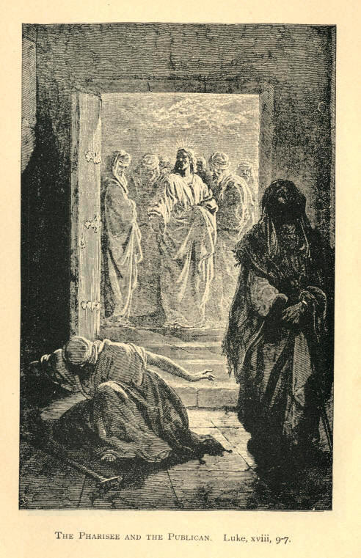
The Pharisee And The Publican. Luke, xviii, 9-14.
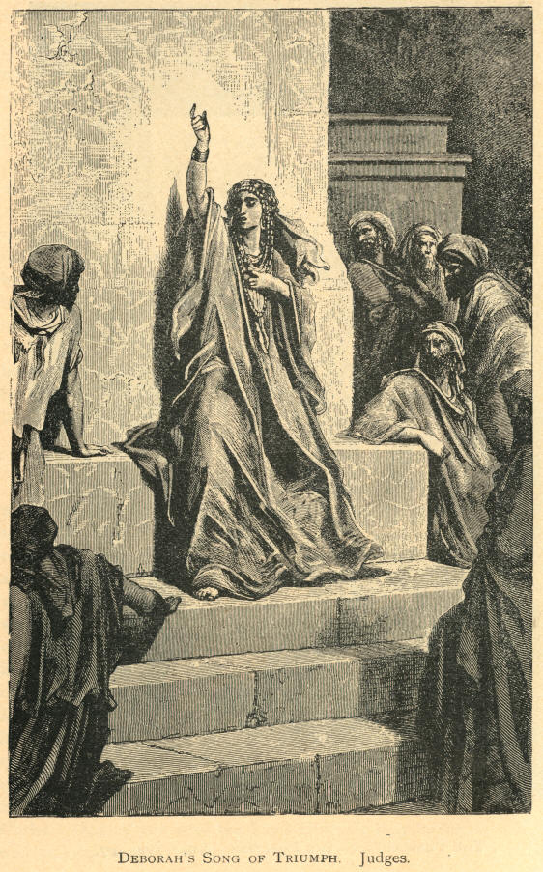
Deborah's Song of Triumph. Judges
182 MOODY'S ANECDOTES

SONG STORIES.

"Hold the fort, For I am Coming."

I am told that when General Sherman went through Atlanta towards the sea--through the Southern States--he left in the fort in the Kennesaw Mountains a little handful of men to guard some rations that he brought there. And General Hood got into the outer rear and attacked the fort, drove the men in from the outer works into the inner works, and for a long time the battle raged fearfully. Half of the men were either killed or wounded; the general who was in command was wounded seven different times; and when they were about ready to run up the white flag and surrender the fort, Sherman got within fifteen miles, and through the signal corps on the mountain he sent the message:
"Hold the fort; I am coming. W. T. Sherman." That message fired up their hearts, and they held the fort till reinforcements came, and the fort did not go into the hands of their enemies. Our friend, Mr. Bliss, has written a hymn entitled "Hold the fort for I am coming," and I'm going to ask Mr. Sankey to sing that hymn. I hope there will be a thousand young converts coming into our ranks to help hold the fort. Our Saviour is in command, and He is coming. Let us take up the chorus.

Ho! my comrades, see the signal
Waving in the sky!
Reinforcements now appearing,
Victory is nigh!
CHO.--"Hold the fort, for I am coming,"
Jesus signals still.
Wave the answer back to heaven,
"By Thy grace we will."
See the mighty hosts advancing,
Satan leading on;
Mighty men around us falling,
Courage almost gone.--Cho
See the glorious banner waving
Hear the bugle blow.
In our Leader's name we'll triumph
Over every foe.--Cho.
Fierce and long the battle rages,
But our Help is near;
Onward comes our Great Commander,
Cheer, my comrades, cheer!--Cho.
P. P. Bliss.
Song Stories. AND ILLUSTRATIONS. 183

"Let the Lower Lights be Burning."

A few years ago at the mouth of Cleveland harbor there were two lights, one at each side of the bay, called the upper and lower lights; and to enter the harbor safely by night, vessels must sight both of the lights. These western lakes are more dangerous sometimes than the great ocean. One wild, stormy night, a steamer was trying to make her way into the harbor. The Captain and pilot were anxiously watching for the lights. By and by the pilot was heard to say, "Do you see the lower lights?" "No," was the reply; "I fear we have passed them." "Ah, there are the lights," said the pilot; "and they must be from the bluff on which they stand, the upper lights. We have passed the lower lights; and have lost our chance of getting into the harbor;" What was to be done? They looked back, and saw the dim outline of the lower lighthouse against the sky. The lights had gone out. "Can't you turn your head around?" "No; the night is too wild for that. She won't answer to her helm." The storm was so fearful that they could do nothing. They tried again to make for the harbor, but they went crash against the rocks, and sank to the bottom. Very few escaped; the great majority found a watery grave. Why? Simply because the lower lights had gone out. Now with us the upper lights are all right. Christ himself is the upper light, and we are the lower lights, and the cry to us is, Keep the lower lights burning; that is what we have to do. He will lead us safe to the sunlit shore of Canaan, where there is no more night.

Brightly beams our Father's mercy
From His lighthouse ever more.
But to us He gives the keeping
Of the lights along the shore.
184 MOODY'S ANECDOTES Song Stories.

CHO.--Let the lower lights be burning!
Send a gleam across the wave!
Some poor fainting struggling seaman
You may rescue, you may save.
Dark the night of sin has settled,
Loud and angry billows roar;
Eager eye's are watching, longing,
For the lights along the shore.--Cho.
Trim your feeble lamp, my brother;
Some poor seaman tempest-tost,
Trying now to make the harbor,
In the darkness may be lost.--Cho.
P. P. BLISS.

"More to Follow."

Rowland Hill tells a good story of a rich man and a poor man in his congregation. The rich man desired to do an act of benevolence, and so he sent a sum of money to a friend to be given to this poor man as he thought best. The friend, just sent him five pounds, and said in the note: "This is thine; use it wisely; there is more to follow." After a while he sent another five pounds and said, "more to follow." Again and again, he sent the money to the poor man, always with the cheering words, "more to follow." So it is with the wonderful grace of God. There is always "more to follow."

Have you on the Lord believed?
Still there's more to follow;
Of His grace have you received?
Still there's more to follow;
Oh, the grace the Father shows!
Still there's more to follow,
Freely He His grace bestows,
Still there's more to follow.
CHO.--More and more, more and more,
Always more to follow,
Oh, his boundless matchless love!
Still there's more to follow.
Have you felt the Saviour near?
Still there's more to follow;
Does His blessed presence, cheer?
Still there's more to follow;
Oh, the love that Jesus shows!
Still there's more to follow,
Freely He His love bestows,
Still there's more to follow.--Cho.
Song Stories. AND ILLUSTRATIONS. 185

Have you felt the spirit's power?
Still there's more to follow;
Falling like the gentle shower?
Still there's more to follow;
Oh, the power the spirit shows!
Still there's more to follow,
Freely He His power bestows,
Still there's more to follow.--Cho.
P. P. Bliss.

"Pull for the Shore, Sailor."

A vessel was wrecked off the shore. Eager eyes were watching and strong arms manned the life-boat. For hours they tried to reach that vessel through the great breakers that raged and foamed on the sand-bank but it seemed impossible. The boat appeared to be leaving the crew to perish. But after a while the Captain and sixteen men were taken off, and the vessel went down. "When the life-boat came to you," said a friend, "did you expect it had brought some tools to repair your old ship?" "Oh, no," was the response; "she was a total wreck. Two of her masts were gone, and if we had stayed mending her, only a few minutes, we must have gone down, sir." "When once off the old wreck and safe in the life-boat, what remained for you to do?" "Nothing, sir, but just to pull for the shore."

Light in the darkness, sailor, day is at hand!
See o'er the foaming billows fair Haven's land,
Drear was the voyage, sailor, now almost o'er
Safe within the life-boat, sailor, pull for the shore.

CHO.--Pull for the shore, sailor, pull for the shore!
Heed not the rolling waves, but bend to the oar;
Safe in the life-boat, sailor, cling to self no more!
Leave the poor old stranded wreck, and pull for the shore.

Trust in the life-boat, sailor, all else will fail,
Stronger the surges dash and fiercer the gale,
Heed not the stormy winds, though loudly they roar;
Watch the "bright morning star," and pull for the shore.-Cho.

Bright gleams the morning, sailor, lift up thy eye;
Clouds and darkness disappearing, glory is nigh!
Safe in the life-boat, sailor, sing evermore;
"Glory, glory, hallelujah!" pull for the shore.--Cho.
P. P. BLISS.
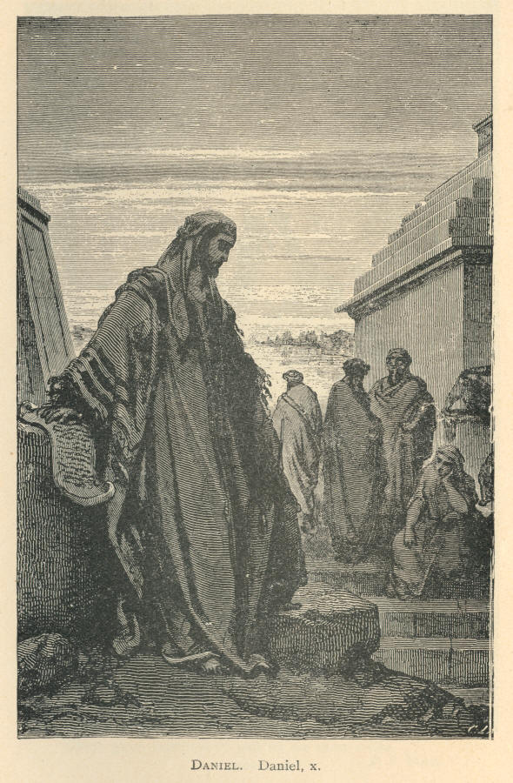
Daniel. Daniel, x.
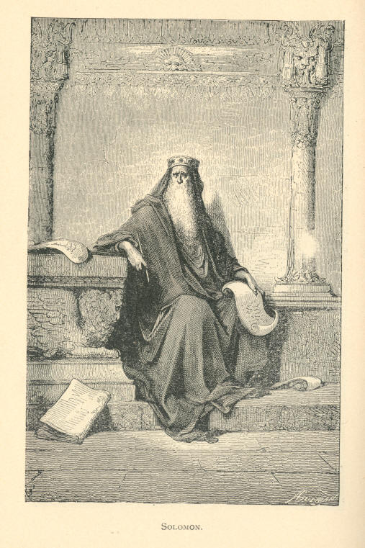
Solomon.
186 MOODY'S ANECDOTES

TRUST.

"I Am Trusting Jesus"--A Young Lady's Trust.

The other Sunday, when I was speaking on "Trust," a person came to me next day and said, "I want to tell you how I was saved. You remember you told about that lady who sought Christ three years and could not find Him, and when you told that, it was I. I was in that same condition and through your story I got light." I don't think I have ever told it but what somebody got light and life. I will tell it again, for I would go up and down the world telling it if I could get a convert. One night I was preaching, and happening to cast my eyes down during the sermon, I saw two eyes just riveted upon me. Every word that fell from my lips she just seemed to catch with her own lips, and I was very anxious to go down where she was. After the Sermon I went to the pew and said, "My friend, are you a Christian?" "Oh, no," said she, "I wish I was. I have been seeking Christ three years and I cannot find Him." Said I; "Oh, there is a great mistake about that." Says she, "'Do you think I am not in earnest? Do you think, sir, I have not been seeking Christ?" Said I, "I suppose you think you have, but Christ has been seeking you these twenty years, and it would not take an anxious sinner and an anxious Saviour three years to meet, and if you had been really seeking Him you would have found Him long before this." "What would you do, then?" Said I, "Do nothing, only believe on the Lord Jesus Christ and thou shalt be saved." "Oh," said she, "I have heard that till my head swims. Everybody says, believe! believe! believe! and I am none the wiser. I don't know what you mean by it." "Very well," said I, "I will drop the word; but just trust the Lord Jesus Christ to save." "If I say I trust Him, will He save me?" "No, you may do a thousand things; but if you really trust Him, He will save you."
Trust. AND ILLUSTRATIONS. 187

"Well," said she, "I trust Him, but I don't feel any different." "Ah," said I, "I have found your difficulty. You have been hunting for feeling all these three years. You have not been looking for Christ." Says she, "Christians tell how much joy they have got." "But," said I, "you want Christian experience before you get one. Instead of trusting God, you are looking for Christian experience." Then I said: "Right here in this pew, just commit yourself to the Lord Jesus Christ, and trust Him, and you will be saved," and I held her right to that word "trust," which is the same as the word "believe" in the Old Testament. "You know what it is to trust a friend. Cannot you trust God as a friend?" She looked at me for five minutes, it seemed, and then said slowly: "Mr. Moody, I trust the Lord Jesus Christ this night to save my soul." Turning to the pastor of the church she took him by the hand and repeated the declaration. Turning to an elder in the church she said again the solemn words, and near the door, meeting another officer of the church, she repeated for the fourth time, "I am trusting Jesus," and went off home. The next night when I was preaching I saw her right in front of me, "Eternity" written in her eyes, her face lighted up, and when I asked inquirers to go into the other room she was the first to go in. I wondered at it, for I could see by her face that she was in the joy of the Lord. But when I got in I found her with her arms around a young lady's neck, and I heard her say, "It is only just trusting. I stumbled over it three years and found it all in trusting;" and the three weeks I was there she led more souls to Christ than anybody else. If I got a difficult case I would send it to her. Oh, my friends, won't you trust Him? Let us put our trust in Him.

Mrs. Moody Teaching her Child.

There was a time when our little boy did not like to go to church, and would get up in the morning and say to his mother, "What day is to-morrow?" "Tuesday." "Next day?" "Wednesday." "Next day?" "Thursday;" and so on, till he came to the answer, "Sunday." "Dear me," he said. I said to the mother, "We cannot have our boy grow up to hate Sunday in this way; that will never do.
188 MOODY'S ANECDOTES. Trust.

That is the way I used to feel when I was a boy. I used to look upon Sunday with a certain amount of dread. Very few kind words were associated with the day. I don't know that the minister ever put his hand on my head. I don't know that the minister even noticed me, unless it was when I was asleep in the gallery, and he woke me up. This kind of thing won't do; we must make the Sunday the most attractive day of the week; not a day to be dreaded; but a day of pleasure." Well the mother took the work up with this boy. Bless those mothers in their work with the children. Sometimes I feel as if I would rather be the mother of John Wesley or Martin Luther or John Knox than have all the glories in the world. Those mothers who are faithful with the children God has given them will not go unrewarded. My wife went to work and took those Bible stories and put those blessed truths in a light that the child could comprehend, and soon the feeling of dread for the Sabbath with the boy was the other way, "What day's to-morrow?" he would ask, "Sunday." "I am glad." And if we make those Bible truths interesting--break them up in some shape so that these children can get at them, then they will begin to enjoy them.

AND ILLUSTRATIONS. 189

WISDOM.

-- I remember a gentleman of Boston, a man high in life, a Congressman, who was accustomed to carry with him little cards and distribute them wherever he went, and on some of these cards were words like these: "I expect to pass through this world but once, and therefore if there be any kindness I can show, if there is anything I can do to make men happy, I shall do it, for I may not pass this way again.
-- A man was asked what his persuasion was. He said it was the same as Paul's. I don't know what Paul's persuasion was. All persuasions claim him. Sankey says he is a Methodist. Listen: "I am not ashamed, for I know whom I believe, and am persuaded that He is able to keep that which I have committed to Him." That is Paul's persuasion. You may call it what you have a mind to, it is a good persuasion.
-- If we are going to be successful, we have got to take our stand for God, and let the world and everyone know we are on the Lord's side. I have great respect for the woman that started out during the war with a poker. She heard the enemy were coming and went to resist them. When some one asked her what she could do with the poker, she said she would at least let them know what side she was on. And that is what we want.
-- Let us do all the work we can. If we can't be a lighthouse, let us be a tallow candle. There used to be a period when people came to meeting bringing their candles with them. The first one, perhaps, wouldn't make a great illumination, but when two or three got there, there would be more light. If the people of Boston should do that now, if each one should come here in this Tabernacle, with a candle, don't you think there would be a little light.
-- When I was a little boy I used to try and catch my own shadow. I don't know whether any of you have ever been so foolish as that or not. I could not see why the shadow always kept ahead of me. Once I happened to be racing with my face to the sun and I looked over my head and saw my shadow coming back of me, and it kept behind me all the way. It is the same with the Sun of Righteousness. Peace and joy will go with you while you go with your face toward Him.
190 MOODY'S ANECDOTES Wisdom.

-- There are nine different qualities--peace, gentleness, long-suffering, hope, patience, charity, etc., but you can sum them all into one, and you have love. I saw something in writing the other day bearing upon the subject which I just took a copy of: "The fruit of the Spirit is in just one word--love. Joy is love exalted; peace is love in repose, long-suffering is love enduring, gentleness is love in society, goodness is love in action, faith is love on the battle field, meekness is love in school, and temperance is love in training. And so you can say that the fruit is all expressed by one word--love."
-- I believe there is a great deal more hope for a drunkard or a murderer or a gambler than there is for a lazy man. I never heard of a lazy man being converted yet, though I remember talking once with a minister in the back woods of Iowa about lazy men. He was all discouraged in his efforts to convert lazy men, and I said to him, "Did you ever know of a lazy man being converted?" "Yes," said he; "I knew of one, but he was so lazy that he didn't stay converted but about six weeks." And that is as near as I ever heard of a lazy man being converted.
-- I remember, I was talking with a man one day and an acquaintance of his came in, and he jumped up at once and shook him by the hand--why I thought he was going to shake his hand out of joint, he shook so hard--and he seemed to be so glad to see him and wanted him to stay, but the man was in a great hurry and could not stay, and he coaxed and urged him to stay, but the man said no, he would come another time; and after that man went out my companion turned to me and said, "Well, he is an awful bore, and I am glad he's gone." Well I began to feel that I was a bore too, and I got out as quickly as I could. That is not real love.

AND ILLUSTRATIONS. 191

WORD PICTURES.

The Prodigal Son.

The boy got his money, and away he went. He feels very independent; he can take care of himself; he can work his own way. I don't know where he went to. Perhaps he went away down to Memphis, and perhaps he went to Egypt--got as far away from home as he could. When he went away he soon commenced to go down to ruin. When he gets down to that part of the country he suddenly becomes very popular with a certain class of men. Perhaps he was very popular with the men who hung around the opera house, or the theatre, or the billiard halls. A great many courted his company. Perhaps he was a good talker, perhaps he was a good singer and could sing a comic song; perhaps he was a literary man, and entertained them with his wit, and all were delighted with him. But as we would say, he got to the end of his rope, and when his money went his friends disappeared: The poor fellow was in a blaze of glory while his money lasted, but when it had gone he woke up to find himself without friends. A man in New England said while his money lasted he had friends, but when he was ruined and in prison he found out who his real friends were. Not one of his old friends came near him, but the Christian people came and spoke to him words of kindness and comfort, and it was then he made the discovery who his true friends were. So this young prodigal didn't get his eyes open till his money was all gone. No one in that foreign country loved him then, no one in that land cared for him; but away off over those green hills there was one who loved him still. It was his father, and that father received him back.
192 MOODY'S ANECDOTES Word Pictures.

The Cross and Crown.

At last He cried, with a loud voice: "It is finished!" Perhaps not many on earth heard it, or cared about it when they did hear it; but I can imagine there were not many in heaven who did not hear it, and if they have bells in heaven how they must have rung out that day; "It is finished! It is finished!" The Son of God had died that poor sinful man might have life eternal. I can imagine the angels walking through the streets of heaven crying: "It is finished!" and the mansions of that world ringing with the glad tidings: "It is finished!" It was the shout of victory. All you have got to do is to look and be saved. You have seen the waves of the sea come dashing up against a rocky shore. They come up and beat against the rock, and, breaking into pieces, go back to gather fresh strength, and again they come up and beat against the rock only to be again broken into pieces. And so it would seem as if the dark waves of hell had gathered all their strength together and had come beating up against the bosom of the Son of God; but he drives them all back again with that shout of a conqueror: "It is finished." And with that shout He snapped the fetters of sin, and broke the power of Satan.

While I was at a convention in Illinois an old man past 70 years, got up, and said he remembered but one thing about his father, and that one thing followed him all through life. He could not remember his death, he had no recollection of his funeral, but he recollected his father one winter night, taking a little chip, and with his pocket knife whittling out a little cross, and with the tears in his eyes he held up that cross telling how God in His infinite love sent His Son down here to redeem us, how He had died on the cross for us. The story of the cross followed him through life.


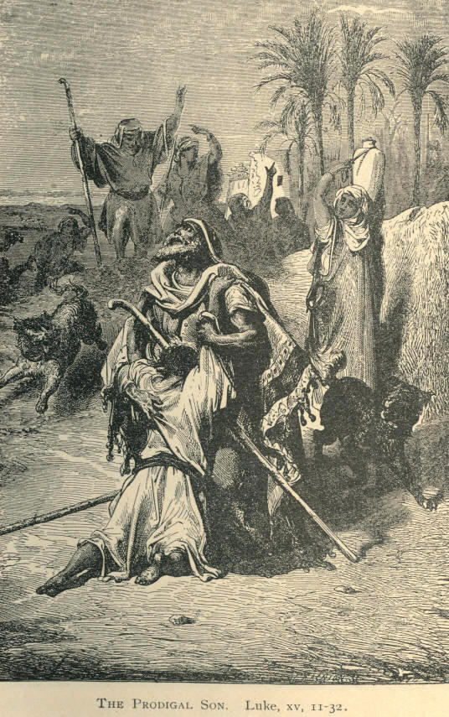
The Prodigal Son. Luke, xv 11-32.
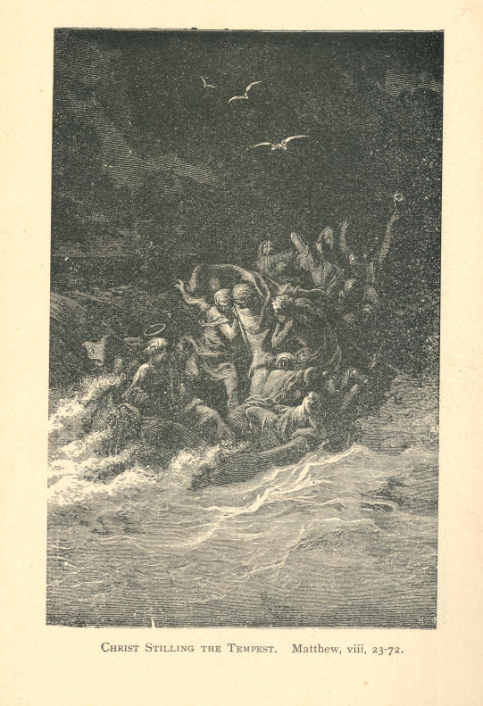
Christ Stilling The Tempest. Matthew. viii, 23-27.
AFFECTING INCIDENT AT SEA.

Moody's Love and Prayer for 700 "Quaking Souls."

"I remember clearly lying in my berth early that Saturday morning (Nov. 26th, 1892, on the steamer Spree when she was one thousand miles out from Southampton on her way to New York), congratulating myself that I had gotten passage in so swift a ship, when my thoughts were stopped by a great crash that shook the vessel from stem to stern.
"My son, William Revell Moody, jumped from his berth and rushed on deck. He was back again in an instant, crying that the shaft was broken and the ship sinking. Then ensued a scene the like of which I hope never to witness again. There was no panic, but the passengers, who had scrambled on deck at the first warning, looked at each other in an appealing way that was, if anything, more terrible than demonstrative fear. The captain told us there was no danger, and some of the second cabin passengers returned to their berths only to tumble back pellmell a moment later. The rising water had driven them out. Some of them lost all their clothes and valuables.
"At this point the officers buckled on their revolvers, but there was no need to use them. The people, though terribly frightened, did not seem to realize what had happened. The women didn't scream, but stood around trembling and with blanched faces. Nobody said a word, but each waited for his neighbor to speak. We felt that we might be looking on our graves.

(1)
2 MOODY'S ANECDOTES

"The captain told us at noon that he thought he had the water under control and was in hopes of drifting in the way of some passing vessel. The ship's bow was now high in the air, while the stern seemed to settle more and more. There was no storm, but the sea, was very rough, and the ship rolled from side to side with fearful lurches. I think that if she had pitched at all the overstrained, bulkheads would have burst and we should have gone to the bottom. The captain cheered us by telling us that he thought we should run in with a ship by 3 o'clock that Saturday afternoon, but the night drew on and no sail appeared to lighten our gloom.
"We knew the ship was sinking when we came on deck, but there was no panic. The big engines of the ship were all working at the pumps, but the water was steadily gaining in spite of them. With each roll of the ship it could be heard like the roar of the surf. All the day was passed in anxiously watching for a sail. We could not talk of religion, for the first word brought forth a hundred exclamations, 'Are we sinking?' Then in that first night one woman went insane. It seemed an age until the Sabbath morning came, When the vigil on the deck was resumed.
"I think that was the darkest night in all our lives. None of us thought to live to see the light of another day. Nobody slept. We were all huddled in the saloon of the first cabin--Americans and Germans, Jews, Protestants, Catholics and skeptics--although at that time I doubt if there were many skeptics among us. For forty-eight hours we were in this mortal fear.
"Sabbath morning dawned upon as wretched a ship's company as ever sailed the sea. There was at that time no talk of religious services. I think that if this had been suggested then there would have been a panic. To talk of religion to those poor people would have been to suggest the most terrible things to them. Everybody was waiting for his neighbor to say: 'Are we, then, doomed to die?'
"But as night approached I gathered those 700 quaking souls together and we held a prayer meeting. I think everybody prayed. There were no skeptics present. I have been under fire in the war, I have stood by deathbeds during the cholera epidemic in Chicago, but I never was so sorely tried. I could with difficulty command my voice as I read the ninety-first Psalm. I read without comment, and then I prayed that God would still the anger of the deep and bring us safely to our desired heaven. The people were weeping all around me. I also read from the 107th Psalm.
AND ILLUSTRATIONS. 3
3
"We tried to sing. I gave out the first verse of 'Jesus, Lover of My Soul,' and General Howard started the tune. He sang the hymn through in a strong voice, but very few joined him. Instead, the melody was punctuated by broken sobs and exclamation of grief. That night I went to bed and slept, I felt that everything would be all right.
"Never was a more earnest meeting held than this. All prayed together, and I did not hear much talk of skepticism, I can tell you. At 2:30 o'clock in the morning a ship's light was sighted, and in a few hours we were comparatively safe, although our danger was not over. The strain on our minds was almost as great, and minds gave way under it. Two women became violently insane and it was necessary to confine them. A young man from Vienna threw himself overboard and was drowned.
"When we were finally safe in port we had a thanksgiving service, and then such singing as there was--such praises that went up.
"We prayed that the ship be brought to a haven, and relief came on the night after our prayer meeting. I am a firm believer in prayer. I always have been. I believe and I know that God saved the Spree in response to our prayers."
PUBLISHED BY
RHODES & McCLURE PUBLISHING CO.,
CHICAGO.

All handsomely bound in the best English and American cloths, with full Silver embossed side and back stamp; uniform, in style and binding. Together making a handsome library, or, separately, making handsome center-table volumes.
PRICE, $1.00 EACH. SENT POST-PAID.

ABRAHAM LINCOLN'S STORIES AND SPEECHES; in one volume, complete New (1897) edition, handsomely illustrated; containing the many witty, pointed and unequaled stories as told by Mr. Lincoln, including Early life stories, Professional life stories, White House and War stories; also presenting the full text of the popular Speeches of Mr. Lincoln on the great questions of the age, including his "First Political Speech," "Rail-Splitting Speech," "Great Debate with Douglas," and his Wonderful Speech at Gettysburg, etc., etc.; and including his two great Inaugurals, with many grand illustrations. An instructive and valuable book; 477 pages.
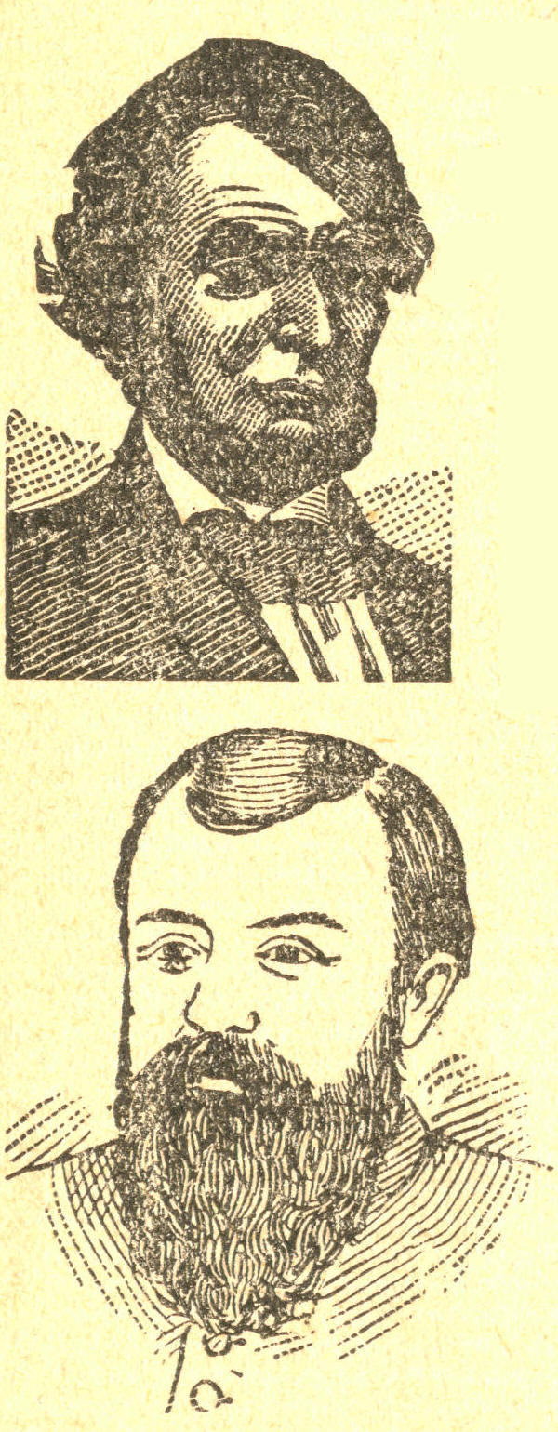

MOODY'S ANECDOTES; 210 pages exclusive of engravings. Containing several hundred interesting stories, told by the great evangelist, D. L. Moody, in his wonderful work in Europe and America. Hundreds of thousands of copies have been sold. Illustrated with excellent engravings of Messrs. Moody, Sankey, Whittle and Bliss, and thirty-two full-page engravings from Gustave Dore, making and artistic and handsome volume. "A book of anecdotes which have thrilled hundreds of thousands,"--Pittsburg Banner.

MOODY'S GOSPEL SERMONS. As delivered by the great Evangelist, Dwight Lyman Moody, in his revival work in Great Britain and America, Together with a biography of Mr. Moody and his co-laborer, Ira David Sanke. Including, also, a short history of the Great Revival. Each sermon is illustrated with a handsome, full page engraving from Gustave Dore. The book also contains an engraving of D. L. Moody, Ira D. Sankey, Mr. Moody preaching in the Royal Opera House, Haymarket, London, Chicago Tabernacle (erected for Mr. Moody's Services) and "I Am the Way." A handsome and attractive volume of 443 pages.

MOODY'S LATEST SERMONS. As delivered by the great Evangelist, Dwight Lyman Moody. Handsomely illustrated with twenty-four full-page engravings from Gustave Dore. 335 pages.

MOODY'S CHILD STORIES. As related by Dwight Lyman Moody in his revival work. Handsomely illustrated with sixteen full-page engravings from Gustave Dore and 106 illustrations from J. Stuart Littlejohn. A book adapted to children, but interesting to adults. A handsome volume. Should be in every family 237 pages.

End of the Project Gutenberg EBook of Moody’s Anecdotes And Illustrations, by
Dwight L. Moody

*** END OF THIS PROJECT GUTENBERG EBOOK MOODY’S ANECDOTES AND ILLUSTRATIONS ***

***** This file should be named 19830-doc.doc or 19830-doc.zip *****
This and all associated files of various formats will be found in:
http://www.gutenberg.org/1/9/8/3/19830/

Produced by Don Kostuch

Updated editions will replace the previous one--the old editions
will be renamed.

Creating the works from public domain print editions means that no
one owns a United States copyright in these works, so the Foundation
(and you!) can copy and distribute it in the United States without
permission and without paying copyright royalties. Special rules,
set forth in the General Terms of Use part of this license, apply to
copying and distributing Project Gutenberg-tm electronic works to
protect the PROJECT GUTENBERG-tm concept and trademark. Project
Gutenberg is a registered trademark, and may not be used if you
charge for the eBooks, unless you receive specific permission. If you
do not charge anything for copies of this eBook, complying with the
rules is very easy. You may use this eBook for nearly any purpose
such as creation of derivative works, reports, performances and
research. They may be modified and printed and given away--you may do
practically ANYTHING with public domain eBooks. Redistribution is
subject to the trademark license, especially commercial
redistribution.

*** START: FULL LICENSE ***

THE FULL PROJECT GUTENBERG LICENSE
PLEASE READ THIS BEFORE YOU DISTRIBUTE OR USE THIS WORK

To protect the Project Gutenberg-tm mission of promoting the free
distribution of electronic works, by using or distributing this work
(or any other work associated in any way with the phrase "Project
Gutenberg"), you agree to comply with all the terms of the Full Project
Gutenberg-tm License (available with this file or online at
http://gutenberg.org/license).

Section 1. General Terms of Use and Redistributing Project Gutenberg-tm
electronic works

1.A. By reading or using any part of this Project Gutenberg-tm
electronic work, you indicate that you have read, understand, agree to
and accept all the terms of this license and intellectual property
(trademark/copyright) agreement. If you do not agree to abide by all
the terms of this agreement, you must cease using and return or destroy
all copies of Project Gutenberg-tm electronic works in your possession.
If you paid a fee for obtaining a copy of or access to a Project
Gutenberg-tm electronic work and you do not agree to be bound by the
terms of this agreement, you may obtain a refund from the person or
entity to whom you paid the fee as set forth in paragraph 1.E.8.

1.B. "Project Gutenberg" is a registered trademark. It may only be
used on or associated in any way with an electronic work by people who
agree to be bound by the terms of this agreement. There are a few
things that you can do with most Project Gutenberg-tm electronic works
even without complying with the full terms of this agreement. See
paragraph 1.C below. There are a lot of things you can do with Project
Gutenberg-tm electronic works if you follow the terms of this agreement
and help preserve free future access to Project Gutenberg-tm electronic
works. See paragraph 1.E below.

1.C. The Project Gutenberg Literary Archive Foundation ("the Foundation"
or PGLAF), owns a compilation copyright in the collection of Project
Gutenberg-tm electronic works. Nearly all the individual works in the
collection are in the public domain in the United States. If an
individual work is in the public domain in the United States and you are
located in the United States, we do not claim a right to prevent you from
copying, distributing, performing, displaying or creating derivative
works based on the work as long as all references to Project Gutenberg
are removed. Of course, we hope that you will support the Project
Gutenberg-tm mission of promoting free access to electronic works by
freely sharing Project Gutenberg-tm works in compliance with the terms of
this agreement for keeping the Project Gutenberg-tm name associated with
the work. You can easily comply with the terms of this agreement by
keeping this work in the same format with its attached full Project
Gutenberg-tm License when you share it without charge with others.

1.D. The copyright laws of the place where you are located also govern
what you can do with this work. Copyright laws in most countries are in
a constant state of change. If you are outside the United States, check
the laws of your country in addition to the terms of this agreement
before downloading, copying, displaying, performing, distributing or
creating derivative works based on this work or any other Project
Gutenberg-tm work. The Foundation makes no representations concerning
the copyright status of any work in any country outside the United
States.

1.E. Unless you have removed all references to Project Gutenberg:

1.E.1. The following sentence, with active links to, or other immediate
access to, the full Project Gutenberg-tm License must appear prominently
whenever any copy of a Project Gutenberg-tm work (any work on which the
phrase "Project Gutenberg" appears, or with which the phrase "Project
Gutenberg" is associated) is accessed, displayed, performed, viewed,
copied or distributed:

This eBook is for the use of anyone anywhere at no cost and with
almost no restrictions whatsoever. You may copy it, give it away or
re-use it under the terms of the Project Gutenberg License included
with this eBook or online at www.gutenberg.org

1.E.2. If an individual Project Gutenberg-tm electronic work is derived
from the public domain (does not contain a notice indicating that it is
posted with permission of the copyright holder), the work can be copied
and distributed to anyone in the United States without paying any fees
or charges. If you are redistributing or providing access to a work
with the phrase "Project Gutenberg" associated with or appearing on the
work, you must comply either with the requirements of paragraphs 1.E.1
through 1.E.7 or obtain permission for the use of the work and the
Project Gutenberg-tm trademark as set forth in paragraphs 1.E.8 or
1.E.9.

1.E.3. If an individual Project Gutenberg-tm electronic work is posted
with the permission of the copyright holder, your use and distribution
must comply with both paragraphs 1.E.1 through 1.E.7 and any additional
terms imposed by the copyright holder. Additional terms will be linked
to the Project Gutenberg-tm License for all works posted with the
permission of the copyright holder found at the beginning of this work.

1.E.4. Do not unlink or detach or remove the full Project Gutenberg-tm
License terms from this work, or any files containing a part of this
work or any other work associated with Project Gutenberg-tm.

1.E.5. Do not copy, display, perform, distribute or redistribute this
electronic work, or any part of this electronic work, without
prominently displaying the sentence set forth in paragraph 1.E.1 with
active links or immediate access to the full terms of the Project
Gutenberg-tm License.

1.E.6. You may convert to and distribute this work in any binary,
compressed, marked up, nonproprietary or proprietary form, including any
word processing or hypertext form. However, if you provide access to or
distribute copies of a Project Gutenberg-tm work in a format other than
"Plain Vanilla ASCII" or other format used in the official version
posted on the official Project Gutenberg-tm web site (www.gutenberg.org),
you must, at no additional cost, fee or expense to the user, provide a
copy, a means of exporting a copy, or a means of obtaining a copy upon
request, of the work in its original "Plain Vanilla ASCII" or other
form. Any alternate format must include the full Project Gutenberg-tm
License as specified in paragraph 1.E.1.

1.E.7. Do not charge a fee for access to, viewing, displaying,
performing, copying or distributing any Project Gutenberg-tm works
unless you comply with paragraph 1.E.8 or 1.E.9.

1.E.8. You may charge a reasonable fee for copies of or providing
access to or distributing Project Gutenberg-tm electronic works provided
that

- You pay a royalty fee of 20% of the gross profits you derive from
the use of Project Gutenberg-tm works calculated using the method
you already use to calculate your applicable taxes. The fee is
owed to the owner of the Project Gutenberg-tm trademark, but he
has agreed to donate royalties under this paragraph to the
Project Gutenberg Literary Archive Foundation. Royalty payments
must be paid within 60 days following each date on which you
prepare (or are legally required to prepare) your periodic tax
returns. Royalty payments should be clearly marked as such and
sent to the Project Gutenberg Literary Archive Foundation at the
address specified in Section 4, "Information about donations to
the Project Gutenberg Literary Archive Foundation."

- You provide a full refund of any money paid by a user who notifies
you in writing (or by e-mail) within 30 days of receipt that s/he
does not agree to the terms of the full Project Gutenberg-tm
License. You must require such a user to return or
destroy all copies of the works possessed in a physical medium
and discontinue all use of and all access to other copies of
Project Gutenberg-tm works.

- You provide, in accordance with paragraph 1.F.3, a full refund of any
money paid for a work or a replacement copy, if a defect in the
electronic work is discovered and reported to you within 90 days
of receipt of the work.

- You comply with all other terms of this agreement for free
distribution of Project Gutenberg-tm works.

1.E.9. If you wish to charge a fee or distribute a Project Gutenberg-tm
electronic work or group of works on different terms than are set
forth in this agreement, you must obtain permission in writing from
both the Project Gutenberg Literary Archive Foundation and Michael
Hart, the owner of the Project Gutenberg-tm trademark. Contact the
Foundation as set forth in Section 3 below.

1.F.

1.F.1. Project Gutenberg volunteers and employees expend considerable
effort to identify, do copyright research on, transcribe and proofread
public domain works in creating the Project Gutenberg-tm
collection. Despite these efforts, Project Gutenberg-tm electronic
works, and the medium on which they may be stored, may contain
"Defects," such as, but not limited to, incomplete, inaccurate or
corrupt data, transcription errors, a copyright or other intellectual
property infringement, a defective or damaged disk or other medium, a
computer virus, or computer codes that damage or cannot be read by
your equipment.

1.F.2. LIMITED WARRANTY, DISCLAIMER OF DAMAGES - Except for the "Right
of Replacement or Refund" described in paragraph 1.F.3, the Project
Gutenberg Literary Archive Foundation, the owner of the Project
Gutenberg-tm trademark, and any other party distributing a Project
Gutenberg-tm electronic work under this agreement, disclaim all
liability to you for damages, costs and expenses, including legal
fees. YOU AGREE THAT YOU HAVE NO REMEDIES FOR NEGLIGENCE, STRICT
LIABILITY, BREACH OF WARRANTY OR BREACH OF CONTRACT EXCEPT THOSE
PROVIDED IN PARAGRAPH F3. YOU AGREE THAT THE FOUNDATION, THE
TRADEMARK OWNER, AND ANY DISTRIBUTOR UNDER THIS AGREEMENT WILL NOT BE
LIABLE TO YOU FOR ACTUAL, DIRECT, INDIRECT, CONSEQUENTIAL, PUNITIVE OR
INCIDENTAL DAMAGES EVEN IF YOU GIVE NOTICE OF THE POSSIBILITY OF SUCH
DAMAGE.

1.F.3. LIMITED RIGHT OF REPLACEMENT OR REFUND - If you discover a
defect in this electronic work within 90 days of receiving it, you can
receive a refund of the money (if any) you paid for it by sending a
written explanation to the person you received the work from. If you
received the work on a physical medium, you must return the medium with
your written explanation. The person or entity that provided you with
the defective work may elect to provide a replacement copy in lieu of a
refund. If you received the work electronically, the person or entity
providing it to you may choose to give you a second opportunity to
receive the work electronically in lieu of a refund. If the second copy
is also defective, you may demand a refund in writing without further
opportunities to fix the problem.

1.F.4. Except for the limited right of replacement or refund set forth
in paragraph 1.F.3, this work is provided to you 'AS-IS' WITH NO OTHER
WARRANTIES OF ANY KIND, EXPRESS OR IMPLIED, INCLUDING BUT NOT LIMITED TO
WARRANTIES OF MERCHANTIBILITY OR FITNESS FOR ANY PURPOSE.

1.F.5. Some states do not allow disclaimers of certain implied
warranties or the exclusion or limitation of certain types of damages.
If any disclaimer or limitation set forth in this agreement violates the
law of the state applicable to this agreement, the agreement shall be
interpreted to make the maximum disclaimer or limitation permitted by
the applicable state law. The invalidity or unenforceability of any
provision of this agreement shall not void the remaining provisions.

1.F.6. INDEMNITY - You agree to indemnify and hold the Foundation, the
trademark owner, any agent or employee of the Foundation, anyone
providing copies of Project Gutenberg-tm electronic works in accordance
with this agreement, and any volunteers associated with the production,
promotion and distribution of Project Gutenberg-tm electronic works,
harmless from all liability, costs and expenses, including legal fees,
that arise directly or indirectly from any of the following which you do
or cause to occur: (a) distribution of this or any Project Gutenberg-tm
work, (b) alteration, modification, or additions or deletions to any
Project Gutenberg-tm work, and (c) any Defect you cause.

Section 2. Information about the Mission of Project Gutenberg-tm

Project Gutenberg-tm is synonymous with the free distribution of
electronic works in formats readable by the widest variety of computers
including obsolete, old, middle-aged and new computers. It exists
because of the efforts of hundreds of volunteers and donations from
people in all walks of life.

Volunteers and financial support to provide volunteers with the
assistance they need, is critical to reaching Project Gutenberg-tm's
goals and ensuring that the Project Gutenberg-tm collection will
remain freely available for generations to come. In 2001, the Project
Gutenberg Literary Archive Foundation was created to provide a secure
and permanent future for Project Gutenberg-tm and future generations.
To learn more about the Project Gutenberg Literary Archive Foundation
and how your efforts and donations can help, see Sections 3 and 4
and the Foundation web page at http://www.pglaf.org.

Section 3. Information about the Project Gutenberg Literary Archive
Foundation

The Project Gutenberg Literary Archive Foundation is a non profit
501(c)(3) educational corporation organized under the laws of the
state of Mississippi and granted tax exempt status by the Internal
Revenue Service. The Foundation's EIN or federal tax identification
number is 64-6221541. Its 501(c)(3) letter is posted at
http://pglaf.org/fundraising. Contributions to the Project Gutenberg
Literary Archive Foundation are tax deductible to the full extent
permitted by U.S. federal laws and your state's laws.

The Foundation's principal office is located at 4557 Melan Dr. S.
Fairbanks, AK, 99712., but its volunteers and employees are scattered
throughout numerous locations. Its business office is located at
809 North 1500 West, Salt Lake City, UT 84116, (801) 596-1887, email
business@pglaf.org. Email contact links and up to date contact
information can be found at the Foundation's web site and official
page at http://pglaf.org

For additional contact information:
Dr. Gregory B. Newby
Chief Executive and Director
gbnewby@pglaf.org

Section 4. Information about Donations to the Project Gutenberg
Literary Archive Foundation

Project Gutenberg-tm depends upon and cannot survive without wide
spread public support and donations to carry out its mission of
increasing the number of public domain and licensed works that can be
freely distributed in machine readable form accessible by the widest
array of equipment including outdated equipment. Many small donations
($1 to $5,000) are particularly important to maintaining tax exempt
status with the IRS.

The Foundation is committed to complying with the laws regulating
charities and charitable donations in all 50 states of the United
States. Compliance requirements are not uniform and it takes a
considerable effort, much paperwork and many fees to meet and keep up
with these requirements. We do not solicit donations in locations
where we have not received written confirmation of compliance. To
SEND DONATIONS or determine the status of compliance for any
particular state visit http://pglaf.org

While we cannot and do not solicit contributions from states where we
have not met the solicitation requirements, we know of no prohibition
against accepting unsolicited donations from donors in such states who
approach us with offers to donate.

International donations are gratefully accepted, but we cannot make
any statements concerning tax treatment of donations received from
outside the United States. U.S. laws alone swamp our small staff.

Please check the Project Gutenberg Web pages for current donation
methods and addresses. Donations are accepted in a number of other
ways including checks, online payments and credit card donations.
To donate, please visit: http://pglaf.org/donate

Section 5. General Information About Project Gutenberg-tm electronic
works.

Professor Michael S. Hart is the originator of the Project Gutenberg-tm
concept of a library of electronic works that could be freely shared
with anyone. For thirty years, he produced and distributed Project
Gutenberg-tm eBooks with only a loose network of volunteer support.

Project Gutenberg-tm eBooks are often created from several printed
editions, all of which are confirmed as Public Domain in the U.S.
unless a copyright notice is included. Thus, we do not necessarily
keep eBooks in compliance with any particular paper edition.

Most people start at our Web site which has the main PG search facility:

http://www.gutenberg.org

This Web site includes information about Project Gutenberg-tm,
including how to make donations to the Project Gutenberg Literary
Archive Foundation, how to help produce our new eBooks, and how to
subscribe to our email newsletter to hear about new eBooks.

