The Project Gutenberg EBook of History of the United States, Volume 5, by
E. Benjamin Andrews

This eBook is for the use of anyone anywhere at no cost and with
almost no restrictions whatsoever. You may copy it, give it away or
re-use it under the terms of the Project Gutenberg License included
with this eBook or online at www.gutenberg.org

Title: History of the United States, Volume 5

Author: E. Benjamin Andrews

Release Date: September 27, 2007 [EBook #22777]

Language: English

Character set encoding: ASCII

*** START OF THIS PROJECT GUTENBERG EBOOK HISTORY UNITED STATES ***

Produced by Don Kostuch

[Transcriber's Notes]

Text has been moved to avoid fragmentation of sentences.

Here are the definitions of some uncommon words.

ad valorem
In proportion to the value:

akouphone
Table model hearing aid sold around 1900.

auriferous
Containing gold.

balustrades
Rail and the row of posts that support it.

between Scylla and Charybdis
Between two perilous alternatives, which cannot be passed without falling victim to one or the other.

biograph
Moving-picture machine.

brevet
Promoting a military officer to a higher rank without an increase of pay and with limited exercise of the higher rank, often granted as an honor immediately before retirement.

Caryatids
Sculptured female figure used as a column.

catafalque
Raised structure on which a deceased person lies or is carried in state.
A hearse.

Charybdis
Daughter of Gaea and Poseidon, a monster mentioned in Homer and later identified with the whirlpool Charybdis, in the Strait of Messina off the NE coast of Sicily. See: between Scylla and Charybdis.

climacteric
Period of decrease of reproductive capacity; any critical period; a year of important changes in health and fortune.

cloture
Closing a debate and causing an immediate vote to be taken on the question.

Cobden Club
A gentlemen's club in West London founded in the 1870s and named after Richard Cobden. The club offers "art and entertainment for the working man".

derogation
Detract, as from authority, estimation, etc.; stray in character or conduct; degenerate; disparage or belittle.

enginery
Machinery consisting of engines collectively.

Ethnology
Branch of anthropology that analyzes cultures, (formerly) a branch of anthropology dealing with the origin, distribution, and distinguishing characteristics of the races of humankind.

excogitated
Think out; devise; invent; study intently to comprehend fully.

execrable
Utterly detestable; abominable; abhorrent; very bad:

ex proprio vigore
By its own strength; of its own force.

fyke net
Long bag net distended by hoops; fish can pass easily in, without being able to exit.

gonfalons
Banner suspended from a crosspiece, especially for an ecclesiastical procession or as the ensign of a medieval Italian republic.

graphophone
Phonograph for recording and reproducing sounds on wax records.

hegira
Journey to a more desirable or congenial place.

hustings
Temporary platform where candidates for the British Parliament stood when nominated and from which they addressed the electors; any place where political campaign speeches are made; political campaign trail.

imbroglios
Complicated or bitter misunderstanding; confused heap.

mare clausum
Body of navigable water under the sole jurisdiction of a nation.

memoriter
By heart; by memory.

modus vivendi
Manner of living; way of life; lifestyle.
Temporary arrangement pending a settlement of matters in debate.

mugwumpery
Republican who refused to support the party nominee, James G. Blaine, in the presidential campaign of 1884.
Uncommitted person; a person who is neutral on a controversial issue.

muniment
Title deed or a charter, defending rights.

mutoscope
Simple form of moving-picture machine; a series of views are printed on paper and mounted around the periphery of a wheel. The rotation of the wheel brings them sequentially into view and the blended effect renders apparent motion.

Nestor
Oldest and wisest of the Greeks in the Trojan War and a king of Pylos

obloquy
Censure, blame, or abusive language; discredit, disgrace, denunciation.

outre-mer
French: Overseas.

pergolas
Arbor or a passageway of columns supporting a roof or trelliswork of climbing plants.

Plaisance
Place laid out as a pleasure garden or promenade.

pelagic
Pertaining to the oceans; living near the surface of the ocean, far from land.

pendency
Pending, undecided, as a lawsuit awaiting settlement.

peristyle
Colonnade surrounding a building or an open space.

porphyry
Purplish-red rock containing small crystals of feldspar.

quadrennium
Four years.

quadriga
Two-wheeled chariot drawn by four horses abreast.

rapprochement
Establishment of harmonious relations.

recreant
Coward, craven, unfaithful, disloyal, apostate, traitor, renegade.

recrudescence
Recurrence of symptoms after a period of improvement.

redoubtable
To be feared; formidable; commanding respect, reverence.
reprobated, reprobation
Depraved, unprincipled, wicked; beyond hope of salvation.

Scylla
Female sea monster who lived in a cave opposite Charybdis and devoured sailors. See: between Scylla and Charybdis.

truckling
Submit tamely; grovel, bow, concede, kowtow.

unwonted
Usual; rare.

[End Transcriber's Notes]
HISTORY OF THE UNITED STATES

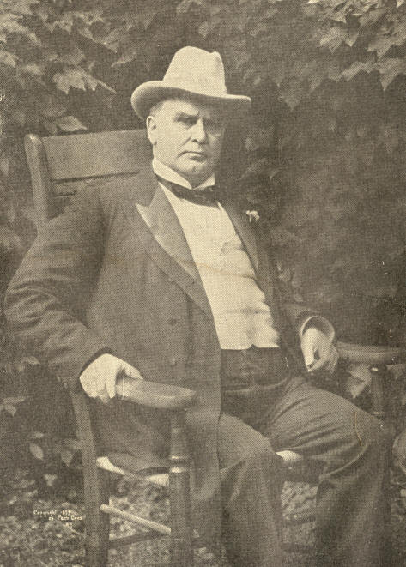
From a photograph copyright, 1899, by Pach Bros., N. Y.
President William McKinley.
HISTORY OF
THE UNITED STATES

FROM THE EARLIEST DISCOVERY OF AMERICA TO THE PRESENT TIME

BY

E. BENJAMIN ANDREWS

CHANCELLOR OF THE UNIVERSITY OF NEBRASKA
FORMERLY PRESIDENT OF BROWN UNIVERSITY

With 650 Illustrations and Maps

VOLUME V.

NEW YORK
CHARLES SCRIBNER'S SONS
1912
COPYRIGHT, 1903 AND 1905, BY
CHARLES SCRIBNER'S SONS


CONTENTS

PERIOD VI

EXPANSION

1888--1902
PAGE
CHAPTER I. DRIFT AND DYE IN LAW--MAKING 17

General Revision and Extension of State Constitutions.--Introduction of Australian Ballot in Various States.--Woman Suffrage in the West.--Negro Suffrage in the South.--Educational Qualification.--"The Mississippi Plan."--South Carolina Registration Act.--The "Grandfather" Clause in Louisiana Constitution.--Alabama Suffrage.

CHAPTER II. THE PRESIDENTIAL CAMPAIGN OF 1888 33

Tariff Reform Democratic Creed.--Republican Banner, High Protection.--Republican Convention at Chicago.--Nomination of Benjamin Harrison for President.--Biographical Sketch of Benjamin Harrison.--Political Strength in the West.--National Association of Democratic Clubs and Republican League.--Civil Service as an Issue in Campaign.--Democratic Blunders.--The "Murchison" Letter.--Lord Sackville-West Given His Passports.--Use of Money in Campaign by Both Political Parties.--Tariff the Main Issue.--Trusts.--"British Free Trade."--Popular Vote at the Election. .
2 CONTENTS.

PAGE
CHAPTER III. MR. HARRISON'S ADMINISTRATION 49

Steamship Subsidies Advocated.--Chinese Immigration and the Geary Law.--Immigration Restriction.--Thomas B. Reed Institutes Parliamentary Innovations in the House of Representatives.--Counting a Quorum.--The "Force Bill" in Congress.--Resentment of the South.--Defeated in Senate.--The "Billion Dollar Congress" and the Dependent Pensions Act.--Pension Payments.--The McKinley Tariff Act and "Blaine" Reciprocity.--International Copyright Act Becomes a Law.--Mr. Blaine as Secretary of State.--Murder by "Mafia" Italians Causes Riot in New Orleans.--The Itata at San Diego, California.--The "Barrundia" Incident.--U. S. Assumes Sovereignty Over Tutuila, Samoa.--Congressional Campaign, 1890.

CHAPTER IV. NON-POLITICAL EVENTS OF
PRESIDENT HARRISON'S TERM 69

Commemorative Exercises of the Centennial Anniversary of Washington's Inauguration as President.--Verse Added to Song "America."--Whittier Composes an Ode.--Unveiling of Lee Monument.--Sectional Feeling Allayed.--The Louisiana Lottery Put Down.--The Opening of Oklahoma.--Sum Paid Seminole Indians.--The Messiah Craze of the Indians.--The Johnstown Flood.--The Steel Strike at Homestead, Pa.--Congressional Investigation.--Riot in Tennessee Over Convict Labor in the Mines.--Mormonism.--America Aids Russia in Famine.

CHAPTER V. THE WORLD'S COLUMBIAN EXPOSITION 91

Preparation for the World's Fair.--Columbus Day in Chicago.--In New York.--Presidential Election of 1892.--The Campaign.--Cleveland and Harrison Nominated by the Respective Parties.--Populism.--Gen. Weaver Populistic Candidate.--Reciprocity in the Campaign of 1892.--Result of the Election.--Opening Exercises of the World's Fair.--The Buildings and Grounds.--The Spanish Caravals.--The Court of Honor.--Burning of the Cold Storage Building.--Government Exhibits.--Midway Plaisance.--The Ferris Wheel.--Buildings Burned.--Fair Not a Financial Success.--The Attendance.

ONTENTS. 3

PAGE
CHAPTER VI. ECONOMIC AND SOCIAL MOVEMENT 107

Growth of Population in Cities and States.--Centre of Population.--The Railroads.--Industrial Progress.--Development of Use of Electricity in Telegraph, Telephone, Lighting, and Manufacturing.--Niagara Falls Harnessed.--Thomas A. Edison.--Nikola Tesla.--The Use of the Bicycle.--Growth of Agriculture and Improvement of Implements.--Position of Women.--The Salvation Army Established in America.--Its Growth and Work.

CHAPTER VII. MR. CLEVELAND AGAIN PRESIDENT 122

Democratic Congress.--President Extends Merit System.--Anti-Lottery Bill.--President Calls a Special Session of Congress.--Sale of Bonds to Maintain Reserve of Gold.--The Wilson Tariff Law Passed.--Income Tax Unconstitutional.--Bond Issues.-- Foreign Affairs.--Coup d'etat of Provisional Government of Hawaii.--Special Commissioner.--Queen Liliuokalani.--Queen Renounces Throne.--President Cleveland's Venezuelan Message.--Measures to Preserve National Credit.--Venezuelan Boundary Commission.--Lexow Committee Investigation in New York City.--Reform Ticket Elected.--Greater New York.--American Protective Association.

CHAPTER VIII. LABOR AND THE RAILWAYS 138

The March of the Coxey Army.--Arrest of Leaders.--The American Railway Union Strike.--Refusal of Pullman Company to Arbitrate.--Association of General Managers.--Federal Injunction.--Federal Riot Proclamation and Troops Detailed.--Governor Altgeld's Protest.--Debs.--"Government by Injunction."--Commission of Investigation.--General Allotment of Indian Lands Under the Dawes Act.
4 CONTENTS.

PAGE
CHAPTER IX. NEWEST DIXIE 153

Harmony Between North and South.--Consecration of Chickamauga-Chattanooga Military Park.--Agricultural Development in the South.--Manufactures.--Natural Products.--Southern Characteristics.--The "Black Belt."-- Montgomery Conference on the Negro Question.--Lynching.--Booker T. Washington and the Tuskegee Institute.--Negro Population.

CHAPTER X. THE MEN AND THE ISSUE IN 1896 171

Free Silver Coinage Issue in the Campaign.--Republican Convention in St. Louis.--The Money Plank in the Platform.--Withdrawal of Senator Teller and Free Silver Delegates.--William McKinley and Garret A. Hobart Nominated for President and Vice-President.--Sketch of Life of William McKinley.--Democratic Convention Held in Chicago.--Demand for Free and Unlimited Coinage of Silver.--William J. Bryan Makes "Cross of Gold" Speech.--Delegates Refuse to Vote.--W. J. Bryan and Arthur Sewall Nominated.--Sketch of William J. Bryan.--Thomas Watson Nominated for Vice-President by Populist Convention.--National or Gold Democratic Ticket.--Speeches Made by Candidates.--Result of the Election.

CHAPTER XI. MR. MCKINLEY'S ADMINISTRATION 191

John Sherman, William R. Day, and John Hay as Secretary of State.--Other Members of Cabinet.--Revival of Business in 1897.--Gold Discovery in Yukon, Klondike, and Cape Nome.--Alaskan Boundary Controversy Between United States and Great Britain. --Joint High Commission Canvasses Boundary and Sealing Question.--Estimate of Loss to Seal Herd.--Sealskins Ordered Confiscated and Destroyed at United States Ports.--Hawaiian Islands Annexed.--Special Envoys to the Powers Appointed to Consider International Bi-Metallism.--President Withdraws Positions from the Classified Service.--Extra Session of Congress.--Passes Dingley Tariff Act.--Reciprocity Clauses.--Grant Mausoleum Completed.--Presentation Ceremonies at New York.

CONTENTS. 5

PAGE
CHAPTER XII. THE WAR WITH SPAIN 210

Cuban Discontent with Spanish Rule.--United States' Neutral Attitude Toward Spain and Cuba.--Red Cross Society Aids Reconcentrados.--Spanish Minister Writes Letter that Leads to Resignation.--United States Battleship Maine Sunk in Havana Harbor.--Congress Declares the People of Cuba Free and Independent.--Minister Woodford Receives his Passports at Madrid.--Increase of the Regular Army.--Spain Prepares for War.--Army Equipment Insufficient.--Strength of Navy.--The Oregon Makes Unprecedented Run.--Admiral Cervera's Fleet in Santiago Harbor.--Navy at Santiago Harbor Entrance.--Army Lands near Santiago.--The Darkest Day of the War.--Sinking of the Collier Merrimac to Block Harbor Entrance.--Spanish Ships Leave.--General Toral Surrenders.--Expedition of General Miles to Porto Rico.--Commodore George Dewey Enters Manila Bay.--Destroys Spanish Fleet.--Manila Capitulates.--Treaty of Paris Signed.

CHAPTER XIII. "CUBA LIBRE". 240

Admiral Sampson and Admiral Schley in Santiago Naval Battle.--Court of Inquiry Appointed.--Paris Treaty of Peace Ratified.--Foreign Criticism.--The Samoan Islands.--Civil Government Established in Porto Rico.--Foreign Commerce of Porto Rico.--Congressional Pledge about Cuba.--Census of Cuba.--General Leonard Wood, Governor of Cuba.--Cuban Constitutional Convention.--"Platt Amendment."--Cuban Constitution Adopted.--First President of Cuba.--Reciprocity with Cuba.

CHAPTER XIV. THE UNITED STATES IN THE ORIENT.--
PHILIPPINES AND FILIPINOS. 258

Area of the Philippines.--The Native Tribes.--Population.--Education Under Spanish Rule.--Filipinos.--Iocoros.--Igorrotes.--Ilocoans.--Moros.--Spain as a Colonist.--Religious Orders.--Secret Leagues.--Spain and the Filipinos.--Emilio Aguinaldo.--The Philippines in the Treaty of Paris.--Senate Resolution.
6 CONTENTS.

PAGE
CHAPTER XV. THE UNITED STATES IN THE ORIENT.--
WAR.--CONTROVERSY.--PEACE 281

Filipinos' Foothold in Philippines.--Attitude Toward Filipinos.--President Orders Government Extended Over Archipelago.--American Rule Awakens Hostility.--First Philippine Commission.--Philippine Congress Votes for Peace.--Revolution.--Treachery of Filipinos.--General Frederick Funston Captures Aguinaldo.--Aguinaldo Swears Allegiance to the United States.--The Constitution and the Philippines.--United States Supreme Court Decisions.--Tariff.--Anti-Imperialism.--Second Commission.--Civil Government Inaugurated.--Educational Reforms.

CHAPTER XVI. POLITICS AT THE TURNING OF THE CENTURY. 301

Candidates for President in 1900.--McKinley Renominated.--Bryan Nominated.-- Gold Democrats.--Fusion.--Populists.--Silver Republicans.--Anti-Imperialism.--Tariff for Colonies.--Porto Rico Tariff.--President McKinley's Opposition to Bill.--Campaign Issues.--Boer War.--Trusts.--Democratic Defeat.--Coal Strike.--Reasons for Democratic Defeat.--Mr. Bryan Insists on Silver Issue.--Monetary System on a Gold Basis.--Result of Election.

CHAPTER XVII. THE TWELFTH CENSUS 325

Permanent Census Bureau.--Alaska Census.--Method of Taking Census.--Two Thousand Employees.--Population of United States.--Nevada Loses in Population.--Urban Increase.--Greater New York.--Cities of More than a Million Inhabitants.--Loss in Rural Population.--Centre of Population.--Proportion of Males to Females.--Foreign Born Population.--Character of Immigration.--Chinese.--Congressional Apportionment. --Farms.--Crops.--Manufacturing Capital Invested.--Foreign Commerce.--Revenues.--War Taxes Repealed.--National Debt.

CONTENT 7

PAGE
CHAPTER XVIII. THE PAN-AMERICAN EXPOSITION, 1901 341

The Opening.--Triumphal Bridge.--Electric Tower.--Temple of Music.--Architecture.--Coloring of the "Rainbow City."--Symbolism of Coloring.--Sculpture.-- Electrical Illumination.--The Chaining of Niagara.--The Midway.--The Athletic Congress.--Conservatory.--The Spanish-American Countries Represented.--United States Government Building.

CHAPTER XIX. MR. McKINLEY'S END 359

President McKinley's Address at the Pan-American Exposition.--The President Shot.--His Illness and Death.--The Funeral Ceremony.--In Washington.--At Canton.--Commemorative Services.--Mr. McKinley's Career.--Political Insight.--Americanism.-- His Administration as President.--Leon Czolgosz, the Murderer of President McKinley. --Anarchists.--Anti-Anarchist Law.--Vice-President Theodore Roosevelt Succeeds to the Presidency.

8
LIST OF ILLUSTRATIONS

PAGE
PRESIDENT WILLIAM MCKINLEY.
(From a copyright photograph, 1899, by Pach Bros., New York). Frontispiece
A NEW YORK POLLING PLACE, SHOWING BOOTHS ON THE LEFT. 22
BENJAMIN R. TILLMAN, 28
GROVER CLEVELAND. (Photograph copyrighted by C. M. Bell), 33
W. Q. GRESHAM, 34
LEVI P. MORTON, 35
BENJAMIN HARRISON, 36
LORD L. S. SACKVILLE-WEST, 42
JOSEPH B. FORAKER, 46
"THE CHINESE MUST GO!" DENIS KEARNEY ADDRESSING
THE WORKINGMEN ON THE NIGHT OF OCTOBER 29,
ON NOB HILL, SAN FRANCISCO, 50
THOMAS B. REED, 52
DAVID C. HENNESSY, 59
AN EPISODE OF THE LYNCHING OF THE ITALIANS IN NEW ORLEANS.
THE CITIZENS BREAKING DOWN THE DOOR OF THE PARISH
PRISON WITH THE BEAM BROUGHT THERE THE NIGHT BEFORE
FOR THAT PURPOSE 60
OLD PARISH JAIL, NEW ORLEANS, LA., 61
CANAL STREET, NEW ORLEANS, LA., 61
A. G. THURMAN, 63
CHILIAN STEAMER ITATA IN SAN DIEGO HARBOR, 64
PRESIDENT HARRISON BEING ROWED ASHORE AT FOOT
OF WALL STEEET, NEW YORK, APRIL 29, 1889, 67
WASHINGTON INAUGURAL CELEBRATION, 1889, NEW YORK.
PARADE PASSING UNION SQUARE ON BROADWAY, 71
10 LIST OF ILLUSTRATIONS

PAGE
UNVEILING OF THE EQUESTRIAN STATUE
OF ROBERT E. LEE, MAY 29, 1890, 74
HENRY W. GRADY, 75
FRANCIS T. NICHOLLS, 77
THE BUILDING OF A WESTERN TOWN, GUTHRIE, OKLAHOMA:
A GENERAL VIEW OF THE TOWN ON APRIL 24, 1889, THE SECOND
DAY AFTER THE OPENING. A VIEW ALONG OKLAHOMA A VENUE
ON MAY 10, 1889. OKLAHOMA AVENUE AS IT APPEARED ON
MAY 10, 1893, DURING GOVERNOR NOBLE'S VISIT, 79
MAIN STREET, JOHNSTOWN, AFTER THE FLOOD, 83
BURNING OF BARGES DURING HOMESTEAD STRIKE, 85
THE CARNEGIE STEEL WORKS. SHOWING THE SHIELD USED BY THE
STRIKERS WHEN FIRING THE CANNON AND WATCHING THE
PINKERTON MEN--HOMESTEAD STRIKE, 86
INCITING MINERS TO ATTACK FORT ANDERSON.
THE GROVE BETWEEN BRICEVILLE AND COAL CREEK, 87
STATE TROOPS AND MINERS AT BRICEVILLE, TENN., 88
THE MORMON TEMPLE AT SALT LAKE CITY, 89
COLUMBIAN CELEBRATION, NEW YORK, APRIL 28, 1893.
PARADE PASSING FIFTH AVENUE HOTEL, 91
PINTA, SANTA MARIA, NINA--LYING IN THE NORTH RIVER,
NEW YORK--THE CARAVELS WHICH CROSSED FROM SPAIN TO BE PRESENT AT THE WORLD'S FAIR AT CHICAGO, 93
THE MANUFACTURES AND LIBERAL ARTS BUILDING,
SEEN FROM THE SOUTHWEST, 96
HORTICULTURAL BUILDING, WITH ILLINOIS BUILDING
IN THE BACKGROUND, 98
A VIEW TOWARD THE PERISTYLE FROM MACHINERY HALL, 100
THE ADMINISTRATION BUILDING, SEEN FROM
THE AGRICULTURAL BUILDING, 102
MIDWAY PLAISANCE, WORLD'S FAIR, CHICAGO, 103
THE BURNING OF THE WHITE CITY:
ELECTRICITY BUILDING--MINES AND MINING BUILDING, 105

LIST OF ILLUSTRATIONS 11

PAGE
THE NEW YORK LIFE INSURANCE BUILDING IN CHICAGO.
(Showing the construction of outer walls), 108
INTERIOR OF THE POWER HOUSE AT NIAGARA FALLS, 111
THOMAS ALVA EDISON. (Copyright-photograph by W. A. Dickson), 114
NIKOLA TESLA, 115
BICYCLE PARADE, NEW YORK, FANCY COSTUME DIVISION, 116
HATCHERY ROOM OF THE FISH COMMISSION BUILDING AT
WASHINGTON, D. C., SHOWING THE HATCHERY
JARS IN OPERATION, 117
WILLIAM BOOTH. (From a photograph by Rockwood, New York), 120
GROVER CLEVELAND. (From a photograph by Alexander Black), 123
WILLIAM L. WILSON, 126
PRINCESS (AFTERWARDS QUEEN) LILIUOKALANI, 128
JAMES H. BLOUNT, 129
ALBERT S. WILLIS, 130
RICHARD OLNEY, 132
THE LEXOW INVESTIGATION. THE SCENE IN THE COURT ROOM
AFTER CREEDEN'S CONFESSION, DECEMBER 15, 1894, 134
CHARLES H. PARKHURST. (Copyright photograph by C. C. Langill), 135
WILLIAM L. STRONG, 136
COXEY'S ARMY ON THE MARCH TO
THE CAPITOL STEPS AT WASHINGTON, 139
THE TOWN OF PULLMAN, 141
GEORGE M. PULLMAN, 142
CAMP OF THE U. S. TROOPS ON THE LAKE FRONT, CHICAGO, 143
BURNED CARS IN THE C., B. & Q. YARDS AT HAWTHORNE, CHICAGO, 143
OVERTURNED BOX CARS AT CROSSING OF RAILROAD TRACKS
AT 39TH STREET, CHICAGO, 143
HAZEN S. PINGREE, 145
GOV. JOHN P. ALTGELD, 147
EUGENE V. DEBS, 148
THE CHICKAMAUGA NATIONAL MILITARY PARK. GROUP OF
MONUMENTS ON KNOLL SOUTHWEST OF SNODGRASS HILL, 154
12 LIST OF ILLUSTRATIONS

PAGE
A GROVE OF ORANGES AND PALMETTOES NEAR ORMOND, FLORIDA. 156
BOOKER T. WASHINGTON, 165
THE ATLANTA EXPOSITION. ENTRANCE TO THE ART BUILDING, 167
SENATOR TELLER, OF COLORADO, 172
SENATOR CANNON, 173
GARRET A. HOBART. VICE-PRESIDENT.
(Copyright photograph, 1899, by Pach Bros., New York), 175
THE McKINLEY-HOBART PARADE PASSING
THE REVIEWING STAND, NEW YORK, OCTOBER 31, 1896, 179
BRYAN SPEAKING FROM THE REAR END OF A TRAIN, 182
ARTHUR SEWALL, 185
EX-SENATOR PALMER, 186
SIMON E. BUCKNER, 187
JOHN SHERMAN, 191
LYMAN J. GAGE, SECRETARY OF THE TREASURY. 192
JOHN D. LONG, SECRETARY OF THE NAVY, 192
CORNELIUS N. BLISS, SECRETARY OF THE INTERIOR, 193
RUSSELL A. ALGER, SECRETARY OF WAR, 193
JAMES WILSON, SECRETARY OF AGRICULTURE,. 194
POSTMASTER-GENERAL GARY. (Copyright photograph by Clinedinst), 194
RUSH OF MINERS TO THE YUKON. THE CITY OF CACHES
AT THE SUMMIT OF CHILCOOT PASS, 196
NELSON DINGLEY, 205
WARSHIPS IN THE HUDSON RIVER CELEBRATING THE
DEDICATION OF GRANT'S TOMB, APRIL 27, 1897, 206
GRANT'S TOMB, RIVERSIDE DRIVE, NEW YORK.
(Copyright photograph, 1901, by Detroit Photographic Co.), 207
GOVERNOR-GENERAL WEYLER, 211
U. S. BATTLESHIP MAINE ENTERING THE HARBOR OF HAVANA,
JANUARY, 1898. (Copyright photograph, 1898, by J. C. Hemment), 213

LIST OF ILLUSTRATIONS 13

PAGE
WRECK OF U. S. BATTLESHIP MAINE. (Photograph by J. C. Hernment), 214
BOW OF THE SPANISH CRUISER ALMIRANTE OQUENDO.
(Photograph by J. C. Hemment--copyright, 1898, by W. R. Hearst). 216
THE LANDING AT DAIQUIRI. TRANSPORTS IN THE OFFING, 217
CAPTAIN CHARLES E. CLARK,. 219
AFTERDECK ON THE OREGON, SHOWING TWO 13-INCH, FOUR 8-INCH,
AND Two 6-INCH GUNS.
(Copyright photograph, 1899, by Strohmeyer & Wyman), 220
BLOCKHOUSE ON SAN JUAN HILL, 221
ADMIRAL CERVERA, COMMANDER OF THE SPANISH SQUADRON, 223
MAJOR-GENERAL WILLIAM R. SHAFTER,. 224
TROOPS IN THE TRENCHES, FACING SANTIAGO, 225
GENERAL JOSEPH WHEELER, 226
VIEW OF SAN JUAN HILL AND BLOCKHOUSE, SHOWING
THE CAMP OF THE UNITED STATES FORCES, 227
THE COLLIER MERRIMAC SUNK BY HOBSON AT THE
MOUTH OF SANTIAGO HARBOR, 229
THE SPANISH CRUISER CRISTOBAL COLON.
(From a photograph by J. C. Hemment-copyright, 1898, by W. R. Hearst), 232
THE U. S. S. BROOKLYN.
(Copyright photograph, 1898, by C, C. Langill, New York), 233
GENERAL NELSON A. MILES, 234
ADMIRAL GEORGE DEWEY, 235
PROTECTED CRUISER OLYMPIA, 236
14 LIST OF ILLUSTRATIONS

PAGE
GENERAL A. R. CHAFFEE, 237
GENERAL MERRITT AND GENERAL GREENE TAKING A LOOK
AT A SPANISH FIELD-GUN ON THE MALATE FORT. 238
ADMIRAL WILLIAM T. SAMPSON, 240
ADMIRAL W. S. SCHLEY. 241
THE NEW CUBAN POLICE AS ORGANIZED BY
EX-CHIEF OF NEW YORK POLICE McCULLAGH, 245
SHOWING CONDITION OF STREETS IN SANTIAGO BEFORE
STREET CLEANING DEPARTMENT WAS ORGANIZED 249
SANTIAGO STREET CLEANING DEPARTMENT, 250
GOVERNOR-GENERAL LEONARD A. WOOD IN THE
UNIFORM OF COLONEL OF ROUGH RIDERS, 252
GOVERNOR-GENERAL LEONARD A. WOOD TRANSFERRING THE
ISLAND OF CUBA TO PRESIDENT TOMASO ESTRADA PALMA,
AS A CUBAN REPUBLIC, MAY, 1902. (Copyright stereoscopic
photograph, by Underwood & Underwood, New York), 254
THE JOLO TREATY COMMISSION, 259
THREE HUNDRED BOYS IN THE PARADE OF JULY 4, 1902,
YIGAN, ILOCOS, 261
GIRL'S NORMAL INSTITUTE, YIGAN, ILOCOS, APRIL, 1902 264
IGORROTE RELIGIOUS DANCE, LEPONTO, 266
IGORROTE HEAD HUNTERS, WITH HEAD AXES AND SPEARS, 268
NATIVE MOROS--INTERIOR OF JOLO, 269
EMILIO AGUINALDO, 273
GENERAL FREDERICK FUNSTON--GENERAL A. McARTHUR, 275
LIST OF ILLUSTRATIONS 15

PAGE
A COMPANY OF INSURRECTOS, NEAR BONGUED, ABIA PROVINCE,
JUST PREVIOUS TO SURRENDERING EARLY IN 1901, 277
ELEVENTH CAVALRY LANDING AT VIGAN, ILOCOS, APRIL, 1902, 278
JULES CAMBON, THE FRENCH AMBASSADOR, ACTING FOR SPAIN, RECEIVING FROM THE HONORABLE JOHN HAY, THE U. S.
SECRETARY OF STATE, DRAFTS TO THE AMOUNT OF $20,000,000,
IN PAYMENT FOR THE PHILIPPINES.
(Copyright photograph, 1899, by Frances B. Johnston), 279
NATIVE TAGALS AT ANGELES, FIFTY-ONE MILES FROM MANILA, 283
BRINGING AMMUNITION TO THE FRONT FOR GENERAL
OTIS'S BRIGADE, NORTH OF MANILA, 288
FORT MALATE, CAVlTE, 290
THE PASIG RIVER, MANILA,. 292
THE INAUGURATION OF GOVERNOR TAFT, MANILA, JULY 4, 1901, 297
GROUP OF AMERICAN TEACHERS ON THE STEPS OF THE
ESCUELA MUNICIPAL, MANILA, 299
W. J. BRYAN ACCEPTING THE NOMINATION FOR PRESIDENT AT A
JUBILEE MEETING HELD AT INDIANAPOLlS, AUGUST 8, 1900, 303
THE REPUBLICAN NATIONAL CONVENTION, HELD IN PHILADELPHIA,
JUNE, 1900, 309
PARADE OF THE SOUND MONEY LEAGUE, NEW YORK, 1900
PASSING THE REVIEWING STAND, 315
MR. MERRIAM, DIRECTOR OF THE CENSUS, 326
CENSUS EXAMINATION, 328
THE CENSUS OFFICE, WASHINGTON, D. C., 333
A CENSUS-TAKER AT WORK, 337
ELECTRIC TOWER AND FOUNTAINS [BUFFALO], 343

16

ETHNOLOGY BUILDING AND UNITED STATES
GOVERNMENT BUILDING, 345
TEMPLE OF MUSIC BY ELECTRIC LIGHT, 347
GROUP OF BUFFALOS--PAN-AMERICAN EXPOSITION, 350
ELECTRIC TOWER AT NIGHT, 353
TRIUMPHAL BRIDGE AND ENTRANCE TO THE EXPOSITION,
SHOWING ELECTRIC DISPLAY AT NIGHT, 355
THE ELECTRICITY BUILDING,. 357
PRESIDENT McKINLEY AT NIAGARA--ASCENDING THE STAIRS
FROM LUNA ISLAND TO GOAT ISLAND.
(Copyright photograph, 1901, by C. E. Dunlap), 361
THE LAST PHOTOGRAPH OF THE LATE PRESIDENT McKINLEY--
TAKEN AS HE WAS ASCENDING THE STEPS OF THE TEMPLE OF
MUSIC, SEPTEMBER 6, 1901, 363
THE MILBURN RESIDENCE, WHERE PRESIDENT McKINLEY DIED--
BUFFALO, N. Y.
(Copyright photograph, 1902, by Underwood & Underwood), 365
ASCENDING THE CAPITOL STEPS AT WASHINGTON, D. C., WHERE
THE CASKET LAY IN STATE IN THE ROTUNDA, 367
PRESIDENT McKINLEY'S REMAINS PASSING THE UNITED STATES
TREASURY, WASHINGTON, D. C.
(Copyright photograph, 1901, by Underwood & Underwood), 372
THE HOME OF WILLIAM McKINLEY AT CANTON, OHIO.
(Copyright photograph, 1901, by Underwood & Underwood), 376
INTERIOR OF ROOM IN WILCOX HOUSE WHERE THEODORE
ROOSEVELT TOOK THE OATH OF PRESIDENCY, 380
PERIOD VI.

EXPANSION

1888-1902

CHAPTER I.

DRIFT AND DYE IN LAW-MAKING

Race war at the South following the abolition of slavery, new social conditions everywhere, and the archaic nature of many provisions in the old laws, induced, as the century drew to a close, a pretty general revision of State constitutions. New England clung to instruments adopted before the civil war, though in most cases considerably amended. New Jersey was equally conservative, as were also Ohio, Indiana, Michigan, and Wisconsin. New York adopted in 1894 a new constitution which became operative January 1, 1895.
18 EXPANSION [1890

Of the old States beyond the Mississippi only Kansas, Iowa, Minnesota, and Oregon remained content with ante-bellum instruments. Between 1864 and 1866 ten of the southern States inaugurated governments which were not recognized by Congress and had to be reconstructed. Ten of the eleven reconstruction constitutions were in turn overthrown by 1896. In a little over a generation, beginning with Minnesota, 1858, fourteen new States entered the Union, of which all but West Virginia and Nebraska retained at the end of the century their first bases of government. In some of these cases, however, copious amendments had rendered the constitutions in effect new.
As a rule the new constitutions reserved to the people large powers formerly granted to one or more among the three departments of government. Most of them placed legislatures under more minute restrictions than formerly prevailed. The modern documents were much longer than earlier ones, dealing with many subjects previously left to statutes.
1890] DRIFT AND DYE IN LAW-MAKING 19

Distrust of legislatures was further shown by shortening the length of sessions, making sessions biennial, forbidding the pledging of the public credit, inhibiting all private or special legislation, and fixing a maximum for the rate of taxation, for State debts, and for State expenditures.
South Dakota, the first State to do so, applied the initiative and referendum, each to be set in motion by five per cent. of the voters, to general statutory legislation. Wisconsin provided for registering the names of legislative lobbyists, with various particulars touching their employment. The names of their employers had also to be put down. Many new points were ordered observed in the passing of laws, such as printing all bills, reading each one thrice, taking the yeas and nays on each, requiring an absolute majority to vote yea, the inhibition of "log-rolling" or the joining of two or more subjects under one title, and enactments against legislative bribery, lobbying, and "riders."

20 EXPANSION [1890

While the legislature was snubbed there appeared a quite positive tendency to concentrate responsibility in the executive, causing the powers of governors considerably to increase. The governor now enjoyed a longer term, was oftener re-eligible, and could veto items or sections of bills. By the later constitutions most of the important executive officers were elected directly by the people, and made directly responsible neither to governors nor to legislatures.
The newer constitutions and amendments paid great attention to the regulation of corporations, providing for commissions to deal with railroads, insurance, agriculture, dairy and food products, lands, prisons, and charities. They restricted trusts, monopolies. and lotteries. Modifications of the old jury system were introduced. Juries were made optional in civil cases, and not always obligatory in criminal cases. Juries of less than twelve were sometimes allowed, and a unanimous vote by a jury was not always required. Growing wealth and the consequent multiplication of litigants necessitated an increase in the number of judges in most courts. Efforts were made, with some success, by combining common law with equity procedure, and in other ways, to render lawsuits more simple, expeditious, and inexpensive.

1890] DRIFT AND DYE IN LAWMAKING 21

Restrictions were enacted on the hours of labor, the management of factories, the alien ownership of land. The old latitude of giving and receiving by inheritance was trenched upon by inheritance taxes. The curbing of legislatures, the popular election of executives, civil service reform, and the creation of a body of administrative functionaries with clearly defined duties, betrayed movement toward an administrative system.
A stronghold of political corruption was assaulted from 1888 to 1894 by a hopeful measure known as the "Australian" ballot. It took various forms in different States yet its essence everywhere was the provision enabling every voter to prepare and fold his ballot in a stall by himself, with no one to dictate, molest, or observe. Massachusetts, also the city of Louisville, Ky., employed this system of voting so early as 1888.
22 EXPANSION [1890

Next year ten States enacted similar laws. In 1890 four more followed, and in 1891 fourteen more. By 1898 thirty-nine States, all the members of the Union but six, had taken up "kangaroo voting," as its foes dubbed it. Of these six States five were southern.

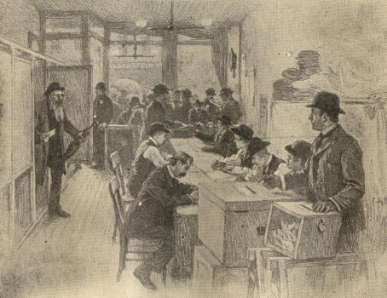
A New York Polling Place, showing booths on the left,

1890] DRIFT AND DYE IN LAW-MAKING 23

An official ballot replaced the privately--often dishonestly--prepared party ballots formerly hawked about each polling place by political workers. The new ballot was a "blanket," bearing a list of all the candidates for each office to be filled. The arrangement of candidates' names varied in different States. By one style of ticket it was easy for the illiterate or the straight-out party man to mark party candidates. Another made voting difficult for the ignorant, but a delight to the discriminating.
The new ballot, though certainly an improvement, failed to produce the full results expected of it. The connivance of election officials and corrupt voters often annulled its virtue by devices growing in variety and ingenuity as politicians became acquainted with the reform. Statutes and sometimes constitutions therefore went further, making the count of ballots public, ordering it carried out near the polling place, and allowing municipalities to insure a still more secret vote and an instantaneous, unerring tally by the use of voting machines.
In the North and West the tendency of the new fundamental laws was to widen the suffrage, rendering it, for males over twenty-one years of age, practically universal.
24 EXPANSION [1890

Woman suffrage, especially on local and educational matters, spread more and more, Wyoming, Colorado, Idaho, and Utah women voted upon exactly the same terms as men, In Idaho women sat in the legislature. There was much agitation for minority representation. Illinois set an example by the experiment of cumulative voting in the election of lower house members of the legislature.
Nearly everywhere at the South constitutional reform involved negro disfranchisement. The blacks were numerous, but their rule meant ruin. It was easy for the whites to keep them in check, as had been done for years, by bribery and threats, supplemented, when necessary, by flogging and the shotgun, But this gave to the rising generation of white men the worst possible sort of a political education. The system was too barbarous to continue. What meaning could free institutions have for young voters who had never in all their lives seen an election carried save by these vicious means! New constitutions which should legally eliminate most of the negro vote were the alternative.
1890] DRIFT AND DYE IN LAWMAKING 25

In Florida, Alabama, Tennessee, Arkansas, Louisiana, Mississippi, Georgia, North and South Carolina, proof of having paid taxes or poll-taxes was (as in some northern and western States) made an indispensable prerequisite to voting, either alone or as an alternative for an educational qualification. Virginia used this policy until 1882 and resumed it again in 1902, cutting off such as had not paid or had failed to preserve or bring to the polls their receipts. Many States surrounded registration and voting with complex enactments. An educational qualification, often very elastic, sometimes the voter's alternative for a tax-receipt, was resorted to by Alabama, Arkansas, Mississippi, Tennessee, and South Carolina. Georgia in 1898 rejected such a device. Alabama hesitated, jealous lest illiterate whites should lose their votes. But, after the failure of one resolution for a convention, this State, too, upon the stipulation that the new constitution should disfranchise no white voter and that it should be submitted to the people for ratification, not promulgated directly by its authors as was done in South Carolina, Louisiana, and later in Virginia and Delaware, consented to a revision, which was ratified at the polls November, 1901, not escaping censure for its drastic thoroughness.
26 EXPANSION [1890

Its distinctive feature was the "good character clause," whereby an appointment board in each county registers "all voters under the present [previous] law" who are veterans or the lawful descendants of such, and "all who are of good character and understand the duties and obligations of citizenship."
In the above line of constitution-framing, whose problem was to steer between the Scylla of the Fifteenth Amendment and the Charybdis of negro domination, viz., legally abridge the negro vote so as to insure Caucasian supremacy at the polls, Mississippi led. The "Mississippi plan," originating, it is believed, in the brain of Senator James Z. George, had for its main features a registry tax and an educational qualification, all adjustable to practical exigencies.

1890] DRIFT AND DYE IN LAWMAKING 27

Each voter must pay a poll-tax of at least $2.00 and never to exceed $3.00, producing to the election overseers satisfactory evidence of having paid such poll and all other legal taxes. He must be registered "as provided by law" and "be able to read any section of the constitution of the State, to understand the same when read to him, or to give a reasonable interpretation thereof." In municipal elections electors were required to have "such additional qualifications as might be prescribed by law."
This constitution was attacked as not having been submitted to the people for ratification and as violating the Act of Congress readmitting Mississippi; but the State Supreme Court sustained it, and was confirmed in this by the United States Supreme Court in dealing with the similar Louisiana constitution.
As a spur to negro education the Mississippi constitution worked well. The Mississippi negroes who got their names on the voting list rose from 9,036 in 1892 to 16,965 in 1895.
28 EXPANSION [1890

This result of the "plan" did not deter South Carolina from adopting it. Dread of negro domination haunted the Palmetto State the more in proportion as her white population, led by the enterprising Benjamin R. Tillman, who became governor and then senator, got control and set aside the "Bourbons."

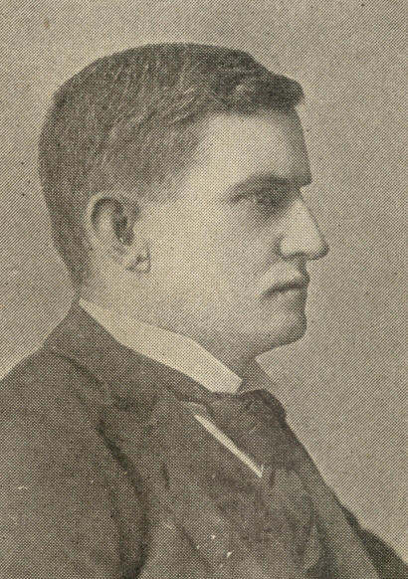
Benjamin R. Tillman

So early as 1882 South Carolina passed a registration act which, amended in 1893 and 1894, compelled registration some four months before ordinary elections and required registry certificates to be produced at the polls. Other laws made the road to the ballot-box a labyrinth wherein not only most negroes but some whites were lost. The multiple ballot-boxes alone were a Chinese puzzle.

1890] DRIFT AND DYE IN LAW-MAKING 29

This act was attacked as repugnant to the State and to the federal constitution. On May 8, 1895, Judge Goff of the United States Circuit Court declared it unconstitutional and enjoined the State from taking further action under it. But in June the Circuit Court of Appeals reversed Judge Goff and dissolved the injunction, leaving the way open for a convention.
The convention met on September 10th and adjourned on December 4, 1895. By the new constitution the Mississippi plan was to be followed until January 1, 1898. Any male citizen could be registered who was able to read a section of the constitution or to satisfy the election officers that he understood it when read to him. Those thus registered were to remain voters for life. After the date named applicants for registry must be able both to read and to write any section of the constitution or to show tax-receipts for poll-tax and for taxes on at least $300 worth of property. The property and the intelligence qualification each met with strenuous opposition, but it was thought that neither alone would serve the purpose.
30 EXPANSION [1890

The Louisiana constitution of 1898, in place of the Mississippi "understanding" clause or the Alabama "good character" clause, enacted the celebrated "grandfather" clause. The would-be voter must be able to read and write English or his native tongue, or own property assessed at $300 or more; but any citizen who was a voter on January I, 1867, or his son or his grandson, or any person naturalized prior to January 1, 1898, if applying for registration before September 1, 1898, might vote, notwithstanding both illiteracy and poverty. Separate registration lists were provided for whites and blacks, and a longer term of residence required in State, county, parish, and precinct before voting than by the constitution of 1879.
North Carolina adopted her suffrage amendment in 1900. It lengthened the term of residence before registration and enacted both educational qualification and prepayment of poll-tax, only exempting from this tax those entitled to vote January 1, 1867.
1890] DRIFT AND DYE IN LAWMAKING 31

In 1902 Virginia adopted an instrument with the "understanding cause for use until 1904, hedging the suffrage after that date by a poll-tax. Application for registration must be in the applicant's handwriting, written in the presence of the registrar.
White solidarity yielding with time, there were heard in the Carolinas, Alabama, and Louisiana, loud allegations, not always unfounded, that this side or that had availed itself of negro votes to make up a deficit or turned the enginery of vote suppression against its opponents' white supporters.
Most States which overthrew negro suffrage seemed glad to think of the new regime as involving no perjury, fraud, violence, or lese-constitution. Some of Alabama's spokesmen were of a different temper, paying scant heed to the federal questions involved. "The constitution of '75," they said, "recognized the Fifteenth Amendment, which Alabama never adopted, and guaranteed the negro all the rights of suffrage the white man enjoys. The new constitution omits that section. Under its suffrage provisions the white man will rule for all time in Alabama."
32 EXPANSION [1890

The North, once ablaze with zeal for the civil and political rights of the southern negro, heard the march of this exultant southern crusade with equanimity, with indifference, almost with sympathy. Perfunctory efforts were made in Congress to secure investigation of negro disfranchisement, but they evoked feeble response.
CHAPTER II.

THE PRESIDENTIAL CAMPAIGN OF 1888

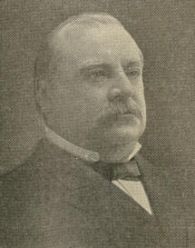
Grover Cleveland.
Photograph copyrighted by C. M. Bell.

It looking forward to the presidential campaign of 1888 the Democracy had no difficulty in selecting its leader or its slogan. The custom, almost like law, of renominating a presidential incumbent at the end of his first term, pointed to Mr. Cleveland's candidacy, as did the considerable success of his administration in quelling factions and in silencing enemies. At the same time reform for a lower tariff, with which cause he had boldly identified himself, was marked anew as a main article of the Democratic creed.
34 EXPANSION [1888

The nomination of Allen G. Thurman for Vice-President brought to the ticket what its head seemed to lack--popularity among the people of the West--and did much to hearten all such Democrats as insisted upon voting a ticket free from all taint of mugwumpery.

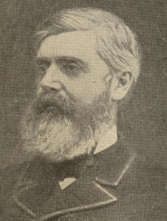
W. Q. Gresham.

The attitude of the Democratic party being favorable to tariff reduction, the Republicans must perforce raise the banner of high protection; but public opinion did not forestall the convention in naming the Republican standard-bearer. The convention met in Chicago. At first John Sherman of Ohio received 229 votes; Walter Q. Gresham of Indiana, 111; Chauncey M. Depew of New York, 99; and Russell A. Alger of Michigan, 84. Harrison began with 80; Blaine had but 35.

1888] PRESIDENTIAL CAMPAIGN OF 1888 35

After the third ballot Depew withdrew his name. On the fourth, New York and Wisconsin joined the Harrison forces. A stampede of the convention for Blaine was expected, but did not come, being hindered in part by the halting tenor of despatches received from the Plumed Knight, then beyond sea. After the fifth ballot two cablegrams were received from Blaine, requesting his friends to discontinue voting for him. Two ballots more having been taken, Allison, who had been receiving a considerable vote, withdrew. The eighth ballot nominated Harrison, and the name of Levi P. Morton, of New York, was at once placed beneath his on the ticket.

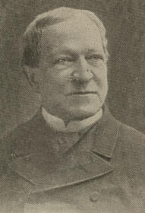
Levi P. Morton.

36 EXPANSION [1888

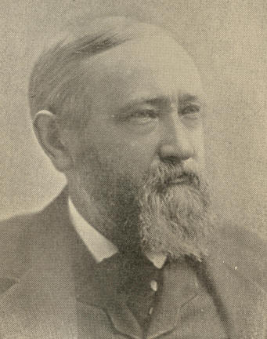
Benjamin Harrison.

1888] PRESIDENTIAL CAMPAIGN OF I888 37

Mr. Harrison was the grandson of President William Henry Harrison, great grandson, therefore, of Governor Benjamin Harrison, of Virginia, the ardent revolutionary patriot, signer of the Declaration of Independence. An older scion of the family had served as major-general in Cromwell's army and been executed for signing the death-warrant of King Charles I. The Republican candidate was born on a farm at North Bend, Ohio, August 20, 1883. The boy's earliest education was acquired in a log schoolhouse. He afterward attended Miami University, in Ohio, where he graduated at the age of nineteen. The next year he was admitted to the bar. In 1854 he married, and opened a law office in Indianapolis. In 1860 he became Reporter of Decisions to the Indiana Supreme Court. When the civil war broke out, obeying the spirit that in his grandfather had won at Tippecanoe and the Thames, young Harrison recruited a regiment, of which he was soon commissioned colonel. Gallant services under Sherman at Resaca and Peach Tree Creek brought him the brevet of brigadier. After his return from war, owing to his high character, his lineage, his fine war record, his power as a speaker and his popularity in a pivotal State, he was a prominent figure in politics, not only in Indiana, but more and more nationally. In 1876 he ran for the Indiana Governership, but was defeated by a small margin. In 1880 he was chairman of the Indiana delegation to the Republican National Convention.
38 EXPANSION [1888

In 1881 he was elected United States Senator, declining an offer of a seat in Garfield's Cabinet. From 1880, when Indiana presented his name to the Republican National Convention, General Harrison was, in the West, constantly thought of as a presidential possibility. Eclipsed by Blaine in 1884, he came forward again in 1888, this time to win.
In the East General Harrison was much underrated. Papers opposing his election fondly cartooned him wearing "Grandfather's hat," as if family connection alone recommended him. It was a great mistake. The grandson had all the grandsire's strong qualities and many besides. He was a student and a thinker. His character was absolutely irreproachable. His information was exact, large, and always ready for use. His speeches had ease, order, correctness, and point. With the West he was particularly strong, an element of availability which Cleveland lacked. In the Senate he had won renown both as a debater and as a sane adviser.

1888] PRESIDENTIAL CAMPAIGN OF 1888 39

As a consistent protectionist he favored restriction upon Chinese immigration and prohibition against the importation of contract labor. He upheld all efforts for reform in the civil service and for strengthening the navy.
In the presidential campaign of 1888 personalities had little place. Instead, there was active discussion of party principles and policies. The tariff issue was of course prominent. A characteristic piece of enginery in the contest was the political club, which now, for the first time in our history, became a recognized force. The National Association of Democratic Clubs comprised some 3,000 units, numerous auxiliary reform and tariff reform clubs being active on the same side. The Republican League, corresponding to the Democratic Association, boasted, by August, 1887, 6,500 clubs, with a million voters on their rolls. Before election day Indiana alone had 1,100 Republican clubs and New York 1,400.

40 EXPANSION [1888

During most of the campaign Democratic success was freely predicted and seemed assured. Yet from the first forces were in exercise which threatened a contrary result. Federal patronage helped the administration less than was expected, while it nerved the opposition. The Republicans had a force of earnest and harmonious workers. Of the multitude, on the other hand, who in 1884 had aided to achieve victory for the Democracy, few, of course, had received the rewards which they deemed due them. In vain did officeholders contribute toil and money while that disappointed majority were so slow and spiritless in rallying to the party's summons, and so many of them even hostile. The zeal of honest Democrats was stricken by what Gail Hamilton wittily called "the upas bloom" of civil service reform, which the President still displayed upon his lapel. To a large number of ardent civil service reformers who had originally voted for Cleveland this decoration now seemed so wilted that, more in indignation than in hope, they went over to Harrison.
1888] PRESIDENTIAL CAMPAIGN OF 1888 41

The public at large resented the loss which the service had suffered through changes in the civil list. Harrison without much of a record either to belie or to confirm his words, at least commended and espoused the reform.
Democratic blunders thrust the sectional issue needlessly to the fore. Mr. Cleveland's willingness to return to their respective States the Confederate flags captured by Union regiments in the civil war; his fishing trip on Memorial Day; the choice of Mr. Mills, a Texan, to lead the tariff fight in Congress; and the prominence of southerners among the Democratic campaign orators at the North, were themes of countless diatribes.
A clever Republican device, known as "the Murchison letter," did a great deal to impress thoughtless voters that Mr. Cleveland was "un-American." The incident was dramatic and farcical to a degree. The Murchison letter, which interested the entire country for two or three weeks, purported to come from a perplexed Englishman, addressing the British Minister at Washington, Lord Sackville-West.
42 EXPANSION [1888

It sought counsel of Her Majesty's representative, as the "fountainhead of knowledge," upon "the mysterious subject" how best to serve England in voting at the approaching American election. The seeker after light recounted President Cleveland's kindness to England in not enforcing the retaliatory act then recently passed by Congress as its ultimatum in the fisheries dispute, his soundness on the free trade question, and his hostility to the "dynamite schools of Ireland." The writer set Mr. Harrison down as a painful contrast to the President. He was "a high-tariff man, a believer on the American side of all questions, and undoubtedly, an enemy to British interests generally."

1888] PRESIDENTIAL CAMPAIGN OF 1888 43

But the inquirer professes alarm at Cleveland's message on the fishery question which had just been sent to Congress, and wound up with the query "whether Mr. Cleveland's policy is temporary only, and whether he will, as soon as he secures another term of four years in the presidency, suspend it for one of friendship and free trade."

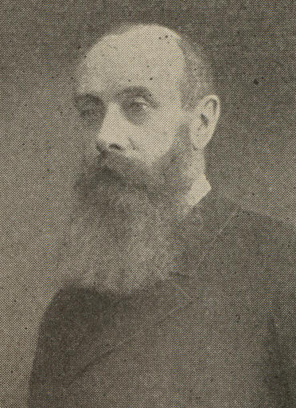
Lord L. S. Sackville-West.

The Minister replied:
"Sir:--I am in receipt of your letter of the 4th inst., and beg to say that I fully appreciate the difficulty in which you find yourself in casting your vote. You are probably aware that any political party which openly favored the mother country at the present moment would lose popularity, and that the party in power is fully aware of the fact. The party, however, is, I believe, still desirous of maintaining friendly relations with Great Britain and still desirous of settling questions with Canada which have been, unfortunately, reopened since the retraction of the treaty by the Republican majority in the Senate and by the President's message to which you allude. All allowances must therefore be made for the political situation as regards the Presidential election thus created.
44 EXPANSION [1888

It is, however, impossible to predict the course which President Cleveland may pursue in the matter of retaliation should he be elected; but there is every reason to believe that, while upholding the position he has taken, he will manifest a spirit of conciliation in dealing with the question involved in his message. I enclose an article from the New York 'Times' of August 22d, and remain. yours faithfully,
"L. S. SACKVILLE-WEST."

This correspondence, published on October 24th, took instant and universal effect. The President at first inclined to ignore the incident, but soon yielded to the urgency of his managers, and, to keep "the Irish vote" from slipping away, asked for the minister's recall. Great Britain refusing this, the minister's passports were delivered him. The act was vain and worse. Without availing to parry the enemy's thrust, it incurred not only the resentment of the English Government, but the disapproval of the Administration's soberest friends at home.

1888] PRESIDENTIAL CAMPAIGN OF 1888 45

Influences with which practical politicians were familiar had their bearing upon the outcome. In New York State, where occurred the worst tug of war, Governor Hill and his friends, while boasting their democracy, were widely believed to connive at the trading of Democratic votes for Harrison in return for Republican votes for Hill. At any rate, New York State was carried for both.
It is unfortunately necessary to add that the 1888 election was most corrupt. The campaign was estimated to have cost the two parties $6,000,000. Assessments on office-holders, as well as other subsidies, replenished the Democrats' campaign treasury; while the manufacturers of the country, who had been pretty close four years before, now regarding their interest and even their honor as assailed, generously contributed often as the Republican hat went around.
In Indiana, Mr. Harrison's home State, no resource was left untried. The National Republican Committee wrote the party managers in that State: "Divide the floaters into blocks of five, and put a trusted man with necessary funds in charge of these five, and make him responsible that none get away, and that all vote our ticket." This mandate the workers faithfully obeyed.
46 EXPANSION [1888

So far as argument had weight the election turned mainly upon the tariff issue. The Republicans held that protection was on trial for its life. Many Democrats cherished the very same view, only they denounced the prisoner at the bar as a culprit, not a martyr. They inveighed against protection as pure robbery. They accused the tariff of causing Trusts, against which several bills had recently been introduced in Congress. Democratic extremists proclaimed that Republicans slavishly served the rich and fiendishly ground the faces of the poor. Even moderate Democrats, who simply urged that protective rates should be reduced, more often than otherwise supported their proposals with out and out free trade arguments.

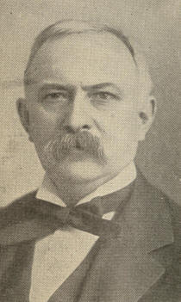
Joseph B. Foraker
1888] PRESIDENTIAL CAMPAIGN OF 1888 47

As to President Cleveland himself no one could tell whether or not he was a free trader, but his discussions of the tariff read like Cobden Club tracts. The Mills bill, which passed the House in the Fiftieth Congress, would have been more a tariff for revenue than in any sense protective. Republican orators and organs therefore pictured "British free trade" as the dire, certain sequel of the Cleveland policy if carried out, and, whether convinced by the argument or startled by the ado of Harrison's supporters, people, to be on the safe side, voted to uphold the "American System."
More than eleven million ballots were cast at the election, yet so closely balanced were the parties that a change of 10,000 votes in Indiana and New York, both of which went for Harrison would have reelected Cleveland. As it was, his popular vote of 5,540,000 exceeded by 140,000 that of Harrison, which numbered 5,400,000.
48 EXPANSION [1888

Besides bolding the Senate the Republicans won a face majority of ten in the House, subsequently increased by unseating and seating. They were thus in control of all branches of the general government.
CHAPTER III.

MR. HARRISON'S ADMINISTRATION.

The new President, of course, renounced his predecessor's policy upon the tariff, but continued it touching the navy. He advocated steamship subsidies, reform in electoral laws, and such amendment to the immigration laws as would effectively exclude undesirable foreigners.
A chief effect of the Kearney movement in California, culminating in the California constitution of 1879, was intense opposition throughout the Pacific States to any further admission of the Chinese. The constitution named forbade the employment of Chinese by the State or by any corporation doing business therein. This hostility spread eastward, and, in spite of interested capitalists and disinterested philanthropists, shaped all Subsequent Chinese legislation in Congress. The pacific spirit of the Burlingame treaty in 1868, shown also by President Hayes in vetoing the Anti-Chinese bill of 1878, died out more and more.
50 EXPANSION [1888

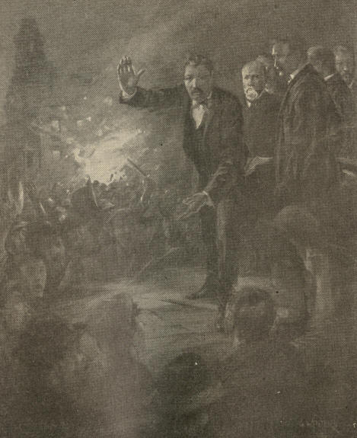
"The Chinese must go!"
Denis Kearney addressing the working-men
on the night of October 29, on Nob Hill, San Francisco.

1888] MR. HARRISON'S ADMINISTRATION 51

A law passed in 1881 provided that Chinese immigration might be regulated, limited, or suspended by the United States. A bill prohibiting such immigration for twenty years was vetoed by President Arthur, but another reducing the period to ten years became law in 1882. In 1888 this was amended to prohibit the return of Chinese laborers who had been in the United States but had left. In 1892 was passed the Geary law re-enacting for ten years more the prohibitions then in force, only making them more rigid. Substantially the same enactments were renewed in 1902.
Mr. Harrison wished this policy of a closed state put in force against Europe as well as against Asia. An act of Congress passed August 2, 1882, prohibited the landing from any country of any would-be immigrant who was a convict, lunatic, idiot, or unable to take care of himself. This law, like the supplementary one of March 3, 1887, proved inadequate. In 1888 American consuls represented that transatlantic steamship companies were employing unscrupulous brokers to procure emigrants for America, the brokerage being from three to five dollars per head, and that most emigrants were of a class utterly unfitted for citizenship.
52 EXPANSION [1888

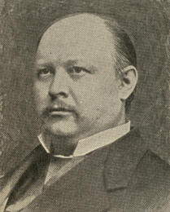
Thomas B. Reed.

The President's urgency in this matter had little effect, the attention of Congress being early diverted to other subjects. Three great measures mainly embodied the Republican policy--the Federal Elections Bill, the McKinley Tariff Bill, and the Dependent Pensions Bill.
As Speaker of the House, Hon. Thomas B. Reed, of Maine, put through certain parliamentary innovations necessary to enact the party's will. He declined to entertain dilatory motions. More important, he ordered the clerk to register as "present and not voting," those whom he saw endeavoring by stubborn silence to break a quorum.

1888] MR. HARRISON'S ADMINISTRATION 53

A majority being the constitutional quorum, theretofore, unless a majority answered to their names upon roll-call, no majority appeared of record, although the sergeant-at-arms was empowered to compel the presence of every member. As the traditional safeguard of minorities and as a compressed airbrake on majority action, silence became more powerful than words. Under the Reed theory, since adopted, that the House may, through its Speaker, determine in its own way the presence of a quorum, the Speaker's or the clerk's eye was substituted for the voice of any member in demonstrating such member's presence.
Many, not all Democrats, opposed the Reed policy as arbitrary. Mr. Evarts is said to have remarked, "Reed, you seem to think a deliberative body like a woman; if it deliberates, it is lost." On the "yeas and nays" or at any roll-call some would dodge out of sight, others break for the doors only to find them closed. A Texas member kicked down a door to make good his escape.
54 EXPANSION [1888

Yet, having calculated the scope of his authority, Mr. Reed coolly continued to count and declare quorums whenever such were present. The Democratic majority of 1893 transferred this newly discovered prerogative of the Speaker, where possible, to tellers. Now and then they employed it as artillery to fire at Mr. Reed himself, but he each time received the shot with smiles.
The cause for which the counting of quorums was invoked made it doubly odious to Democratic members. To restore the suffrage to southern negroes the Republicans proposed federal supervision of federal elections. This suggestion of a "Force Bill" rekindled sectional bitterness. One State refused to be represented at the World's Columbian Exposition of 1893, a United States marshal was murdered in Florida, a Grand Army Post was mobbed at Whitesville, Ky. Parts of the South proposed a boycott on northern goods.
1888] MR. HARRISON'S ADMINISTRATION 55

Many at the North favored white domination in the South rather than a return of the carpet-bag regime, regarding the situation a just retribution for Republicans' highhanded procedure in enfranchising black ignorance. Sober Republicans foresaw that a force law would not break up the solid South, but perpetuate it. The House, however, passed the bill. In the Senate it was killed only by "filibuster" tactics, free silver Republican members joining members from the South to prevent the adoption of cloture.
A Treasury surplus of about $97,000,000 (in October, 1888) tempted the Fifty-first Congress to expenditures then deemed vast, though often surpassed since. The Fifty-first became known as the "Billion Dollar Congress." What drew most heavily upon the national strong-box was the Dependent Pensions Act. In this culminated a course of legislation repeating with similar results that which began early in the history of our country, occasioning the adage that "The Revolutionary claimant never dies." By 1820 the experiment entailed an expenditure of a little over twenty-five cents per capita of our population.
56 EXPANSION [1888

In 1880 Congress was induced to endow each pensioner with a back pension equal to what his pension would have been had he applied on the date of receiving his injury. Under the old law pension outlay had been at high tide in 1871, standing then at $34,443,894. Seven years later it shrank to $27,137,019. In 1883 it exceeded $66,000,000; in 1889 it approached $88,000,000. But the act of 1890, similar to one vetoed by President Cleveland three years before, carried the pension figure to $106,493,000 in 1890, to $118,584,000 in 1891, and to about $159,000,000 in 1893. It offered pensions to all soldiers and sailors incapacitated for manual labor who had served the Union ninety days, or, if they were dead, to their widows, children, or dependent parents. 311,567 pension certificates were issued during the fiscal year 1891-1892.

1888] MR. HARRISON'S ADMINISTRATION 57

While thus increasing outgo, the Fifty-first Congress planned to diminish income, not by lowering tariff rates, as the last Administration had recommended, but by pushing them up to or toward the prohibitive point. The McKinley Act, passed October 1, 1890, made sugar, a lucrative revenue article, free, and gave a bounty to sugar producers in this country, together with a discriminating duty of one-tenth of a cent per pound on sugar imported hither from countries which paid an export bounty thereon.
The "Blaine" reciprocity feature of this act proved its most popular grace. In 1891 we entered into reciprocity agreements with Brazil, with the Dominican Republic, and with Spain for Cuba and Porto Rico. In 1892 we covenanted similarly with the United Kingdom on behalf of the British West Indies and British Guiana, and with Nicaragua, Salvador, Honduras, Guatemala and Austria-Hungary. How far our trade was thus benefited is matter of controversy. Imports from these countries were certainly much enlarged. Our exportation of flour to these lands increased a result commonly ascribed to reciprocity, though the simultaneous increase in the amounts of flour we sent to other countries was a third more rapid.
58 EXPANSION [1888

The international copyright law, meeting favor with the literary, was among the most conspicuous enactments of the Fifty-first Congress. An international copyright treaty had been entered into in 1886, but it did not include the United States. Two years later a bill to the same end failed in Congress. At last, on March 3, 1891, President Harrison signed an act which provided for United States copyright for any foreign author, designer, artist, or dramatist, albeit the two copies of a book, photograph, chromo, or lithograph required to be deposited with the Librarian of Congress must be printed from type set within the limits of the United States or from plates made therefrom, or from negatives or drawings on stone made within the limits of the United States or from transfers therefrom. Foreign authors, like native or naturalized, could renew their United States copyrights, and penalties were prescribed to protect these rights from infringement.
1891] MR. HARRISON'S ADMINISTRATION 59

Mr. Blaine, the most eminent Republican statesman surviving, was now less conspicuous than McKinley, Lodge, and Reed, with whom, by his opposition to extreme protection and to the Force Bill, he stood at sharp variance. As Secretary of State, however, to which post President Harrison had perforce assigned him, he still drew public attention, having to deal with several awkward international complications.

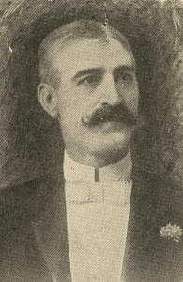
David C. Hennessy.

The city of New Orleans, often tempted to appeal from bad law to anarchy, was in the spring of 1891 swept off its feet by such a temptation. Chief of Police David C. Hennessy was one night ambushed and shot to death near his home by members of the Sicilian "Mafia," a secret, oath-bound body of murderous blackmailers whom he was hunting to earth. When at the trial of the culprits the jury, in face of cogent evidence, acquitted six and disagreed as to the rest, red fury succeeded white amazement. A huge mob encircled the jail, crushed in its barricaded doors, and shot or hung the trembling Italians within.
60 EXPANSION [1891

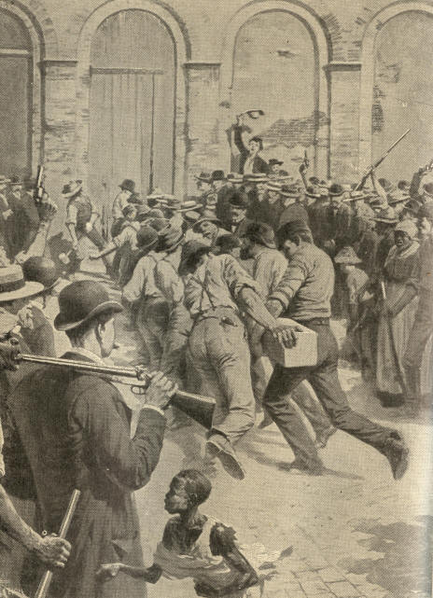
An episode of the lynching of the Italians in New Orleans.
The citizens breaking down the door of the parish prison with
the beam brought there the night before for that purpose.
1891] MR. HARRISON'S ADMINISTRATION 61

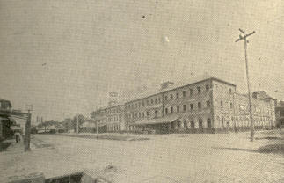
Old Parish Jail, New Orleans, La.

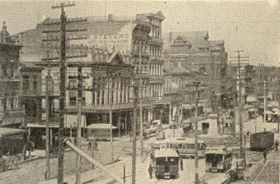
Canal Street. New Orleans La.

62 EXPANSION [1891

Italy forthwith sent her protest to Mr. Blaine, who expressed his horror at the deed, and urged Governor Nicholls to see the guilty brought to justice. The Italian consul at New Orleans averred that, while the victims included bad men, many of the charges against them were without foundation; that the violence was foreseen and avoidable; that he had in vain besought military protection for the prisoners, and had himself, with his secretary, been assaulted and mobbed.
The Marquis di Rudini insisted on indemnity for the murdered men's families and on the instant punishment of the assassins. Secretary Blaine, not refusing indemnity in this instance, denied the right to demand the same, still more the propriety of insisting upon the instant punishment of the offenders, since the utmost that could be done at once was to institute judicial proceedings, which was the exclusive function of the State of Louisiana. The Italian public thought this equivocation, mean truckling to the American prejudice against Italians. Baron Fava, Italian Minister at Washington, was ordered to "affirm the inutility of his presence near a government that had no power to guarantee such justice as in Italy is administered equally in favor of citizens of all nationalities." "I do not," replied Mr. Blaine, "recognize the right of any government to tell the United States what it shall do; we have never received orders from any foreign power and shall not begin now. It is to me," he said, "a matter of indifference what persons in Italy think of our institutions. I cannot change them, still less violate them."
1891] HARRISON'S ADMINISTRATION 63

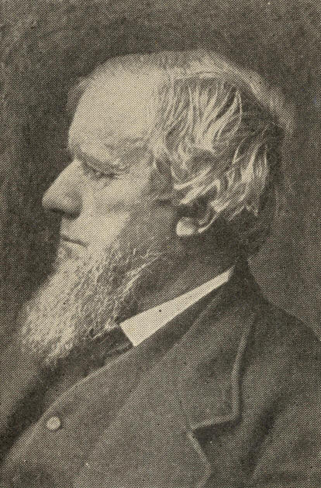
A. G. Thurman.

Such judicial proceedings as could be had against the lynchers broke down completely. The Italian Minister withdrew, but his government finally accepted $25,000 indemnity for the murdered men's families.
Friction with Chile arose from the "Itata incident." Chile was torn by civil war between adherents of President Balmaceda and the "congressional party." Mr. Egan, American Minister at Santiago, rendered himself widely unpopular among Chilians by his espousal of the President's cause.
64 EXPANSION [1891

The Itata, a cruiser in the congressionalist service, was on May 6, 1891, at Egan's request, seized at San Diego, Cal., by the federal authorities, on the ground that she was about to carry a cargo of arms to the revolutionists. Escaping, she surrendered at her will to the United States squadron at Iquique.

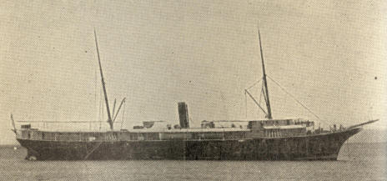
Chilian steamer Itata in San Diego Harbor.

The congressionalists resented our interference; the Balmaceda party were angry that we interfered to so little effect. A Valparaiso mob killed two American sailors and hurt eighteen more. Chile, however, tendered a satisfactory indemnity.

1890] MR. HARRISON'S ADMINISTRATION 65

In the so-called "Barrundia incident" occurring in 1890 Americanism overshot itself. The Gautemalan refugee, General Barrundia, boarded the Pacific Mail steamer Acapulco for Salvador upon assurance that he would not be delivered to the authorities of his native land. At San Jose de Gautemala the Gautemala authorities sought to arrest him, and United States Minister Mizner, Consul-General Hosmer, and Commander Reiter of the United States Ship of War Ranger, concurred in advising Captain Pitts of the Acapulco that Gautemala had a right to do this. Barrundia resisted arrest and was killed. Both Mizner and Reiter were reprimanded and removed, Reiter being, however, placed in another command.
Our government's attitude in this matter was untenable. The two officials were in fact punished for having acted with admirable judgment and done each his exact duty.

66 EXPANSION [1890

One of President Harrison's earliest diplomatic acts was the treaty of 1889 with Great Britain and Germany, by which, in conjunction with those nations, the United States established a joint protectorate over the Samoan Islands. On December 2, 1899, the three powers named agreed to a new treaty, by which the United States assumed full sovereignty over Tutuila and all the other Samoan islands east of longitude 171 degrees west from Greenwich, renouncing in favor of the other signatories all rights and claims over the remainder of the group.
In the congressional campaign of 1890 issue was squarely joined upon the neoRepublican policy. The billion dollars gone, the Force Bill, and, to a less extent, the McKinley tariff, especially its sugar bounty, had aroused popular resentment. The election, an unprecedented "landslide," precipitated a huge Democratic majority into the House of Representatives. Every community east of the Pacific slope felt the movement. Pennsylvania elected a Democratic governor.
67

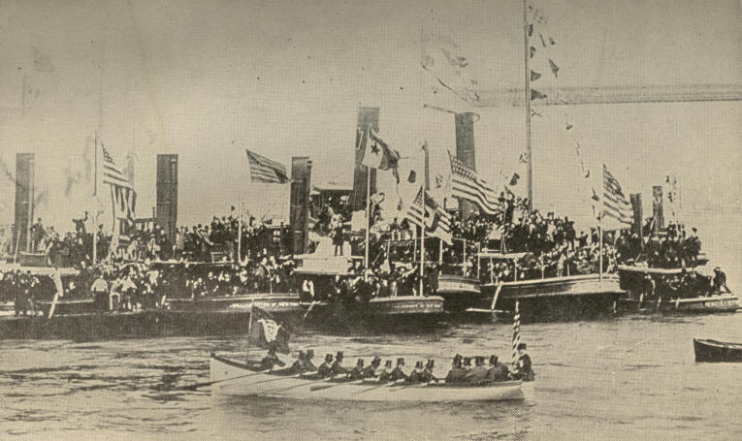
President Harrison being rowed ashore at foot of Wall Street,
New York, April 29, 1889.
68
CHAPTER IV.

NON-POLITICAL EVENTS OF PRESIDENT HARRISON'S TERM

President Harrison's quadrennium was a milestone between two generations. Memorials on every hand to the heroes of the Civil War shocked one with the sense that they and the events they molded were already of the past. Logan, Arthur, Sheridan, and Hancock had died. In 1891 General Sherman and Admiral Porter fell within a day of each other. General Joseph E. Johnston, who had been a pall-bearer at the funeral of each, rejoined them in a month.

70 EXPANSION [1889

This presidential term was pivotal in another way. The centennial anniversary of Washington's inauguration as President fell on April 30, 1889. In observance of the occasion President Harrison followed the itinerary of one hundred years before, from the Governor's mansion in New Jersey to the foot of Wall Street, in New York City, to old St. Paul's Church, on Broadway, and to the site where the first Chief Magistrate first took the oath of office. Three days devoted to the commemorative exercises were a round of naval, military, and industrial parades, with music, oratory, pageantry, and festivities. For this Centennial Whittier composed an ode. The venerable Rev. S. F. Smith, who had written "America" fifty-seven years before, was also inspired by the occasion to pen a Century Hymn, and to add to "America" the stanza:

"Our joyful hearts to-day,
Their grateful tribute pay,
Happy and free,
After our toils and fears,
After our blood and tears,
Strong with our hundred years,
O God, to Thee."

71

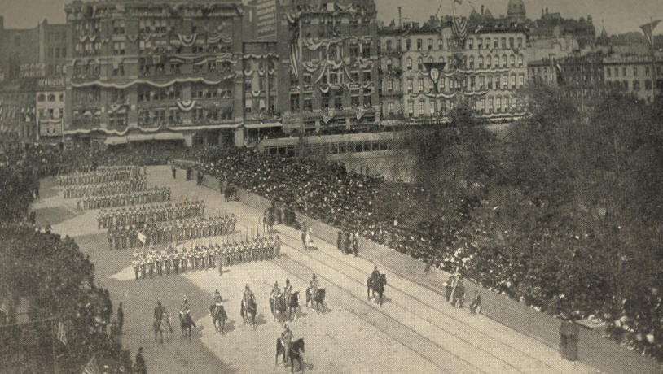
Washington Inaugural Celebration, 1889, New York.
Parade passing Union Square on Broadway.
72
1890] EVENTS OF HARRISON'S TERM 73

At the opening of this its second century of existence the nation was confronted by entirely new issues. Bitterness between North and South, spite of its brief recrudescence during the pendency of the Force Bill, was fast dying out. At the unveiling of the noble monument to Robert E. Lee at Richmond, in May, 1890, while, of course, Confederate leaders were warmly cheered and the Confederate flag was displayed, various circumstances made it clear that this zeal was not in derogation of the restored Union.
The last outbreaks of sectional animosity related to Jefferson Davis, in whom, both to the North and to the South, the ghost of the Lost Cause had become curiously personified. The question whether or not he was a traitor was for years zealously debated in Congress and outside. The general amnesty after the war had excepted Davis. When a bill was before Congress giving suitable pensions to Mexican War soldiers and sailors, an amendment was carried, amid much bitterness, excluding the ex-president of the Confederacy from the benefits thereof. Northerners naturally glorified their triumph in the war as a victory for the Constitution, nor could they wholly withstand the inclination to question the motives of the secession leaders. Southerners, however loyal now to the Union, were equally bold in asserting that, since in 1861 the question of the nature of the Union had not been settled, Mr. Davis and the rest might attempt secession, not as foes of the Constitution, but as, in their own thought, its most loyal friends and defenders.
74 EXPANSION [1890

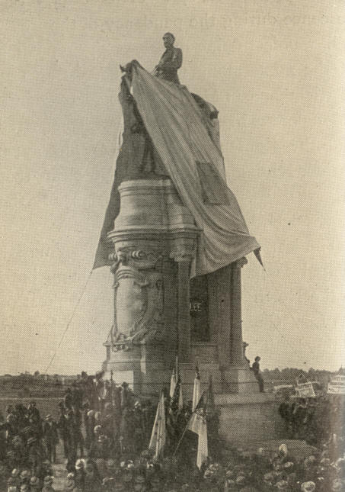
Unveiling of the Equestrian Statue
of Robert E. Lee, May 29. 1890.

1890] EVENTS OF HARRISON'S TERM 75

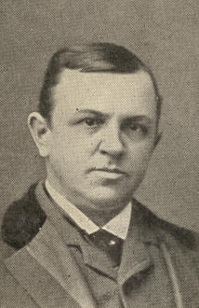
Henry W. Grady.

By 1890 the days were passed when denunciation of Davis or of the South electrified the North, nor did the South on its part longer waste time in impotent resentments or regrets. The brilliant and fervid utterances on "The New South" by editor Henry W. Grady, of the Atlanta Constitution, went home to the hearts of Northerners, doing much to allay sectional feeling. Grady died, untimely, in 1889, lamented nowhere more sincerely than at the North.
76 EXPANSION [1890

When Federal intervention occurred to put down the notorious Louisiana Lottery, the South in its gratitude almost forgot that there had been a war. This lottery had been incorporated in 1868 for twenty-five years. In 1890 it was estimated to receive a full third of the mail matter coming to New Orleans, with a business of $30,000 a day in postal notes and money orders. As the monster in 1890, approaching its charter-term, bestirred itself for a new lease of life, it found itself barred from the mails by Congress.
And this was, in effect, its banishment from the State and country. It could still ply its business through the express companies, provided Louisiana would abrogate the constitutional prohibition of lotteries it had enacted to take effect in 1893. For a twenty-five year re-enfranchisement the impoverished State was offered the princely sum of a million and a quarter dollars a year. This tempting bait was supplemented by influences brought to bear upon the venal section of the press and of the legislature.
1890] EVENTS OF HARRISON'S TERM 77

A proposal for the necessary constitutional change was vetoed by Governor Nicholls. Having pushed their bill once more through the House, the lottery lobby contended that a proposal for a constitutional amendment did not require the governor's signature, but only to be submitted to the people, a position which was affirmed by the State Supreme Court. A fierce battle followed in the State, the "anti" Democrats of the country parishes, in fusion with Farmers' Alliance men, fighting the "pro" Democrats of New Orleans.

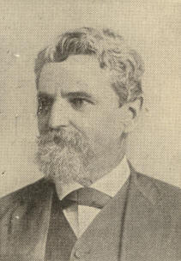
Francis T. Nicholls.

78 EXPANSION [l889

The "Antis" and the Alliance triumphed. Effort for a constitutional amendment was given up, and Governor Foster was permitted to sign an act prohibiting, after December 31, 1893, all sale of lottery tickets and all lottery drawings or schemes throughout the State of Louisiana. In January, 1894, the Lottery Company betook itself to exile on the island of Cuanaja, in the Bay of Honduras, a seat which the Honduras Government had granted it, together with a monopoly of the lottery business for fifty years.
Matters in the West drew attention. The pressure of white population, rude and resistless as a glacier, everywhere forcing the barriers of Indian reservations, now concentrated upon the part of Indian territory known as Oklahoma. This large tract the Seminole Indians had sold to the Government, to be exclusively colonized by Indians and freedmen. In 1888-89, as it had become clearly impossible to shut out white settlers, Congress appropriated $4,000,000 to extinguish the trust upon which the land was held. By December the newly opened territory boasted 60,000 denizens, eleven schools, nine churches, and three daily and five weekly newspapers. In a few years it was vying for statehood with Arizona and New Mexico.

79

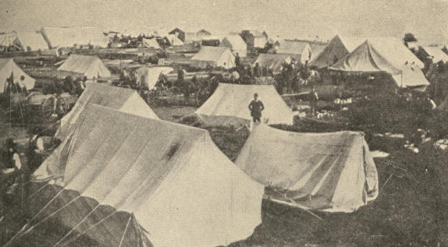
A general view of the town on April 24, 1889, the second day after the opening .

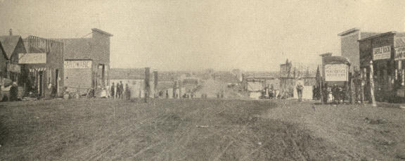
A view along Oklahoma Avenue on May 10, 1889.

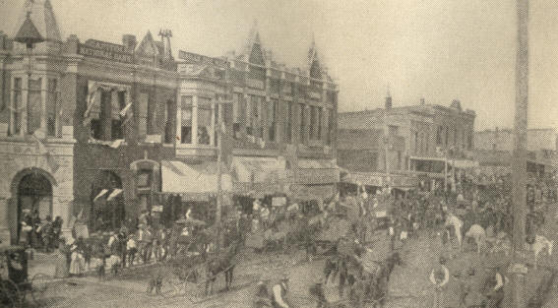
Oklahoma Avenue as it appeared on May 10, 1893, during Governor Noble's visit.
THE BUILDING OF A WESTERN TOWN, GUTHRIE, OKLAHOMA.
80
1890] EVENTS OF HARRISON'S TERM 81

In addition to the prospect of thus losing all their lands, the Indians were, in the winter of 1890, famine-stricken through failure of Government rations. With little hope of justice or revenge in their own strength, the aggrieved savages sought supernatural solace. The so-called "Messiah Craze" seized upon Sioux, Cheyennes, Arapahoes, Osages, Missouris, and Seminoles. Ordinarily at feud with one another, these tribes all now united in ghost dances, looking for the Great Spirit or his Representative to appear with a high hand and an outstretched arm to bury the white and their works deep underground, when the prairie should once more thunder with the gallop of buffalo and wild horses. Southern negroes caught the infection. Even the scattered Aztecs of Mexico gathered around the ruins of their ancient temple at Cholula and waited a Messiah who should pour floods of lava from Popocatapetl, inundating all mortals not of Aztec race.

82 EXPANSION [1892

While frontiersmen trembled lest massacres should follow these Indian orgies, people in the East were shuddering over the particulars of a real catastrophe indescribably awful in nature. On a level some two hundred and seventy-five feet lower than a certain massive reservoir, lay the city of Johnstown, Pa. The last of May, 1889, heavy rains having fallen, the reservoir dam burst, letting a veritable mountain of water rush down upon the town, destroying houses, factories, bridges, and thousands of lives. Relief work, begun at once and liberally supplied with money from nearly every city in the Union and from many foreign contributors, repaired as far as might be the immediate consequences of the disaster.
Along with the Johnstown Flood will be remembered in the annals of Pennsylvania the Homestead strike, in 1892, against the Carnegie Steel Company, occasioned by a cut in wages. The Amalgamated Steel and Iron Workers sought to intercede against the reduction, but were refused recognition.
83

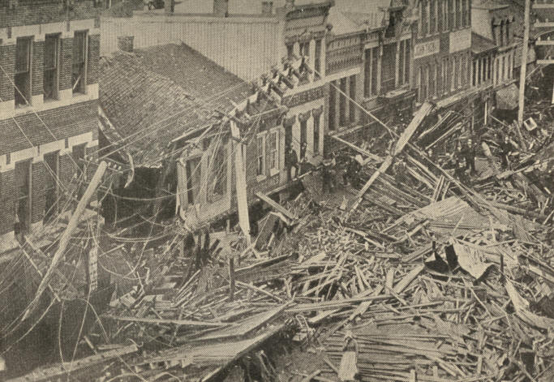
Main Street, Johnstown, after the flood.
84
1892] EVENTS OF HARRISON'S TERM 85

Preparing to supplant the disaffected workmen with non-union men, a force of Pinkerton detectives was brought up the river in armored barges. Fierce fighting ensued. Bullets and cannon-balls rained upon the barges, and receptacles full of burning oil were floated down stream. The assailants wished to withdraw, repeatedly raising the white flag, but it was each time shot down.

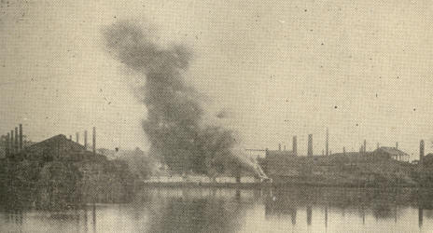
Burning of Barges during Homestead Strike

Eleven strikers were killed; of the attacking party from thirty to forty fell, seven dead. When at last the Pinkertons were forced to give up their arms and ammunition and retire, a bodyguard of strikers sought to shield them, but so violent was the rage which they had provoked that, spite of their escort, the mob brutally attacked them. Order was restored only when the militia appeared.
86 Expansion [1892

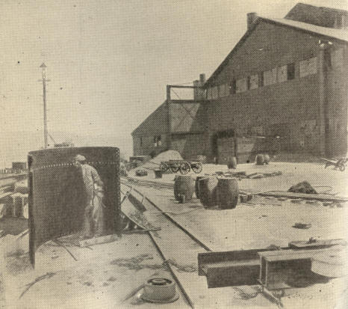
The Carnegie Steel Works. Showing the shield used by the strikers when
firing the cannon and watching the Pinkerton men. Homestead strike.

This bloodshed was not wholly in vain. Congress made the private militia system, the evil consequences of which were so manifest in these tragedies, a subject of investigation, while public sentiment more strongly than ever reprobated, on the one hand, violence by strikers or strike sympathizers, and, on the other, the employment of armed men, not officers of the law, to defend property.
1892] EVENTS OF HARRISON'S TERM 87

That, however, other causes than these might endanger the peace was shown about the same time at certain Tennessee mines where prevailed the bad system of farming out convicts to compete with citizen-miners.

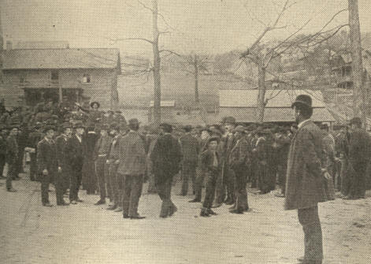
Inciting miners to attack Fort Anderson.
The grove between Briceville and Coal Creek.

88 EXPANSION [1892

Business being slack, deserving workmen were put on short time. Resenting this, miners at Tracy City, Inman, and Oliver Springs summarily removed convicts from the mines, several of these escaping. At Coal Creek the rioters were resisted by Colonel Anderson and a small force. They raised a flag of truce, answering which in person, Colonel Anderson was commanded, on threat of death, to order a surrender. He refused. A larger force soon arrived, routed the rioters, and rescued the colonel.

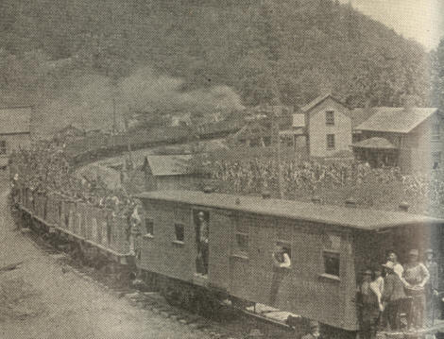
State troops and miners at Briceville, Tenn.

1890] EVENTS OF HARRISON'S TERM 89

The year 1891 formed a crisis in the history of Mormonism in America. For a long time after their settlement in the "Great American Desert," as it was then called, Mormons repudiated United States authority. Gentile pioneers and recreant saints they dealt with summarily, witness the Mountain Meadow massacre of 1857, where 120 victims were murdered in cold blood after surrendering their arms.

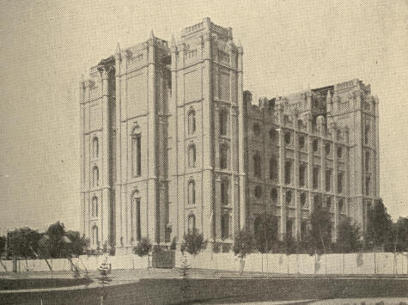
The Mormon Temple at Salt Lake City.

90 EXPANSION [1891

Anti-polygamy bills were introduced in Congress in 1855 and 1859. In 1862 such a bill was made law. Seven years later the enforcement of it became possible by the building of a trans-continental railroad and the influx of gentiles drawn by the discovery of precious metals in Utah. In 1874 the Poland Act, and in 1882 the Edmunds Act, introduced reforms. Criminal law was now much more efficiently executed against Mormons. In 1891 the Mormon officials pledged their church's obedience to the laws against plural marriages and unlawful cohabitation.
America was quick and generous in her response to the famine cry that in 1891 rose from 30,000,000 people in Russia. Over a domain of nearly a half million square miles in that land there was no cow or goat for milk, nor a horse left strong enough to draw a hearse. Old grain stores were exhausted, crops a failure, and land a waste. Typhus, scurvy, and smallpox were awfully prevalent. To relieve this misery, our people, besides individual gifts, despatched four ship-loads of supplies gathered from twenty-five States. In values given New York led, Minnesota was a close second, and Nebraska third. America became a household word among the Russians even to the remotest interior.
CHAPTER V.

THE WORLD'S COLUMBIAN EXPOSITION

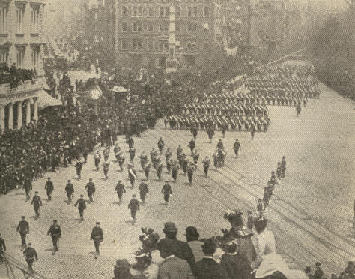
Columbian Celebration, New York, April 28, 1893.
Parade passing Fifth Avenue Hotel.

92 EXPANSION [1892

The thought of celebrating by a world's fair the third centennial of Columbus's immortal deed anticipated the anniversary by several years. Congress organized the exposition so early as 1890, fixing Chicago as its seat. That city was commodious, central, typically American. A National Commission was appointed; also an Executive Committee, a Board of Reference and Control, a Chicago Local Board, and a Board of Lady Managers.
The task of preparation was herculean. Jackson Park had to be changed from a dreary lakeside swamp into a lovely city, with roads, lawns, groves and flowers, canals, lagoons and bridges, a dozen palaces, and ten score other edifices. An army of workmen, also fire, police, ambulance, hospital, and miscellaneous service was organized.
Wednesday, October 21 (Old Style, October 12), 1892, was observed as Columbus Day, marking the four hundredth anniversary of Columbus's discovery. A reception was held in the Chicago Auditorium, followed by dedication of the buildings and grounds at Jackson Park and an award of medals to artists and architects. Many cities held corresponding observances. New York chose October 12th for the anniversary. On April 26-28, 1893, again, the eastern metropolis was enlivened by grand parades honoring Columbus. In the naval display, April 22d, thirty-five war ships and more than 10,000 men of divers flags, took part.
1893] WORLD'S COLUMBIAN EXPOSITION 93

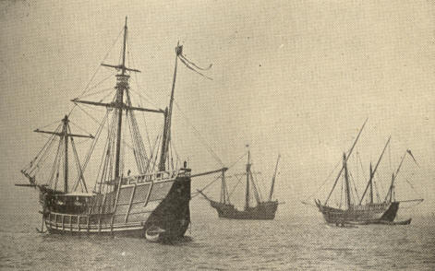
Pinta, Santa Maria, Nina,
Lying in the North River, New York.
The caravels which crossed from Spain
to be present at the World's Fair at Chicago,

Between Columbus Day and the opening of the Exposition came the presidential election of 1892. Ex-President Cleveland had been nominated on the first ballot, in spite of the Hill delegation sent from his home State to oppose. Harrison, too, had overcome Platt, Hill's Republican counterpart in New York, and in Pennsylvania had preferred John Wanamaker to Quay.
94 EXPANSION [1893

But Harrison was not "magnetic" like Blaine. With what politicians call the "boy" element of a party, he was especially weak. Stalwarts complained that he was ready to profit by their services, but abandoned them under fire. The circumstances connected with the civil service that so told against Cleveland four years before, now hurt Harrison equally. Though no doubt sincerely favoring reform, he had, like his predecessor, succumbed to the machine in more than one instance.
The campaign was conducted in good humor and without personalities. Owing to Australian voting and to a more sensitive public opinion, the election was much purer than that of 1888. The Republicans defended McKinley protection, boasting of it as sure, among other things, to transfer the tin industry from Wales to America. Free sugar was also made prominent. Some cleavage was now manifest between East and West upon the tariff issue.
1893] WORLD'S COLUMBIAN EXPOSITION 95

In the West "reciprocity" was the Republican slogan; in the East, "protection." Near the Atlantic, Democrats contented themselves with advocacy of "freer raw materials "; those by the Mississippi denounced "Republican protection" as fraud and robbery. If the platform gave color to the charge that Democrats wished "British free trade," Mr. Cleveland's letter of acceptance was certainly conservative.
Populism, emphasizing State aid to industry, particularly in behalf of the agricultural class, made great gains in the election. General Weaver was its presidential nominee. In Colorado, Idaho, Kansas, and Wyoming most Democrats voted for him. Partial fusion of the sort prevailed also in North Dakota, Nevada, Minnesota, and Oregon. Weaver carried all these States save the two last named. In Louisiana and Alabama Republicans fused with Populists. The Tillman movement in South Carolina, nominally Democratic, was akin to Populism, but was complicated with the color question, and later with novel liquor legislation.
96 EXPANSION [1893

It was a revolt of the ordinary whites from the traditional dominance of the aristocracy. In Alabama a similar movement, led by Reuben F. Kolb, was defeated, as he thought, by vicious manipulation of votes in the Black Belt.
Of the total four hundred and forty-four electoral votes Cleveland received two hundred and seventy-seven, a plurality of one hundred and thirty-two. The Senate now held forty-four Democrats, thirty-seven Republicans, and four Populists; the House two hundred and sixteen Democrats, one hundred and twenty-five Republicans, and eleven Populists.

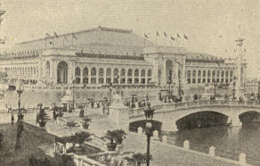
The Manufactures and liberal Arts Building, seen from the southwest.

Early on the opening day of the Exposition, May 1, 1893, the Chief Magistrate of the nation sat beside Columbus's descendant, the Duke of Veragua. Patient multitudes were waiting for the gates of Jackson Park to swing.
1893] WORLD'S COLUMBIAN EXPOSITION 97

"It only remains for you, Mr. President," said the Director-General, concluding his address, "if in your opinion the Exposition here presented is commensurate in dignity with what the world should expect of our great country, to direct that it shall be opened to the public. When you touch this magic key the ponderous machinery will start in its revolutions and the activity of the Exposition will begin." After a brief response Mr. Cleveland laid his finger on the key. A tumult of applause mingled with the jubilant melody of Handel's "Hallelujah Chorus." Myriad wheels revolved, waters gushed and sparkled, bells pealed and artillery thundered, while flags and gonfalons fluttered forth.
The Exposition formed a huge quadrilateral upon the westerly shore of Lake Michigan, from whose waters one passed by the North Inlet into the North Pond, or by the South Inlet into the South Pond. These united with the central Grand Basin in the peerless Court of Honor.
98 EXPANSION [1893

The grounds and buildings were of surpassing magnitude and splendor. Interesting but simple features were the village of States, the Nations' tabernacles, lying almost under the guns of the facsimile battleship Illinois, and the pigmy caravels, Nina, Pinta, and Santa Maria, named and modelled after those that bore Columbus to the New World. These, like their originals, had fared from Spain across the Atlantic, and then had come by the St, Lawrence and the Lakes, without portage, to their moorings at Chicago.

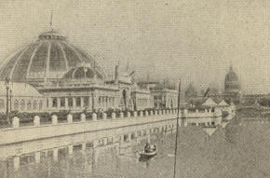
Horticultural Building, with
Illinois Building in the background.

Near the centre of the ground stood the Government Building, with a ready-made look out of keeping with the other architecture. Critics declared it the only discordant note in the symphony.
1893] WORLD'S COLUMBIAN EXPOSITION 99

Looking from the Illinois Building across the North pond, one saw the Art Palace, of pure Ionic style, perfectly proportioned, restful to view, contesting with the Administration Building for the architectural laurels of the Fair. South of the Illinois Building rose the Woman's Building, and next Horticultural Hall, with dome high enough to shelter the tallest palms. The Manufactures and Liberal Arts Building, of magnificent proportions, did not tyrannize over its neighbors, though thrice the size of St. Peter's at Rome, and able easily to have sheltered the Vendome Column. It was severely classical, with a long perspective of arches, broken only at the corners and in the centre by portals fit to immortalize Alexander's triumphs.
The artistic jewel of the Exposition was the "Court of Honor." Down the Grand Basin you saw the noble statue of the Republic, in dazzling gold, with the peristyle beyond, a forest of columns surmounted by the Columbus quadriga. On the right hand stood the Agricultural Building, upon whose summit the "Diana" of Augustus St. Gaudens had alighted. To the left stood the enormous Hall of Manufactures. Looking from the peristyle the eye met the Administration Building, a rare exemplification of the French school, the dome resembling that of the Hotel des lnvalides in Paris.
100 EXPANSION [1893

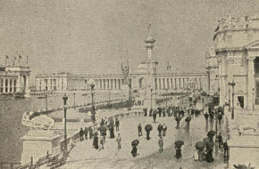
A view toward the Peristyle from Machinery Hall.

A most unique conception was the Cold Storage Building, where a hundred tons at ice were made daily. Save for the entrance, flanked by windows, and the fifth floor, designed for an ice skating rink, its walls were blank. Four corner towers set off the fifth, which rose from the centre sheer to a height of 225 feet.
The cheering coolness of this building was destined not to last. Early in the afternoon of July 10th flames burst out from the top of the central tower. Delaying his departure until he had provided against explosion, the brave engineer barely saved his life.

1893] WORLD'S COLUMBIAN EXPOSITION 101

Firemen were soon on hand. Sixteen of them forthwith made their way to the balcony near the blazing summit. Suddenly their retreat was cut off by a burst of fire from the base of the tower. The rope and hose parted and precipitated a number who were sliding back to the roof. Others leaped from the colossal torch. In an instant, it seemed, the whole pyre was swathed in flames. As it toppled, the last wretched form was seen to poise and plunge with it into the glowing abyss.
The Fisheries Building received much attention. Its pillars were twined with processions of aquatic creatures and surmounted by capitals quaintly resembling lobster-pots. Its balustrades were supported by small fishy caryatids.
If wonder fatigued the visitor, he reached sequestered shade and quiet upon the Wooded Island, where nearly every variety of American tree and shrub might be seen.
102 EXPANSION [1893

The Government's displays were of extreme interest. The War Department exhibits showed our superiority in heavy ordnance, likewise that of Europe in small arms. A first-class post-office was operated on the grounds. A combination postal car, manned by the most expert sorters and operators, interested vast crowds. Close by was an ancient mail coach once actually captured by the Indians, with effigies of the pony express formerly so familiar on the Western plains, of a mail sledge drawn by dogs, and of a mail carrier mounted on a bicycle. Models of a quaint little Mississippi mail steamer and of the ocean steamer Paris stood side by side.

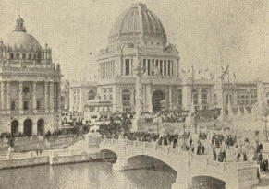
The Administration Building,
seen from the Agricultural Building.

1893] WORLD'S COLUMBIAN EXPOSITION 103

Swarms visited the Midway Plaisance, a long avenue out from the fair grounds proper, lined with shows. Here were villages transported from the ends of the earth, animal shows, theatres, and bazaars. Cairo Street boasted 2,250,000 visitors, and the Hagenbeck Circus over 2,000,000. The chief feature was the Ferris Wheel, described in engineering terms as a cantilever bridge wrought around two enormous bicycle wheels. The axle, supported upon steel pyramids, alone weighed more than a locomotive. In cars strung upon its periphery passengers were swung from the ground far above the highest buildings.

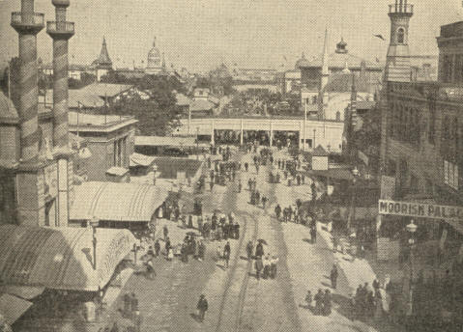
Midway Plaisance,
World's Fair, Chicago.

104 EXPANSION [1893

Facilitating passenger transportation to and from the Fair remarkable railway achievements were made. One train from New York to Chicago covered over 48 miles an hour, including stops. In preparation for the event the Illinois Central raised its tracks for two and a half miles over thirteen city streets, built 300 special cars, and erected many new stations. These improvements cost over $2,000,000. The Fair increased Illinois Central traffic over 200 per cent.
Save the Art Building, the structures at the Fair were designed to be temporary, and they were superfluous when the occasion which called them into being had passed. The question of disposing of them was summarily solved. One day some boys playing near the Terminal Station saw a sinister leer of flame inside. A high wind soon blew a conflagration, which enveloped the structures, leaving next day naught but ashes, tortured iron work, and here and there an arch, to tell of the regal White City that had been.
1893] WORLD'S COLUMBIAN EXPOSITION 105

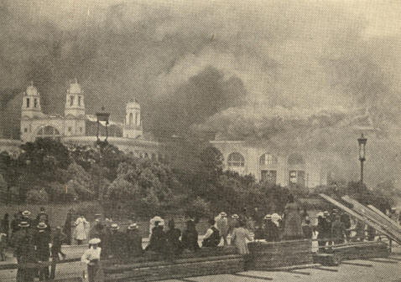
Electricity Building. Mines and Mining Building.
The Burning of the White City.

106 EXPANSION [1893

The financial backers of the Fair showed no mercenary temper. The architects, too, worked with public spirit and zeal which money never could have elicited. Notwithstanding the World's Fair was not financially a "success," this was rather to the credit of its unstinted magnificence than to the want of public appreciation. The paid admissions were over 21,000,000, a daily average of 120,000. The gross attendance exceeded by nearly a million the number at the Paris Exposition of 1889 for the corresponding period, though rather more than half a million below the total at the French capital. The monthly average at Chicago increased from 1,000,000 at first to 7,000,000 in October.
The crowd was typical of the best side of American life; orderly, good-natured, intelligent, sober. The grounds were clean, and there was no ruffianism. Of the $32,988 worth of property reported stolen, $31,875 was recovered and restored.
CHAPTER VI.

ECONOMIC AND SOCIAL MOVEMENT

The century from 1790 to 1890 saw our people multiplied sixteen times, from
3,929,214 at its beginning, to 62,622,250 at its end. The low percentage of increase for the last decade, about 20 per cent., disappointed even conservative estimates. The cities not only absorbed this increase, but, except in the West, made heavy draughts upon the country population. Of each 1,000 people in 1880, 225 were urban; in 1890, 290. Chicago's million and a tenth was second only to New York's million and a half. Philadelphia, Brooklyn, and St. Louis appeared respectively as the third, fourth, and fifth in the list of great cities. St. Paul, Omaha, and Denver domiciled three or four times as many as ten years before. Among Western States only Nevada lagged. The State of Washington had quintupled its numbers. The centre of population had travelled fifty miles west and nine miles north, being caught by the census about twenty miles east of Columbus, Indiana.
108 EXPANSION [1890

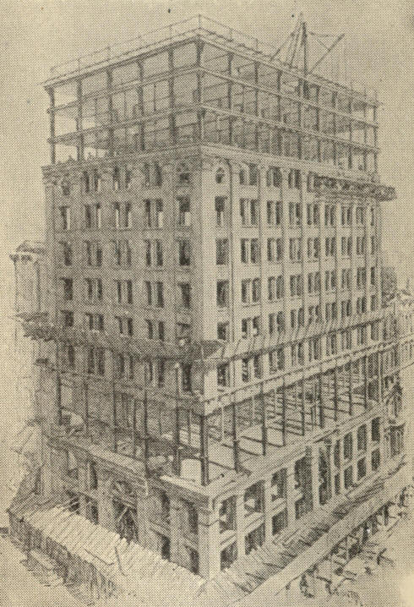
The New York Life Insurance Building in Chicago.
(Showing the construction of outer walls.)

The railroads of the country spanned an aggregate of 163,000 miles, twice the mileage of 1880. The national wealth was appraised at $65,037,091,197, an increase for the decade of $21,395,091,197 in the gross. Our per capita wealth was now $1,039, a per capita increase of $169. Production in the mining industry had gone up more than half. The improved acreage, on the other hand, had increased less than a third, the number of farms a little over an eighth.
1890] ECONOMIC AND SOCIAL MOVEMENT. 109

School enrollment had advanced from 12 per cent. in 1840 to 23 per cent. in 1890. Not far from a third of the people were communicants of the various religious bodies. About a tenth were Roman Catholics.
Improvement in iron and steel manufacture revolutionized the construction of bridges, vessels, and buildings. The suspension bridge, instanced by the stupendous East River bridge between New York and Brooklyn, was supplanted by the cantilever type, consisting of trusswork beams poised upon piers and meeting each other mid-stream. Iron and steel construction also made elevated railways possible. In 1890 the elevated roads of New York City alone carried over 500,000 passengers daily. Steel lent to the framework of buildings lightness, strength, and fire-proof quality, at the same time permitting swift construction. Walls came to serve merely as covering, not sustaining the floors, the weight of which lay upon iron posts and girders.
110 EXPANSION [1890

At the time of the Centennial, electricity was used almost exclusively for telegraphic communication. By 1893 new inventions, as wonderful as Morse's own, had overlaid even that invention. A single wire now sufficed to carry several messages at once and in different directions. Rapidity of transmission was another miracle. During the electrical exposition in New York City, May, 1896, Hon. Chauncey M. Depew dictated a message which was sent round the world and back in fifty minutes. It read:
"God creates, nature treasures, science utilizes electrical power for the grandeur of nations and the peace of the world." These words travelled from London to Lisbon, thence to Suez, Aden, Bombay, Madras, Singapore, Hong-Kong, Shanghai, Nagasaki, and Tokio, returning by the same route to New York, a total distance of over 27,500 miles.

1890] ECONOMIC AND SOCIAL MOVEMENT 111

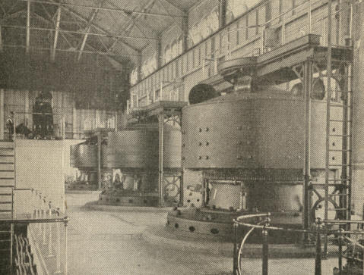
Interior of the Power House at Niagara Falls.

Self-winding and self-regulating clocks came into vogue, being automatically adjusted through the Western Union telegraph lines, so that at noon each day the correct time was instantly communicated to their hands from the national observatory. Another invaluable use of the telegraph was its service to the Weather Bureau, established in 1870. By means of simultaneous reports from a tract of territory 3,000 miles long by 1,500 wide, this bureau was enabled to make its forecasts indispensable to every prudent farmer, traveller, or mariner.
112 EXPANSION [1890

The three great latter-day applications of electrical force were the telephone, the electric light, and the electric motor. In 1876, almost simultaneously with its discovery by other investigators, Alexander Graham Bell exhibited an electric transmitter of the human voice. By the addition of the Edison carbon transmitter the same year the novelty was assured swift success. In 1893 the Bell Telephone Company owned 307,748 miles of wire, an amount increased by rival companies' property to 444,750. Estimates gave for that year nearly 14,000 "exchanges," 250,000 subscribers, and 2,000,000 daily conversations. New York and Chicago were placed on speaking terms only three or four days before "Columbus Day." All the chief cities were soon connected by telephone.
At the Philadelphia Exposition arc electric lamps were the latest wonder, and not till two years later did Edison render the incandescent lamp available.
1893] ECONOMIC AND SOCIAL MOVEMENT 113

The use of electricity for the development of power as well as of light, unknown in the Centennial year, was in the Columbian year neither a scientific nor a practical novelty. On the contrary, it was fast supplanting horses upon street railways, and making city systems nuclei for far-stretching suburban and interurban lines. Street railways mounted steep hills inaccessible before save by the clumsy system of cables. Even steam locomotives upon great railways gave place in some instances to motors. Horseless carriages and pedalless bicycles were clearly in prospect.
It was found that by the use of copper wiring electric power could be carried great distances. A line twenty-five miles long bore from the American River Falls, at Folsom, California, to Sacramento, a current which the city found ample for traction, light, and power. Niagara Falls was harnessed to colossal generators, whose product was transmitted to neighboring cities and manufactories. Loss en route was at first considerable, but cunning devices lessened it each year.

114 EXPANSION [1890

Thomas Alva Edison and Nikola Tesla were conspicuously identified with these astonishing applications of electric energy. Edison, first a newsboy, then (like Andrew Carnegie) a telegraph operator, without school or book training in physics, rose step by step to the repute of working miracles on notification.

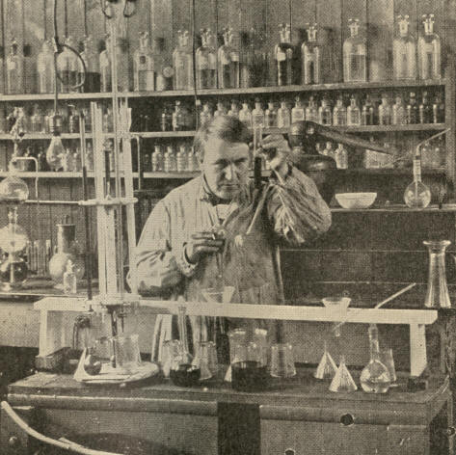
Thomas Alva Edison.
Copyright by W. A. Dickson.

1890] ECONOMIC AND SOCIAL MOVEMENT 115

Tesla, a native of Servia, who happened, upon migrating to the United States, to find employment with Edison, was totally unlike his master. He was a highly educated scientist, herein at a great advantage. He was, in opposition to Edison, peculiarly the champion of high tension alternating current distribution. He aimed to dispense so far as possible with the generation of heat, pressing the ether waves directly into the service of man.

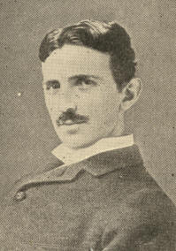
Nikola Tesla.

The bicycle developed incredible popularity in the '90's. Through all the panic of 1893 bicycle makers prospered. It was estimated in 1896 that no less than $100,000,000 had been spent in the United States upon cycling. A clumsy prototype of the "wheel" was known in 1868, but the first bicycle proper, a wheel breast-high, with cranks and pedals connected with a small trailing wheel by a curved backbone and surmounted by a saddle, was exhibited at the Centennial. Two years later this kind of wheel began to be manufactured in America, and soon, in spite of its perils, or perhaps in part because of them, bicycle riding was a favorite sport among experts.
116 EXPANSION [1890

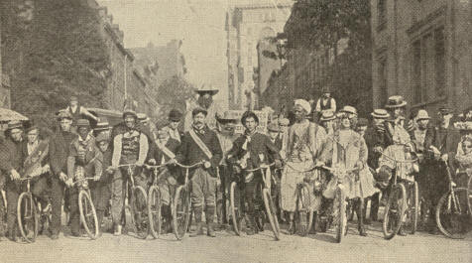
Bicycle Parade, New York.
Fancy Costume Division.

In 1889 a new type was introduced, known as the "safety." Its two wheels were of the same size, with saddle between them, upon a suitable frame, the pedals propelling the rear wheel through a chain and sprocket gearing. An old invention, that of inflated or pneumatic tires of rubber, coupled with more hygienic saddles, gave great impetus to cycling sport. The fad dwindled, but the bicycle remained in general use as a convenience and even as a necessity.
1890] ECONOMIC AND SOCIAL MOVEMENT 117

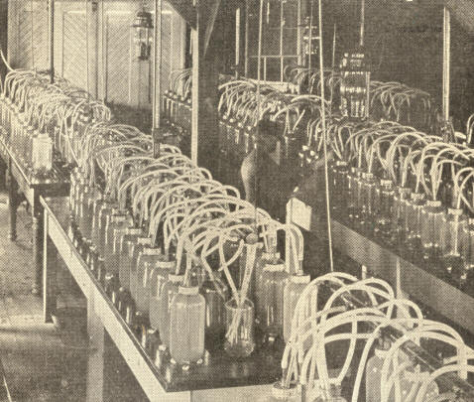
Hatchery Room of the Fish Commission Building at Washington, D. C.,
showing the hatchery jars in operation.

The Fish Commission, created by the Government in 1870, proved an important agency in promoting the great industries of fishing and fish culture. At the World's Fair it appeared that the fishing business had made progress greater than many others which were much more obtrusively displayed, though the fishtrap, the fyke net, and the fishing steamer had all been introduced within a generation.
118 EXPANSION [1890

In no realm did invention and the application of science mean more for the country's weal than in agriculture. Each State had its agricultural college and experiment station, mainly supported by United States funds provided under the Morrill Acts. Soils, crops, animal breeds, methods of tillage, dairying, and breeding were scientifically examined. Forestry became a great interest. Intensive agriculture spread. By early ploughing and incessant use of cultivators keeping the surface soil a mulch, arid tracts were rendered to a great extent independent of both rainfall and irrigation. Improved machinery made possible the farming of vast areas with few hands. The gig horse hoe rendered weeding work almost a pleasure. A good reaper with binder attachment, changing horses once, harvested twenty acres a day. The best threshers bagged from 1,000 to 2,500 bushels daily. One farmer sowed and reaped 200 acres of wheat one season without hiring a day's work.
1890] ECONOMIC AND SOCIAL MOVEMENT 119

Woman's position at the Fair was prominent and gratifying. How her touch lent refinement and taste was observed both in the Woman's Building, the first of its kind, and in other departments of the Exposition. Power of organization was noticeably exemplified in the Woman's Christian Temperance Union. This body originated in the temperance crusade of 1873 and the following year, when a State Temperance Association was formed in Ohio, leading shortly to the rise of a national union.
Related to this movement in elevated moral aims, as well as in the prominent part it assigned to women, was the Salvation Army. In 1861 William Booth, an English Methodist preacher, resigned his charge and devoted himself to the redemption of London's grossest proletariat. Deeming themselves not wanted in the churches, his converts set up a separate and more militant organization. In 1879 the Army invaded America, landing at Philadelphia, where, as in the Old Country and in other American cities, pitiable sin and wretchedness grovelled in obscurity. In 1894 there were in the United States 539 corps and 1,953 officers, and in the whole world 3,200 corps and 10,788 officers.
120 EXPANSION [1890

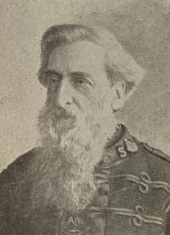
William Booth.
From a photograph by Rockwood, New York.

Without proposing any programme of social or political reform, and without announcing any manifesto of human rights, the Salvationists uplifted hordes of the fallen, while drawing to the lowliest the notice, sympathy, and help of the middle classes and the rich. Army discipline was rigidly maintained. The soldiers were sworn to wear the uniform, to obey their officers, to abstain from drink, tobacco, and worldly amusements, to live in simplicity and economy, to earn their living, and of their earnings always to give something to advance the Kingdom.

1890] ECONOMIC AND SOCIAL MOVEMENT 121

The officers could not marry or become engaged without the consent of the Army authorities, for their spouses must be capable of cooperating with them. They could receive no presents, not even food, except in cases of necessity. An officer must have experienced "full salvation"--that is, must endeavor to be living free from every known sin. Except as to pay, the Army placed women on an absolute equality with men, a policy which greatly furthered its usefulness.
The peculiar uniform worn by the Salvation soldiers, always sufficing to identify them, called attention to a fact never obvious till about 1890--the relative uniformity in the costumes of all fairly dressed Americans whether men or women. The wide circulation of fashion plates and pictorial papers accounted for this. About this time cuts came to be a feature even of newspapers, a custom on which the more conservative sheets at first frowned, though soon adopting it themselves.
CHAPTER VII.

MR. CLEVELAND AGAIN PRESIDENT

In the special session beginning August 7, 1893, a Democratic Congress met under a Democratic President for the first time since 1859. The results were disappointing. Divided, leaderless, in large part at bitter variance with the Administration, the Democrats trooped to their overthrow two years later.
During his second Administration Mr. Cleveland considerably extended the merit system in the civil service. Candidates for consulships were subjected to (non-competitive) examination. Public opinion commended these moves, as it did the President's prompt signing of the Anti-Lottery Bill, introduced in Congress when it was learned that the expatriated Louisiana Lottery from its seat under Honduras jurisdiction was operating in the United States through the express companies. The bill prohibiting this abuse was passed at three in the morning on the last day of the Congressional session, and received the President's signature barely five minutes before the Congress expired.
1895] CLEVELAND AGAIN PRESIDENT 123

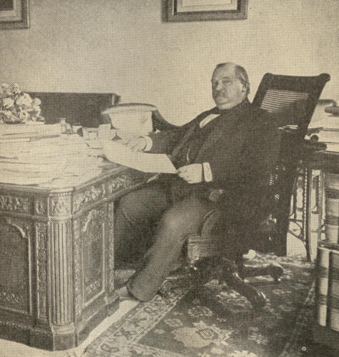
Grover Cleveland.
From a photograph by Alexander Black.

124 EXPANSION [1893

At the opening of the Special Session, in August, 1893, the President demanded the repeal of that clause in the Sherman law of 1890 requiring the Government to make heavy monthly purchases of silver. The suspension in India of the free coinage of silver the preceding June had precipitated a disastrous monetary panic in the United States. Gold was hoarded and exported, vast sums being drained from the Treasury. Credits were refused, values shrivelled, business was palsied, labor idle. It was this situation which led the President to convoke Congress in special session.
Though achieving the repeal on November 1st, after Congressional wrangles especially long and bitter in the Senate, President Cleveland, pursuing the policy of paying gold for all greenbacks presented at the Treasury, was unable, even by the sale of $50,000,000 in bonds, to keep the Treasury gold reserve up to the $100,000,000 figure. Both old greenbacks and Sherman law greenbacks, being redeemed in gold, reissued and again redeemed, were used by exchangers like an endless chain pump to pump the Treasury dry.
1894 CLEVELAND AGAIN PRESIDENT 125

In February, 1895, the reserve stood at the low figure of $41,340,181. None knew when the country might be forced to a silver basis. In consequence, business revived but slightly, if at all, after the repeal.
In its first regular session the same Congress enacted the Wilson Tariff. As it passed the House the bill provided for free sugar, wool, coal, lumber, and iron ore, besides reducing duties on many other articles.
It also taxed incomes exceeding $4,000 per annum. The Senate, except in the case of wool and lumber, abandoned the proposal of free raw materials, stiffened the rates named by the House, and preferred specific to ad valorem duties. Many believed, without proof, that improper influences had helped the Senate to shape its sugar schedule favorably to the great refiners. The President pronounced sugar a legitimate subject for taxation in spite of the "fear, quite likely exaggerated," that carrying out this principle might "indirectly and inordinately encourage a combination of sugar refining interests."
126 EXPANSION [1894

In a letter read in the House, however, he upbraided as guilty of "party perfidy and dishonor" Democratic Senators who would abandon the principle of free raw materials. But nothing shook the senatorial will. What was in substance the Senate bill passed Congress, and the President permitted it to become a law without his signature.

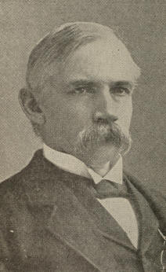
William L. Wilson.

The Wilson law pleased no one. It violated the Democrats' plighted word apparently at the dictation of parties selfishly interested. The Supreme Court declared its income tax unconstitutional. The revenue from it was inadequate, and had to be eked out with new bond issues. These were alleged to be necessary to meet the greenback debt, but this need not have embarrassed the Government had it followed the French policy of occasionally paying in silver a small percentage of the demand notes presented.

1895] CLEVELAND AGAIN PRESIDENT 127

Borrowing gold abroad, moreover, tended to inflate prices here, stimulating imports, discouraging exports, increasing the exportation of gold to settle the unfavorable balance of trade, and so on in ceaseless round.
The Democratic management of foreign affairs was severely criticised. Our extradition treaty with Russia, a country supposed to pay little or no regard to personal rights, and our delay in demanding reparation from Spain for firing upon the Allianca, a United States passenger steamer, were quite generally condemned. There were those who thought that Cuban insurgents against the sovereignty of Spain might have received some manifestation of sympathy from our Government, and that we should not have permitted Great Britain to endanger the Monroe Doctrine by occupying Corinto in Nicaragua to enforce the payment of an indemnity.

128 EXPANSION [1893

The President offended many in dealing as he did with the Hawaiian Islands' problem. Most did not consider it the duty of this country to champion the cause of the native dynasty there, a course likely to subserve no enlightened interest. Whites, chiefly Americans, had come to own most of the land in the islands, while imported Asiatics and Portuguese competed sharply with the natives as laborers. Political power, even, was largely exercised by the whites, through whose influence the monarchy had been reduced to a constitutional form.

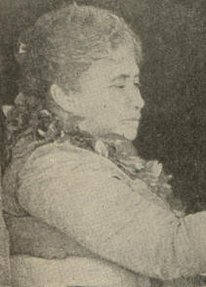
Princess (afterwards Queen) Liliuokalani,

In January, 1893, Queen Liliuokalani sought by a coup d'etat to reinvest her royal authority with its old absoluteness and to disfranchise non-naturalized whites. The American man-of-war Boston, lying in Honolulu harbor, at the request of American residents, landed marines for their protection. The American colony now initiated a counter revolution, declaring the monarchy abrogated and a provisional government established. Minister Stevens at once recognized the Provisional Government as de facto sovereign. Under protest the Queen yielded.
1893] CLEVELAND AGAIN PRESIDENT 129

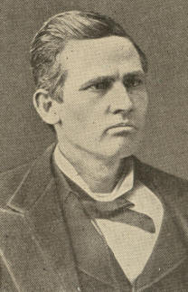
James H. Blount.

The new government formally placed itself under the protectorate of the United States, and the Stars and Stripes were hoisted over the Government Building. President Harrison disavowed the protectorate, though he did not withdraw the troops from Honolulu, regarding them as necessary to assure the lives and property of American citizens. Nor did he lower the flag. A treaty for the annexation of the islands was soon negotiated and submitted to the Senate.

130 EXPANSION [1894

The Cleveland Administration reversed this whole policy with a jolt. The treaty withdrawn, Mr. Cleveland despatched to Honolulu Hon. James H. Blount as a special commissioner, with "paramount authority," which he exercised by formally ending the protectorate, hauling down the flag, and embarking the garrison of marines. Mr. Blount soon superseded Mr. Stevens as minister. Meantime the Provisional Government had organized a force of twelve hundred soldiers, got control of the arms and ammunition in the islands, enacted drastic sedition laws, and suppressed disloyal newspapers.

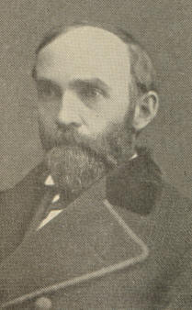
Albert S. Willis.

So complete was its sway, and so relentless did the dethroned Queen threaten to be toward her enemies in case she recovered power, that Minister Albert S. Willis, on succeeding Mr. Blount, lost heart in the contemplated enterprise of restoring the monarchy.

1894] CLEVELAND AGAIN PRESIDENT 131

He found the Provisional Government and its supporters men of "high character and large commercial interests," while those of the Queen were quite out of sympathy with American interests or with good government for the islands. A large and influential section of Hawaiian public opinion was unanimous for annexation, even Prince Kunniakea, the last of the royal line, avowing himself an annexationist with heart, soul, and, if necessary, with rifle.
A farcical attempt at insurrection was followed by the arrest of the conspirators and of the ex-Queen, who thereupon, for herself and heirs, forever renounced the throne, gave allegiance to the Republic, counselled her former subjects to do likewise, and besought clemency. Her chief confederates were sentenced to death, but this was commuted to a heavy fine and long imprisonment. After the retirement of the Democracy from power in 1896 the annexation of the islands was promptly consummated.

132 EXPANSION [1895

Walter Q. Gresham, Secretary of State in the early part of Cleveland's second term, died in May, 1895, being succeeded by Richard Olney, transferred from the portfolio of Attorney General. In a day, Cleveland's foreign policy, hitherto so inert, became vigorous to the verge of rashness. Deeming the Monroe Doctrine endangered by Great Britain's apparently arbitrary encroachments on Venezuela in fixing the boundary between Venezuela and British Guiana, he insisted that the boundary dispute should be settled by arbitration.

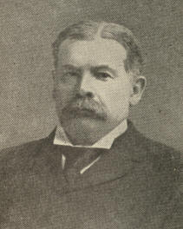
Richard Olney

The message in which the President took this ground shook the country like a declaration of war against Great Britain. American securities fell, the gold reserve dwindled. The President was, however, supported. Congress was found ready to aid the Administration by passing any measures necessary to preserve the national credit.

1894] CLEVELAND AGAIN PRESIDENT 133

In December, 1895, it unanimously authorized the appointment of a commission to decide upon the true boundary line between Venezuela and British Guiana, with the purpose of giving its report the full sanction and support of the United States. The dispute was finally submitted to a distinguished tribunal at Paris, ex-President Harrison, among others, appearing on behalf of the Venezuelan Republic. While Great Britain's claim was, in a measure, vindicated, this proceeding established a new and potent precedent in support both of the Monroe Doctrine and of international arbitration.
In 1894 a ten months' session of the famous Lexow legislative committee in New York City uncovered voluminous evidence of corrupt municipal government there. The police force habitually levied tribute for protection not only upon legitimate trade and industry, but upon illicit liquor-selling, gambling, prostitution, and crime. The chief credit for the exposures was due to Rev. Charles H. Parkhurst, President of the New York City Society for the Prevention of Crime. A fusion of anti-Tammany elements carried the autumn elections of 1894 for a reform ticket nominated by a committee of seventy citizens and headed by William L. Strong as candidate for mayor.
134 EXPANSION [1894

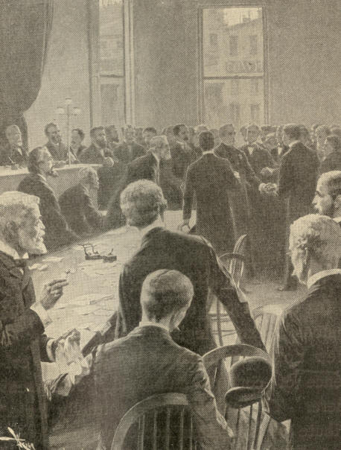
The Lexow Investigation.
The scene in the Court Room after
Creeden's confession, December 15, 1894.

1901] CLEVELAND AGAIN PRESIDENT 135

At the next election, however, the Tammany candidate, Van Wyck, became the first mayor of the new municipality known as Greater New York, in which had been merged as boroughs the metropolis itself, Brooklyn, and other near cities. As was revealed by the Mazet Committee, little change had occurred in Tammany's predatory spirit. In 1901, therefore, through an alliance similar to that which elected Mayor Strong, Greater New York chose as its mayor to succeed Van Wyck, Seth Low, who resigned the Presidency of Columbia University to become Fusion candidate for the position.

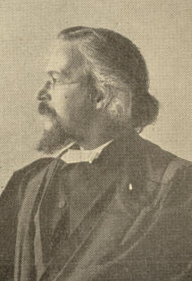
Charles H. Parkhurst.
Copyright by C. C. Langill.

136 EXPANSION [1894

A recrudescence of the old Know-Nothing spirit in a party known as the "A. P. A.," or "American Protective Association," marked these years. So early as 1875 politicians had noticed the existence of a secret anti-Catholic organization, the United American Mechanics, but it had a brief career. The A. P. A., organized soon after 1885, drew inspiration partly from the hostility of extreme Protestants to the Roman Catholic Church, and partly from the aversion felt by many toward the Irish. In 1894 the A. P. A., though its actual membership was never large, pretended to control 2,000,000 votes. Its subterranean methods estranged fair-minded people. Still more turned against it when its secret oath was exposed. The A. P. A. member promised (1) never to favor or aid the nomination, election, or appointment of a Roman Catholic to any political office, and (2) never to employ a Roman Catholic in any capacity if the services of a Protestant could be obtained.

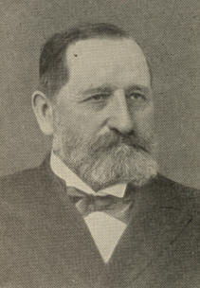
William L. Strong.
1894] CLEVELAND AGAIN PRESIDENT 137

A. P. A. public utterances garbled history and disseminated clumsy falsehoods touching Catholics, which reacted against the order. The Association declined as swiftly as it rose. Chiefly affiliating with the Republicans, it received no substantial countenance from any political party.
CHAPTER VIII.

LABOR AND THE RAILWAYS

In March, 1894, bands of the unemployed in various parts of the West, styling themselves "Commonweal," or "Industrial Armies," started for Washington to demand government relief for "labor." "General" Coxey, of Ohio, led the van. "General" Kelly followed from Trans-Mississippi with a force at one time numbering 1,250. Smaller itinerant groups joined the above as they marched. For supplies the tattered pilgrims taxed the sympathies or the fears of people along their routes. Most of them were well-meaning, but their destitution prompted some small thefts. Even violence occasionally occurred, as in California, where a town marshal killed a Commonweal "general," and in the State of Washington, where two deputy marshals were wounded. The Commonwealers captured a few freight trains and forced them into service.

1894] LABOR AND THE RAILWAYS 139

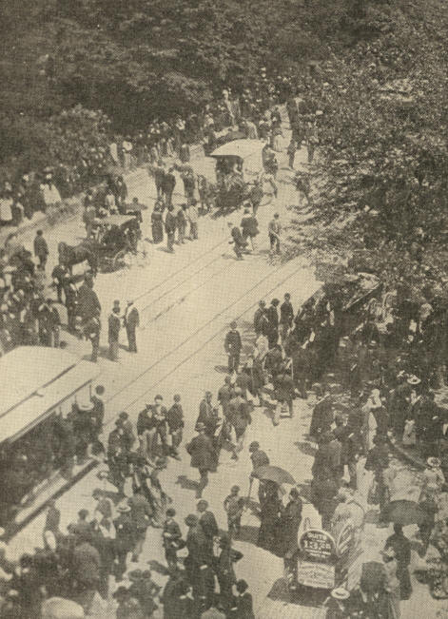
Coxey's army on the march to the Capitol steps at Washington.
140 EXPANSION [1894

Only Coxey's band reached Washington. On May Day, attempting to present their "petition-in-boots" on the steps of the Capitol, the leaders were jailed under local laws against treading on the grass and against displaying banners on the Capitol Grounds. On June 10th Coxey was released, having meantime been nominated for Congress, and in little over a month the remnant of his forces was shipped back toward the setting sun.
The same year, 1894, marked a far more widespread and formidable disorder, the A. R. U. Railway Strike. The American Railway Union claimed a membership of 100,000, and aspired to include all the 850,000 railroad workmen in North America. It had just emerged with prestige from a successful grapple with the Great Northern Railway, settled by arbitration.
The union's catholic ambitions led it to admit many employees of the Pullman Palace Car Company, between whom and their employers acute differences were arising. The company's landlordism of the town of Pullman and petty shop abuses stirred up irritation, and when Pullman workers were laid off or put upon short time and cut wages, the feeling deepened.
1894] LABOR AND THE RAILWAYS 141

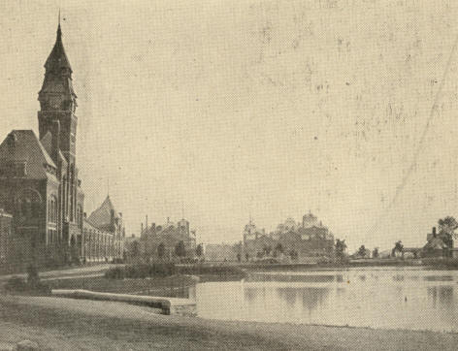
The town of Pullman.

They pointed out that rents for the houses they lived in were not reduced, that the company's dividends the preceding year had been fat, and that the accumulation of its undivided surplus was enormous. The company, on the other hand, was sensible of a slack demand for cars after the brisk business done in connection with World's Fair travel.
142 EXPANSION [1894

The Pullman management refused the men's demand for the restoration of the wages schedule of June, 1893, but promised to investigate the abuses complained of, and engaged that no one serving on the laborer's committee of complaint should be prejudiced thereby. Immediately after this, however, three of the committee were laid off, and five-sixths of the other employees, apparently against the advice of A. R. U. leaders, determined upon a strike.

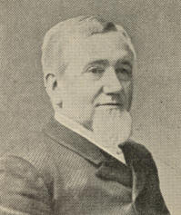
George M. Pullman.

Unmoved by solicitations from employees, from the Chicago Civic Federation, from Mayor Pingree of Detroit, indorsed by the mayors of over fifty other cities, the Pullman Company steadfastly refused to arbitrate or to entertain any communication from the union. "We have nothing to arbitrate" was the company's response to each appeal. A national convention of the A. R. U. unanimously voted that unless the Pullman Company sooner consented to arbitration the union should, on June 26th, everywhere cease handling Pullman cars.

143

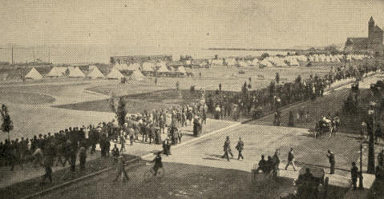
Camp of the U. S. troops on the lake front, Chicago.

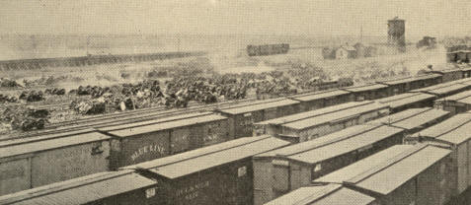
Burned cars in the C., B. & Q. yards at Hawthorne, Chicago.

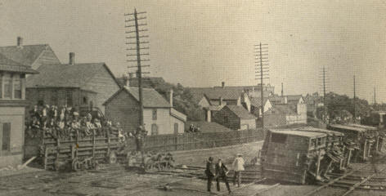
Overturned box cars at crossing of railroad tracks at 39th street, Chicago.
144
1894] LABOR AND THE RAILWAYS 145

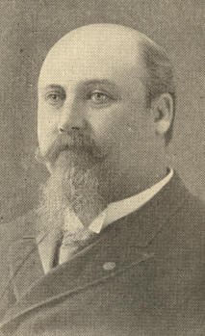
Hazen S. Pingree.

At this turn of affairs the A. R. U. found itself confronted with a new antagonist, the Association of General Managers of the twenty-four railroads centering in Chicago, controlling an aggregate mileage of over 40,000, a capitalization of considerably over $2,000,000,000, and a total workingmen force of 220,000 or more. The last-named workers had their own grievances arising from wage cuts and black-listing by the Managers' Association. Such of them as were union men were the objects of peculiar hostility, which they reciprocated. Thus the Pullman boycott, sympathetic in its incipience, swiftly became a gigantic trial of issues between the associated railroad corporations and the union.
146 EXPANSION [1894

For a week law and order were preserved. On July 2d the Federal Court in Chicago issued an injunction forbidding A. R. U. men, among other things, to "induce" employees to strike. Next day federal troops appeared upon the scene. Thereupon, in contempt of the injunction, railroad laborers continued by fair means and foul to be persuaded from their work.
Disregarding the union leaders' appeal and defying regular soldiers, State troops, deputy marshals, and police, rabble mobs fell to destroying cars and tracks, burning and looting. The mobs were in large part composed of Chicago's semi-criminal proletariat, a mass quite distinct from the body of strikers.
The A. R. U. strike approached its climax about the 10th of July. Chicago and the Northwest were paralyzed. President Cleveland deemed it necessary to issue a riot proclamation. A week later Debs and his fellow-leaders were jailed for contempt of court, and soon after their following collapsed.

1894] LABOR AND THE RAIL WAYS 147

Governor Altgeld, of Illinois, protested against the presence of federal troops, denying federal authority to send force except upon his gubernatorial request, inasmuch as maintaining order was a purely State province, and declaring his official ignorance of disorder warranting federal intervention.

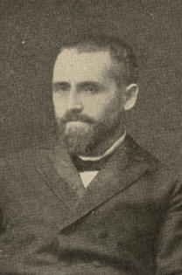
Gov. John P. Altgeld.

Mr. Cleveland answered, appealing to the Constitution, federal laws, and the grave nature of the situation. United States power, he said, may and must whenever necessary, with or without request from State authorities, remove obstruction of the mails, execute process of the federal courts, and put down conspiracies against commerce between the States.
148 "EXPANSION [1894

During the Pullman troubles, the judicial department of the United States Government, no less prompt or bold than the Executive, extended the equity power of injunction a step farther than precedents went. After 1887 United States tribunals construed the Interstate Commerce Law as authorizing injunctions against abandonment of trains by engineers. Early in 1894 a United States Circuit judge inhibited Northern Pacific workmen from striking in a body. For contempt of his injunctions during the Pullman strike Judge Woods sentenced Debs to six months' imprisonment and other arch-strikers to three months each under the so-called Anti-Trust Law.

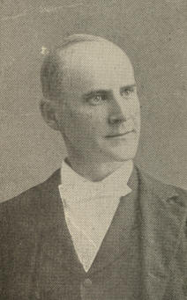
Eugene V. Debs.
1902] LABOR AND THE RAILWAYS 149

As infringing the right of trial by jury this course of adjudication aroused protest even in conservative quarters. Later, opposition to "government by injunction" became a tenet of the more radical Democracy. A bill providing for jury trials in instances of contempt not committed in the presence of the court commanded support from members of both parties in the Fifty-eighth Congress. Federal decisions upheld workingmen's right, in the absence of an express contract, to strike at will, although emphatically affirming the legitimacy of enjoining violent interference with railroads, and of enforcing the injunction by punishing for contempt.
Federal injunctions subsequently went farther still, as in the miners' strike of 1902 during which Judge Jackson of the United States District Court for Northern West Virginia, enjoined miners' meetings, ordering the miners, in effect, to cease agitating or promoting the strike by any means whatever, no matter how peaceful. Speech intended to produce strikes the judge characterized as the abuse of free speech, properly restrainable by courts. Refusing to heed the injunction, several strike leaders were sentenced to jail for contempt, periods varying from sixty to ninety days.
150 EXPANSION [1894

Late in July, 1894, the President appointed a commission to investigate the Pullman strike. The report of this body, alluding to the Managers' Association as a usurpation of powers not obtainable directly by the corporations concerned, recommended governmental control over quasi-public corporations, and even hinted at ultimate government ownership. They counselled some measure of compulsory arbitration, urged that labor unions should become incorporated, so as to be responsible bodies, and suggested the licensing of railway employees. The Massachusetts State Board of Conciliation and Arbitration was favorably mentioned in this report, and became the model for several like boards in various States.

1887] LABOR AND THE RAILWAYS 151

The labor question and other problems excluded from public thought a change in our dealings with our Indian wards that should not be overlooked. Up to 1887 the Indian village communities could, under the law, hold land only in common. Individual Indians could not, without abandoning their tribes, become citizens of the United States. Such a legal status could not but discourage Indians' emergence from barbarism.
A better method was hinted at in an old Act of the Massachusetts General Court, passed so early as October, 1652.
"It is therefore ordered and enacted by this Court and the authority thereof, that what landes any of the Indians, within this jurisdiction, have by possession or improvement, by subdueing of the same, they have just right thereunto accordinge to that Gen: 1: 28, Chap. 9:1, Psa: 115, 16." This old legislation further provided that any Indians who became civilized might acquire land by allotment in the white settlements on the same terms as the English.

152 EXPANSION [1890

In 1887, the so-called "General Allotment" or " Dawes" Act, empowered the President to allot in severalty a quarter section to each head of an Indian family and to each other adult Indian one eighth of a section, as well as to provide for orphaned children and minors, the land to be held in trust by the United States for twenty-five years. The act further constituted any allottee or civilized Indian a citizen of the United States, subject to the civil and criminal laws of the place of his residence.
The Dawes Act was later so amended as to allot one-eighth of a section or more, if the reservation were large enough, to each member of a tribe. The amended law also regulated the descent of Indian lands, and provided for leases thereof with the approval of the Indian Department. This last provision was in instances twisted by white men to their advantage and to the Indians' loss; but on the whole the new system gave eminent satisfaction and promise.
CHAPTER IX.

NEWEST DIXIE

The reader of this history is already aware how forces and events after the Civil War gradually evolved a New South, unlike the contemporary North, and differing still more, if possible, from ante-bellum Dixie. By 1900 this interesting situation had become quite pronounced. The picture here given is but an enlargement of that presented earlier--few features new, but many of them more salient, and the whole effect more impressive.
Harmony and good feeling between the capital sections of our country continued to manifest itself in striking ways, as by the dedication of a Confederate monument at Chicago, the gathering of the Grand Army of the Republic at Louisville, Ky., and the cordial fraternizing of Gray and Blue at the consecration of the Chickamauga-Chattanooga Military Park, on the spot where had occurred, perhaps, the fiercest fighting which ever shook United States ground.
154 EXPANSION [1895

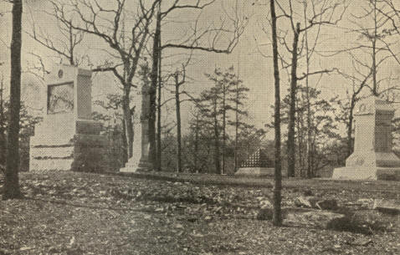
The Chickamauga National Military Park.
Group of monuments on knoll southwest of Snodgrass Hill.

The Atlanta Exposition, opening on September 18, 1895, epitomized the Newest South. The touch of an electric button by President Cleveland's little daughter, Marian, at his home on Buzzard's Bay, Mass., opened the gates and set the machinery awhirl.
1897] NEWEST DIXIE 155

Atlanta was a city of but 100,000, hardly more than 60,000 of them whites, yet her Fair not only excelled the Atlanta Exposition of 1881, that at Louisville in 1883, and the New Orleans World's Industrial and Cotton Centennial Exposition of 1884-5, all which were highly successful, but in many features outdid even the Centennial at Philadelphia. The Tennessee Centennial and International Exposition at Nashville, in 1897, was another revelation. Its total expenditures, fully covered by receipts, were $1,087,227.85; its total admissions 1,886,714. On J. W. Thomas Day the attendance was within a few of 100,000. The exhibits were ample, and many of them strikingly unique. Few, even at the South, believed that the Southern States could set forth such displays. The fact that this was possible so soon after a devastating war, which had left the section in abject poverty, was a speaking compliment to the land and to the energy of those developing it.
The progress of most Southern communities was extraordinary. Agriculture, still too backward in methods and variety, gradually improved, gaining marked impetus and direction from the agricultural colleges planted in the several States by the aid of United States funds conveyed under the "Morrill" acts.
156 EXPANSION [1890

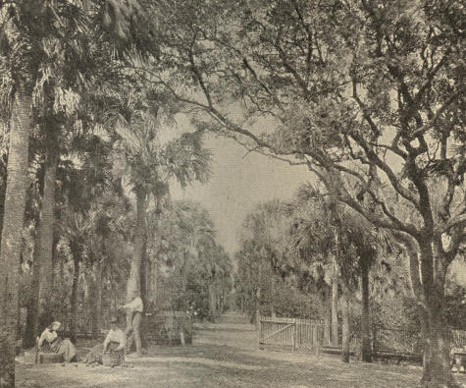
A grove of oranges and palmettoes near Ormond, Florida.

The abominable system of store credit kept the majority of farmers, black and white, in servitude, but was giving way, partly to regular bank credit--a great improvement--and partly to cash transactions.
1895] NEWEST DIXIE 157

Florida came to the front as a lavish producer of tropical fruits. Winter was rarely known there. If it paid a visit now and then the State's sugar industry made up for the losses which frost inflicted upon her orange crop. The rich South Carolina rice plantations bade fair to be left behind by the new rice belt in Louisiana and Texas, a strip averaging thirty miles in width and extending from the Mississippi to beyond the Brazos, 400 miles. Improved methods of rice farming had transformed this region, earlier almost a waste, into one of the most productive areas in the country, attracting to it settlers from various parts of the North and West, and even from Scandinavia. Dairying, fruit and cattle-raising and market-gardening for northern markets, other new lines of enterprise, created wealth for multitudes. King Cotton was not dethroned to make way for these rivals, but increased his domain each decade.

158 EXPANSiON [1895

In 1880 the value of farm products at the South exceeded by more than $200,000,000 that of the manufactured products there. In 1900 the case was nearly reversed: manufactures outvaluing farm products by over $190,000,000. During this decade the persons engaged in agriculture at the South increased in number 36 per cent., but the wage-earners in manufacturing multiplied more than four times as much, viz., 157 per cent. Each of these rates at the South was larger than the corresponding rate for the country. The same decade the capital which the South had invested in manufacturing increased 348 per cent., that of the whole United States only 252 per cent. The increase in manufactured products value was for the South 220 per cent., for the whole country only 142 per cent. The increase in farm property value was for the South 92 per cent., for the country only 67 per cent. The increase in farm products value was for the South 92 per cent.; for the whole United States it was greater, viz., 133 per cent.

1895] NEWEST DIXIE 159

Land at the South was boundlessly rich in unexploited resources. More than half the country's standing timber grew there, much of it hard wood and yellow pine. Quantities of phosphate rock, limestone, and gypsum were to be dug, also salt, aluminum, mica, topaz, and gold. Especially in Texas, petroleum sought release from vast underground reservoirs. The farmer did not lack for rain, the manufacturer for water-power, or the merchant for water transportation to keep down railroad rates.
The white Southerner, of purest Saxon-Norman blood, had the vigorous and comely physique of that race. Nowhere else in the land were the generality of white men and women so fine-looking. Easy circumstances had enabled them to become gracious as well, with the dignified and pleasing manners characterizing Southern society before the Civil War. High intelligence was another racial trait. The administration of the various Industrial Expositions named in this chapter required and evinced business ability of the highest order. During the quarter century succeeding reconstruction popular education developed even more astonishingly at the South than in the North or the West. Nothing could surpass the avidity with which young Southern men and women sought and utilized intellectual opportunities.
160 EXPANSION [1895

With few exceptions Southerners had become intensely loyal to the national ideal, faithfully abiding the arbitrament of the war, which alone, to their mind--but at any rate, finally and forever--overthrew the old doctrine that the Union was a compact among States, with liberty to each to secede at will.
Straightforwardness and intensity of purpose marked the Southern temper. If a county or a city voted "dry," practically all the whites aided to see the mandate enforced. The liquor traffic was thus regulated more stringently and prohibited more widely and effectively at the South than in any other part of the country. Even the lynchings occurring from time to time in some quarters, while atrocious and frowned upon by the best people, seemed due in most cases less to disregard for the spirit of the law than to distrust of legal methods and machinery. Indications multiplied, moreover, that this damning blot on Southern civilization would ere long disappear.

1895] NEWEST DIXIE 161

The most aggravating and insoluble perplexity which tormented the Southern people lay in dealing with the colored race. Sections of the so-called black belts still weltered in unthrift and decay, as in the darkest reconstruction days. These belts were three in number. The first, about a hundred miles wide, reached from Virginia and the Carolinas through the Gulf States to the watershed of the State of Mississippi. The second bordered the Mississippi from Tennessee to just above New Orleans, and extended up the Red River into Arkansas and Texas. A third region of negro preponderance covered fifteen counties of southern Texas.
In these tracts and elsewhere white political supremacy was maintained, as it had been regained, by the forms of law when possible; if not, then in some other way. The wisest negro leaders dismissed, as for the present a dream, all thought of political as of social equality between whites and blacks.
162 EXPANSION [1895

Swarms of the colored, resigned to political impotence, were prolific of defective, pauper, and criminal population. Education, book-education at least, did not seem to improve them; many believed that it positively injured them, producing cunning and vanity rather than seriousness. This was perhaps the rule, though there were many noble exceptions. In 1892, while the proportion of vicious negroes seemed to be increasing in cities and large towns, it was almost to a certainty decreasing in rural districts--improvement due in good part to enforced temperance.
A conference on the negro and the South opened at Montgomery May 8, 1900. Many able and fair-minded men participated, representing various attitudes, parties, and sections of the country. Limitation of the colored franchise, the proper sort of education for negroes, the evils of "social equality" agitation, and the causes and frequency of lynching were the main subjects discussed.

1895] NEWEST DIXIE 163

The consensus of opinion seemed to be that for "the negro, on account of his inherent mental and emotional instability," acquirement of the franchise should be less easy than for whites. It was maintained that the industrially trained colored men became leaders among their people, commanding the respect of both races and acquiring much property, yet that ex-slaves, rather than the younger, educated set, formed the bulk of colored property-holders. Figures revealed among the colored population a frightful increase of illegitimacy and of flagrant crimes. It seemed that crimes against women, almost unknown before the war but now increasing at an alarming rate, proceeded not from ex-slaves, but from the smart new generation. Lynching for these offences was by some excused in that negroes would not assist in bringing colored perpetrators to justice, and in that a spectacular mode of punishment affected negroes more deeply than the slow process of law, even when this issued in conviction.

164 EXPANSION [1895

The severer utterances at this conference may have been more or less biased; still, if, allowing for this, one considered the data available for forming a judgment, one was forced to feel that calm Southerners had apprehended the case better than Northern enthusiasts. Colored people as a class lacked devotion to principle, also initiative and endurance, whether mental or physical. Colored deputies, of whom there were many in various parts of the South, so long as they acted under white chiefs, were, like most colored soldiers, marvels of bravery, defying revolvers, bowie knives, and wounds, and fighting to the last gasp with no sign of flinching; but the black men who could be trusted as sheriffs-in-chief were extremely rare.
Whether the faults named were strictly hereditary or resulted rather from the longcontinued ill education and environment of the race, none could certainly tell. As a matter of fact, however, few even among friendly critics longer regarded these faults as entirely eliminable. A well qualified and wholly unbiased judge of negro character gave it as emphatically his opinion that any autonomous community of colored people, no matter how highly educated or civilized, would relapse into barbarism in the course of two generations. This view was not rendered absurd by the existence of fairly well administered municipalities here and there with negro mayors.
1895] NEWEST DIXIE 165

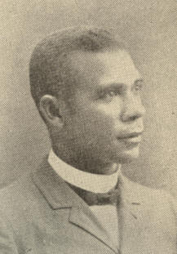
Booker T. Washington.

Many negroes were extremely bright and apt in imitation, also in all memoriter and linguistic work. The New Orleans Cotton Centennial and the Nashville Exposition each had its negro department. But it was distinctive of the Atlanta Fair that one of its buildings was entirely devoted to exhibits of negro handicraft. At once in range and in the quality of the objects which it embraced, the display was creditable to the race. Here and there, moreover, the race had produced a grand character. The most notable of the opening addresses at the Atlanta Fair was made by the colored educator, Booker T. Washington, President of the Tuskegee Normal and Industrial Institute for negro youth.
166 EXPANSION [1895

His oration on this occasion directed attention to Mr. Washington not only as a remarkable negro, but as a remarkable man. Born poor as could be and fighting his way to an education against every conceivable obstacle, he had at the age of forty distinguished himself as a business organizer, as an educator, as a writer, and as, a public speaker. His modesty, discretion, and industry were phenomenal, at once constituting him a leader of his race and rendering his leadership valuable. He eschewed politics, avoided in everything the demagogue's ways, and never spoke ill of the whites, not even of Southern whites.
But, unfortunately, a great negro such as Washington stood like a mountain in a marsh, sporadic and solitary.

1895] NEWEST DIXIE 167

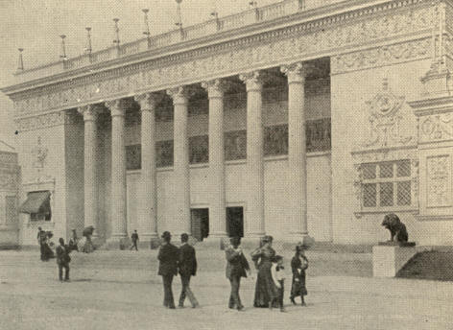
The Atlanta Exposition.
Entrance to the Art Building.

Save in West Virginia, Florida, and the black belts the whites at the South increased more swiftly than the blacks. Certain of what Malthus called the "positive checks" upon population--viz., diseases, mainly syphilis, typhoid, and consumption--decimated the negroes everywhere. Colored population drifted from the country to cities, which probably accounted for the fact that in 1890 more negroes lived in the North than ever before. In the South itself, on the other hand, the movement of colored population was southward and westward, from the highlands to the lowlands, so that Kentucky, along with western Virginia, northeastern Mississippi, and rural parts of Maryland, North Alabama, and eastern Virginia, had, in 1890, fewer colored inhabitants than ten years previous.
168 EXPANSION [1895

These confusing data explain why few were rash enough to prophesy the fate of the American negro. Such predictions as were heard, were, in the main, little hopeful. Colonization abroad was no resource. In 1895 the International Immigration Society shipped 300 negroes to Liberia, and in 1897 the Central Labor Union of New York 311 more, but no movement of the kind could be set going. In fact, the one certainty touching the American negroes' future was that they would remain in the United States.
From 1870 to 1880 the percentage of negroes to the total population had increased, but a century had reduced this ratio from 19.3 per cent. to 12 per cent. The climatic area where black men had any advantage over white in the struggle for life was less than eight per cent. of the country. White laborers competed more and more sharply. The paternal affection of the old slave-holding generation toward negroes was not inherited by the makers of the New South.
1895] NEWEST DIXIE 169

There was one hopeful force at work--Booker Washington at Tuskegee, in the very heart of the Alabama black belt. His personality, his example, his ideas were inspiring. He bade his race to expect improvement in its condition not from any political party nor from Northern benevolence, but from its own advance in industry and character. His great and successful college at Tuskegee, with an enrolment of 1,231 students in 1889, gave much impetus to industrial education among the blacks, turning in that direction educational interest and energy which had previously found vent to too great an extent, relatively, in providing negro students with mere literary training. The Slater-Armstrong Memorial Trades' Building, dedicated January 10, 1890, was erected and finished by the students practically alone. At least three-fourths of those receiving instruction at this school pursued, after leaving, the industries learned there.
170 EXPANSION [1895

The color line had ceased to be sectional. In 1900 mobs in New York City and Akron, Ohio, baited black citizens with barbarity little less than that of the worst Southern lynchings. Texas courts the same year affirmed negroes' right to serve as jurymen. After 1900 one noticed in several Southern States a tendency to oust negroes from official connection even with the Republican party, each State organization affecting to be "Lily-White." The Administration seemed to favor this movement by appointing liberal Democrats at the South to federal offices, allying such, in a way, with the Republican cause. This helped make President Roosevelt popular at the South, spite of the criticism with which the press there greeted his entertainment of Booker T. Washington at the White House. When he visited the Exposition at Charleston, December, 1901-May, 1902, he was enthusiastically received.
CHAPTER X.

THE MEN AND THE ISSUE IN 1896

Early in 1896 it became clear that the dominant issue of the presidential campaign would be the resumption by the United States of silver-dollar free coinage. Agitation for this, hushed only for a moment by the passage of the Bland Act, had been going on ever since demonetization in 1873. The fall in prices, which the new output of gold had not yet begun to arrest; the money stringency since 1893; the insecure, bond-supplied gold reserve, and the repeal of the silver-purchase clause in the Sherman Act combined to produce a wish for increase in the nation's hard-money supply. Had the climax of fervor synchronized with an election day, a free-coinage President might have been elected.

172 EXPANSION [1896

Only the Populists were a unit in favoring free coinage. Recent Republican and Democratic platforms had been phrased with Delphic genius to suit the East and West at once. The best known statesmen of both parties had "wobbled" upon the question. The Republican party contained a large element favorable to silver, while the Democratic President, at least, had boldly and steadfastly exerted himself to establish the gold standard.

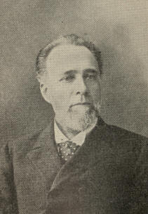
Senator Teller of Colorado.

Realignment of forces begot queer alliances between party foes, lasting bitterness between party fellows. Even the Prohibitionists, who held the first convention, were riven into "narrow-gauge" and "broad-gauge," the latter in a rump convention incorporating a free-coinage plank into their creed. If the Republicans kept their ranks closed better than the Democrats, this was largely due to the prominence they gave to protection, attacked by the Wilson-Gorman Act.

1896] THE MEN AND THE ISSUE IN I896 173

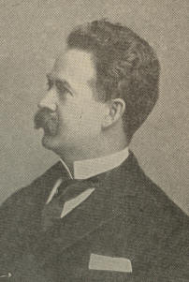
Senator Cannon.

Their convention sat at St. Louis, June 16th. It was an eminently business-like body, even its enthusiasm and applause wearing the air of discipline. In making the platform, powerful efforts for a catch-as-catch-could declaration upon the silver question succumbed to New England's and New York's demand for an unequivocal statement. The party "opposed the free coinage of silver except by international agreement with the leading commercial nations of the world." . . . "Until such agreement can be obtained, the existing gold standard must be preserved."
174 EXPANSION [1890

Senator Teller, of Colorado, moved a substitute favoring "the free, unrestricted, and independent coinage of gold and silver at our mints at the ratio of 16 parts of silver to 1 of gold." It was at once tabled by a vote of 818-1/2 to 105-1/2. The rest of the platform having been adopted, Senator Cannon, of Utah, read a protest against the money plank, which recited the evils of falling prices as discouraging industry and threatening perpetual servitude of American producers to consumers in creditor nations.
Then occurred a dramatic scene, the first important bolt from a Republican convention since 1872. "Accepting the present fiat of the convention as the present purpose of the party," Teller shook hands with the chairman, and, tears streaming down his face, left the convention, accompanied by Cannon and twenty other delegates, among them two entire State delegations. Senators Mantle, of Montana, and Brown, of Utah, though remaining, protested against the convention's financial utterance.
The Republican platform lauded protection and reciprocity, favored annexing the Hawaiian Islands, and the building, ownership, and operation of the Nicaragua Canal by the United States. It reasserted the Monroe Doctrine "in its full extent," expressed sympathy for Cuban patriots, and bespoke United States influence and good offices to give Cuba peace and independence.
1896] THE MEN AND THE ISSUE IN 1896 175

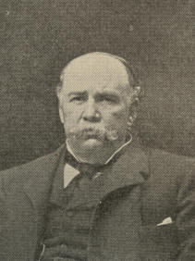
Garret A. Hobart, Vice-President.
Copyright,1899, by Pack Bros., N. Y.

The first ballot, by a majority of over two-thirds, nominated for the presidency William McKinley, Jr., of Ohio, the nomination being at once made unanimous. Garret A. Hobart, of New Jersey, was nominated for Vice-President.
William McKinley, Jr., was born at Niles, Ohio, January 29, 1843, of Scotch-Irish stock. In 1860 he entered Allegheny College, Meadville, Pa., but ill health compelled him to leave. He taught school. For a time he was a postal clerk at Poland, Ohio. At the outbreak of the Civil War he enlisted as a private in Company E, 23d Ohio Infantry, the regiment with which William S. Rosecrans, Rutherford B. Hayes, and Stanley Matthews were connected.
176 EXPANSION [1896

Successive promotions attended his gallant and exemplary services. He shared every engagement in which his regiment took part, was never absent on sick leave, and had only one short furlough. A month before the assassination of President Lincoln McKinley was commissioned a major by brevet.
After the war Major McKinley studied law. He was admitted to the bar in 1867, settling in Canton, Ohio. In 1876 he made his debut in Congress, where he served with credit till 1890, when, owing partly to a gerrymander and partly to the unpopular McKinley Bill, he was defeated by the narrow margin of 300 votes. As Governor of Ohio and as a public speaker visiting every part of the country, McKinley was more and more frequently mentioned in connection with the presidency.
1896] THE MEN AND THE ISSUE IN 1896 177

The nomination was a happy one. No other could have done so much to unite the party. Not only had Mr. McKinley's political career been honorable, he had the genius of manly affability, drawing people to him instead of antagonizing them. Republicans who could not support the platform, in numbers gave fealty to the candidate as a true man, devoted to their protective tenets, and a "friend of silver."
The Democratic convention sat at Chicago July 7th to 10th. Though Administration and Eastern Democratic leaders had long been working to stem free coinage sentiment, this seemed rather to increase. By July 1st, in thirty-three of the fifty States and Territories, Democratic platforms had declared for free coinage. The first test of strength in the convention overruled the National Committee's choice of David B. Hill for temporary chairman, electing Senator Daniel, of Virginia, by nearly a two-thirds vote. The silver side was then added to by unseating and seating.
178 EXPANSION [1896

Hot fights took place over planks which the minority thought unjust to the Administration or revolutionary. The income-tax plank drew the heaviest fire, but was nailed to the platform in spite of this. It attacked the Supreme Court for reversing precedents in order to declare that tax unconstitutional, and suggested the possibility of another reversal by the same court "as it may hereafter be constituted."
The platform assailed "government by injunction as a new and highly dangerous form of oppression, by which federal judges in contempt of the laws of the States and the rights of citizens become at once legislators, judges, and executioners."
Attention having been called to the demonetization of silver in 1873 and to the consequent fall of prices and the growing onerousness of debts and fixed charges, gold monometallism was indicted as the cause "which had locked fast the prosperity of an industrial people in the paralysis of hard times" and brought the United States into financial servitude to London. Demand was therefore made for "the free and unlimited coinage of silver at the present legal ratio of 16 to 1 without waiting for the aid or consent of any other nation." Practically the entire management of the Treasury under Mr. Cleveland was condemned.
179

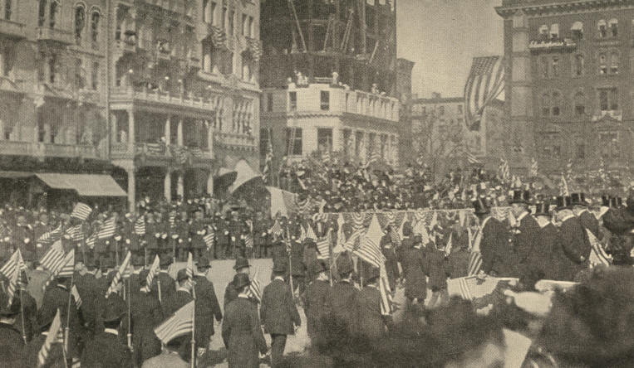
The McKinley-Hobart Parade Passing the Reviewing Stand,
New York, October 31, 1896.
180
1896] THE MEN AND THE ISSUE IN 1896 181

The platform being read, Hill, of New York, Vilas, of Wisconsin, and ex-Governor Russell, of Massachusetts, spoke. William J. Bryan, of Nebraska, was called upon to reply. In doing so he made the memorable "cross of gold" speech, which more than aught else determined his nomination. In a musical but penetrating voice, that chained the attention of all listeners, he sketched the growth of the free-silver belief and prophesied its triumph. While, shortly before, the Democratic cause was desperate, now McKinley, famed for his resemblance to Napoleon, and nominated on the anniversary of Waterloo, seemed already to hear the waves lashing the lonely shores of St. Helena. The gold standard, he said, not any "threat" of silver, disturbed business. The wage-worker, the farmer, and the miner were as truly business men as "the few financial magnates who in a dark room corner the money of the world." "We answer the demand for the gold standard by saying, 'You shall not press down upon the brow of labor this crown of thorns. You shall not crucify mankind upon a cross of gold!' "
182 EXPANSION [1896

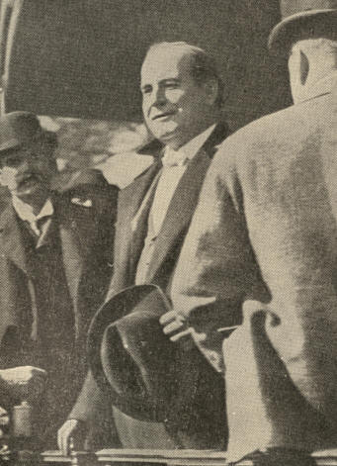
Bryan Speaking from the Rear End of a Train.

1896] THE MEN AND THE ISSUE IN 1896 183

Sixteen members of the Resolutions Committee presented a minority report criticising majority declarations. As a substitute for the silver plank they offered a declaration similar to that of the Republican convention. In a further plank they commended the Administration. The substitute money plank was lost 301 to 628, and the resolution of endorsement 357 to 564. No delegates withdrew, but a more formidable bolt than shook the Republican convention here expressed itself silently. In the subsequent proceedings 162 delegates, including all of New York's 72, 45 of New England's 77, 18 of New Jersey's 20, and 19 of Wisconsin's 24 took no part whatever.
Before Bryan spoke, a majority of the silver delegates probably favored Hon. Richard P. Bland, of Missouri, father of the Bland Act, as the presidential candidate, but the first balloting showed a change. Upon the fifth ballot Bryan received 500 votes, a number which changes before the result was announced increased to the required two-thirds. Arthur Sewall, of Maine, was the nominee for Vice-President.
184 EXPANSION [1896

Mr. Bryan, then barely thirty-six, was the youngest man ever nominated for the presidency. He was born in Salem, Ill., March 19, 1860. His father was a man of note, having served eight years in the Illinois Senate, and afterwards upon the circuit bench. Young Bryan passed his youth on his father's farm, near Salem, and at Illinois College, Jacksonville, where he graduated in 1881 with oratorical honors. Having read law in Chicago, and in 1887 been admitted to the bar, he removed to Lincoln, Neb., and began practising law.
Mr. Bryan was inclined to politics, and his singular power on the platform drew attention to him as an available candidate. In 1890 he was elected to Congress as a Democrat. He served two terms, declining a third nomination. In 1894 he became editor of the Omaha World-Herald, but later resumed the practice of law.

1896] THE MEN AND THE ISSUE IN 1896 185

In Nebraska, as in some other Western States, Republicans so outnumbered Democrats that Populist aid was indispensable in any State or congressional contest. In 1892 it had been eagerly courted on Cleveland's behalf. Bryan had helped in consummating fusion between Populism and Democracy in Nebraska. This occasioned the unjust charge that he was no Democrat. The allegation gained credence when the Populist national convention at St. Louis placed him at the head of its ticket, refusing at the same time to accept Sewall, choosing instead a typical Southern Populist, Thomas Watson, of Georgia.

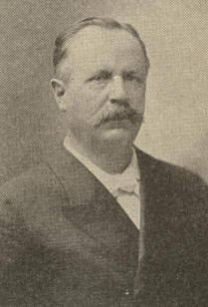
Arthur Sewall.

To Southern Populists Democrats were more execrable than Republicans. Westerners of that faith were jealous of Sewall as an Eastern man and rich. Too close union with Democracy threatened Populism with extinction. Rightly divining that their leaders wished such a "merger," the Populist rank and file insisted on nominating their candidate for the vice-presidency first. Bryan was made head of the ticket next day. The silver Republicans acclaimed the whole Democratic ticket, Sewall as well as Bryan.
186 EXPANSION [1896

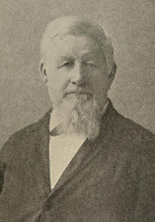
Ex-Senator Palmer.

The Democratic opponents of the "Chicago Democracy" determined to place in the field a "National" or "Gold" Democratic ticket. A convention for this purpose met in Indianapolis, September 3d. The Indianapolis Democrats lauded the gold standard and a non-governmental currency as historic Democratic doctrines, endorsed the Administration, and assailed the Chicago income-tax plank. Ex-Senator Palmer, of Illinois, and Simon E. Buckner, of Kentucky, were nominated to run upon this platform, Gold Democrats who could not in conscience vote for a Republican here found their refuge.

1896] THE MEN AND THE ISSUE IN 1896 187

Parties were now seriously mixed. Thousands of Western Republicans declared for Bryan; as many or more Eastern Democrats for McKinley. Party newspapers bolted. In Detroit the Republican Journal supported Bryan, the Democratic Free Press came out against him. Not a few from both sides "took to the woods"; while many, to be "regular," laid inconvenient convictions on the table.

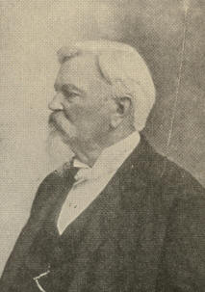
Simon E. Buckner.

The campaign was fierce beyond parallel. Neither candidate's character could be assailed, but the motives governing many of their followers were. Catchwords like "gold bug" and "popocrat" flew back and forth. The question-begging phrase "sound money"--both parties professed to wish "sound money"--did effective partisan service. Neither party's deepest principles were much discussed.
188 EXPANSION [1896

Many gold people assumed as beyond controversy that free coinage would drive gold from the country and wreck public credit. Advocates of silver too little heeded the consequences which the mere fear of those evils must entail, impatiently classing such as mentioned them among bond-servants to the money power.
So great was the fear of free silver in financial circles, corporations voted money to the huge Republican campaign fund. The opposition could tap no such mine. Never before had a national campaign seen the Democratic party so abandoned by Democrats of wealth, or with so slender a purse.
Nor was this the worst. Had Mr. Bryan been able through the campaign to maintain the passionate eloquence of his Chicago speech, or the lucid logic of that with which at Madison Square Garden he opened the campaign, he would still not have succeeded in sustaining "more hard money" ardor at its mid-summer pitch.
1896] THE MEN AND THE ISSUE IN 1896 189

His eloquence, indeed, in good degree continued, but the level of his argument sank. Instead of championing the cause of producers, whether rich or poor, against mere money-changers, which he might have done with telling effect, he more and more fell to the tone of one speaking simply against all the rich, an attitude which repelled multitudes who possessed neither wealth nor much sympathy for the wealthy.
Save for one short trip to Cleveland the Republican candidate did not, during the campaign, leave Canton, though from his doorstep he spoke to visiting hordes. His opponent, in the course of the most remarkable campaigning tour ever made by a candidate, preached free coinage to millions. The immense number of his addresses; their effectiveness, notwithstanding the slender preparation possible for most of them severally; the abstract nature of his subject when argued on its merits, as it usually was by him; and the strain of his incessant journeys evinced a power in the man which was the amazement of everyone.
190 EXPANSION [1896

Spite of all this, as election day drew near, the feeling rose that it post-dated by at least two months all possibility of a Democratic victory. Republicans' limitless resources, steady discipline, and ceaseless work told day by day. They polled, of the popular vote, 7,104,244; the combined Bryan forces, 6,506,853; the Gold Democracy, 134,652; the Prohibitionists, 144,606; and the Socialists, 36,416.
CHAPTER XI.

MR. McKINLEY'S ADMINISTRATION

The Nestor of the original McKinley Cabinet was John Sherman, who left his Senate seat to the swiftly rising Hanna that he himself might devote his eminent but failing powers to the Secretaryship of State. Upon the outbreak of the Spanish War he was succeeded by William R. Day, who had been Assistant Secretary. In 1898 Day in turn resigned, when Ambassador John Hay was called to the place from the Court of St. James. The Treasury went to Lyman J. Gage, a distinguished Illinois banker.

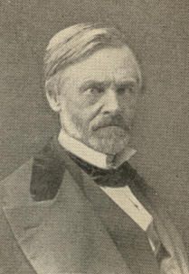
John Sherman.

192 EXPANSION [1897

Mr. Gage was a Democrat, and this appointment was doubtless meant as a recognition of the Gold Democracy's aid in the campaign. General Russell A. Alger, of Michigan, took charge of the War Department, holding it till July 19, 1899, after which Elihu Root was installed.

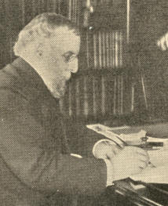
Lyman J. Gage, Secretary of the Treasury.

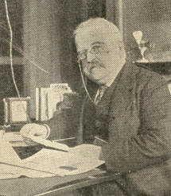
John D. Long, Secretary of the Navy.

Postmaster-General James A. Gary, of Maryland, resigned the same month with Sherman, giving place to Charles Emory Smith, of the Philadelphia Press. The Navy portfolio fell to John D. Long, of Massachusetts; that of the Interior to Cornelius N. Bliss, of New York; that of Agriculture to James Wilson, of Iowa. In December, 1898, Ethan Allen Hitchcock, of Missouri, succeeded Bliss.
1897] MR. McKINLEY'S ADMINISTRATION 193

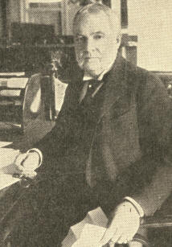
Cornelius N. Bliss,
Secretary of the Interior.

Fortunately for the new Chief Magistrate, who had been announced as the "advance agent of prosperity," the year 1897 brought a revival of business. This was due in part to the end, at least for the time, of political suspense and agitation, in part to the confidence which capitalists felt in the new Administration.

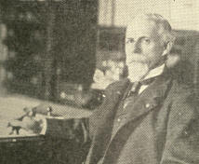
Russell A. Alger,
Secretary of War.

194 EXPANSION [1897

The money stringency, too, now began to abate. The annual output of the world's gold mines, which had for some years been increasing, appeared to have terminated the fall of general prices, prevalent almost incessantly since 1873. Moreover, continued increase seemed assured, not only by the invention of new processes, which made it lucrative to work tailings and worn-out mines, but also by the discovery of several rich auriferous tracts hitherto unknown.

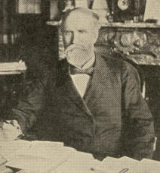
James Wilson,
Secretary of Agriculture.

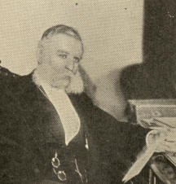
Postmaster-General Gary.
From a copyrighted photo by Clinedinst.

The valley of the Yukon, in Alaska and the adjacent British territory, had long been known to contain gold, but none suspected there a bonanza like the South African Rand. In the six months' night of 1896-1897 an old squaw-man made an unprecedented strike upon the Klondike (Thron-Duick or Tondak) River, 2,000 miles up the Yukon.
1897] MR. McKINLEY'S ADMINISTRATION 195

By spring all his neighbors had staked rich claims. Next July $2,000,000 worth of gold came south by one shipment, precipitating a rush to the inhospitable mining regions hardly second to the California migration of 1849.
Latter-day Argonauts, not dismayed by the untold dangers and hardships in store, toiled up the Yukon, or, swarming over the precipitous Chilcoot Pass, braved, too often at cost of life, the boiling rapids to be passed in descending the Upper Yukon to the gold fields. Later the easier and well-wooded White Pass was found, traversed, at length, by a railroad. In October, 1898, the Cape Nome coast, north of the Yukon mouth, uncovered its riches, whereupon treasure-seekers turned thither their attention, even from the Yukon.
Little lawlessness pestered the gold settlements. The Dominion promptly despatched to Dawson a body of her famous mounted police. Our Government, more tardily, made its authority felt from St. Michaels, near the Yukon mouth, all the way to the Canadian border. On June 6, 1900, Alaska was constituted a civil and judicial district, with a governor, whose functions were those of a territorial governor. When necessary the miners themselves formed tribunals and meted out a rough-and-ready justice.
196 EXPANSION [1897

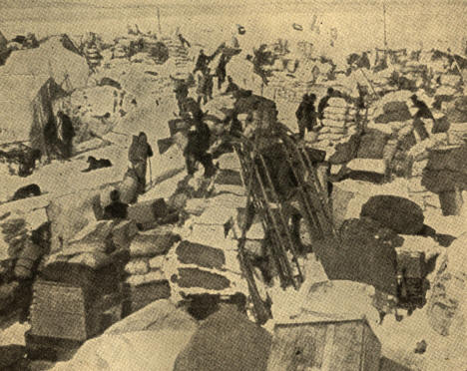
Rush of Miners to the Yukon.
The City of Caches at the Summit of Chilcoot Pass.
1897] MR. McKINLEY'S ADMINISTRATION 197

The rush of miners to the middle Yukon gold region, which, together with certain ports and waters on the way thither, were claimed by both the United States and Great Britain, made acute the question of the true boundary between Alaskan and British territory.
In 1825 Great Britain and Russia, the latter then owning Alaska, agreed by treaty to separate their respective possessions by a line commencing at the southernmost point of Prince of Wales Island and running along Portland Channel to the continental coast at 56 degrees north latitude. North of that degree the boundary was to run along mountain summits parallel to the coast until it intersected the 141st meridian west longitude, which was then to be followed to the frozen ocean. In case any of the summits mentioned should be more than ten marine leagues from the ocean, the line was to parallel the coast, and be never more than ten marine leagues therefrom.

198 EXPANSION [1898

When it became important to determine and mark the boundary in a more exact manner, Great Britain advanced two new claims; first, that the "Portland Channel" mentioned in the Russo-British treaty was not the channel now known by that name, but rather Behm Channel, next west, or Clarence Straits; and, secondly, that the ten-league limit should be measured from the outer rim of the archipelago skirting Alaska, and not from the mainland coast. If conceded, these claims would add to the Canadian Dominion about 29,000 square miles, including 100 miles of sea-coast, with harbors like Lynn Channel and Tahko Inlet, several islands, vast mining, fishery, and timber resources, as well as Juneau City, Revilla, and Fort Tongass, theretofore undisputably American.
In September, 1898, a joint high commission sat at Quebec and canvassed all moot matters between the two countries, among them that of the Alaska boundary. It adjourned, however, without settling the question, though a temporary and provisional understanding was reached and signed October 20, 1899.
The commissioners gave earnest attention to the sealing question, which had been plaguing the United States ever since the Paris arbitration tribunal upset Secretary Blaine's contention that Bering Sea was mare clausum.
1897] MR. McKINLEY'S ADMINISTRATION 199

Upon that tribunal's decision the modus vivendi touching seals lapsed, and Canadians, with renewed and ruthless zeal, plied seal-killing upon the high seas. Dr. David S. Jordan, American delegate to the 1896-1897 Conference of Fur-Seal Experts, estimated that the American seal herd had shrunken 15 per cent. in 1896, and that a full third of that year's pups, orphaned by pelagic sealing, had starved. Reckoning from the beginning of the industry and in round numbers, he estimated that 400,000 breeding females had been slaughtered, that 300,000 pups had perished for want of nourishment, and that 400,000 unborn pups had died with their dams. This estimate disregarded the multitude of females lost after being speared or shot. Dr. Jordan predicted the not distant extinction of the fur-seal trade unless protective measures should be forthwith devised. British experts questioned some of his conclusions, but admitted the need of restriction upon pelagic sealing.
200 EXPANSION [1897

The McKinley Administration besought Great Britain for a suspension of seal-killing during 1897. After a delay of four months the Foreign Office replied that it was too late to stop the sealers that year. In a rather undiplomatic note, dated May 10, 1897, Secretary Sherman charged dilatory and evasive conduct upon this question. The retort was that the American Government was seeking to embarrass British subjects in pursuing lawful vocations.
Moved by Canada, Great Britain recanted her offer to join the United States, Russia, and Japan in a complete system of sealing regulations. The three countries last named thereupon agreed with each other to suspend pelagic sealing so long as expert opinion declared it necessary to the continued existence of the seals. The Canadians declined to consider suspension save on the condition that the owners of sealing vessels should receive compensation.
1897] MR. McKINLEY'S ADMINISTRATION 201

In December, the same year (1897), our Government ordered confiscated and destroyed all sealskins brought to our ports not accompanied with invoices signed by the United States Consul at the place of exportation, certifying that they were not taken at sea. This cut off the Canadians' best market and so far diminished their activity; but pelagic sealing still continued, under the inefficient Paris regulations, and the herd went on diminishing.
That these Canadian controversies left so little sting, but were followed by closer and closer rapprochement between the United States and Great Britain, was fortunate in view of the failure of the Anglo-American Arbitration Treaty. This had been negotiated by Mr. Cleveland's able Secretary of State, Hon. Richard Olney, and represented the best ethical thought of both nations. President McKinley endorsed it, but it fell short of a two-thirds Senatorial vote.

202 EXPANSION [1898

On June 16, 1897, a treaty was signed annexing the Hawaiian Republic to the United States. The Government of Hawaii speedily ratified this, but it encountered in the United States Senate such buffets that after a year it was withdrawn, and a resolution to the same end introduced in both Houses. A majority in each chamber would annex, while the treaty method would require a two-thirds vote in the Senate. The resolution provided for the assumption by the United States of the Hawaiian debt up to $4,000,000. Our Chinese Exclusion Law was extended to the islands, and Chinese immigration thence to the continental republic prohibited. The joint resolution passed July 6, 1898, a majority of the Democrats and several Republicans, among these Speaker Reed, opposing. Shelby M. Cullom, John T. Morgan, Robert R. Hitt, Sanford B. Dole, and Walter F. Frear, made commissioners by its authority, drafted a territorial form of government, which became law April 30, 1900.
Pursuant to the platform pledge of his party President McKinley early in his term appointed Edward O. Wolcott, Adlai E. Stevenson, and Charles J. Paine special envoys to the Powers in the interest of international bi-metallism.
1898] MR. McKINLEY'S ADMINISTRATION 203

The mission was mentioned with smiles by gold men and with sneers by silver men, yet the cordial cooperation of France made it for a time seem hopeful. The British Cabinet, too, were not ill-disposed, pointing out that while Great Britain herself must retain the gold standard, they earnestly wished a stable ratio between silver and gold on British India's account. Sir Michael Hicks-Beach, Chancellor of the Exchequer, had little doubt that if a solid international agreement could be reached India would reopen her mints to silver. But the Indian Council unanimously declined to do this. The Bank of England was at first disposed to accept silver as part of its reserve, a course which the law permitted; but a storm of protests from the "city banks" dismayed the directors into withdrawal. Lacking England's cooperation the mission, like its numerous predecessors, came to naught.

204 EXPANSION [1899

In Civil Service administration Mr. McKinley took one long and unfortunate step backward. The Republican platform, adopted after Mr. Cleveland's extension of the merit system, emphatically endorsed this, as did Mr. McKinley himself. Against extreme pressure, particularly in the War Department, the President bravely stood out till May 29, 1899. His order of that date withdrew from the classified service 4,000 or more positions, removed 3,500 from the class theretofore filled through competitive examination or an orderly practice of promotion, and placed 6,416 more under a system drafted by the Secretary of War. The order declared regular a large number of temporary appointments made without examination, besides rendering eligible, as emergency appointees, without examination, thousands who had served during the Spanish War.
Republicans pointed to the deficit under the Wilson Law with much the same concern manifested by President Cleveland in 1888 over the surplus. A new tariff law must be passed, and, if possible, before a new Congressional election. An extra session of Congress was therefore summoned for March 15, 1897.
1897] MR. McKINLEY'S ADMINISTRATION 205

The Ways and Means Committee, which had been at work for three months, forthwith reported through Chairman Nelson Dingley the bill which bore his name. With equal promptness the Committee on Rules brought in a rule, at once adopted by the House, whereby the new bill, spite of Democratic pleas for time to examine, discuss, and propose amendments, reached the Senate the last day of March. More deliberation marked procedure in the Senate. This body passed the bill after toning up its schedules with some 870 amendments, most of which pleased the Conference Committee and became law. The Act was signed by the President July 24, 1897.

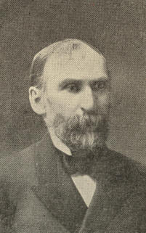
Nelson Dingley.

The Dingley Act was estimated by its author to advance the average rate from the 40 per cent. of the Wilson Bill to approximately 50 per cent., or a shade higher than the McKinley rate. As proportioned to consumption the tax imposed by it was probably heavier than that under either of its predecessors.
206 EXPANSION [1897

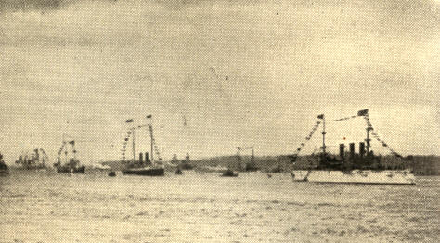
Warships in the Hudson River Celebrating
the Dedication of Grant's Tomb, April 27, 1897.

Reciprocity, a feature of the McKinley Tariff Act, was suspended by the Wilson Act. The Republican platform of 1896 declared protection and reciprocity twin measures of Republican policy. Clauses graced the Dingley Act allowing reciprocity treaties to be made, "duly ratified" by the Senate and "approved" by Congress; yet, of the twins, protection proved stout and lusty, while the weaker sister languished.
1897] MR. McKINLEY'S ADMINISTRATION 207

Under the third section of the Act some concessions were given and received, but the treaties negotiated under the fourth section, which involved lowering of strictly protective duties, met summary defeat when submitted to the Senate.

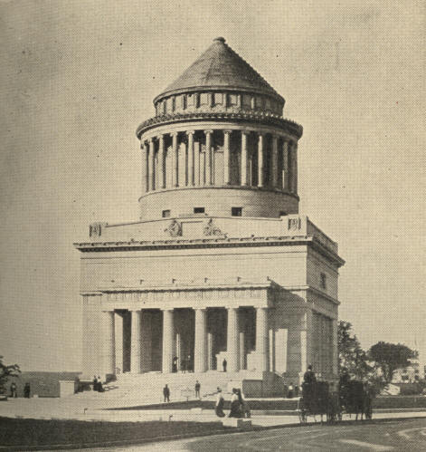
Grant's Tomb, Riverside Drive, New York.
Copyright, 1901, by Detroit Photographic Co.

208 EXPANSION [1897

The granite mausoleum in Riverside Park, New York City, designed to receive the remains of General Grant, was completed in 1897, and upon the 27th of April, that year, formally presented to the city. Ten days previously the body had been removed thither from the brick tomb where it had reposed since August 8, 1885. Four massive granite piers, with rows of Doric columns between, supported the roof and the obtuse cone of the cupola, which rested upon a great circle of Ionic pillars. The interior was cruciform. In the centre was the crypt, where, upon a square platform, rested the red porphyry sarcophagus. From the mausoleum summit, 150 feet above, the eye swept the Hudson for miles up and down.
The presentation day procession was headed by the presidential party. The Governor of New York State, the Mayor of the city, and the United States diplomatic corps were prominent. Other distinguished guests attended, including Union and Confederate Veterans. The entire procession reached six miles.
1897] MR. McKINLEY'S ADMINISTRATION 209

There were 53,500 participants, military and civil, and 160 bands of music. At the same time, in majestic column upon the Hudson, Great Britain, France, Italy, and Spain joined, with men-of-war, our North Atlantic squadron, saluting the President as he passed.
The exercises at the tomb were simple. Bishop Newman offered prayer. "America" was sung. President McKinley delivered an address of eulogy. General Horace Porter gave the mausoleum into the city's keeping, a trust which Mayor Strong in a few words accepted.
CHAPTER XII.

THE WAR WITH SPAIN

How early Cuban discontent with Spain's rule became vocal is not known. An incipient revolt in 1766 was ruthlessly put down. Though the "Ever Faithful Isle" did not rebel with the South American colonies under Bolivar, it was never at rest, as attested by the servile revolts of 1794 and 1844, the" Black Eagle" rebellion of 1829, and the ten-years' insurrection beginning in 1868. In 1894-1895, just as "Home Rule for Cuba" had become a burning issue in Spain, martial law was proclaimed in Havana, precipitating the last and successful revolution.
American interest in the island, material and otherwise, was great. The barbarity and devastation marking the wars made a strong appeal to our humane instincts; nor could Americans be indifferent to a neighboring people struggling to be free.
1895] THE WAR WITH SPAIN 211

The suppression of filibustering expeditions taxed our Treasury and our patience. Equally embarrassing were the operations of Cuban juntas from our ports. To solve the complex difficulty Presidents Polk, Buchanan, and Grant had each in his time vainly sought to purchase the island. The Virginius outrage during Grant's incumbency brought us to the very verge of war, prevented only by the almost desperate resistance of Secretary Hamilton Fish.

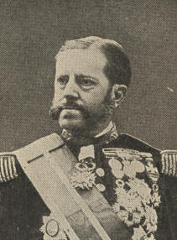
Governor-General Weyler.

212 EXPANSION [1897

When the final rebellion was under way the humane Governor-General Martinez Campos was succeeded by General Weyler, ordered to down the rebellion at all costs. Numberless buildings were burnt and plantations destroyed, the insurgents retaliating in kind. Non-combatants were huddled in concentration camps, where half their number perished. American citizens were imprisoned without trial. One, Dr. Ruiz, died under circumstances occasioning strong suspicions of foul play.
President Cleveland, while willing to mediate between Spain and the Cubans, preserved a neutral attitude, refusing to recognize the insurgents even as belligerents, though they possessed all rural Cuba save one province. Only when about to quit office did Mr. Cleveland hint at intervention.
. Soon after McKinley's accession an anarchist shot Premier Canovas, when Sagasta, his Liberal successor, promised Cuba reform and home rule. Weyler was succeeded by Blanco, who revoked concentration, proclaimed amnesty, and set on foot an autonomist government. Americans were loosed from prison. Clara Barton, of the American Red Cross Society, hastened with supplies to the relief of the wretched reconcentrados, turned loose upon a waste. Spain, too, appropriated a large sum for reconcentrado relief, promising implements, seed, and other means for restoring ruined homes and plantations.

1897] THE WAR WITH SPAIN 213

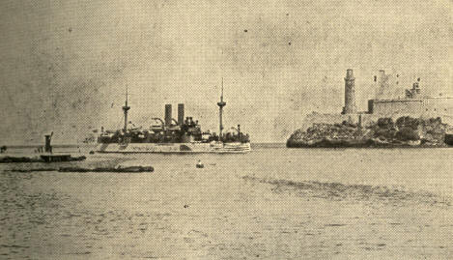
Copyright. 1898, by F. C. Hemment.
U. S. Battleship Maine Entering the Harbor of Havana, January, 1898.

But the iron had entered the Cuban's soul. The belligerents rejected absolutely the offers of autonomy, demanding independence. The "pacificos" were no better off than before, and relations between the United States and Spain grew steadily more strained. Two incidents precipitated a crisis.

214 EXPANSION [1898

A letter by the Spanish Minister at Washington, Senor de Lome, was intercepted and published, holding President McKinley up as a time-serving politician. De Lome forestalled recall by resigning; yet his successor, Polo y Bernabe, could not fail to note on arriving in Washington a chill diplomatic atmosphere.

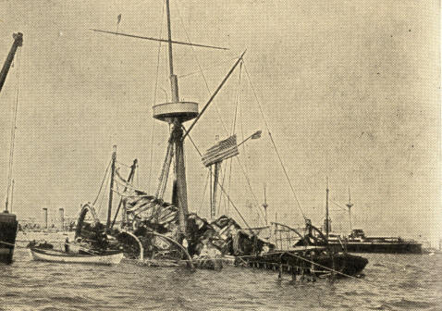
Wreck of U. S. Battleship Maine.
Photograph. by F. C. Hemment.

In January, 1898, the United States battleship Maine was on a friendly visit at Havana, where she was received with the greatest courtesy, being taken to her harbor berth by the Spanish government pilot.
1898] THE WAR WITH SPAIN 215

At 9.40 on the evening of February 15th, the harbor air was rent by a tremendous explosion. Where the Maine had been, only a low shapeless hump was distinguishable. The splendid vessel, with officers and crew on board to the number of 355, had sunk, a wreck. Of the 355, 253 never saw day.
Strong suspicions gained prevalence that this was a deed of Spanish treachery, or attributable, at the very least, to criminal indifference on the part of the authorities. Some alleged positive connivance by Spanish officials. War fever ran high. When, five days later, the Spanish cruiser Vizcaya visited New York City, it was thought well to accord her special protection. March, 9th, Congress placed in the President's hands $50,000,000 to be used for national defence. The 21st, a naval court of inquiry confirmed the view that the Maine disaster was due to the explosion of a submarine mine. War fever became a fire. "Remember the Maine" echoed up and down and across the land, the words uttered with deep earnestness.

216 EXPANSION [1898

The war spirit welded North and South, permeating the Democracy even more than the party in power. Democrats would have at once recognized the Cuban Republic. This was at first the attitude of the Senate, which, upon deliberation, wisely forbore. It, however, on April 20th, joined the House in declaring the people of Cuba free and independent, adding that Spain must forthwith relinquish her authority there.

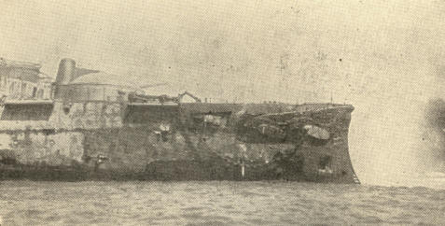
Bow of the Spanish Cruiser Almirante Oquendo.
From a Photograph by F. C. Hemment.
Copyright, 1898, by W. R. Hearst.

The President was authorized to use the nation's entire army, navy, and militia to enforce withdrawal. This was in effect a declaration of war. Minister Woodford, at Madrid, received his passports; as promptly Bernabe withdrew to Montreal. April 23d, 125,000 volunteers were called out. April 26th an increase of the regular army to some 62,000 was authorized. Soon came a call for 75,000 more volunteers. Responses from all the States flooded the War Department.
217

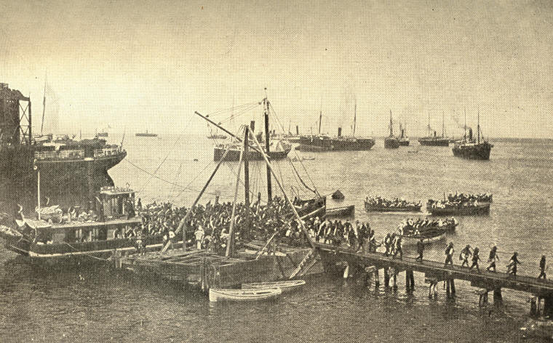
The Landing at Daiquiri. Transports in the Offing.
218
1898] THE WAR WITH SPAIN 219

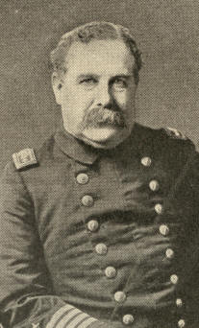
Captain Charles E. Clark.

Spain, ruled by a clique of privileged Catalonians, groaned under all the oppressiveness of militarism, with none of its power. Plagued by Carlism and anarchy at home, she was grappling, at tremendous outlay, with two rebellions abroad. Yet all her many parties cried for war. Popular subscriptions were taken to aid the impoverished treasury; reserves were called out; in Cuba, Blanco summoned all able-bodied men. The navy was supplemented by ships purchased wherever hands could be laid upon them.
220 EXPANSION [1898

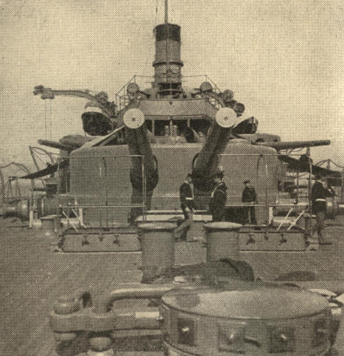
After Deck on the Oregon, Showing Two 13-inch,
Four 8-inch, and Two 6-inch Guns.
Copyright. 1899. by Strohmeyer & Wyman.

Owing to the parsimony of Congress, our equipment for a large army, or even for our 25,000 regulars, if they were to go on a tropical campaign, was totally inadequate. Our artillery had no smokeless powder. Many infantry regiments came to camp armed with nothing but enthusiasm. No khaki cloth for uniforms was to be had in the country.
1898] THE WAR WITH SPAIN 221

Canvas had to be taken from that provided by the Post-Office Department for repairing mail bags. While the utmost possible at short notice was done with the just voted $50,000,000 defence fund, the comprehensive system of fortifications long before designed had hardly been begun.

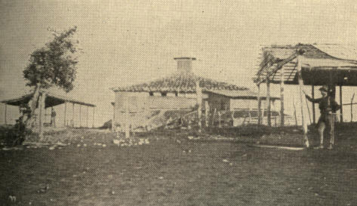
Blockhouse on San Juan Hill.

The navy had been treated least illiberally; still the construction budget had been so cut that only a few of the proposed vessels had been transferred from paper to the sea.
222 EXPANSION [1898

The United States navy which did exist was a noble one. Both its ships and their crews were as fine as any afloat. Had the Spanish navy been manned like ours the two would have been of about equal strength. Ours boasted the more battleships, but Spain had several new and first-rate armored cruisers, besides a flotilla of swift torpedo boats. The Spaniards were, however, poor gunners, clumsy sailors, awkward and careless mechanics; while American gunners had a deadly aim, and spared no skill or pains in the care or handling of their ships.
American superiority in these points was tellingly proved by the Oregon's unprecedented run from ocean to ocean. Before hostilities she was ordered from San Francisco, via Cape Horn to join the Atlantic squadron. The long, hard, swift trip was made without the break of a bar or the loosening of a bolt, a result which attracted expert notice abroad as attesting the very highest order of seamanship. Meantime war had commenced. It was feared that off Brazil Admiral Cervera would endeavor to intercept and destroy her; yet, with well-grounded confidence, Captain Clark expected in that event not only to save himself but to punish his assailants.
1898] THE WAR WITH SPAIN 223

He met no interference, however, and at the end of her unparalleled voyage his noble ship was without overhauling ready to join in the Santiago blockade and in destroying the Spanish fleet.

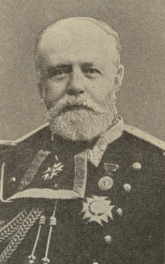
Admiral Cervera,
Commander of the Spanish Squadron.

Admiral Cervera's departure westward from the Cape Verde Islands, and the subsequent discovery of his squadron in the harbor of Santiago, determined the Government to invest that city. The navy acted with promptitude. Commodore Schley first, then, in conjunction with him, his superior, Rear-Admiral Sampson, drew a tight line of war-vessels across the channel entrance.

224 EXPANSION [1898

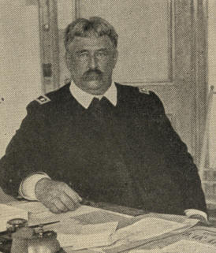
Major-General William R. Shafter.

Unfortunately delayed by inadequate shipping facilities and the unsystematic consignment of supplies, also by the unfounded rumor of a Spanish cruiser and destroyer lying in wait, the army of 17,000, under Major-General William R. Shafter, landed with little opposition a short distance east of Santiago. The sickly season had begun. Moreover, it was as good as certain that, spite of all the miserable Cuban army could do, Santiago's 8,000 defenders would soon be increased from neighboring Spanish garrisons. So, notwithstanding his inadequate provision for sound, sick, or wounded and his weakness in artillery, Shafter pushed forward. His gallant little army brushed the enemy's intercepting outpost from Las Guasimas, tore him, amid red carnage, from his stubborn holds at El Caney and San Juan Ridge, and by July 3d had the city invested, save on the west. From this quarter, however, General Escario, with 3,600 men, had forced his way past our Cuban allies and joined his besieged compatriots in Santiago.

1898] THE WAR WITH SPAIN 225

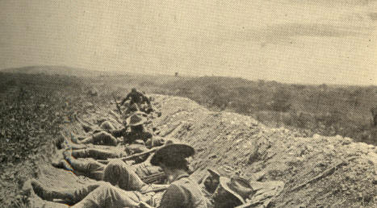
Troops in the Trenches, Facing Santiago.

The third of July opened, for the Americans, the darkest day of the war. Drenched by night, roasted by day, haversacks which had been cast aside for battle lost or purloined, supply trains stalled in the rear, fighting by day, by night digging trenches and rifle-pits--little wonder that many lost heart and urged withdrawal to some position nearer the American base.
226 EXPANSION [1898

Shafter himself for a moment considered such a step. But General Wheeler, on the fighting line, set his face against it, as, upon reflection, did Shafter. A bold demand for surrender was sent to General Toral, commanding the city, while Admiral Sampson came to confer with Shafter for a naval assault.

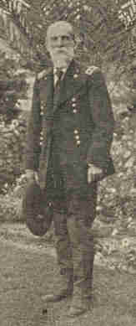
General Joseph Wheeler.

The squadron had not been idle. By day their vigilance detected the smallest movement at the harbor mouth. Upon that point each night two battleships bent their dazzling search-lights like cyclopean eyes.

227

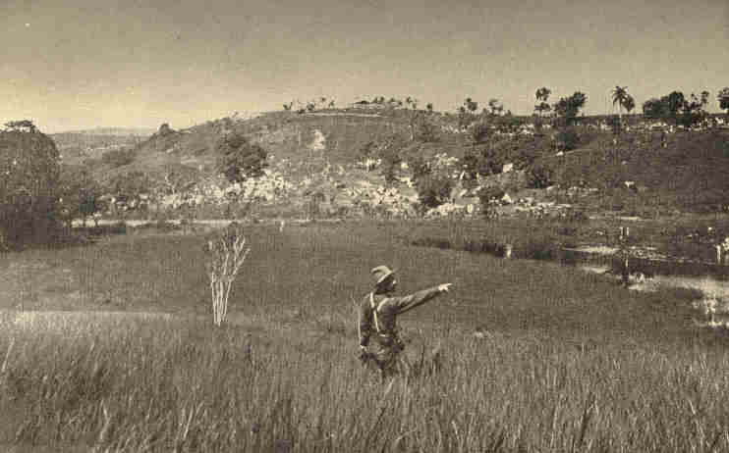
View of San Juan Hill and Blockhouse,
Showing the Camp of the United States Forces.
228
1898] THE WAR WITH SPAIN 229

It was decided to block the narrow channel by sinking the collier Merrimac across its neck. Just before dawn on June 3d the young naval constructor, Hobson, with six volunteers chosen from scores of eager competitors, and one stowaway who joined them against orders, pushed the hulk between the headland forts into a roaring hell of projectiles.

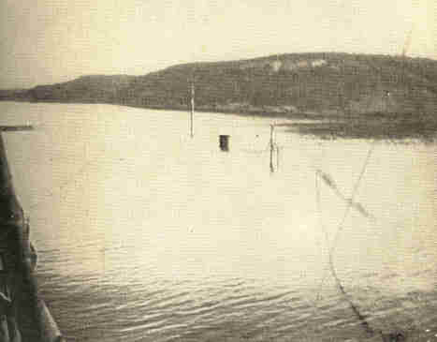
The Collier Merrimac Sunk by Hobson at the Mouth of Santiago Harbor.

230 EXPANSION [1898

An explosion from within rent the Merrimac's hull, and she sank; but, the rudder being shot away, went down lengthwise of the channel. When the firing ceased, the little crew, exhausted, but not one of the eight missing, clustered, only heads out of water, around their raft. A launch drew near. In charge was the Spanish admiral, who took them aboard with admiring kindness, and despatched a boat to notify the American fleet of their safety.
It was well that "Hobson's choice" as to the way his tub should sink failed. On July 3d, just after Sampson steamed away to see Shafter, the Maria Teresa was seen poking her nose from the Santiago harbor, followed by the Almirante Oquendo, the Vizcaya, and the Christobal Colon. Under peremptory orders from his Government, Admiral Cervera had begun a mad race to destruction. "It is better," said he, "to die fighting than to blow up the ships in the harbor." These had become the grim alternatives.

1898] THE WAR WITH SPAIN 231

The Brooklyn gave chase, the other vessels in suit, the Texas and the Oregon leading. As the admiral predicted, it was "a dreadful holocaust." One by one his vessels had to head for the beach, silenced, crippled, flames bursting from decks, portholes, and the rents torn by our cannonade. Two destroyers, Furor and Pluton, met their fate near the harbor. Only the Colon remained any time afloat, but her doom was sealed. Outdoing the other pursuers and her own contract speed the grand Oregon, pride of the navy, poured explosives upon the Spaniard, until, within three hours and forty minutes of the enemy's appearance, his last vessel was reduced to junk. Cervera was captured with 76 officers and 1,600 men. 350 Spaniards were killed, 160 wounded. The American losses were inconsiderable. The ships' injuries also were hardly more than trifling.
So closed the third of July, so opened the glorious Fourth! To Shafter and his men the navy's victory was worth a reenforcement of 100,000. Bands played, tired soldiers danced, shouted, and hugged each other. Correspondingly depressed were the Spaniards. They endeavored, as Hobson had, to choke the harbor throat with the Reina Mercedes; but she, like the Merrimac, had her steering apparatus shot away and sank lengthwise of the channel. Still, it was not deemed wise to attempt forcing a way in, nor did this prove necessary.
232 EXPANSION [1898

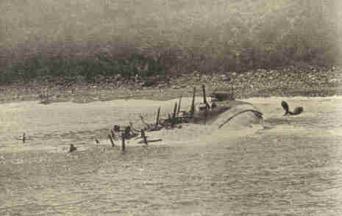
From a Photograph by F. C. Hemment. Copyright, 1898, by W. R. Hearst.
The Spanish Cruiser Christobal Colon.

Toral saw reenforcements extending the American right to surround him, and out at sea over fifty transports loaded with fresh soldiers. Spanish honor had been signalized not only by the devoted heroism of Cervera's men but by the gallantry of his own. The Americans offered to convey his command back to Spain free of charge.
1898] THE WAR WITH SPAIN 233

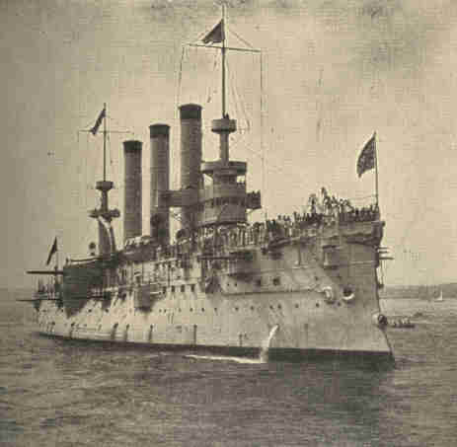
Copyright, 1898. by C C. Langill. N. Y.
The U. S. S. Brooklyn.

He therefore sought from Madrid, and after some days obtained, authority to surrender. He surrendered July 16th. Besides the Santiago garrison, Toral's entire command in eastern Cuba, about 24,000 men, became our prisoners of war.

234 EXPANSION [1898

The Santiago surrender left the United States free to execute what proved the last important expedition of the war, that of General Miles to Porto Rico. It was a complete success. Miles proclaiming the beneficent purposes of our Government, numbers of volunteers in the Spanish army deserted, the regulars were swept back by four simultaneous movements, and our conquest was as good as complete when the peace protocol put an end to all hostilities.

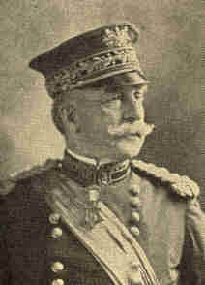
General Nelson A. Miles

Meantime an independent campaign was under way in the far Orient. At once after war was declared Commodore George Dewey, commanding the United States naval forces in Asiatic waters, was ordered to capture or sink the Spanish Philippine fleet. Obliged at once to leave the neutral port of Hong-Kong, and on April 27th to quit Mirs Bay as well, he steamed for Manila.

1898] THE WAR WITH SPAIN 235

A little before midnight, on April 30th, Dewey's flagship Olympia entered the Boca Grande channel to Manila Bay, the Baltimore, Petrel, Raleigh, Concord, and Boston following. By daybreak Cavite stood disclosed and, ready and waiting, huddled under its batteries, Admiral Montojo's fleet: Reina Christina, Castilla, Don Antonio de Ulloa, Don Juan de Austria, Isla de Luzon, Isla de Cuba, General Lezo, Marquis del Duero, El Curreo and Velasco--ten vessels to Dewey's six. Counting those of the batteries, the Spaniards' guns outnumbered and outcalibred Dewey's. All the Spanish guns, from ships and from batteries alike, played on our fleet--a thunder of hostile welcome, harmless as a salute.

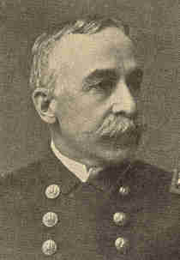
Admiral George Dewey.

236 EXPANSION [1898

The commodore delayed his fire till every shot would tell, when, circling around in closer and closer quarters, he concentrated an annihilating cyclone of shot and shell upon the Spanish craft. Two torpedo boats ventured from shore. One was sunk, one beached.

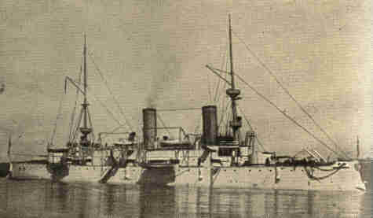
Protected Cruiser Olympia.

The Reina Christina, the Amazon of the fleet, steamed out to duel with the Olympia, but "overwhelmed with deadly attentions" could barely stagger back. One hundred and fifty men were killed and ninety wounded on the Christina alone. In a little less than two hours, having sunk the Christina, Castilla, and Ulloa and set afire the other warships, the American ceased firing to assure and arrange his ammunition supply and to breakfast and rest his brave crews.
1898] THE WAR WITH SPAIN 237

He reopened at 11.16 A.M. to finish. By half-past twelve every Spanish warship had been sunk or burned and the forts silenced. The Spanish reported their loss at 381 killed and wounded. Seven Americans were wounded, not one killed.

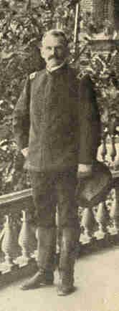
General A. R. Chaftee.

As the Filipino insurgents encircled Manila on the land side the Spaniards could not escape, and, to spare life, Dewey deemed it best to await the arrival of land forces before completing the reduction.
Waiting tried the admiral's discretion more than the battle had his valor. It was necessary to encourage the insurgents, at the same time to prevent excesses on their part, and to avoid recognizing them even as allies in such manner as to involve our Government.
238 EXPANSION [1898

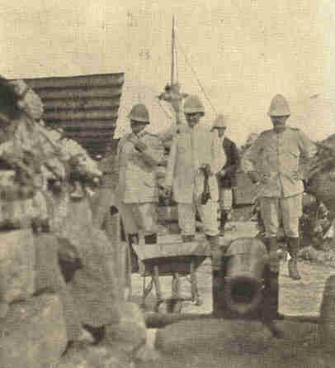
General Merritt and General Greene taking a
look at a Spanish field-gun on the Malate Fort.

Another embarrassment, threatening for a time, was the German admiral's impertinence. One of his warships was about to steam into harbor contrary to Dewey's instructions, but was halted by a shot across her bows. Dewey's firmness in this affair was exemplary.
1898] THE WAR WITH SPAIN 239

On June 30th the advance portion of General Merritt's troops arrived and supplanted the insurgents in beleaguering Manila. The war was now closing. Manila capitulated August 13th. The peace protocol was signed August 12th. The Treaty of Paris was signed December 10th. Spain evacuated Cuba and ceded to the United States Porto Rico, at the same time selling us the Philippine Archipelago for $20,000,000.
CHAPTER XIII.

"CUBA LIBRE"

As if Santiago had not afforded "glory enough for all," some disparaged Admiral Sampson's part in the battle, others Admiral Schley's. As commander of the fleet, whose routine and emergency procedure he had sagaciously prescribed, Sampson, though on duty out of sight of the action at its beginning, was entitled to utmost credit for the brilliant outcome. The day added his name to the list of history's great sea captains.

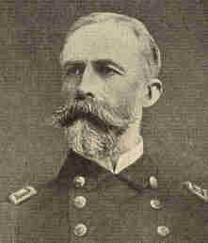
Admiral William T. Sampson.

1898] "CUBA LIBRE" 241

Schley had the fortune to be senior officer during his chief's temporary absence. He fought his ship, the Brooklyn, to perfection, and, while it was not of record that he issued any orders to other commanders, his prestige and well-known battle frenzy inspired all, contributing much to the victory. The early accounts deeply impressed the public, and they made Schley the central figure of the battle. Unfortunately Sampson's first report did not even mention him. Personal and political partisans took up the strife, giving each phase the angriest possible look. Admiral Schley at length sought and obtained a court of inquiry.

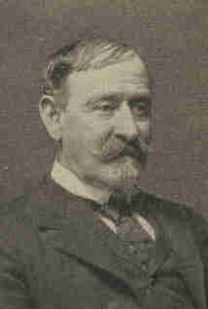
Admiral W. S. Schley

242 EXPANSION [1898

The court found Schley's conduct in the part of the campaign prior to June 1, 1898 (which our last chapter had not space to detail), vacillating, dilatory, and lacking enterprise. It maintained, however, that during the battle itself, despite the Brooklyn's famous "loop," which it seemed to condemn, his conduct was self-possessed, and that he inspired his officers and men to courageous fighting. Admiral Dewey, president of the court, held in part a dissenting opinion, which carried great weight with the country. He considered Schley the actual fleet commander in the battle, thus giving him the main credit for the victory.
Legally, it turned out, Sampson, not Schley, commanded during the hot hours. Moreover, the evidence seemed to reveal that the court's strictures upon Schley, like many criticisms of General Grant at Shiloh and in his Wilderness campaign, were probably just. In both cases the public was slow to accept the critics' view,
Both before and after his resignation, July 19, 1899, Secretary of War Alger was subjected to great obloquy. Shafter's corps undoubtedly suffered much that proper system and prevision would have prevented.
1899] "CUBA LIBRE" 243

The delay in embarking at Tampa; the crowding of transports, the use of heavy uniforms in Cuba and of light clothing afterward at Montauk Point, the deficiency in tents, transportation, ambulances, medicines, and surgeons, ought not to have occurred. Indignation swept the country when it was charged that Commissary-General Eagan had furnished soldiers quantities of beef treated with chemicals and of canned roast beef unfit for use. A commission appointed to investigate found that "embalmed beef" had not been given out to any extent. Canned roast beef had been, and the commission declared it improper food.
The commission made it clear that the Quartermaster's Department had been physically and financially unequal to the task of suddenly equipping and transporting the enlarged army--over ten times the size of our regular army--for which it had to provide. If wanting at times in system the department had been zealous and tireless. At the worst it was far less to blame than recent Congresses, which had stinted both army and navy to lavish money upon objects far less important to the country. The army system needed radical reform. There was no general staff, and the titular head of the army had less real authority than the adjutant-general with his bureau.
244 EXPANSION [1899

These imbroglios had little significance compared with the problems connected with our new dependencies. The Senate ratified the peace treaty February 6, 1899, by the narrow margin of two votes--forty-two Republicans and fifteen others in favor, twenty-four Democrats and three others opposing. But for the advocacy of the Democratic leader, William J. Bryan, who thought that the pending problems could be dealt with by Congress better than in the way of diplomacy, ratification would have failed.
The ratification of the Treaty of Paris marked a momentous epoch in our national life and policy. In a way, the very fact of a war with Spain did this. A century and a quarter before a Spanish monarch had furnished money and men to help the American colonies become free from England.

1899] "CUBA LIBRE" 245

"The people of America can never forget the immense benefit they have received from King Carlos III.," wrote George Washington. At that time a Spaniard predicted that the American States, born a pigmy, would become a mighty giant, forgetful of gratitude, and absorbed in selfish aggression at Spain's expense.

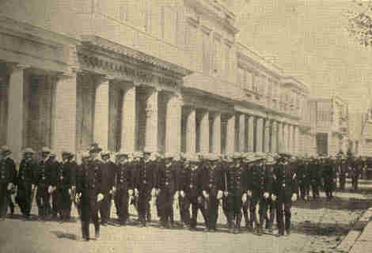
The New Cuban Police as organized by
ex-Chief of New York Police, McCullagh.

246 EXPANSION [1899

Our change to quasi-alliance with Great Britain against Spain seemed to not a few the fulfilment of that prophecy. Europe declared that we had hopelessly broken with our ideals. Cynics there applied to the United States the Scriptures: "Hell from beneath is moved for thee to meet thee at thy coming: it stirreth up the dead for thee, even all the chief ones of the earth; it hath raised up from their thrones all the kings of the nations. All they shall speak and say unto thee, Art thou also become weak as we? art thou become like one of us? . . . How art thou fallen from heaven, O Lucifer, son of the morning!"
The United States did not heed these sneers. Hawaii had been annexed. Sale tenure of the Samoan Islands west of 171 degrees west longitude, including Tutuila and Pago-Pago harbor, the only good haven in the group, was ours. These measures, which a few years earlier all would have deemed radical, did not stir perceptible opposition. Nearly all felt that they were justified, by considerations of national security, to obtain naval bases or strategic points. Such motives also excused the acquisition of Guam in the Pacific, ceded by Spain in Article II of the Paris Treaty, and that of Porto Rico.

1902] "CUBA LIBRE" 247

Civil government was established in Porto Rico with the happiest results. The Insular Treasury credit balance trebled in a year, standing, July 1, 1902, at $314,000. The exports for 1902 increased over 50 per cent., most of the advance being consigned to the United States. The principal exports were sugar, tobacco, the superior coffee grown in the island, and straw hats. Of the coffee, the year named, Europe took $5,000,000 worth, America only $29,000 worth. Porto Rico imported from Spain over $95,000 worth of rice, $500,000 worth of potatoes. The first year under our government there were 13,000 fewer deaths than the year before, improvement due to better sanitation and a higher standard of living. Mutual respect between natives and Americans grew daily.
248 EXPANSION [1900

Touching Cuba, too, the course of the Administration evoked no serious opposition. We were in the island simply as trustees for the Cubans. The fourth congressional resolution of April 20, 1898, gave pledge as follows: "The United States hereby disclaims any disposition or intention to exercise sovereignty, jurisdiction, or control over said island (Cuba) except for the pacification thereof, and asserts its determination when that is completed to leave the government and control of the island to its people." This "self-denying ordinance," than which few official utterances in all our history ever did more to shape the nation's behavior, was moved and urged, at first against strong opposition, by Senator Teller, of Colorado. Senator Spooner thought it likely that but for the pledge just recited European States would have formed a league against the United States in favor of Spain.
December 13, 1898, a military government was established for "the division of Cuba," including Porto Rico. The New Year saw the last military relic of Spanish dominion trail out of Cuba and Cuban waters.
1900] "CUBA LIBRE" 249

The Cuban army gradually disbanded. The work of distributing supplies and medicines was followed by the vigorous prosecution of railroad, highway and bridge repairing and other public works, upon which many of the destitute found employment.

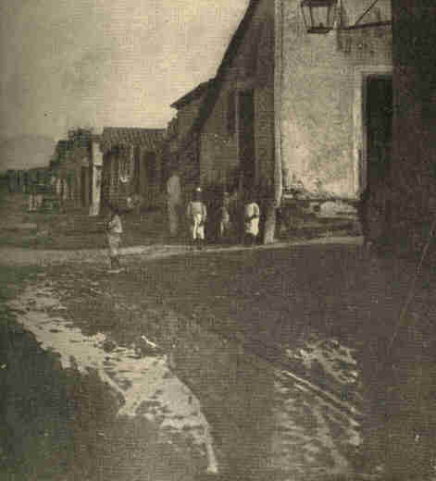
Showing Condition of Streets in Santiago
before Street Cleaning Department was organized.

250 EXPANSION [1900

Courts and schools were resumed. Hundreds of new schools opened --in Santiago city 60, in Santiago province over 300. Brigandage was stamped out. Cities were thoroughly cleaned and sewer systems constructed. The death rate fell steadily to a lower mark than ever before. In 1896 there were in Havana 1,262 deaths from yellow fever, and during the eleven years prior to American occupation an average of 440 annually.

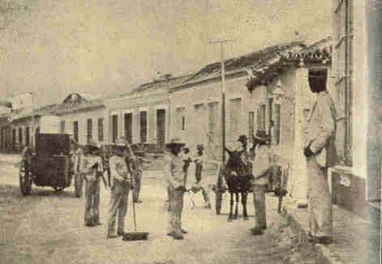
Santiago Street Cleaning Department.

In 1901 there were only four. Under the "pax Americana" industry awoke. New huts and houses hid the ashes of former ones. Miles of desert smiled again with unwonted tillage.

1899] "CUBA LIBRE" 251

A census of Cuba taken by the War Department, October 16, 1899, showed a population of 1,572,797, a falling off of nearly 60,000 in the twelve years since the last Spanish census, indicating the loss due to the civil war. The average density of population was about that of Iowa, varying, however, from Havana province, as thickly peopled as Connecticut, to Puerto Principe, with denizens scattered like those of Texas. Seventy per cent. of the island's inhabitants were Cuban citizens, two per cent. were Spanish, eighteen per cent. had not determined their allegiance, while about ten per cent. were aliens. Eighty per cent. of the people in the rural districts could neither read nor write.
In December, 1899, Governor Brooke retired in favor of General Leonard Wood. A splendid object-lesson in good government having been placed before the people, they were, in June, 1900, given control of their municipal governments and the powers of these somewhat enlarged.

252 EXPANSION [1900

In July Governor Wood issued a call for a constitutional convention, which met in November. The fruit of its deliberations was an instrument modelled largely upon the United States Constitution. The bill of rights was more specific, containing a guarantee of freedom in "learning and teaching" any business or profession, and another calculated to prevent "reconcentration." The Government was more centralized than ours. The President, elected by an electoral college, held office four years, and was not re-eligible twice consecutively. The Senate consisted of six senators from each of the six departments, the term being six years. One-third were elected biennially.

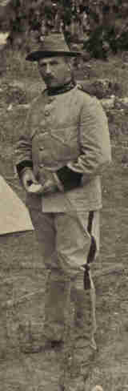
Governor - General Leonard A Wood
in the Uniform of Colonel of Rough Riders.

1901] "CUBA LIBRE" 253

The House of Representatives consisted of one representative to every 25,000 people. One-half were elected biennially. Four years was the term of office. The judicial power vested in a Supreme Court and such other courts as might be established by law. Suffrage was universal.
In his call for the convention, also in his opening address before it, Governor Wood mentioned its duty to determine the relations between Cuba and the United States. Jealous and suspicious, the convention, believing the United States bound by its pledge to leave the island to the unconditional control of its inhabitants, slighted these hints. Meantime, at President McKinley's instance, Congress adopted, March 2, 1901, as a rider to the pending army appropriation bill, what was known as "the Platt amendment," so called from its author, Senator Platt, of Connecticut.
This enacted that in fulfilment of the congressional joint resolution of April 20, 1898, which led to the freeing of Cuba, the President was to leave the government and Control of the island to its people only when a Government should be established there under a constitution defining the future relations of the United States with Cuba.
254 EXPANSION [1901

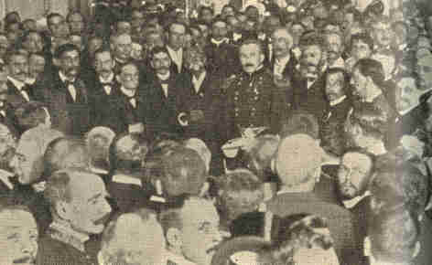
Judge Cruz Perez Gov. Gen. Wood.
General Maximo Gomez. T. E. Palma.
Governor-General Leonard A. Wood transferring the Island of Cuba to President
Tomaso Estrada Palma, as a Cuban Republic, May, 1902.
From copyrighted stereoscopic photograph. By Underwood & Underwood. N. Y.

The points to be safe-guarded were that Cuba should permit no foreign lodgment or control, contract no excessive debt, ratify the acts of the military government, and protect rights acquired thereunder, continue to improve the sanitation of cities, give the United States certain coaling and naval stations, and allow it to intervene if necessary to preserve Cuban independence, maintain adequate government, or discharge international obligations created by the Paris Treaty.

1902] "CUBA LIBRE" 255

A week before the Platt amendment passed, the Cuban convention adopted a declaration of relations, "provided the future government of Cuba thinks them advisable," not mentioning coaling stations or a right of intervention, but declaring that "the governments of the United States and Cuba ought to regulate their commercial relations by means of a treaty based on reciprocity."
When the convention heard that the Platt amendment must be complied with, a commission was sent to Washington to have this explained. Upon its return the convention, June 12, 1901, not without much opposition, adopted the amendment.
The first President of the Cuban Republic was Tomaso Estrada Palma. He had been years an exile in the United States, and was much in sympathy with our country. His home-coming was an ovation. In May, 1902, the Stars and Stripes were hauled down, and the Cuban tricolor raised. The military governor and all but a few of his soldiers left the island, as the Spaniards had done less than three years before; yet with a record of dazzling achievement that had in a few months done much to repair the mischiefs of Spain's chronic misrule.
256 EXPANSION [1901

Cut off from her former free commercial intercourse with Spain, Cuba looked to the United States as the main market for her raw sugar. Advocates of reciprocity urged considerations of honor and fair dealing with Cuba, where, it was said, ruin stared planters in the face. The Administration and a majority of the Republicans favored the cause. Not so senators and representatives from beet-sugar sections. The "insurgents," as the opponents of reciprocity were called, urged that raising sugar beets was a distinctively American industry, and that to sacrifice it was to relinquish the principle of protection altogether. The so-called "Sugar Trust" favored reciprocity, being accused of expending large sums in that interest. Against it was pitted the "Sugar Beet Trust," a new figure among combinations.
1901] "CUBA LIBRE" 257

During the long session of the Fifty-seventh Congress, a Cuban reciprocity bill being before the House, the sugar-beet interest demonstrated its power. The House "insurgents," joining the Democratic members, overrode the Speaker and the Ways and Means chairman, and attached to the bill an amendment cutting off the existing differential duty in favor of refined sugar. A locking of horns thus arose, which outlasted the session, neither side being able to convince or outvote the other. Sanguine Democrats thought that they espied here a hopeful Republican schism like that of 1872.
CHAPTER XIV.

THE UNITED STATES IN THE ORIENT

PHILIPPINES AND FILIPINOS

The Philippine Archipelago lies between 4 degrees 45 minutes and 21 degrees north latitude and 118 and 127 degrees east longitude. It consists of nineteen considerable and perhaps fifteen hundred lesser islands, an area nearly equal that of New Jersey, New York, and New England combined. The island of Luzon comprises a third of this, that of Mindanao a fifth or a sixth. The archipelago is rich in natural resources, but mining and manufactures had not at the American occupation been developed. Agriculture was the main occupation, though only a ninth of the land surface was under cultivation. The islands were believed capable of sustaining a population like Japan's 42,000,000. Luzon boasted a glorious and varied landscape and a climate salubrious and inviting, considering the low latitude. Manila hemp, sugar, tobaco, coffee, and indigo were raised and exported in large amounts.
1899] UNITED STATES IN THE ORIENT 259

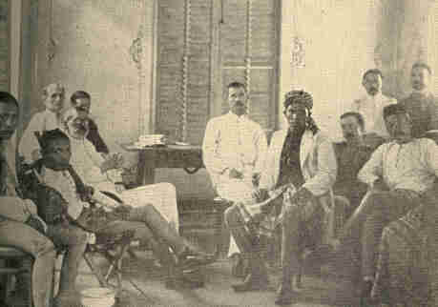
General Bates. The Sultan.
The Jolo Treaty Commission.

The islands lay in three groups, the Luzon, the Visaya (Negros, Panay, Cebu, Bohol, Leyte, Samar, and islets), and the Mindanao, including Palawan and the Sulu Islands. Some of these islands were in parts unexplored. The Tagals and the Visayas, Christian and more or less civilized Malay tribes, dominated respectively the first and the second group.
260 EXPANSION [l899

The Mindanao coasts held here and there a few Christian Filipinos, but the chief denizens of the southern islands were the fierce Arab-Malay Mohammedans known as Moros, most important and dangerous of whose tribes were the Illanos.
In all, there were thirty or more races, with an even greater number of different dialects. Northern Luzon housed the advanced Ilocoans, Pampangos, Pangasinanes, and Cagayanes, with their hardy bronze heathen neighbors, the Igorrotes. The Visayas had many degraded aborigines, the Negritos among them. Over against the Moros in the Mindanao group one could not ignore the warlike Visayan variation, or the swarming savages of the interior, hostile alike to Moro and Visaya.

261

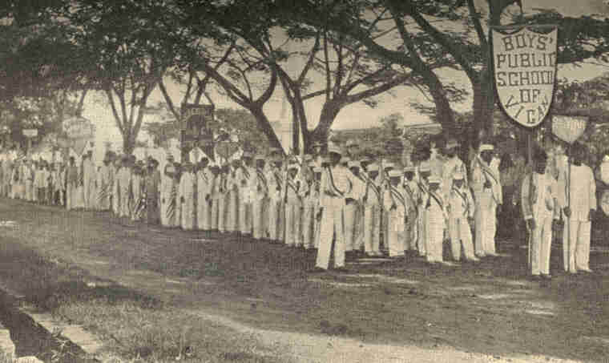
Three Hundred Boys in the Parade of July 4, 1902, Vigan, Ilocos.
262
1899] UNITED STATES IN THE ORIENT 263

The population of the islands numbered 8,000,000 or 10,000,000, 25,000 being Europeans. Half the islanders were Christians, eight or ten per cent. Mohammedan, perhaps ten per cent. heathen. One considerable fraction were Chinese, another of mixed extraction. Probably none of the races were of pure Malay blood, though Malay blood predominated. Mercantile pursuits were largely in Chinese hands. The Moros disdained tillage and commerce alike, living on slave labor and captures in war.
Spain had done in the islands much more educational work than the Americans at first recognized, though none of an advanced kind. Schools were numerous but not general. Many Filipinos had studied in Europe. There was a select class possessing information and manners which would have admitted them to cultivated circles in Paris or London, and thousands of Filipinos were intellectually the peers of average middle-class Europeans. The University of St. Thomas graced Manila. Some seventy colleges and academies at various centres professed to prepare pupils for it.
Filipinos of aught like cosmopolitan intelligence numbered less than 100,000. Below them were the half-breeds, perhaps 500,000 strong, white, yellow, or brown, according to the special blend of blood.
264 EXPANSION [1899

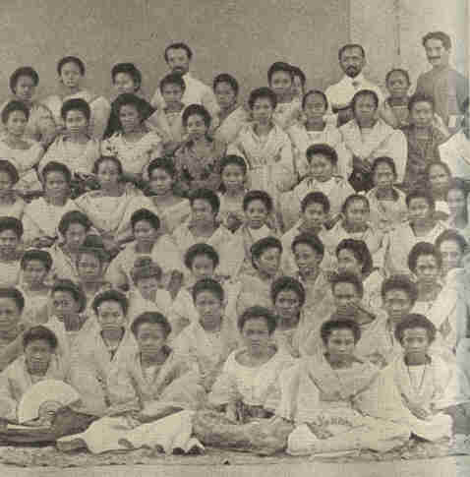
Girls' Normal Institute, Vigan, lIocos, April, 1902.

1899] UNITED STATES IN THE ORIENT 265

They were "intelligent but uneducated, active but not over industrious. They loved excitement, military display, and the bustle and pomp of government." Farther down still were the vast toiling masses neither knowing nor caring much who governed them. Only in suffering were they experts, having learned of this under the iron heel of Spain all there was to be known.
In the Philippines one had incessantly before him social and economic problems in their rudimentary form--populations the debris of centuries, and the reactions upon them of their first contact with real civilization. In case of any but the most advanced tribes the immediate suggestion was despair, a feeling that they could never appropriate the culture offered them. But the heartiness of the response which even such communities made to our advances brought hope. Our methods were better than the Spanish, and our progress correspondingly rapid; yet the task we undertook bade fair to last centuries. Nor were its initial steps undefaced by errors.
A Blue Book would not suffice to describe this motley material. We can only illustrate.
The Iocoros were in a forward state, if not of civilization, of preparation therefor. On all hands their youth were anxiously waiting to be taught. Compared with Teutonic races they were superficial and emotional, but they had great ambition and perseverance.
266 EXPANSION [1899

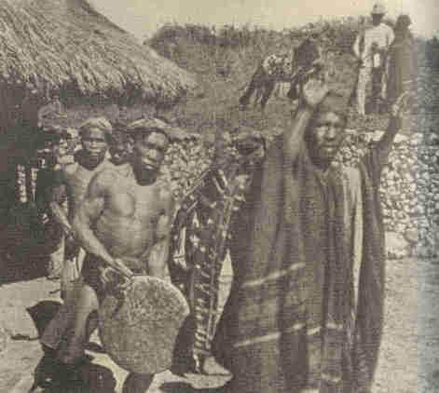
Igarrote Religious Dance, Lepanto.

1899] UNITED STATES IN THE ORIENT 267

A sharp contrast were the Igorrotes. These appeared to be at bottom Malays, though Mongolian features marked many a face. They had withstood all attempts to christianize them, and stubbornly clung to their primitive mode of life as tillers of the soil. Mentally they were near savagery, entirely without ambition or moral outlook. Nevertheless they adhered to the American arms and rendered valuable porter service.
Their religion had elements of sun and ancestor worship. The one tangible feature in it was the "kanyan," a drunken feast held on such occasions--fifteen in all--as marriage, birth, death, and serious illness. The feast began with an invocation to Kafunion, the sun god, and a dance much like that of the American Indians. Then came the drinking of tapi, a strong beer made from rice, and gorging with buffalo, horse, or dog meat, the last being the greatest delicacy. Till the Americans vetoed the practice, the Igorrotes were "head hunters." The theory was that the brains of the captured head became the captor's.
The Igorrotes had magnificent chests and legs, and were extensively used as burden-bearers. Sustained by only a few bowlfuls of rice and some sweet potatoes, a man would carry fifty or even seventy-five pounds on his head or back all day over the most difficult mountain trails. The Igorrotes had a mild form of slavery, and, though good-natured and at times industrious, appeared utterly without spirit of progress. It was interesting to mark whether or not contact with a superior race would be a stimulus to them.
268 EXPANSION [1899

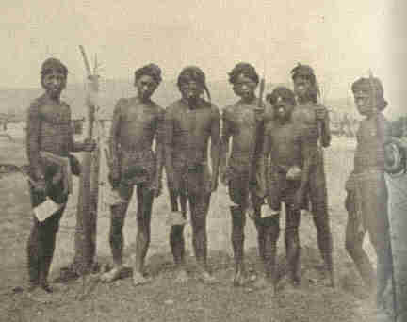
Igarrote Head Hunters with Head Axes and Spears.

A contrast, again, to the Igorrotes was presented by the Ilocoans, an intelligent, industrious, Christian people, eager for education, yet promising to cherish independent ideals the more dearly the more prosperous and advanced they became.

1899] UNITED STATES IN THE ORIENT 269

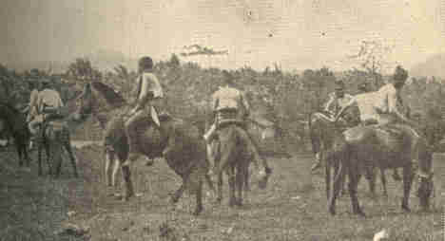
Native Moros-Interior of Jolo.

Most implacable of all the races were the Moros of the Sulu Islands. Warlike, and despising labor, their terrible piracies had been curbed only within fifty years, and their depredations and slave raiding by land were never wholly prevented. They were suspiciously eager to "assist" our forces in subduing the insurgents. The American authorities negotiated a treaty with the Sultan and his dattos, involving their submission to the United States.
270 EXPANSION [1899

A provision of this treaty excited reprobation, that permitting a slave to buy his freedom, a recognition of slavery in derogation of the Thirteenth Amendment to the Constitution. The provision was excused as an absolutely necessary makeshift to put off hostilities till the United States had a freer hand.
Spain never governed a colony well. Her whole record outre-mer was of a piece with the enslavement and extermination of the gentle Caribs, with which it began. In slavery and the slave trade Anglo-Saxon conquistadors shared Spain's dishonor, but in sheer ugliness of despotism, in wholesale, systematic, selfish exploiting, and in corrupt and clumsy administration the Iberian monarchy surpassed all other powers ever called to deal with colonies. The truth of this indictment was, if possible, more manifest in the Philippines than anywhere else in the Spanish world.
1899] UNITED STATES IN THE ORIENT 271

The religious orders, which early achieved the conversion of Tagals, Visayas, and some other tribes, after generations of evangelical devotion, ceased to be aggressive religiously, growing opulent and oppressive instead. They were the pedestal of the civil government. Their word could, and often did, cause natives to be deported, or even put to death. One of their victims was that beautiful spirit, Dr. Rizal, author of Noli me Tangere, the most learned and distinguished Malay ever known. He had taken no part whatever in rebellion or sedition, yet, because he was known to abominate clerical misrule, he was, without a scintilla of evidence that he had broken any law, first expatriated, then shot. This murder occurring December 30, 1896, did much to further the rebellion then spreading.
"Once settled in his position, the friar, bishop, or curate usually remained till superannuated, being therefore a fixed political factor for a generation, while a Spanish civil or military officer never held post over four years. The stay of any officer attempting a course at variance with the order's wishes was invariably shortened by monastic influence.
272 EXPANSION [1899

Every abuse leading to the revolutions of 1896 and 1898 the people charged to the friars; and the autocratic power which each friar exercised over the civil officials of his parish gave them a most plausible ground for belief that nothing of injustice, of cruelty, of oppression, of narrowing liberty was imposed on them for which the friar was not entirely responsible. The revolutions against Spain began as movements against the friars." [footnote: Abridged from Report of Taft Commission.]
Senator Hoar wrote: "I should as soon give back a redeemed soul to Satan as give back the people of the Philippine Islands to the cruelty and tyranny of Spain."
Freemasonry in the Philippines was a redoubtable antagonist to the orders. There were other secret leagues, like the Liga Filipina, with the same aim, most of them peaceful. Not so the "Katipunan," which adopted as its symbol the well-known initials, "K. K. K.," "Kataas-Tassan, Kagalang-Galang, Katipunan," "sovereign worshipful association." If the Ku-Klux Klan did not give the hint for the society's symbol the programmes of the two organizations were alike. The Katipunan was probably the most potent factor in the insurrection of 1896. Its cause was felt to be that of the whole Filipino people.
1899] UNITED STATES IN THE ORIENT 273

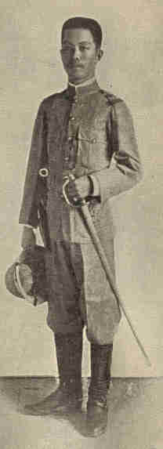
Emilio Aguinaldo.

In December, 1897, the conflict, as in Cuba, had degenerated into a "stalemate." The Spaniard could not be ousted, the Filipino could not be subdued. Spain ended the trouble for the time by promising reform, and hiring the insurgent leaders to leave the country. Only a small part, 400,000 Mexican dollars, of the promised sum was ever paid. This was held in Hong-Kong as a trust fund against a future uprising.
274 EXPANSION [1899

Chief among the leaders shipped to Hong-Kong was Emilio Aguinaldo. He was born March 22, 1869, at Cavite, of which town he subsequently became mayor. His blood probably contained Spanish, Tagal, and Chinese strains. He had supplemented a limited school education by extensive and eager contact with books and men. To a surprising wealth of information the young Filipino added inspiring eloquence and much genius for leadership. He had the "remarkable gift of surrounding himself with able coadjutors and administrators." The insurrection of 1896 early revealed him as the incarnation of Filipino hostility to Spain. Judging by appearances--his zeal in 1896, bargain with Spain in 1897, fighting again in Luzon in 1898, acquiescence in peace with the United States, reappearance in arms, capture, and instant allegiance to our flag--he was a shifty character, little worthy the great honor he received where he was known and, for a long time, here. But if he lacked in constancy, he excelled in enterprise. Spaniards never missed their reckoning more completely than in thinking they had quieted Aguinaldo by sending him to China with a bag of money.
1899] UNITED STATES IN THE ORIENT 275

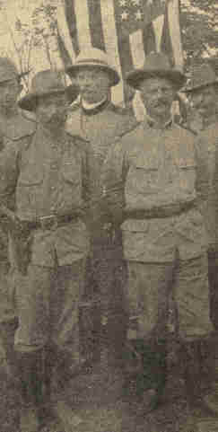
Gen. Frederick Funston, Gen. A. McArthur

It being already obvious that Spain had not redressed, and had no intention of redressing, abuses in the Philippines, Aguinaldo and his aides planned to return. The American war was their opportunity. Conferences were had with Consul Wildman at Hong-Kong and with Commodore Dewey.
276 EXPANSION [1899

Aguinaldo and those about him declared that Wildman, alleging authority from Washington, promised the Filipinos independence; and other Hong-Kong consuls and several press representatives received the impression that this was the case. Wildman absolutely denied having given any assurance of the kind. Admiral Dewey also denied in the most positive manner that he had done so.
Whatever the understanding or misunderstanding at Hong-Kong, Aguinaldo came home with Dewey in the evident belief that the American forces and his own were to work for Filipino independence. He easily resumed his leadership and began planning for an independent Filipino State. Dewey furnished him arms and ammunition. The insurrection was reorganized on a grander scale than ever, with extraordinary ability, tact, energy, and success. Nearly every one of the Luzon provinces had its rebel organization. In each Aguinaldo picked the leader and outlined the plan of campaign. His scheme had unity; his followers were aggressive and fearless. Everywhere save in a few strongholds Spain was vanquished. At last only Manila remained.

1899] UNITED STATES IN THE ORIENT 277

The insurgents must have captured 10,000 prisoners, though part of those they had at the Spanish evacuation were from the Americans. They hemmed in Manila by a line reaching from water to water. We could not have taken Manila as we did, by little more than a show of force, had it not been for the fact that Spain's soldiers, thus, hemmed in by Aguinaldo's, could not retreat beyond the range of our naval guns.

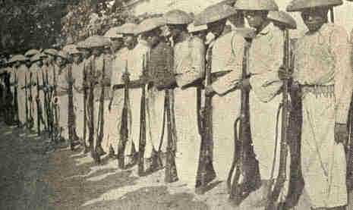
A Company of Insurrectos near Bongued, Abra Province,
just previous to surrendering early in 1901.

January 21, 1899, a Philippine Republic was set up, its capital being Malolos, which effectively controlled at least the Tagal provinces of Luzon. Its methods were irregular and arbitrary--natural in view of the prevalence of war. Aguinaldo, its soul from the first moment, became president.
278 EXPANSION [1899

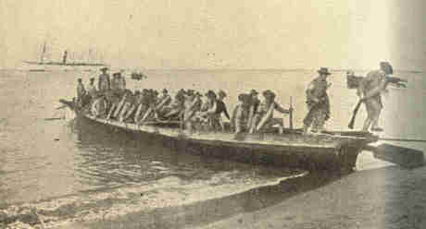
11th Cavalry Landing at Vigan, Ilocos, April, 1902.

The Philippine Republic wished and assumed to act for the archipelago, taking the place of Spain. It, of course, had neither in law nor in fact the power to do this, nor, under the circumstances, could the Administration at Washington, however desirable such a course from certain points of view, consent that it should at present even try. The Philippine question divided the country, raising numerous problems of fact, law, policy, and ethics, on which neither Congress nor the people could know its mind without time for reflection.
1899] UNITED STATES IN THE ORIENT 279

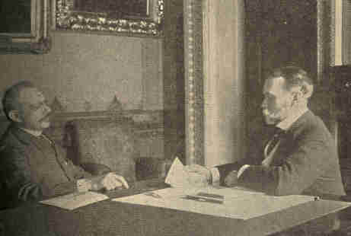
Copyright, 1899, by Frances B. Johnston.
Jules Cambon, the French Ambassador, acting for Spain,
receiving from the Honorable John Hay, the U. S. Secretary of State,
drafts to the amount of $20,000,000, in payment for the Philippines.

When our commissioners met at Paris to draft the Treaty of Peace, one wished our demands in the Orient confined to Manila, with a few harbors and coaling stations. Two thought it well to take Luzon, or some such goodly portion of the archipelago. That the treaty at last called for the entire Philippine domain, allowing $20,000,000 therefor, was supposed due to insistence from Washington.
280 EXPANSION [1899

Only the Vice-President's casting vote defeated a resolution introduced in the Senate by Senator Bacon, of Georgia, declaring our intention to treat the Filipinos as we were pledged to treat the Cubans. After ratification the Senate passed a resolution, introduced by Senator McEnery, of Louisiana, avowing the purpose not to make the Filipinos United States citizens or their land American territory, but to establish for them a government suited to their needs, in due time disposing of the archipelago according to the interests of our people and of the inhabitants.
CHAPTER XV.

THE UNITED STATES IN THE ORIENT

WAR, CONTROVERSY, PEACE

It was wholly problematical how long Aguinaldo unaided could dominate Luzon, still more so whether he would rule tolerably, and more uncertain yet whether centre or south would ever yield to him. The insurgents had foothold in four or five Visayan islands, but were never admitted to Negros, which of its own accord raised our flag. In Mindanao, the Sulu Islands, and Palawan they practically had no influence. Governor Taft was of opinion that they could never, unaided, have set up their sway in these southern regions. But should they succeed in establishing good government over the entire archipelago, clearly they must be for an indefinite period incompetent to take over the international responsibilities connected with the islands. To have at once conceded their sovereignty could have subserved no end that would have been from any point of view rational or humane.
282 EXPANSION [1899

The American situation was delicate. We were present as friends, but could be really so only by, for the time, seeming not to be so. At points we failed in tact. We too little recognized distinctions among classes of Filipinos, tending to treat all alike as savages. When our thought ceased to be that of ousting Spain, and attacked the more serious question what to do next, our manner toward the Filipinos abruptly changed. Our purposes were left unnecessarily equivocal. Our troops viewed the Filipinos with ill-concealed contempt. "Filipinos" and "niggers" were often used as synonyms.
Suspicion and estrangement reached a high pitch after the capture of Manila, when Aguinaldo, instead of being admitted to the capital, was required to fall still farther back, the American lines lying between him and the prize.
283

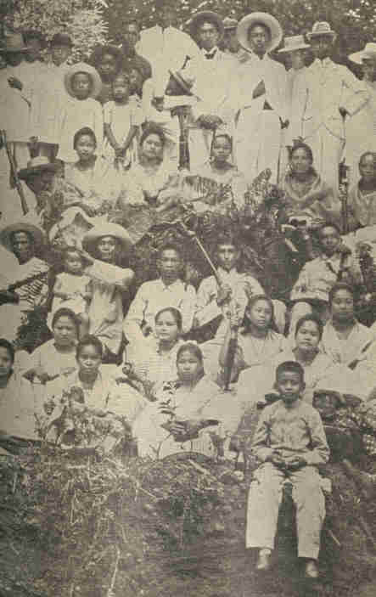
Native Tagals at Angeles,
fifty-one miles from Manila.
284
1899] UNITED STATES IN THE ORIENT 285

December 21, 1898, the President ordered our Government extended with despatch over the archipelago. That the Treaty of Paris summarily gave not only the islands but their inhabitants to the United States, entirely ignoring their wishes in the matter, was a snub. Still worse, it seemed to guarantee perpetuation of the friar abuses under which the Filipinos had groaned so long. Outside Manila threat of American rule awakened bitter hostility. In Manila itself thousands of Tagals, lip-servants of the new masters, were in secret communion with their kinsmen in arms.
No blood flowed till February 4, 1898, when a skirmish, set off by the shot of a bullyragged American sentry, led to war. February 22, 1899, the insurgents vainly attempted to fire Manila, but were pushed back with slaughter, their forces scattered.

286 EXPANSION [1899

March 20, 1899, the first Philippine Commission--Jacob G. Schurman, of New York; Admiral Dewey; General Otis; Charles Denby, ex-minister to China; and Dean C. Worcester, of Michigan-began their labors at Manila. They set to work with great zeal and discretion to win to the cause of peace not only the Filipinos but the government of the Philippine Republic itself. In this latter they succeeded. Their proclamation that United States sway in the archipelago would be made "as free, liberal, and democratic as the most intelligent Filipino desired," "a firmer and surer self-government than their own Philippine Republic could ever guarantee," operated as a powerful agent of pacification.
May 1, 1899, the Philippine Congress almost unanimously voted for peace with the United States. Aguinaldo consented. Mabini's cabinet, opposing this, was overturned, and a new one formed, pledged to peace. A commission of cabinet members was ready to set out for Manila to effectuate the new order.
A revolution prevented this. General Luna, inspired by Mabini, arrested the peace delegates and charged them with treason, sentencing some to prison, some to death. This occurred in May, 1899.
1899] UNITED STATES IN THE ORIENT 287

After that time not so much as the skeleton of any Philippine public authority--president, cabinet, or other official--existed. Later opposition to the American arms seemed to proceed in the main not from real Filipino patriotism, but from selfishness, lust of power, and the spirit of robbery.
Everywhere and always Americans had to guard against treachery. In Samar false guides led an expedition of our Marine Corps into a wilderness and abandoned the men to die, cruelty which was deemed to justify retaliation in kind. Eleven prisoners subsequently captured were shot without trial as implicated in the barbarity. For this Major Waller was court-martialed, being acquitted in that he acted under superior orders and military necessity. A sensational feature of his trial was the production of General Smith's command to Major Waller "to kill and burn"; "make Samar a howling wilderness"; "kill everything over ten" (every native over ten years old). General Smith was in turn court-martialed and reprimanded. President Roosevelt thought this not severe enough and summarily retired him from active service.
288 EXPANSION [1900

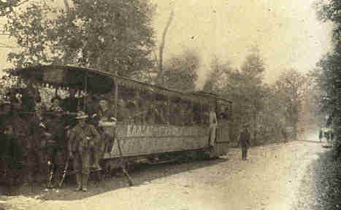
Bringing ammunition to the front for
Gen. Otis's Brigade, north of Manila.

Despite vigilant censorship by the War Department, rumors of other cruelties on the part of our troops gained credence. It appeared that in not a few instances American soldiers had tortured prisoners by the "water cure," the victim being held open-mouthed under a stream of water, the process sometimes supplemented by pounding on the abdomen with rifle-butts.
1901] UNITED STATES IN THE ORIENT 289

These disgraces were sporadic, not general, and occurred, when they did occur, under terrible provocation. Devotion to duty, however trying the circumstances, was the characteristic behavior of our officers and men. Deeds of daring occurred daily. On November 14, 1900, Major John A. Logan, son of the distinguished Civil War general, lost his life in battle near San Jacinto. December 19th the brave General Lawton was killed in attacking San Mateo. Systematic opposition to our arms was at last ended by an enterprise involving both nerve and cleverness in high degree.
Our forces captured a message from Aguinaldo asking reenforcements. This suggested to General Frederick Funston, who had served with Cuban insurgents, a plan for seizing Aguinaldo. Picking some trustworthy native troops and scouts, Funston, Captain Hazzard, Captain Newton, and Lieutenant Mitchell, passed themselves off as prisoners and their forces as the reenforcements expected. When the party approached Aguinaldo's headquarters word was forwarded that reenforcements were coming, with some captured Americans. Aguinaldo sent provisions, and directed that the prisoners be treated with humanity.
290 EXPANSION [1901

March 23, 1901, he received the officers at his house. After brief conversation they excused themselves. Next instant a volley was poured into Aguinaldo's body-guard, and the American officers rushed upon Aguinaldo, seized him, his chief of staff, and his treasurer.

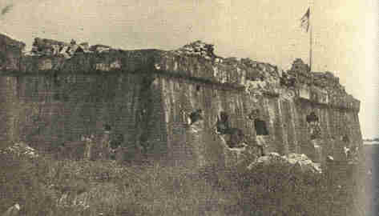
Fort Malate, Cavite.

April 2, 1901, Aguinaldo swore allegiance to the United States, and, in a proclamation, advised his followers to do the same. Great and daily increasing numbers of them obeyed.
1901] UNITED STATES IN THE ORIENT 291

To the Philippines, though Spain's de facto sovereignty there was hardly more than nominal, our title, whether or not good as based on conquest, was unimpeachable considered as a cession by way of war indemnity or sale. Nor, according to the weight of authority, could the right of the federal power to acquire these islands be denied. But did "the Constitution follow the flag" wherever American jurisdiction went? If not, what were the relations of those outlands and their peoples to the United States proper? Could inhabitants of the new possessions emigrate to the United States proper? Did our domestic tariff laws apply there as well as here? Must free trade exist between the nation and its dependencies? Were rights such as that of peaceable assemblage and that to jury trial guaranteed to Filipinos, or could only Americans to the manner born plead them?
On the fundamental question whether the dependencies formed part of the United States the Supreme Court passed in certain so-called "insular cases" which were early brought before it. Four of the justices held that at all times after the Paris Treaty the islands were part and parcel of United States soil. Four held that they at no time became such, but were rather "territories appurtenant" to the country.
292 EXPANSION [1901

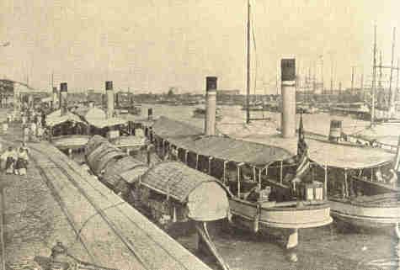
The Pasig River, Manila.

Mr. Justice Brown gave the "casting" opinion. Though reasoning in a fashion wholly his own, he sided, on the main issue, with the latter four of his colleagues, making it the decision of the court that Porto Rico and the Philippines did not belong to the United States proper, yet, on the other hand, were not foreign.
1901] UNITED STATES IN THE ORIENT 293

The revenue clauses of the Constitution did not, therefore, forbid tariffing goods from or going to the islands. In the absence of express legislation, the general tariff did not obtain as against imports from the dependencies. This reasoning, it was observed, was equally applicable to mainland territories and to Alaska. The court intimated that, so far as applicable, the Constitution's provisions in favor of personal rights and human liberty accompanied the Stars and Stripes beyond sea as well as between our old shores.
Unsatisfactory to nearly all as was this utterance of a badly divided court, it sanctioned the Administration policy and opened the way for necessary legislation. It did nothing, however, to hush the anti-imperialist's appeal, based more upon the Declaration of Independence and the spirit of our national ideals.

294 EXPANSION [1901

It was said that having delivered the Filipinos from Spain "we were bound in all honor to protect their newly acquired liberty against the ambition and greed of any other nation on earth, and we were equally bound to protect them against our own. We were bound to stand by them, a defender and protector, until their new government was established in freedom and in honor; until they had made treaties with the powers of the earth and were as secure in their national independence as Switzerland, Denmark, Belgium, Santo Domingo, or Venezuela." But we ought to bind ourselves and promise the world that so soon as these ends could be realized or assured we would leave the Filipinos to themselves, Such was the view of eminent and respected Americans like George F. Hoar, George S. Boutwell, Carl Schurz, and William J. Bryan.

1901] UNITED STATES IN THE ORIENT 295

These and others urged that the Filipinos had inalienable right to life and to liberty; that our policy in the Philippines was in derogation of those rights; that Japan, left to herself, had stridden farther in a generation than England's crown colony of India in a century; that the Filipinos could be trusted to do likewise; that our increments of territory hitherto had been adapted to complete incorporation in the American empire while the new were not; and that growth of any other character would mean weakness, not strength. The mistakes, expense, and difficulties incident to expansion, and the misbehavior and crimes of some of our soldiers were exhibited in their worst light.
Rejoinder usually proceeded by denying the capacity of the Filipinos for self-government without long training. Even waiving this consideration, men found in international law no such mid-status between sovereignty and non-sovereignty as anti-imperialists wished to have the United States assume while the Filipinos were getting upon their feet. Many made great point of minimizing the abuses of our military government and of dilating upon native atrocities. The material wealth of the archipelago was described in glowing terms. Only American capital and enterprise were needed to develop it into a mine of national riches.
296 EXPANSION [1900

The military and commercial advantages of our position at the doorway of the East, our duty to protect lives and property imperilled by the insurgents, and our manifest destiny to lift up the Filipino races, were dwelt upon. The argument having chief weight with most was that there seemed no clear avenue by which we could escape the policy of American occupation save the dishonorable and humiliating one of leaving the islands to their fate--anarchy and intestine feuds at once, conquest by Japan, Germany, or Spain herself a little later.
All demanded that abuses in connection with our rule should be punished and the repetition of such made impossible, and that whatever power we exercised should be lodged, without regard to party, in the hands of men of approved fitness and high and humane character. American tutelage, if it were to exist, must present to our wards the best and not the worst side of our civilization, and do so with tact and sympathy.

1900] UNITED STATES IN THE ORIENT 297

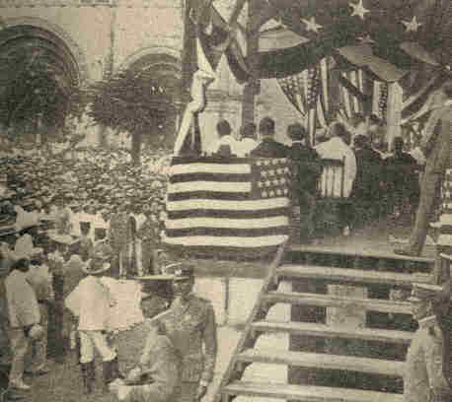
The Inauguration of Governor Taft,
Manila, July 4. 1901.

On April 17, 1900, William H. Taft, of Ohio; Dean C. Worcester, of Michigan; Luke E. Wright, of Tennessee; Henry C. Ide, of Vermont; and Bernard Moses, of California, were commissioned to organize civil government in the archipelago. Three native members were subsequently added to the commission. Municipal governments were to receive attention first, then governments over larger units. Local self-government was to prevail as far as possible.
298 EXPANSION [1901

Pending the erection of a central legislature, the commission was invested with extensive legislative powers. Civil government was actually inaugurated July 4, 1901. Judge Taft was the first civil governor, General Adna R. Chaffee military governor under him.
Educational work in the Philippines was pressed from the very beginning of American control. Our military authorities reopened the Manila schools, making attendance compulsory. In a short time the number of schools in the archipelago doubled. By September, 1901, the commission had passed a general school law, and had placed the schools throughout the archipelago under systematic organization and able headship. About 1,000 earnest and capable men and women went out from the States to teach Filipino youth. Five hundred towns received one or more American teachers each. Associated with them there were in the islands some 2,500 Filipino teachers, mostly doing primary work.
1901] UNITED STATES IN THE ORIENT 299

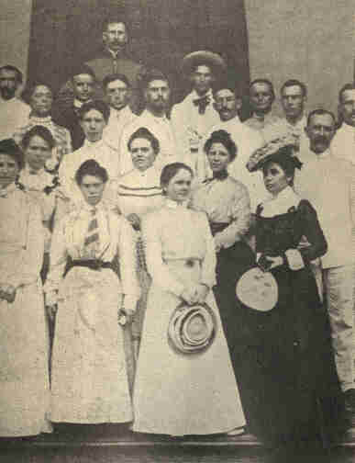
Group of American Teachers on the steps
of the Escuela Municipal, Manila.

300 EXPANSION [1901

American teachers advanced into the interior to the neediest tribes. Nine teachers early settled among the Igorrotes, scattered in towns along the Agno River, and an industrial and agricultural school was soon planned for Igorrote boys. Normal schools and manual training schools were organized. Colonial history, whether ancient or modern, had never witnessed an educational mission like this.
CHAPTER XVI.

POLITICS AT THE TURNING OF THE CENTURY

McKinley and Bryan were presidential candidates again in 1900. It was certain long beforehand that they would be, even when Admiral Dewey announced that he was available. The admiral seemed to offer himself reluctantly, and to be relieved when assured that all were sorry he had done so.
McKinley was unanimously renominated. Unanimously also, yet against his will, Governor Theodore Roosevelt, of New York, was named with him on the ticket. The Democratic convention chose Bryan by acclamation; his mate, ex-Vice-President Adlai E. Stevenson, by ballot.

302 EXPANSION [1900

The 1900 campaign called out rather more than the usual crop of one-idea parties. The Prohibitionists, a unit now, took the field on the "army canteen" issue, making much of the fact that our increased export to the Philippines consisted largely of beer and liquors to curse our soldiers. The anti-fusion or "Middle-of-the-road" Populists, the Socialist Labor Party, the Socialist-Democrats, and the United Christian Party all made nominations.
The Gold Democratic National Committee, while recommending State committees to keep up their organizations, regarded it inexpedient to name a ticket. They reaffirmed the Indianapolis platform of 1896, and again recorded their antagonism to the Bryan Democracy. Certain volunteer delegates who met in September found themselves unable to tolerate either the commercialism which they said actuated the Philippine war, or "demagogic appeals to factional and class passions." They nominated Senator Caffery, of Louisiana, and Archibald M. Howe, of Massachusetts. These gentlemen declined, whereupon it was decided to have no ticket.

303

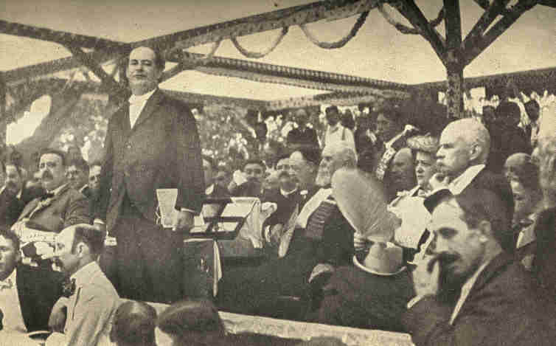
W. J. Bryan accepting the nomination for President at
a Jubilee Meeting held at Indianapolis, August 8, 1900.
304
POLITICS AT END OF CENTURY 305

A number of loosely cohering bodies accorded the Democratic ticket their support while making each its own declaration of doctrine. The Farmers' Alliance and Industrial Union, through its Supreme Council, gave anticipatory endorsement to the Democratic candidate so early as February. May 10th the Fusion Populists nominated Bryan, naming, however, Charles A. Towne instead of Stevenson for the vice-presidency. Towne withdrew in Stevenson's favor. The Silver Republicans likewise nominated Bryan, making no vice-presidential nomination. The Anti-imperialist League, meeting in Indianapolis after the Democratic convention, approved its candidates, its view as to the "paramount issue," and its position thereon.
For a time after his able Indianapolis speech accepting the various nominations, Mr. Bryan's election seemed rather probable spite of incessant Republican efforts to break him down. He had personally gained much strength since 1896. There was not a State in the Union whose Democratic organization was not to all appearance solid for him, an astounding change in four years.
306 EXPANSION [1900

An organization of Civil War Veterans was electioneering for him among old soldiers. Powerful Democratic and independent sheets which had once vilified now extolled him. He was sincere, straightforward, and fearless. His demand at Kansas City that the platform read so and so or he would not run, while probably unwise, showed him no trimmer.
Many Gold Democrats had returned to the party. The gold standard law, approved March 14, 1900, made it impossible for a President, even if he desired to do so, to place the country's money on an insecure basis without the aid of a Congress friendly in both its branches to such a design. There was, to be sure, effort to make this law appear imperfect; to show that Mr. Bryan, if elected, could, without aid from Congress, debauch the monetary system. But these assertions had little basis or effect. Silver dollars could be legally paid by the Government for a variety of purposes; but outside holders of silver could not get it coined, and the Treasury could not buy more.
1900] POLITICS AT END OF CENTURY 307

New issues--imperialism and the trusts--seemed certain to be vote-winners for the Democracy. The cause of anti-imperialism had taken deep hold of the public mind, drawing to its support a host of eminent and respected Republicans. The Democratic platform expressly named this the "paramount issue" of the campaign. The party in power defended its Philippine policy in the manner sketched at the end of the last chapter, ever asserting, of course, that so far as consistent with their welfare and our duties the Filipinos must be accorded the largest possible measure of self-government. In this tone was perceived some sensitiveness to the anti-imperialist cry. Though Republican campaign writers and speakers affected to ignore this issue, some of them denying its existence, imperialism was more and more discussed.
308 EXPANSION [1900

After the Spanish War the question whether the United States should, the inhabitants agreeing, keep any of the territory obtained from Spain, divided the Democratic as well as the Republican ranks. So long as expansion meant merely addition to United States territory and population after the time-honored fashion, and this was at first all that anyone meant by expansion, no end of prominent Democrats were expansionists. But for their devotion to the policy of protection and their determination to continue high protection at all costs, the Republicans might have kept in existence this Democratic schism over expansion.
According to the Constitution as almost unanimously interpreted (the "insular cases" referred to in the last chapter had not yet been decided), customs duties must be uniform at all United States ports. If Luzon was part of the United States in the usual sense of the words, rates of duty on given articles must be the same at Manila as at New York. If the Philippine Islands and Porto Rico were parts of the United States in the full sense, tariff rates at their ports could not be low unless low in New York, New Orleans, San Francisco, and elsewhere.
309

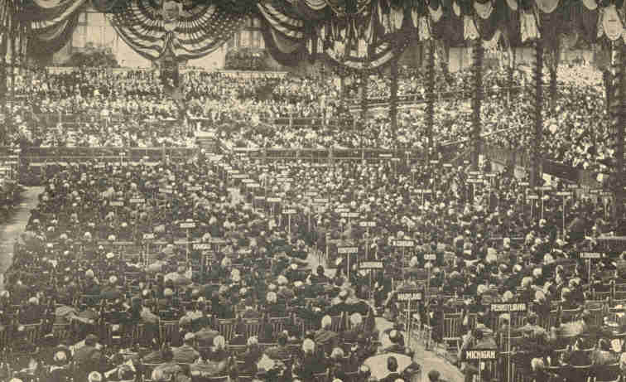
The Republican National Convention,
held in Philadelphia, June l, 1900.
310
1900] POLITICS AT END OF CENTURY 311

No considerable or general tariff reduction for the United States proper was to be thought of by the Republicans. But it would not do to maintain in the ports of the new possessions the high duties established by law in the United States proper. Were this done, the United States would in effect be forcing its colonies to buy and sell in the suzerain country alone, as was done by George III. through those Navigation Acts which occasioned the Revolutionary War. Such a system was certain to be condemned. If the expansion policy was to succeed in pleasing our people a plan had to be devised by which duties at the new ports could be reduced to approximate a revenue level while remaining rigidly protective in the old ports.

312 EXPANSION [1900

Out of this dilemma was gradually excogitated the theory, which had been rejected by nearly all interpreters of the Constitution, that the United States can possess "appurtenant" territory, subject to, but not part of itself, to which the Constitution does not apply save so far as Congress votes that it shall apply. So construed, the Constitution does not ex proprio vigore follow the flag. Under that construction, inhabitants of the acquired islands could not plead a single one of its guaranties unless Congress voted them such a right. If Congress failed to do this, then, so far as concerned the newly acquired populations, the Constitution might as well never have been penned. They were subjects of the United States, not citizens.
The Republican party's first avowal of this "imperialist" theory and policy was the Porto Rico tariff bill, approved April 12, 1900, establishing for Porto Rico a line of customs duties differing from that of the United States. This bill was at first disapproved by President McKinley. "It is our plain duty," he said, "to abolish all customs tariffs between the United States and Porto Rico, and give her products free access to our markets." Until after its passage the bill was earnestly opposed both by a number of eminent Republican statesmen besides the President and by nearly all the leading Republican party organs. Every possible plea--constitutional, humanitarian, prudential--was urged against it. The bill passed, nevertheless.
1900] POLITICS AT END OF CENTURY 313

The result was a momentous improvement in Democratic prospects. The schism on expansion which had divided the Democratic party was closed at once, while many Republicans who had deemed the taking over of the Philippines simply a step in the nation's growth similar in nature to all the preceding ones, and had laughed at imperialism as a Democratic "bogy," changed their minds and sidled toward the Democratic lines.
In their long and able arguments against the Porto Rico tariff, Republican editors and members of Congress provided the opposite party with a great amount of campaign material. Often as a Republican on the hustings or in the press declared imperialism not an issue, or at any rate not an important one, he was drowned in a flood of recent quotations from the most authoritative Republican sources proving that it was not only an issue, but one of the most important ones which ever agitated the Republic. As Democrats put it, Balaam prophesied in favor of Israel.
314 EXPANSION [1900

Several minor matters were much dwelt upon by campaigners, with a net result favorable to the Democrats. A great many in his own party believed, no doubt wrongly, that the President's policy had in main features been influenced by consideration for powerful financial interests, or that at points these had in effect coerced him to courses contrary to what he considered best. The commissariat scandal in the Spanish War incensed many, as did the growth of army, navy, and "militarism" incident to the new colonial policy.

315

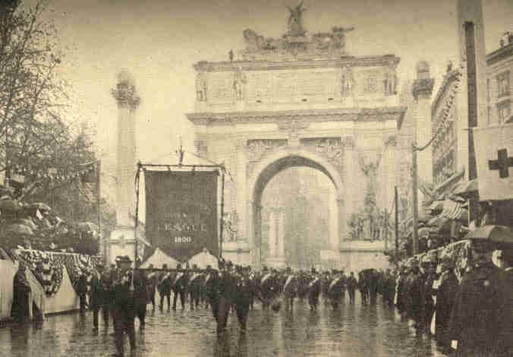
Parade of the Sound Money League,
New York, 1900. Passing the Reviewing Stand.
316
1900] POLITICS AT END OF CENTURY 317

Then there was the awkwardness with which the Administration had treated the Filipinos. In 1900 it seemed clear that these people could never be brought under the flag otherwise than by coercion. Anti-imperialists were not alone in the conviction that Aguinaldo's followers had been needlessly contemned, harassed, and exasperated, and that had greater frankness, tact, and forbearance been used toward them they would, of their own accord, have sought the shelter of the Stars and Stripes. Moreover, our measures toward the Filipinos had alienated Cuba, so that the voluntary adhesion of this island to the United States, so desirable and once so easily within reach, was no longer a possibility; while the coercion of Cuba, in view of our profession when we took up arms for her, would be condemned by all mankind as national perfidy.
The sympathy of official Republicanism with the British in the Boer War tended to solidify the Irish vote as Democratic, but--and it was among the novelties of the campaign--Republicans no longer feared to alienate the Irish. The Government's apparent apathy toward the Boers also drove into the Democratic ranks for the time a great number of Dutch and German Republicans. Colored voters were in this hegira, believing that the adoption of the "subject-races" notion into American public law and policy would be the negro's despair. The championing of this movement by the Republican party they regarded as a renunciation of all its friendship for human liberty.
318 EXPANSION [1900

The Republican campaign watchword was "Protection." Press and platform dilated on the fat years of McKinley's administration as amply vindicating the Dingley Act. "The full dinner pail," said they, "is the paramount issue." Trusts and monopolies they denounced, as their opponents did, but they declared that these "had nothing to do with the tariff." There was wide and intense hostility toward monopolistic organizations. They were decried on all hands as depressing wages, crushing small producers, raising the prices of their own products and lowering those of what they bought, depriving business officials and business travellers of positions, and working a world of other mischief politically, economically, and socially. They had rapidly multiplied since the Republicans last came into power, and nothing had been done to check the formation of them or to control them.

1900] POLITICS AT END OF CENTURY 319

Why, then, was not Democracy triumphant in the campaign of 1900? When the lines were first drawn a majority of the people probably disapproved the Administration's departure into fields of conquest, colonialism, and empire. Republicans themselves denied that a "full dinner pail" was the most fundamental of considerations. Few Republican anti-imperialists were saved to the party by the venerable Senator Hoar's faith that after a while it would surely retrieve the one mistake marring its record. Nor was it that men like Andrew Carnegie could never stomach the Kansas City and Chicago heresies, or that the Republicans had ample money, or yet that votes were attracted to the Administration because of its war record and its martial face. Agriculture had, to be sure, been remunerative. Also, before election, the strike in the Pennsylvania hard coal regions had, at the earnest instance of Republican leaders, been settled favorably to the miners, thus enlisting extensive labor forces in support of the status quo; but these causes also, whether by themselves or in conjunction with the others named, were wholly insufficient to explain why the election went as it did.
320 EXPANSION [1900

A partial cause of Mr. Bryan's defeat in 1900 was the incipient waning of anti-imperialism, the conviction growing, even among such as had doubted this long and seriously, that the Administration painfully faulty as were some of its measures in the new lands, was pursuing there absolutely the only honorable or benevolent course open to it under the wholly novel and very peculiar circumstances.
A deeper cause--the decisive one, if any single cause may be pronounced such--was the fact that Mr. Bryan primarily, and then, mainly owing to his strong influence, also his party, misjudged the fundamental meaning of the country's demand for monetary reform.
1900] POLITICS AT END OF CENTURY 321

The conjunction of good times with increase in the volume of hard money made possible by the world's huge new output of gold, might have been justly taken as vindicating the quantity theory of money value, prosperity being precisely the result which the silver people of 1896 prophesied as certain in case the stock of hard money were amplified. Bimetallists could solace themselves that if they had, with all other people, erred touching the geology of the money question, in not believing there would ever be gold enough to stay the fall of prices, their main and essential reasonings on the question had proved perfectly correct. Good fortune, it might have been held, had removed the silver question from politics and remanded it back to academic political economy.
Probably a majority of the Democrats in 1900 felt this. At any rate the Kansas City convention would have been quite satisfied with a formal reaffirmation of the Chicago platform had not Mr. Bryan flatly refused to run without an explicit platform restatement of the 1896 position. His hope, no doubt, was to hold Western Democrats, Populists, and Silver Republicans, his anti-imperialism meanwhile attracting Gold Democrats and Republicans, especially at the East, who emphatically agreed with him on that paramount issue.
322 EXPANSION [1900

But it appeared as if most of this, besides much else that was quite as well worth while, could have been accomplished by frankly acknowledging and carefully explaining that gold alone had done or bade fair to do substantially the service for which silver had been supposed necessary; for which, besides. it would really have been required but for the unexpected and immense increase in the world's gold crop through a long succession of years.
The Republican leaders gauged the situation better. Mr. McKinley, to a superficial view inconsistent on the silver question, was on this point fundamentally consistent throughout. With all the more conservative monetary reformers he merely wished the fall of prices stopped, and such increment to the hard money supply as would effect that result. The metal, the kind of money producing the needed increase was of no consequence. When it became practically certain that gold alone, at least for an indefinite time, would answer the end, he was willing to relinquish silver except for subsidiary coinage.
1900] POLITICS AT END OF CENTURY 323

The law of March 14, 1900, put our paper currency, save the silver certificates, and also all national bonds, upon a gold basis, providing an ample gold reserve. Silver certificates were to replace the treasury notes, and gold certificates to be issued so long as the reserve was not under the legal minimum. If it ever fell below that the Secretary of the Treasury had discretion.
Other notable features of this law were its provision for refunding the national debt in two per cent. gold bonds--a bold, but, as it proved, safe assumption that the national credit was the best in the world--and the clause allowing national banks to issue circulating notes to the par value of their bonds.
Our money volume now expanded as rapidly as in 1896 advocates of free coinage could have expected even with the aid of free silver. July 1, 1900. the circulation was $2,055,150,998. as against $1,650.223,0400 four years before.
324 EXPANSION [1900

Nearly $163,000,000 in gold certificates had been uttered. The gold coin in circulation had increased twenty per cent. for the four years; silver about one-eighth; silver certificates one-ninth. The Treasury held $222,844,953 of gold coin and bullion, besides some millions of silver, paper, and fractional currency.
The Republican victory was the most sweeping since 1872. The total popular vote was 13,970,300, out of which President McKinley scored a clear majority of 443,054, and a plurality over Bryan of 832,280. Of the Northern States Bryan carried only Colorado, Idaho, and Nevada. He lost his own State and was shaken even in the traditionally "solid South." Unnecessarily ample Republican supremacy was maintained in the legislative branch of the Government.
CHAPTER XVII.

THE TWELFTH CENSUS

The plan for a permanent census bureau was not realized in time for the 1900 enumeration, but the act authorizing this provided important modifications in prior census procedure. Among several great improvements it made the census director practically supreme in his methods and over appointments and removals in his force.
Initial inquiries were restricted to (1) population, (2) mortality, (3) agriculture, and (4) manufactures. Work on these topics was to be completed not later than July 1, 1902. During the year after, special reports were to be prepared on defective, criminal and pauper classes, deaths and births, social data in cities, public indebtedness, taxation and expenditures, religious bodies, electric light and power, telephone and telegraph, water transportation, express business, street railways, mines and mining. A few titles mentioned in the eleventh census were now omitted.
326 EXPANSION [1900

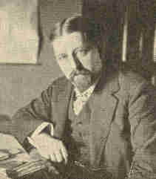
Mr. Merriam,
Director of the Census.

The enumeration extended to Alaska. Two men had charge of it there. Enumerators went out afoot, by dog-teams, canoes, steamboats--up rivers, over mountains, through forests. The Indian Territory was for the first time canvassed like other portions of the Union, and so was the new territory of Hawaii.
The United States were divided into 207 supervisor districts and 53,000 enumeration districts. Enumeration began June 1, 1900, continuing two weeks in cities, elsewhere thirty days. Persons in the navy, army, and on Indian reservations were numbered. For those in institutions there were special enumerators. Each enumerator used a "street-book" or daily record, individual slips for returns of persons absent when the enumerator called, and an "absent family" schedule.
1900] THE TWELFTH CENSUS 327

The returns were tabulated by an electrical device first employed ten years before. Its work was automatic and so fine that it would even obviate errors. For instance, age, sex, etc., being denoted by punch-holes in cards, the machine would refuse to pass a card punched to indicate that the person was three years old and married.
Nearly 2,000 employees toiled upon the census during the latter part of 1900, and nearly a thousand during the entire year, 1901. From July 14, 1900, piecemeal results were announced almost daily. By October the population of the principal cities was out. A preliminary statement of total population was given to the press, October 30, 1900, followed by a verified one a month later. The first official report on population was made December 6, 1901, within eighteen months from the completion of the enumerators' work. Results were first issued in sixty bulletins, all subsequently included in the first half of the first volume. Two volumes were devoted to population, three to manufactures, two to agriculture, and two to vital statistics. One contained an abstract of the whole. Following these came volumes on special lines of inquiry.
328 EXPANSION [1900

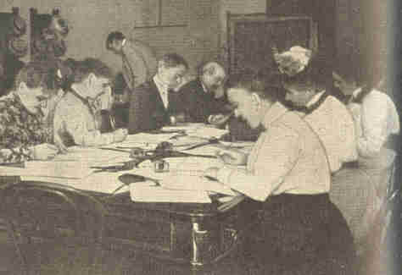
Census Examination.

The population of the United States, not including Porto Rico or the Philippines, was found to be 76,303,387, an increase of not quite 21 per cent. in the decade, or less than during any previous similar period of our history. All the States and territories save Nevada were better peopled than ever before.
1900] THE TWELFTH CENSUS 329

Nevada lost 10.6 per cent. of her inhabitants, as against two and a half times that percentage between 1880 and 1890, occupying in 1900 about the same tracks as in 1870. Oklahoma people increased 518.2 per cent. Indian Territory, Idaho, and Montana came next in rapidity of growth. Kansas, with 2.9 per cent. increase, and Nebraska, with only 0.7 per cent., showed the slowest progress, the figures resulting in considerable part from padded returns in 1890. Vermont, Delaware, and Maine crawled on at a snail's pace. In numerical advance New York, Pennsylvania, and Illinois led. Texas marched close to them, overhauling Massachusetts. In percentage of increase the southern, central, and western divisions were in the van.
Almost a third of our people were now urban, ten times the proportion of 1790. The rate of urban increase (36.8 per cent.) was, however, smaller than during any preceding decade, except 1810-1820, and was notably less than the 61.4 per cent. urban increase from 1880 to 1890. Numerically also city growth was less than at the preceding census.
330 EXPANSION [1900

There were 545 places of 8,000 or more inhabitants, with an average population of 45,857. Of the larger cities fully half adjoined the Atlantic. Greater New York, a monster composite of nearly three and a half millions, ranked first among American cities, and second only to London among those of the world. Chicago, Philadelphia, St. Louis, Boston, and Baltimore followed in the same order as a decade before. The enterprising lake rivals, Cleveland and Buffalo, had raced past San Francisco and Cincinnati. Pittsburgh, instead of New Orleans, now came next after the ten just named.
There were, as in 1890, three cities of more than a million inhabitants each. There were six of more than 500,000, as against four in 1890. Of cities having between 400,000 and 500,000 people none appeared in 1900; three in 1890. Five cities now had over 300,000 and less than 400,000, a class not represented at all in 1890. Thirty-eight cities used in numbering their people six figures or more each, a privilege enjoyed in 1890 by only twenty-eight. The cities of the Pacific coast showed noteworthy increase.

1900] THE TWELFTH CENSUS 331

Ohio, Indiana, Delaware, Kansas, and Nebraska and all the North Atlantic States except Rhode Island, Connecticut, and Pennsylvania, lost in rural population. Rhode Island, with 407 inhabitants to the square mile, was the most densely peopled State. Massachusetts came next. Idaho, Montana, New Mexico, Arizona, Wyoming, and Nevada could not show two souls to the square mile. Alaska, doubled in population, had one in about ten square miles. No western State had ten to the mile.
The Twelfth Census revealed slight change in the centre of population. This now stood six miles southeast of Columbus, Ind., having moved west only fourteen miles since 1890. In computing its position neither Hawaii nor Alaska were considered. Never before had its occidental shunt been less than thirty-six miles in a decade. For three score years it had not fallen under forty per decade.
332 EXPANSION [1900

What sent it southward two and a half miles was the doubling of population in the Indian Territory and the filling of Oklahoma. The trifling shift of fourteen miles westward pointed significantly to the exhaustion of free land in the West and to the immense growth of manufactures, mining, and commerce in eastern and central States, retaining there the bulk of our immigrants and even recalling people from the newer States and territories.
Males still bore about the same proportion to females as in 1890, although females had increased at a rate 0.2 per cent. greater than males. In the North Atlantic and South Atlantic groups the sexes were equal in numbers.
At the South alone did the negro continue a considerable element. Eighty-nine per cent. of the negroes lived there. At the North only Pennsylvania had any large numbers. The country held 8,840,789, an increase of 18.1 per cent. in ten years, the percentage of white increase being 21.4 per cent.
1900] THE TWELFTH CENSUS 333

In West Virginia and Florida, also in the black belts, especially that of Alabama, blacks multiplied faster than whites. In Delaware and Georgia the pace was even. In Alabama as a whole, however, the negro element had not relatively increased since 1850. Blacks outnumbered Caucasians in South Carolina and Mississippi, no longer in Louisiana.

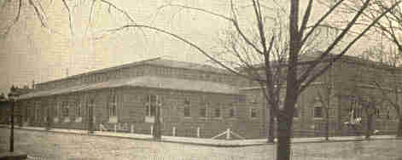
The Census Office, Washingtonl D. C.

In Mississippi the black majority shot up phenomenally. Of the total population the negroes were now only 11.6 per cent., barely one-ninth, as against one-fifth in 1790. Between 1890 and 1900 the proportion of the colored increased both at the North and at the far South, diminishing in the border southern States. This indicated migration both northward and southward from the belt of States just south of Mason and Dixon's line.
334 EXPANSION [1900

The foreign-born fraction of our population, which had alternately risen and fallen since 1860, now fell again, from 14.8 per cent. to 13.7 per cent. The South retained its distinction as the most thoroughly American section of the land, having a foreign. nativity population varying from 7.9 per cent. in Maryland to only 0.2 per cent. in North Carolina.
The foreign born, conspicuous in the Northwest and the North Atlantic States, were mostly confined to cities. They had augmented only 12.4 per cent. as against 38.5 per cent. from 1880 to 1890. Nearly a third of the recorded immigration from 1890 to 1900 was missing in the enumeration, due only in part to census errors. Many foreigners had returned to their native lands, most numerous among these being Canadians. The preponderance of immigrants was no longer from Ireland, Canada, Great Britain, and Germany, but from Austria-Hungary, Bohemia, Italy, Russia, and Poland.

1900] THE TWELFTH CENSUS 335

In 1900 the United States proper had 89,863 Chinese against 107,488 in 1890. Of Japanese there were 24,326 against only 2,039 in 1890. In the Hawaiian Islands alone the Chinese numbered 25,767 and the Japanese 61,111. Natives of Germany still constituted the largest body of our foreign born, being 25.8 per cent. of the whole foreign element compared with 30.1 percent. in 1890. The proportion was about the same in 1900 as in 1850.
The Irish were 15.6 per cent. of the foreign born. The figures had been 20.2 per cent. in 1890, and 42.8 per cent. in 1850. The proportion of native Scandinavians and Danes had slightly increased. Poles. Bohemians, Austrians, Huns, and Russians comprised 13.4 per cent. of the foreign born as against 6.9 per cent. in 1890, and less than one-third per cent. in 1850.

336 EXPANSION [1900

The congressional apportionment act based on the twelfth census, and approved January 16, 1902, avoided the disagreeable necessity of cutting down the representation of laggard States by increasing the House membership from 357 to 386, a gain of twenty-nine members. Twelve of these (reckoning Louisiana) came from west of the Mississippi, two from New England, three each from Illinois and New York, four from the southern States east of the Mississippi, two each from Pennsylvania and New Jersey, and one from Wisconsin.
The number of farms shown by the twelfth census was over five and one-half million, four times the number reported in 1850, and more than a million above the number reported in 1890. This wonderful increase, greater for the last decade than for any other except that between 1870 and 1880, denoted a vast augmentation of cultivated area in the South and in the middle West. Oklahoma, Indian Territory, and Texas alone added over two hundred thousand to the number of their farms. The increase in value of farm resources exceeded the total value of agricultural investments fifty years before.
1900] THE TWELFTH CENSUS 337

In the abundant year of 1899 our cereal crops exceeded $1,484,000,000 in value, more than half this being in corn. The hay crop was worth over $445,000,000, that of potatoes $98,387,000, that of tobacco $56,993,000. Next to corn stood cotton, the crop for this year reaching a value of $323,758,000. The total value of farm and range animals in 1900 was $2,981,722,945.

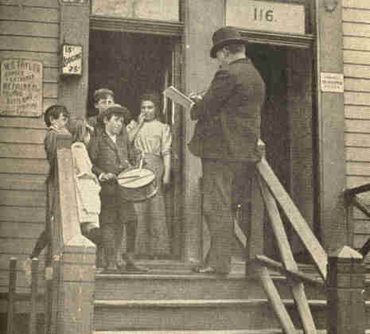
A Census-taker at work.

The census of 1850 reported 123,000 manufacturing establishments, with a capital of $533,000,000. In 1900 there were 512,000 manufacturing establishments, capitalized at $9,800,000,000, employing 5,321,000 wage earners, and evolving $13,004,400,000 worth of product.
338 EXPANSION [1900

In ten years the number of manufacturing plants and the value of products appeared to have increased some 30 per cent. The capital invested had multiplied slightly more, about a third. The number of hands employed had risen but a fifth, betokening the greater efficiency of the individual laborer, and the substitution of machine work for that of men's hands.
Of seventy-three selected industries in 209 principal cities, the most money, $464,000,000, was invested in foundries and machine shops; the next most, $363,000,000, in breweries. $289,000,000 are employed in iron and steel manufacturing.
Our foreign commerce for the fiscal year 1899-1900 reached the astounding total of $2,244,424,266, exceeding that of the preceding year by $320,000,000. Our imports were $849,941,184, an amount surpassed only in 1893.
1900] THE TWELFTH CENSUS 339

Our total exports were $1,394,483,082. The favorable balance of trade had continued for some time, amounting for three years to $ 1,689,849,387, much of which meant the lessening of United States indebtedness abroad. The chief commodities for which we now looked to foreign lands were first of all sugar, then hides, coffee, rubber, silk, and fine cottons. In return we parted with cotton from the South and bread-stuffs from the North, each exceeding $260,000,000 in value. Next in volumes exported were provisions, meat, and dairy products, worth $184,453,055. Iron and steel exports, including $55,000,000 and more in machinery, were valued at about $122,000,000. The live-stock shipped abroad was appraised at about $181,820,000. About 3-1/2 per cent. of our imports came from Cuba, about 20 per cent. from Hawaii, and about 1 per cent. from Porto Rico, Samoa, and the Philippines.
In 1902 the tables were turned somewhat. American exports fell off and the home market was again invaded. Imported steel billets were sold at the very doors of the Steel Corporation factories.
340 EXPANSION [1900

So abundant were the revenues the year named, exceeding expenditures by $79,500,000, that war taxes were shortly repealed. "A billion dollar Congress" would now have seemed economical. Our gross expenditures the preceding year had been $1,041,243,523. For 1900 they were $988,797,697. Our national debt, lessened during the year by some $28,000,000 or $30,000,000, stood at $1,07 1,214,444.
CHAPTER XVIII.

THE PAN-AMERICAN EXPOSITION, 1901

The time had come for North and South America to unite in a noble enterprise illustrating their community of interests. United States people were deplorably ignorant of their southern neighbors, this accounting in part for the paucity of our trade with them. They knew as little of us. Our war with Spain had caused them some doubts touching our intentions toward the Spanish-Americans. An exposition was a hopeful means of bringing about mutual knowledge and friendliness. But the fair could not be ecumenical. At Chicago and Paris World's Fairs had reached perhaps almost their final development. To compete in interest, so soon, with such vast displays, an exposition must specialize and condense.

342 EXPANSION [1901

On May 20th, the day of opening, a grand procession marched from Buffalo to the Exposition grounds. Inspired by the music of twenty bands representing various nations, the parade wound through the park gate up over the Triumphal Bridge into the Esplanade. As the doors of the Temple of Music were thrown open, ten thousand pigeons were released, which, wheeling round and round, soared away to carry in all directions their messages announcing that the Exposition had begun. The Hallelujah Chorus was rendered, when Vice-President Roosevelt delivered the dedicatory address.
The authors of the Pan-American, architects, landscape-gardeners, sculptors, painters, and electricians, aimed first of all to create a beautiful spectacle. Entering by the Park Gateway you passed from the Forecourt, attractive by its terraces and colonnades, to the Triumphal Bridge, a noble portal, with four monumental piers surmounted by equestrian figures, "The Standard-bearers." This dignified entrance was in striking contrast with the gaudy and barbarous opening to the Paris Exposition. From the gate the whole panorama spread out before the eye.
1901] THE PAN-AMERICAN EXPOSITION, 1901 343

Down the long court with its fountains, gardens, and encircling buildings, you saw the Electric Tower soaring heavenward, fit expression of the mighty power from Niagara, which at night made it so glorious.

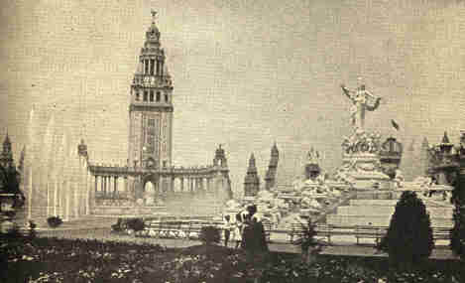
The Electric Tower and Fountains.

The central court bore the form of a cross. At either side of the gate lay transverse courts, each adorned with a lake, fountains, and sunken gardens, and ending in curved groups of buildings. On the east was the Government Group; on the west that devoted to horticulture, mines, and the graphic arts.
344 EXPANSION [1901

The intersection of the two arms formed the Esplanade, spacious enough for a quarter of a million people, and commanding a superb view. Connected by pergolas with the building in the transverse ends two structures, the Temple of Music and the Ethnology Building, stood like sentinels at the entrance to the Court of Fountains. A group of buildings enclosed this court, terminating in the Electric Tower at the north. From the Electric Tower round to the Gateway again all the buildings were joined by cool colonnades. Beyond the Tower was the Plaza, a charming little court, its sunken garden and band-stand surrounded by colonnades holding statuary.
The broad and spacious gardens with their wealth of verdure, their lakes, fountains, and statuary, formed a picture of indescribable charm. Nothing here suggested exhibits. Instead, spectators yielded to the spell of the beautiful scene. Chicago was serious and classic; Buffalo romantic, picturesque, even frivolous. The thought seemed to have been that, life in America being so intense, a rare holiday ought to bring diversion and amusement.
1901] THE PAN-AMERICAN EXPOSITION, 1901 345

No style of architecture could have contributed better to such gayety than the Spanish-Renaissance, light, ornate, and infinitely varied, lending itself to endless decoration in color and relief, and no more delicate compliment could have been paid our southern neighbors than this choice of their graceful and attractive designs. Each building was unique and original in plan.

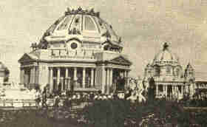
The Ethnology Building and
United States Government Building.

Domes, pinnacles, colonnades, balconies, towers, and low-tiled roofs afforded endless variety. The Electric Tower, designed by Mr. Howard, the central point in the scheme of architecture, its background of columns and its airy perforated walls and circular cupola with the Goddess of Light above, combined massiveness with lightness. Other buildings were strikingly quaint and pleasing, especially those suggesting the old Southern Missions.
346 EXPANSION [1901

All blended into the general scheme with scarcely a discord. This harmony was not accidental, but resulted from combined effort, each architect working at a general plan, yet not sacrificing his individual taste. It was an object lesson in massive architecture, showing how easily public edifices may be made beautiful each in itself, and to increase each other's beauty by artistic grouping.
Perhaps the most novel feature of the Fair was the coloring. Charles Y. Turner's colors-scheme, original and daring, called forth much criticism. With the Chicago White City the Rainbow City at Buffalo was a startling contrast. But the artist knew what he was doing when he boldly applied the gayest and brightest colors to buildings and columns, and added to the quaint architecture that bizarre and oriental touch in keeping with the festal purposes of the occasion. The rich, warm tones formed a perfect background for the white statuary, the green foliage, and the silvery fountains. The Temple of Music was a Pompeian red, Horticultural Hall orange, with details of blue, green, and yellow. The whole effect was fascinating, and at night, when the electric lights illumined and softened the tones, fairy-like.
1901] THE PAN-AMERICAN EXPOSITION, 1901 347

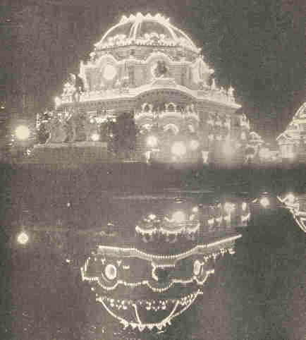
The Temple of Music by Electric Light.

348 EXPANSION [1901

But the coloring had a deeper meaning than this. Mr. Turner tried to depict, in his gradations of tone, the struggle of Man to overcome the elements, and his progress from barbarism to civilization. Thus, at the Gate, the strongest primary colors were used in barbaric warmth, yet in their warmth suggestive of welcome. As you advanced down the court the tones became milder and lighter, until they culminated in the soft ivory and gold of the Electric Tower, symbol of Man's crowning achievements. Everywhere you found the note of Niagara, green, symbolizing the great power of the falls.
Many forgot that in all this Mr. Turner was working from Greek models. Color was lavishly used on the Athenian temples, rich backgrounds of red or blue serving to throw the sculptural adornments into vivid relief. Buffalo was in this a commentary on classic art, revealing what fine effects may be produced by out-of-door coloring when suited to surroundings. We saw that in our timid, conventional avoidance of exterior colors we had missed something; that cheerful colors might well supplant on our houses the eternal sombre of gray and brown, as they so often and so gloriously do in nature.
1901] THE PAN-AMERICAN EXPOSITION. 1901 349

The power sculpture may have in exterior decoration was also taught. At Buffalo statues were not set up in long rows as in museums. Instead you beheld noble and beautiful groups in natural environments of bright green foliage with temples and blue sky above, or forming pediments and friezes upon buildings. White nymphs and goddesses bent over fountains or peeped from beneath trees or the ornate columns of pergolas. One was greeted at every turn by these gleaming figures, a vital and integral part of the landscape.
Carl Bitter, director of sculpture, aimed to make sculpture teach while it decorated. He sought to tell in sculpture the story of man and nature. In the lake fronting the Government Building stood a fountain of Man. A half-veiled form, mysterious Man, occupied a pedestal composed of figures of the five senses. Underneath the basin the Virtues struggled with the Vices. Minor groups depicted the different ages. The most remarkable was Mr. Konti's Despotic Age. The grim tyrant sat in his chariot, driven by Ambition, who goaded on the four slaves in the traces, while Justice and Mercy cowered in chains behind.
350 EXPANSION [1901

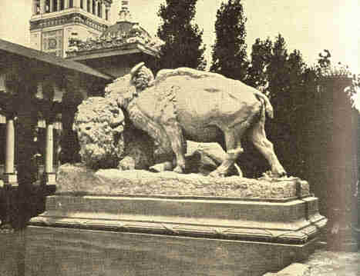
Group of Buffalos--Pan-American Exposition.

In the opposite court was told the story of Nature. Most striking there was Mr. Elwell's figure of Kronos, standing, with winged arms, on a turtle. From the Fountain of Abundance on the Esplanade, Flora was represented as tossing garlands of flowers to the chubby cherubs at her feet. The main court, dedicated to the achievements of man, had groups representing the Human Intellect and Emotions. The sculptures about the Electric Tower naturally related to the Falls. There were primeval Niagara and the Niagara of today, as well as figures symbolic of the Lakes and the Rivers.
1901] THE PAN-AMERICAN EXPOSITION, 1901 351

Copies of the most famous marbles, like the Playful Faun and the Venus of Melos, embellished the Plaza. Many fine modern pieces adorned the grounds, as Roth's stirring "Chariot Race" and St. Gaudens's equestrian statue of General Sherman. Sculpture was profusely used to beautify buildings. Wholly original and charming were the four groups for the Temple of Music: Heroic Music, Sacred Music, Dance Music, and Lyric Music. Perched in every corner were figures of children playing different instruments.
Much of the sculpture, was careless in execution--not surprising when we consider that over 500 pieces were set up in less than five months, and that the artists' models had to be enlarged by machinery. But in vigor and originality of thought and as a testimony to the progress which art had made in this country, the exhibit was truly wonderful. All the arts were employed.
352 EXPANSION [1901

To many it was mainly an Art Exhibition, the artistic feature making a stronger impression than any other. As a work of art the Exposition could not but effect permanent good, demonstrating what may be done to beautify our cities and dwellings and cultivating our love for the beautiful in art and nature.
The supreme glory of the Exposition lay in its electrical illumination. Niagara was used to create a city of light more dazzling than any dream. "As the moment for the illumination approached, the band hushed and a stillness fell upon the multitude. Suddenly dull reddish threads appeared on the globes of the near-by lamp-pillars. A murmur of expectation ran through the crowd. For an instant the great tower seemed to pulse with a thread of life before the eye became sensible to what had taken place. Then its surfaces gleamed with a faint flush like the flush which church spires catch from the dawn. This deepened slowly to pink and then to red. . . . In a moment the architectural skeletons of the great buildings had been picked out in lines of red light. Then the whole effect mellowed into luminous yellow. The material exposition had been transfigured, and its glorified ghost was in its place. . . . Every night this modern miracle was worked by the rheostat housed in a humble shed somewhere in the inner recesses of the exposition."

1901] THE PAN-AMERICAN EXPOSITION, 1901 353

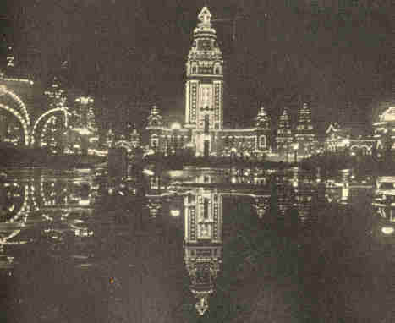
The Electric Tower at Night.

354 EXPANSION [1901

The centre of light was the Tower. It was suffused with the loveliest glow of gold, ivory, and delicate green, all blending. The lights revealed and interpreted the architecture softening the colors and adding the subtle charm of mystery. A hundred beautiful hues were reflected in the waters of the fountains. The floral effects made by submerged lights in the basin were exquisite, and the witchery of the scene was indescribable.
The chaining of Niagara for electric purposes was of course a prominent feature of the fair. Electricity was almost, or quite, the sole motor used on the grounds; 5,000 horsepower being directly from Niagara's total of 50,000. Niagara circulated the salt water in the fisheries and kept their water at the right temperature. It operated telephones, phonographs, soda fountains, the big search-lights, the elevators, the machines in the Machinery Building, the shows and illusions in the Midway.
At Chicago we were ashamed of the Midway. We had since learned to play. Buffalo used utmost ingenuity to provide sensations and novelties. The Midway was made fascinating. You saw in it every variety of buildings, representing all countries from Eskimodom to Darkest Africa.
1901] THE PAN-AMERICAN EXPOSITION, 1901 355

Cairo had eight streets with 600 natives. The Hawaiian and Philippine villages were centres of interest, revealing the every-day life of our new-won lands. In Alt-Nurnberg you dined to the strains of a German orchestra.

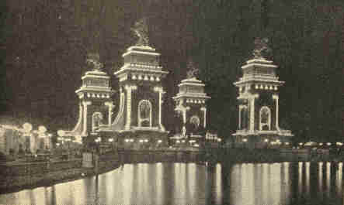
Triumphal Bridge and entrance to the Exposition,
showing electric display at night.

The magnificent amphitheatre, covering ten acres, a monument to American athletics, was built after the marble Stadium of Lycurgus at Athens. An Athletic Congress celebrated American supremacy in athletic sports. The programme included basket-ball tournaments, automobile, bicycle, and track and field championship races, lacrosse matches, and canoe "meets."
356 EXPANSION [1901

The exhibits at Buffalo, though less ample, naturally showed advance over the corresponding ones at Chicago. The guns and ammunition of the United States ordnance department excited interest, for we were now making our own war supplies. A picturesque log building was devoted to forestry. The Graphic Arts Building showed the great strides made in printing and engraving. A model dairy was operated in a quaint little cottage on the grounds. Fifty cows of the best breeds were tested and the tests recorded.
A conservatory contained a very fine collection of food plants, alive and growing, sent from South and Central America; also eight different kinds of tea plants from South Carolina. A small coffee plantation and some vanilla vines had been transplanted from Mexico. Nearly every country in Spanish America was represented. Cuba, San Domingo, Ecuador, Chile, Honduras, Mexico, and Canada had buildings. Sections in the Government Building were devoted to exhibits from Porto Rico, the Hawaiian Islands, and the Philippines.
1901] THE PAN-AMERICAN EXPOSITION, 1901 357

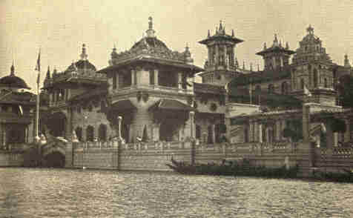
The Electricity Building.

The United States Government Building was most interesting. New inventions made its exhibits live. In place of reading reports and statistics, you saw scenes and heard sounds. Class-room songs and recitations were reproduced by the graphophone. The biograph showed naval cadets marching while at the same time you heard the band music. Labor-saving machines were represented in full operation. Pictures by wire, the mutoscope, and type-setting by electricity were among the wonders shown. Every day a crew of the life-saving service gave a demonstration, launching a life-boat and rescuing a sailor.
358 EXPANSION [1901

Near by was a field hospital, where wounded soldiers were cared for. Many of the newest uses for electricity were displayed. Never before had lighting been so brilliant or covered such large areas, or such speed in telegraphy been attained, or telephoning reached such distances. The akouphone, a blessing to the deaf, was exhibited, as were also the powerful search-lights now a necessity at sea.
CHAPTER XIX.

MR. McKINLEY'S END

Upon invitation President and Mrs. McKinley visited the Pan-American Exposition at Buffalo. September 5, 1901, the first day of his presence, the Chief Magistrate delivered an address, memorable both as a sagacious survey of public affairs and as indicating a modification of his well-known tariff opinions in the direction of freer commercial intercourse with foreign nations.
"We must not," he said, "repose in fancied security that we can forever sell everything and buy little or nothing." … "The period of exclusiveness is past." "Reciprocity treaties are in harmony with the spirit of the times; measures of retaliation are not."… "If perchance some of our tariffs are no longer needed for revenue or to encourage and protect our industries at home, why should they not be employed to extend and promote our markets abroad?" In connection with this thought the President expressed his conviction that we must encourage our merchant marine and, in the same commercial interest, construct a Pacific cable and an Isthmian canal.
360 EXPANSION [1901

The projects of Mr. McKinley's statesmanship thus announced were approved by nearly the entire public, but they were destined to be carried out by other hands. On his second day at Buffalo, Friday, September 6th, about four in the afternoon, the President stood in the beautiful Temple of Music receiving the hundreds who filed past to shake hands with him. A sinister fellow, resembling an Italian, tarried suspiciously, and was pushed forward by the Secret Service attendants. Next behind him followed a boyish-looking workman, his right hand swathed in a handkerchief. As the first made way Mr. McKinley extended his hand to the young man's unencumbered left. The next instant the bandaged right arm raised itself and two shots rang on the air. The President staggered back into the arms of a bystander, while his treacherous assailant was borne to the floor.
361

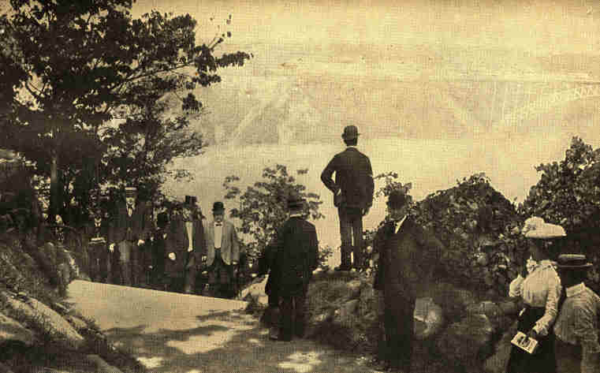
Copyright, 1901, by C. E. Dunlap.
President McKinley at Niagara
Ascending the stairs from Luna Island, to Goat Island.
362
1901] MR. McKINLEY'S END 363

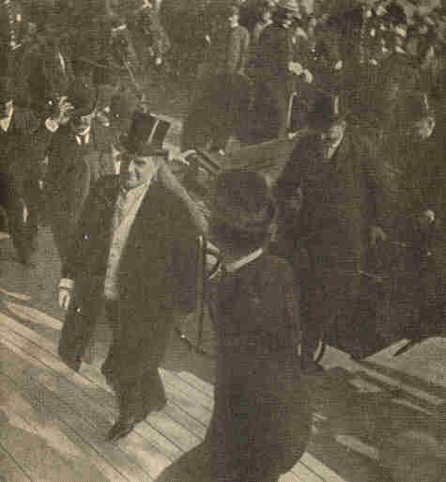
The last photograph of the late President McKinley.
Taken as he was ascending the steps of the Temple of Music,
September 6. 1901.

364 EXPANSION [1901

Grievously wounded as he was in breast and in stomach, the President's first thoughts were for others. He requested that the news be broken gently to Mrs. McKinley, and, it was said, expressed regret that the occurrence would be an injury to the exposition. As cries of "Lynch him" arose from the maddened crowd, the stricken chief urged those about him to see that no hurt befel the assassin. The latter was speedily secured in prison to await the result of his black deed, while President McKinley was without delay conveyed to the Emergency Hospital, where his wounds were dressed.
Except for continued weakness and rapid heart action, the symptoms during the early days of the succeeding week gave strong hopes of the patient's recovery. At the home of Mr. Milburn, President of the exposition, whose guest he was, President McKinley received the tenderest care and most skilful treatment. So far allayed was anxiety that the Cabinet officers left Buffalo, while Vice President Roosevelt betook himself to a sequestered part of the Adirondacks. The President himself, vigorous and naturally sanguine, did not give up till Friday, a week from the date of his injury.

1901] MR. McKINLEY'S END 365

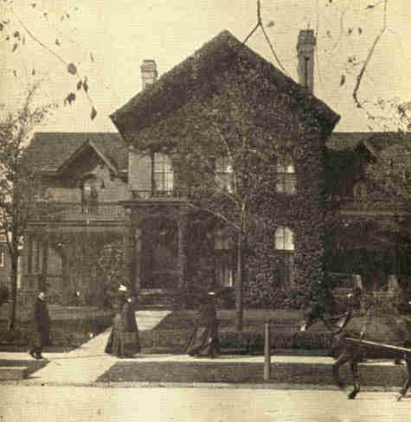
Copyright, 1902, by Underwood & Underwood.
The Milburn Residence, where President McKinley died--Buffalo, N. Y.

Upon that day his condition became alarming. The digestive organs abdicated their functions, nourishment even by injection became impossible, traces of septic poison were manifest. By night the world knew that McKinley was a dying man. In the evening he regained consciousness and bade farewell to those about him. "Good-by, good-by, all; it is God's way; His will be done." The murmured words came from his lips, "Nearer, my God, to Thee; e'en tho' it be a cross that raiseth me."
366 EXPANSION [1901

At the early morning hour of 2.45, Saturday, September 14th, the rest which is deeper than any sleep came to the sufferer. The autopsy showed that death was due to gangrene of the tissues in the path of the wound, the system having failed to repair the ravages of the bullet that had entered the abdomen.
The next Monday morning, after a simple funeral ceremony at the Milburn mansion, the remains were reverently borne to the Buffalo City Hall, where, till midnight, mourning columns filed past the catafalque. The body lay in state under the Capitol rotunda at Washington for a day, and was borne thence, hardly a moment out of hearing of solemn bells or out of sight of half-masted flags and dumb, mourning multitudes, to the old home at Canton, Ohio. Here the late Chief Magistrate's fellow-townsmen, his old army comrades, and other thousands joined the procession to the cemetery or tearfully lined the streets as it passed.
367

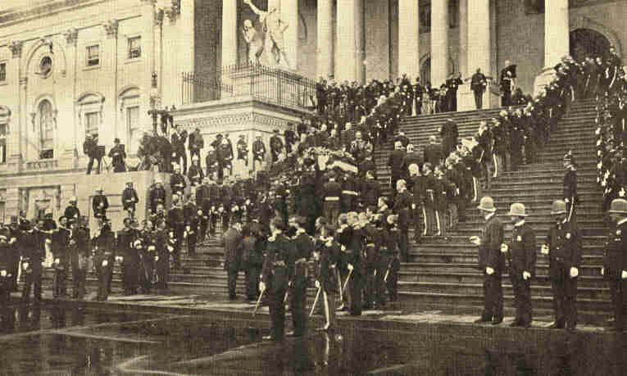
Ascending the Capitol steps at Washington, D, C.,
where the casket lay in state in the Rotunda.
368
1901] MR. McKINLEY'S END 369

On the day of the interment, September 19th, appropriate exercises, attended by enormous concourses of people, occurred all over the country, and even in foreign parts. In hardly an American town of size could a single building contain the crowd, overflow meetings being necessary, filling several churches or halls. Special commemorative services were held in Westminster Cathedral by King Edward's orders.
No king was ever honored by obsequies so widespread or more sincere. Messages of condolence poured in upon the widow from the four quarters of the globe. Business was suspended. For five minutes telegraph clicks and cable flashes ceased, and for ten minutes, upon many lines of railway and street railway, every wheel stood still.

370 EXPANSION [1901

None but the rash undertook, at once after his lamented decease, to assign President McKinley's name to its exact altitude on the roll of America's illustrious men. Ardent eulogists spoke of him as beside the nation's greatest statesman, Lincoln, while his most pronounced opponents in life accorded him very high honor. During his career he had been accused of opportunism, of inconsistency, of partiality to the moneyed interests of the country. His views of great public questions underwent change. One of his altered attitudes, much remarked upon, that concerning silver, involved, as pointed out in the last chapter, no change of essential principle. In regard to protection he at last swung to Blaine's position favoring reciprocity, which, as author of the McKinley Bill, he had been understood to oppose; but it should be remembered that his final utterances on the subject contemplated an industrial situation very different from that prevalent during his early years in politics. The United States had become a mighty exporter of manufactured products, competing effectively with England, Germany, and France in the sale of such everywhere in the world.

1901] MR. MCKINLEY'S END 371

American material supplied in large part the Russian Trans-Siberian Railroad. American food-stuffs and meats wakened agrarian frenzy in Germany. The island-hive of England buzzed loudly with jealous foreboding lest America capture her world-markets. From an average of close to $163,000,000 annually from 1887 to 1897 United States exports of manufactured products reached in 1898 over $290.000,000, in 1899 over $339,000,000, in 1900 nearly $434,000,000, and in 1901, $412,000,000. As coal-producer the United States at last led Britain, American tin-plate reached Wales itself, American locomotives the English colonies and even the mother-country, while boots and shoes from our factories ruled the markets of West Australia and South Africa. For bridge and viaduct construction in British domains American bids heavily undercut British bids both in price and in time limit.
His progressive insight into the tariff question betrayed Mr. McKinley's mental activity and hospitality, as his final deliverances thereupon exhibited fearlessness. None knew better than he that what he said at Buffalo would be challenged by many in the name of party orthodoxy.
372 EXPANSION [1901

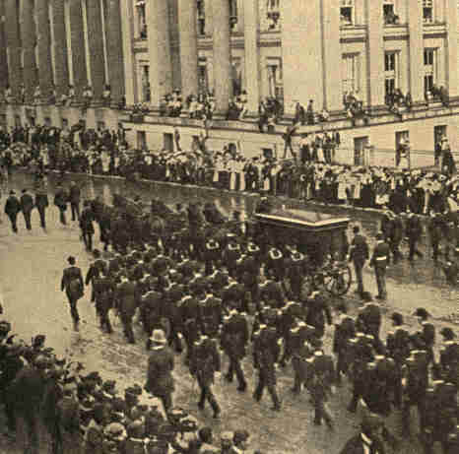
Copyright, 1901, by Underwood & Underwood.
President McKinley's Remains Passing the United States Treasury, Washington, D.C.

1901] MR. McKINLEY'S END 373

Even greater firmness was manifest when, at an earlier date, speaking at Savannah, he ranked Robert E. Lee and Stonewall Jackson as among America's "great" sons. With this brave tribute should be mentioned his commendable nomination of the ex-Confederate Generals Fitz-Hugh Lee and Joseph Wheeler as Major-Generals in the United States Army. Such words and deeds showed skilled leadership also. Each was fittingly timed so as best to escape or fend criticism and so as to impress the public deeply.
Not a little of Mr. McKinley's apparent vacillation and of his complaisance toward men and interests representing wealth was due to an endowment of exquisite finesse which stooped to conquer, which led by seeming to follow, or by yielding an inch took an ell. In him was rooted by inheritance a quick sense of the manufacturer's point of view, for his father and grandfather had been iron-furnace men, and a certain conservative instinct, characteristic of his party, which deemed the counsel of broadcloth wiser than the clamor of rags, and equally patriotic withal. Notwithstanding this, history cannot but pronounce McKinley's love of country, his whole Americanism, in fact, as sincere, sturdy, and democratic as Abraham Lincoln's.
374 EXPANSION [1901

Mr. McKinley's power and breadth as a statesman were greatly augmented by the responsibilities of the presidency. Before his accession to that exalted office he had helped devise but one great public measure, the McKinley Bill, and his speeches upon his chosen theme, protection, were more earnest than varied or profound. But witness the largeness of view marking the directions of April 7, 1900, to the Taft Philippine Commission: "The Commission should bear in mind that the government which they are establishing is designed not for our satisfaction or for the expression of our theoretical views, but for the happiness, peace, and prosperity of the people of the Philippine Islands, and the measures adopted should be made to conform to their customs, their habits, and even their prejudices, to the fullest extent consistent with the accomplishment of the indispensable requisites of just and effective government."

1901] MR. McKINLEY'S END 375

Most of President McKinley's appointments were wise; several of the most important ones quite remarkably so. He managed discreetly in crises. He saw the whole of a situation as few statesmen have done, penetrating to details and obscure aspects, which others, even experts, had overlooked. During the Spanish War his advice was always wise and helpful, and at points vital. Courteous to all foreign powers, and falling into no spectacular jangles with any, he was obsequious to none. No other ruler, party to intervention in China during the Boxer rebellion in 1900, acted there so sanely, or withdrew with so creditable a record.
What made it certain that Mr. McKinley's name would be forever remembered with honor was not merely or mainly the fact that his administration marked a great climacteric in our national career. His intimates in office and in public life unanimously testified that in shaping the nation's new destiny he played an active and not a passive role. He dominated his cabinet, diligently attending to the advice each member offered, but by no means always following it. Party bosses seeking to lead him were themselves led, oftenest without being aware of it, to accomplish his wishes.
376 EXPANSION [1901

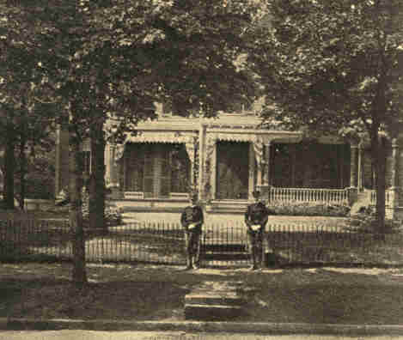
Copyright, 1901, by Underwood & Underwood.
The Home of William McKinley, at Canton, Ohio.

As a practical politician in the better sense of the word McKinley was a master. Repeatedly, at critical junctures, he saved his following from rupture, while the opposition became an impotent rout. Hardly a contrast in American political warfare has been more striking than the pitiful demoralization of the Democracy in the campaign of 1900 compared with the closed ranks and solid front of the Republican array. Anti-imperialists like Carnegie and Hoar, silver men like Senator Stewart, and the low-tariff Republicans of the West united to hold aloft the McKinley banner.
1901] MR. McKINLEY'S END 377

The result was not due, as some fancied, to Mr. Hanna. Nor did it mean that there was no discord among Republicans, for there was much. The discipline proceeded from the candidate's influence, from his harmonizing personal leadership. This he exercised not through oratory, for he had none of the tricks of speech, not even the knack of story-telling, but by the mere force of his will and his wisdom.
Mr. McKinley's private character was pure, exemplary, and noble. His life-long devotion to an invalid wife; his fidelity to his friends; the charm, consideration, and tact of his demeanor toward everyone; and, above all, the Christian sublimity of his last days created at once a foundation and a crown for his fame.

378 EXPANSION [1901

Ex-President Cleveland said: "You will constantly hear as accounting for Mr. McKinley's great success that he was obedient and affectionate as a son, patriotic and faithful as a soldier, honest and upright as a citizen, tender and devoted as a husband, and truthful, generous, unselfish, moral, and clean in every relation of life. He never thought of those things as too weak for his manliness."
A special grand jury forthwith indicted the assassin, who, talking freely enough with his guards, refused all intercourse with the attorneys assigned to defend him, and with the expert sent to test his sanity. He was promptly placed upon trial, convicted, sentenced, and executed, all without any of the unseemly incidents attending the trial of Guiteau after Garfield's assassination. No heed was given to those who, some of them from pulpits, fulminated anarchy as bad as that of the anarchists by demanding that Czolgosz be lynched. These prompt but perfectly orderly and dispassionate proceedings were a great credit to the State of New York.
1901] MR. McKINLEY'S END 379

Leon Czolgosz, the murderer of President McKinley, was born in this country, of Russian-Polish parentage, in 1875. He received some education, was apprenticed to a blacksmith in Detroit, and later employed in Cleveland and in Chicago. At the time of his crime he had been working in a Cleveland wire mill. It was said that at Cleveland he had heard Emma Goldman deliver an anarchist address, and that this inspired his fell purpose. It was suspected that he was the tool of an anarchist plot, and that the man preceding him in the line when he shot the President was an accomplice, but there was no evidence that either was true. There were indications that Czolgosz had made overtures to the anarchists and been rejected as a spy. No accessories were found. Nor did the dreadful act betoken that anarchism was increasing in our country, or that any special propagandism in its favor was on. To all appearance, it stood unrelated, so far as America was concerned.
Leon Czolgosz's heart had caught fire from the malignant passion of red anarchy abroad, which had within seven years struck down the President of France, the Empress of Austria, the King of Italy, and the Prime Minister of Spain. In their fanatic diabolism its devotees impartially hated government, whether despotic or free, and would, no doubt, gladly have made America, the freest of the great commonwealths, for that reason a hatching ground for their dark conspiracies.
380 EXPANSION [1901

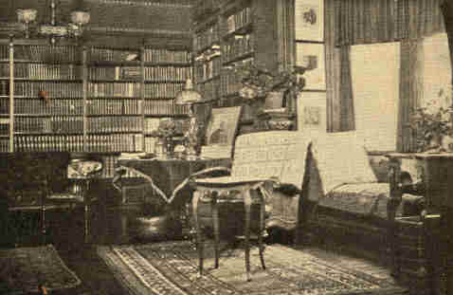
Interior of room in Wilcox House where
Theodore Roosevelt took the oath of Presidency.

They were no less hostile to one than to the other of our political parties. The murder had no political significance, though certainly calculated to rebuke virulent editorials and cartoons in political papers, wont to season political debate with too hot personal condiment, printed and pictorial. President McKinley had suffered from this and so had his predecessor.
1901] MR. McKINLEY'S END 381

Upon such an occasion orderly government, both in the States and in the nation, reasonably sought muniment against any possible new danger from anarchy. McKinley's own State leading, States enacted statutes denouncing penalties upon such as assailed, by either speech or act, the life or the bodily safety of anyone in authority. The Federal Government followed with a similar anti-anarchist law of wide scope.
Deeply as the country prized McKinley--and the sense of loss by his death increased with the days--Vice-President Theodore Roosevelt took over the presidency with as little jar as a military post suffers from changing guard.

End of the Project Gutenberg EBook of History of the United States, Volume 5, by
E. Benjamin Andrews

*** END OF THIS PROJECT GUTENBERG EBOOK HISTORY UNITED STATES ***

***** This file should be named 22777-doc.dod or 22777-doc.zip *****
This and all associated files of various formats will be found in:
http://www.gutenberg.org/2/2/7/7/22777/

Produced by Don Kostuch

Updated editions will replace the previous one--the old editions
will be renamed.

Creating the works from public domain print editions means that no
one owns a United States copyright in these works, so the Foundation
(and you!) can copy and distribute it in the United States without
permission and without paying copyright royalties. Special rules,
set forth in the General Terms of Use part of this license, apply to
copying and distributing Project Gutenberg-tm electronic works to
protect the PROJECT GUTENBERG-tm concept and trademark. Project
Gutenberg is a registered trademark, and may not be used if you
charge for the eBooks, unless you receive specific permission. If you
do not charge anything for copies of this eBook, complying with the
rules is very easy. You may use this eBook for nearly any purpose
such as creation of derivative works, reports, performances and
research. They may be modified and printed and given away--you may do
practically ANYTHING with public domain eBooks. Redistribution is
subject to the trademark license, especially commercial
redistribution.

*** START: FULL LICENSE ***

THE FULL PROJECT GUTENBERG LICENSE
PLEASE READ THIS BEFORE YOU DISTRIBUTE OR USE THIS WORK

To protect the Project Gutenberg-tm mission of promoting the free
distribution of electronic works, by using or distributing this work
(or any other work associated in any way with the phrase "Project
Gutenberg"), you agree to comply with all the terms of the Full Project
Gutenberg-tm License (available with this file or online at
http://gutenberg.org/license).

Section 1. General Terms of Use and Redistributing Project Gutenberg-tm
electronic works

1.A. By reading or using any part of this Project Gutenberg-tm
electronic work, you indicate that you have read, understand, agree to
and accept all the terms of this license and intellectual property
(trademark/copyright) agreement. If you do not agree to abide by all
the terms of this agreement, you must cease using and return or destroy
all copies of Project Gutenberg-tm electronic works in your possession.
If you paid a fee for obtaining a copy of or access to a Project
Gutenberg-tm electronic work and you do not agree to be bound by the
terms of this agreement, you may obtain a refund from the person or
entity to whom you paid the fee as set forth in paragraph 1.E.8.

1.B. "Project Gutenberg" is a registered trademark. It may only be
used on or associated in any way with an electronic work by people who
agree to be bound by the terms of this agreement. There are a few
things that you can do with most Project Gutenberg-tm electronic works
even without complying with the full terms of this agreement. See
paragraph 1.C below. There are a lot of things you can do with Project
Gutenberg-tm electronic works if you follow the terms of this agreement
and help preserve free future access to Project Gutenberg-tm electronic
works. See paragraph 1.E below.

1.C. The Project Gutenberg Literary Archive Foundation ("the Foundation"
or PGLAF), owns a compilation copyright in the collection of Project
Gutenberg-tm electronic works. Nearly all the individual works in the
collection are in the public domain in the United States. If an
individual work is in the public domain in the United States and you are
located in the United States, we do not claim a right to prevent you from
copying, distributing, performing, displaying or creating derivative
works based on the work as long as all references to Project Gutenberg
are removed. Of course, we hope that you will support the Project
Gutenberg-tm mission of promoting free access to electronic works by
freely sharing Project Gutenberg-tm works in compliance with the terms of
this agreement for keeping the Project Gutenberg-tm name associated with
the work. You can easily comply with the terms of this agreement by
keeping this work in the same format with its attached full Project
Gutenberg-tm License when you share it without charge with others.

1.D. The copyright laws of the place where you are located also govern
what you can do with this work. Copyright laws in most countries are in
a constant state of change. If you are outside the United States, check
the laws of your country in addition to the terms of this agreement
before downloading, copying, displaying, performing, distributing or
creating derivative works based on this work or any other Project
Gutenberg-tm work. The Foundation makes no representations concerning
the copyright status of any work in any country outside the United
States.

1.E. Unless you have removed all references to Project Gutenberg:

1.E.1. The following sentence, with active links to, or other immediate
access to, the full Project Gutenberg-tm License must appear prominently
whenever any copy of a Project Gutenberg-tm work (any work on which the
phrase "Project Gutenberg" appears, or with which the phrase "Project
Gutenberg" is associated) is accessed, displayed, performed, viewed,
copied or distributed:

This eBook is for the use of anyone anywhere at no cost and with
almost no restrictions whatsoever. You may copy it, give it away or
re-use it under the terms of the Project Gutenberg License included
with this eBook or online at www.gutenberg.org

1.E.2. If an individual Project Gutenberg-tm electronic work is derived
from the public domain (does not contain a notice indicating that it is
posted with permission of the copyright holder), the work can be copied
and distributed to anyone in the United States without paying any fees
or charges. If you are redistributing or providing access to a work
with the phrase "Project Gutenberg" associated with or appearing on the
work, you must comply either with the requirements of paragraphs 1.E.1
through 1.E.7 or obtain permission for the use of the work and the
Project Gutenberg-tm trademark as set forth in paragraphs 1.E.8 or
1.E.9.

1.E.3. If an individual Project Gutenberg-tm electronic work is posted
with the permission of the copyright holder, your use and distribution
must comply with both paragraphs 1.E.1 through 1.E.7 and any additional
terms imposed by the copyright holder. Additional terms will be linked
to the Project Gutenberg-tm License for all works posted with the
permission of the copyright holder found at the beginning of this work.

1.E.4. Do not unlink or detach or remove the full Project Gutenberg-tm
License terms from this work, or any files containing a part of this
work or any other work associated with Project Gutenberg-tm.

1.E.5. Do not copy, display, perform, distribute or redistribute this
electronic work, or any part of this electronic work, without
prominently displaying the sentence set forth in paragraph 1.E.1 with
active links or immediate access to the full terms of the Project
Gutenberg-tm License.

1.E.6. You may convert to and distribute this work in any binary,
compressed, marked up, nonproprietary or proprietary form, including any
word processing or hypertext form. However, if you provide access to or
distribute copies of a Project Gutenberg-tm work in a format other than
"Plain Vanilla ASCII" or other format used in the official version
posted on the official Project Gutenberg-tm web site (www.gutenberg.org),
you must, at no additional cost, fee or expense to the user, provide a
copy, a means of exporting a copy, or a means of obtaining a copy upon
request, of the work in its original "Plain Vanilla ASCII" or other
form. Any alternate format must include the full Project Gutenberg-tm
License as specified in paragraph 1.E.1.

1.E.7. Do not charge a fee for access to, viewing, displaying,
performing, copying or distributing any Project Gutenberg-tm works
unless you comply with paragraph 1.E.8 or 1.E.9.

1.E.8. You may charge a reasonable fee for copies of or providing
access to or distributing Project Gutenberg-tm electronic works provided
that

- You pay a royalty fee of 20% of the gross profits you derive from
the use of Project Gutenberg-tm works calculated using the method
you already use to calculate your applicable taxes. The fee is
owed to the owner of the Project Gutenberg-tm trademark, but he
has agreed to donate royalties under this paragraph to the
Project Gutenberg Literary Archive Foundation. Royalty payments
must be paid within 60 days following each date on which you
prepare (or are legally required to prepare) your periodic tax
returns. Royalty payments should be clearly marked as such and
sent to the Project Gutenberg Literary Archive Foundation at the
address specified in Section 4, "Information about donations to
the Project Gutenberg Literary Archive Foundation."

- You provide a full refund of any money paid by a user who notifies
you in writing (or by e-mail) within 30 days of receipt that s/he
does not agree to the terms of the full Project Gutenberg-tm
License. You must require such a user to return or
destroy all copies of the works possessed in a physical medium
and discontinue all use of and all access to other copies of
Project Gutenberg-tm works.

- You provide, in accordance with paragraph 1.F.3, a full refund of any
money paid for a work or a replacement copy, if a defect in the
electronic work is discovered and reported to you within 90 days
of receipt of the work.

- You comply with all other terms of this agreement for free
distribution of Project Gutenberg-tm works.

1.E.9. If you wish to charge a fee or distribute a Project Gutenberg-tm
electronic work or group of works on different terms than are set
forth in this agreement, you must obtain permission in writing from
both the Project Gutenberg Literary Archive Foundation and Michael
Hart, the owner of the Project Gutenberg-tm trademark. Contact the
Foundation as set forth in Section 3 below.

1.F.

1.F.1. Project Gutenberg volunteers and employees expend considerable
effort to identify, do copyright research on, transcribe and proofread
public domain works in creating the Project Gutenberg-tm
collection. Despite these efforts, Project Gutenberg-tm electronic
works, and the medium on which they may be stored, may contain
"Defects," such as, but not limited to, incomplete, inaccurate or
corrupt data, transcription errors, a copyright or other intellectual
property infringement, a defective or damaged disk or other medium, a
computer virus, or computer codes that damage or cannot be read by
your equipment.

1.F.2. LIMITED WARRANTY, DISCLAIMER OF DAMAGES - Except for the "Right
of Replacement or Refund" described in paragraph 1.F.3, the Project
Gutenberg Literary Archive Foundation, the owner of the Project
Gutenberg-tm trademark, and any other party distributing a Project
Gutenberg-tm electronic work under this agreement, disclaim all
liability to you for damages, costs and expenses, including legal
fees. YOU AGREE THAT YOU HAVE NO REMEDIES FOR NEGLIGENCE, STRICT
LIABILITY, BREACH OF WARRANTY OR BREACH OF CONTRACT EXCEPT THOSE
PROVIDED IN PARAGRAPH F3. YOU AGREE THAT THE FOUNDATION, THE
TRADEMARK OWNER, AND ANY DISTRIBUTOR UNDER THIS AGREEMENT WILL NOT BE
LIABLE TO YOU FOR ACTUAL, DIRECT, INDIRECT, CONSEQUENTIAL, PUNITIVE OR
INCIDENTAL DAMAGES EVEN IF YOU GIVE NOTICE OF THE POSSIBILITY OF SUCH
DAMAGE.

1.F.3. LIMITED RIGHT OF REPLACEMENT OR REFUND - If you discover a
defect in this electronic work within 90 days of receiving it, you can
receive a refund of the money (if any) you paid for it by sending a
written explanation to the person you received the work from. If you
received the work on a physical medium, you must return the medium with
your written explanation. The person or entity that provided you with
the defective work may elect to provide a replacement copy in lieu of a
refund. If you received the work electronically, the person or entity
providing it to you may choose to give you a second opportunity to
receive the work electronically in lieu of a refund. If the second copy
is also defective, you may demand a refund in writing without further
opportunities to fix the problem.

1.F.4. Except for the limited right of replacement or refund set forth
in paragraph 1.F.3, this work is provided to you 'AS-IS' WITH NO OTHER
WARRANTIES OF ANY KIND, EXPRESS OR IMPLIED, INCLUDING BUT NOT LIMITED TO
WARRANTIES OF MERCHANTIBILITY OR FITNESS FOR ANY PURPOSE.

1.F.5. Some states do not allow disclaimers of certain implied
warranties or the exclusion or limitation of certain types of damages.
If any disclaimer or limitation set forth in this agreement violates the
law of the state applicable to this agreement, the agreement shall be
interpreted to make the maximum disclaimer or limitation permitted by
the applicable state law. The invalidity or unenforceability of any
provision of this agreement shall not void the remaining provisions.

1.F.6. INDEMNITY - You agree to indemnify and hold the Foundation, the
trademark owner, any agent or employee of the Foundation, anyone
providing copies of Project Gutenberg-tm electronic works in accordance
with this agreement, and any volunteers associated with the production,
promotion and distribution of Project Gutenberg-tm electronic works,
harmless from all liability, costs and expenses, including legal fees,
that arise directly or indirectly from any of the following which you do
or cause to occur: (a) distribution of this or any Project Gutenberg-tm
work, (b) alteration, modification, or additions or deletions to any
Project Gutenberg-tm work, and (c) any Defect you cause.

Section 2. Information about the Mission of Project Gutenberg-tm

Project Gutenberg-tm is synonymous with the free distribution of
electronic works in formats readable by the widest variety of computers
including obsolete, old, middle-aged and new computers. It exists
because of the efforts of hundreds of volunteers and donations from
people in all walks of life.

Volunteers and financial support to provide volunteers with the
assistance they need, is critical to reaching Project Gutenberg-tm's
goals and ensuring that the Project Gutenberg-tm collection will
remain freely available for generations to come. In 2001, the Project
Gutenberg Literary Archive Foundation was created to provide a secure
and permanent future for Project Gutenberg-tm and future generations.
To learn more about the Project Gutenberg Literary Archive Foundation
and how your efforts and donations can help, see Sections 3 and 4
and the Foundation web page at http://www.pglaf.org.

Section 3. Information about the Project Gutenberg Literary Archive
Foundation

The Project Gutenberg Literary Archive Foundation is a non profit
501(c)(3) educational corporation organized under the laws of the
state of Mississippi and granted tax exempt status by the Internal
Revenue Service. The Foundation's EIN or federal tax identification
number is 64-6221541. Its 501(c)(3) letter is posted at
http://pglaf.org/fundraising. Contributions to the Project Gutenberg
Literary Archive Foundation are tax deductible to the full extent
permitted by U.S. federal laws and your state's laws.

The Foundation's principal office is located at 4557 Melan Dr. S.
Fairbanks, AK, 99712., but its volunteers and employees are scattered
throughout numerous locations. Its business office is located at
809 North 1500 West, Salt Lake City, UT 84116, (801) 596-1887, email
business@pglaf.org. Email contact links and up to date contact
information can be found at the Foundation's web site and official
page at http://pglaf.org

For additional contact information:
Dr. Gregory B. Newby
Chief Executive and Director
gbnewby@pglaf.org

Section 4. Information about Donations to the Project Gutenberg
Literary Archive Foundation

Project Gutenberg-tm depends upon and cannot survive without wide
spread public support and donations to carry out its mission of
increasing the number of public domain and licensed works that can be
freely distributed in machine readable form accessible by the widest
array of equipment including outdated equipment. Many small donations
($1 to $5,000) are particularly important to maintaining tax exempt
status with the IRS.

The Foundation is committed to complying with the laws regulating
charities and charitable donations in all 50 states of the United
States. Compliance requirements are not uniform and it takes a
considerable effort, much paperwork and many fees to meet and keep up
with these requirements. We do not solicit donations in locations
where we have not received written confirmation of compliance. To
SEND DONATIONS or determine the status of compliance for any
particular state visit http://pglaf.org

While we cannot and do not solicit contributions from states where we
have not met the solicitation requirements, we know of no prohibition
against accepting unsolicited donations from donors in such states who
approach us with offers to donate.

International donations are gratefully accepted, but we cannot make
any statements concerning tax treatment of donations received from
outside the United States. U.S. laws alone swamp our small staff.

Please check the Project Gutenberg Web pages for current donation
methods and addresses. Donations are accepted in a number of other
ways including checks, online payments and credit card donations.
To donate, please visit: http://pglaf.org/donate

Section 5. General Information About Project Gutenberg-tm electronic
works.

Professor Michael S. Hart is the originator of the Project Gutenberg-tm
concept of a library of electronic works that could be freely shared
with anyone. For thirty years, he produced and distributed Project
Gutenberg-tm eBooks with only a loose network of volunteer support.

Project Gutenberg-tm eBooks are often created from several printed
editions, all of which are confirmed as Public Domain in the U.S.
unless a copyright notice is included. Thus, we do not necessarily
keep eBooks in compliance with any particular paper edition.

Most people start at our Web site which has the main PG search facility:

http://www.gutenberg.org

This Web site includes information about Project Gutenberg-tm,
including how to make donations to the Project Gutenberg Literary
Archive Foundation, how to help produce our new eBooks, and how to
subscribe to our email newsletter to hear about new eBooks.

